A learning from home pack

For learners in years 7–8

Theme: Change | Panoni – Is change a good thing?

Context 1: Adaptations

Context 2: Innovation – can I make a better ...?

Layout of the resource
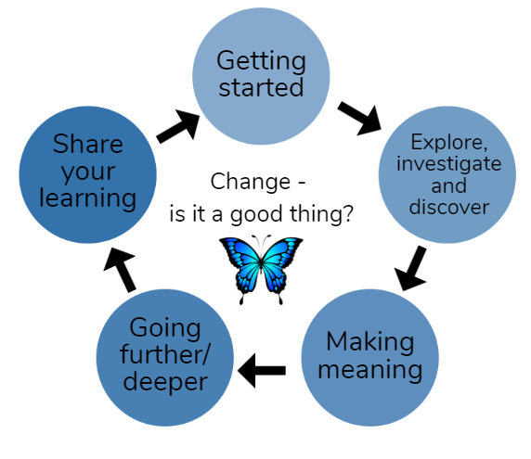
This pack is filled with learning activities that can be used at school or at home. All activities are framed around the theme of change | panoni.
Suggestions are provided for starting the day with a karakia (see p. 9), check in with the teacher, and setting up the learning environment. You can replace these with how you want your learner to start their day. The pack is provided as a Word document so you can adapt it for your learners.
The activities follow an inquiry learning model (figure 1) exploring one big idea through two contexts. Each day the learner will be work through one part of the model culminating with sharing their learning on days five and ten.
Figure 1 Inquiry learning model

Realities
You know your learners and have a good understanding of their learning situations. Many learners will be sharing space and materials. Some may have access to the internet and devices, and others may not. Learners will also have varying levels of adult support. This pack contains a mix of activities using materials found in most homes. Some activities will need support while others can be managed independently.

Resources
This pack uses a range of resources from the Science Learning Hub. We would like to acknowledge their contribution.
The pack uses books from the School Journal series. You might want to send these home with the learner, along with an exercise book. Learners can bring their home learning book back to class to share. For learners without reliable internet access, print and send home these resources to create a paper-based pack.

Resources to print
- https://scienceonline.tki.org.nz/content/download/835/10174/version/7/file/p5.pdf Species cards: https://contemporaryvcebiology.com/survival-through-adaptations-and-regulation/doc/species-cards.pdf
- Adaptation cards: https://contemporaryvcebiology.com/survival-through-adaptations-and-regulation/doc/adaptation-cards.pdf
- Answers: https://contemporaryvcebiology.com/survival-through-adaptations-and-regulation/doc/adaptation-cards-answers.pdf
- https://nzmaths.co.nz/resource/claws
- https://nzmaths.co.nz/resource/bird-scarers
- https://nzmaths.co.nz/resource/inventive-thinkers

Resources to send home
- Spirit of the Bird – School Journal level 3 August 2015 https://instructionalseries.tki.org.nz/content/download/36252/408336/file/Spirit%20of%20the%20Bird-SJ%20L3%20Aug%202015.pdf)
- The Moa – School Journal level 4 November 2017 https://instructionalseries.tki.org.nz/content/download/39560/441069/file/The Moa L4 Nov 2017.pdf
- Sharks – School Journal level 3 June 2018 https://instructionalseries.tki.org.nz/content/download/41167/459236/file/SJL3_2018-Sharks.pdf
- Fantastic Penguins – School Journal level 3 November 2019 https://instructionalseries.tki.org.nz/Instructional-Series/School-Journal/School-Journal-Level-3-November-2019/Fantastic-Penguins
- Rātā me te Rakau https://instructionalseries.tki.org.nz/Instructional-Series/Junior-Journal/Junior-Journal-57-Level-2-2018/Rata-me-te-Rakau

Setting up the learning environment
Encourage whānau to support learners to set up a space for learning at home. Learners might like to design their own space as a separate learning activity. Some materials they may need could include pen, pencils, paper, a notebook, colouring pencils, glue, scissors, and a device to access the internet.
Many of the suggested activities and experiences include the optional use of online resources which can be accessed and viewed using a Smartphone.

Overview of the learning in this pack
The theme of change | panoni will be explored through two contexts.
- Days 1–5 look at this idea through the context of adaptation
- Days 6–10 look at this idea through the context of innovation – can I make a better …?
Learners will explore, investigate, discover, and make meaning as they go through each task. There are times where they look a little deeper into the topic. Some of the tasks may be independent hands-on tasks while some may involve connecting and sharing with others.
Day 1 | Day 2 | Day 3 | Day 4 | Day 5
Launching our learning: checking our prior knowledge, clarifying terminology, categorising information, and making connections. | Exploring ecozones/ biomes and investigating how biomes/ ecozones and adaptations are connected. | Making meaning about the types of adaptations and the factors that influence this. | Going deeper and specifically exploring how humans can impact the environment and other animals. | Sharing our learning by creating an information cube about an animal and how it has adapted to survive.
Day 6 | Day 7 | Day 8 | Day 9 | Day 10
Launching our learning: inventions and innovations. | Exploring the design thinking process: Feel, Imagine, Do, Share. | Making meaning of our ‘Can I make a better ...?’ inquiry by imagining and ideating solutions. | Going deeper into our inquiry by creating an action plan using our design thinking process. | Sharing our learning about my ‘Can I make a better ...?’ inquiry as a storyteller.

Daily timetable
Below is a possible daily timetable. We have allocated 30 minutes for each activity; your learner may take more or less time than this for an activity. We suggest your learner takes the time they need to complete an activity. This may mean they choose which activities they will complete for the day, rather than complete them all.
At the start of each day the learner will draw up their timetable for learning. You can adjust the timing to suit the other activities that might be happening the day, such as Zooming with the class/teacher.

Time | Activity
9:00 am | Starting the day
9:30 am | Activity 1
10:00 am | Break
10:30 am | Activity 2
11:00 am | Fitness break
11:30 am | Activity 3
12:00 pm | Lunch time
1:00 pm | Activity 4
1:30 pm | Reflection time
2:00 pm | End of the school day

Daily fitness – Choose something each day
Please ensure that your learner includes fitness in their daily timetable. If possible, it would be great to do the fitness activity with your learner or have them complete it with others. Below are activities to choose from – or you can make up your own ideas!
Tama Tū, Tama Ora; Tama Noho, Tama Mate.
Through physical activity we thrive. Through inactivity we languish.
Your learner may prefer to go for a walk or run around your house. They could time themselves for fun! Maybe they’d like to go for a bike ride? Play a game with whānau? Have a boogie to a favourite song? Or do some yoga? It is your choice, just get active!
Please note you can change or modify the exercises (in addition to those suggested) if you are not able to do the ones we have suggested, get creative and change it up.
Create your own fitness circuit:
Select 5 or more of these exercises (or other exercises that you like) and create your own fitness circuit in your home or outside. Remember every exercise can be modified to suit your physical ability and fitness level. Have a look at some of the suggestions here.
High knees, running on the spot or brisk walking or shuttle runs/line sprints.  Skipping or galloping.  Slip stepping or marching on the spot.  Skis – stepping side to side as if you are skiing, step wider if this is too easy for you. | Hops – on the spot – forward and back or tap your toes out in the front of you and aback.  Jumping, astride jumps/straddle jumps.  Knee lifts.  Heel to bottom kicks.  Squats –vary how wide apart you place your legs or go lower if you need a challenge. | Abdominal crunchies - tap your knees as you move up or tap your ankles.  Push-ups – either on your feet or on your knees.  Lunges or step-ups.  Double foot jumps – side to side – forward and back.  Leg lifts – lie on the ground on your back and lift your legs up and down.
Repeat your circuit or choose 5 exercises to do for either 20, 30, or 60 seconds each and rest for 20 seconds in between. You choose which length of time suits you! Ka pai!
Māori Movement
Start with a warmup: http://www.Māorimovement.co.nz/warm-up
TŪMATAUENGA is the Māori God of War. Māori Movement is Manu waewae - focusing on isometrics and balance through ‘peruperu’. You will use your waewae (leg/feet) to build your understanding of ‘ihi’ which is your essential force and builds self-control by holding the position of Tū Tane (known as the war stance).
1. You will practice 3 levels of ‘peruperu’.
2. The challenge is to hold the position of Tū Tane for 30 seconds.
Here is your challenge http://www.Māorimovement.co.nz/courses/ruaumoko/level-1-ruaumoko
Ball challenge countdown
You need a small ball, like a tennis ball for this activity.
- Tekau − Toss the ball in the air and catch x 10
- Iwa − Toss the ball in the air and clap and catch x 9
- Waru − Toss the ball in the air and clap three times and catch x 8
- Whitu − Toss the ball in the air and clap behind your back and catch x 7
- Ono − Toss the ball in the air and clap behind and clap in front and catch x 6
- Rima − Toss the ball in the air, snap and clap and catch x 5
- Whā − Toss the ball in the air, clap behind, snap, clap in front and catch x 4
- Toru − Toss the ball in the air clap under each of your knees and catch x 3
- Rua − Toss the ball in the air, touch head, shoulder, knees & toes and catch x 2
- Tahi − Toss the ball in the air and turn around and catch x 1, and you’re done!
Tahi-rua-toru Fitness challenge - Crabwalk-superman-bear crawl
You will need a water bottle and your ‘can do’ attitude!
Tahi – Crab walk. Start sitting down on the floor and then use your legs and arms to lift your torso and walk around like this for as long as you can.
Rua – Superman. Lay down on the floor with your face towards the floor, relax. Now lift your legs slightly off the floor and put your arms out like superman. How long can you remain in this position?
Toru – Bear crawl. Start the bear crawl in a push up position. Your hands should be beneath your shoulders, your back is strong, and your core is engaged. Your feet should be hip distance apart with heels off the floor.
- Move forward by simultaneously (at the same time) moving the right hand and the left leg in a crawling motion. *Your knees never touch the ground.
- Switch sides immediately after placing weight on the right hand and left leg, moving the left hand and right leg forward.
- Continue in a crawling motion, moving forward for as long as you can.
Repeat the three sets of exercises three times.
Can you beat yourself? Great efforts!
Wairua Dance – Maimoa Music
Go to https://www.youtube.com/watch?v=DgGr_n4fgyI and watch Maimoa sing Wairua (an original song sung in te reo Māori).
Practice singing it in te reo and then make up a little dance or fitness routine. Maybe you have to jump up every time you ‘Wairua’? Maybe you have to squat every time the singer changes? Have fun with it and move your body!

Daily wellbeing – Choose something each day
These activities are good to do at the beginning and end of the day but can be done anytime. They can help you get ready for learning, calm your mind and body, and can help you to reflect on your learning:
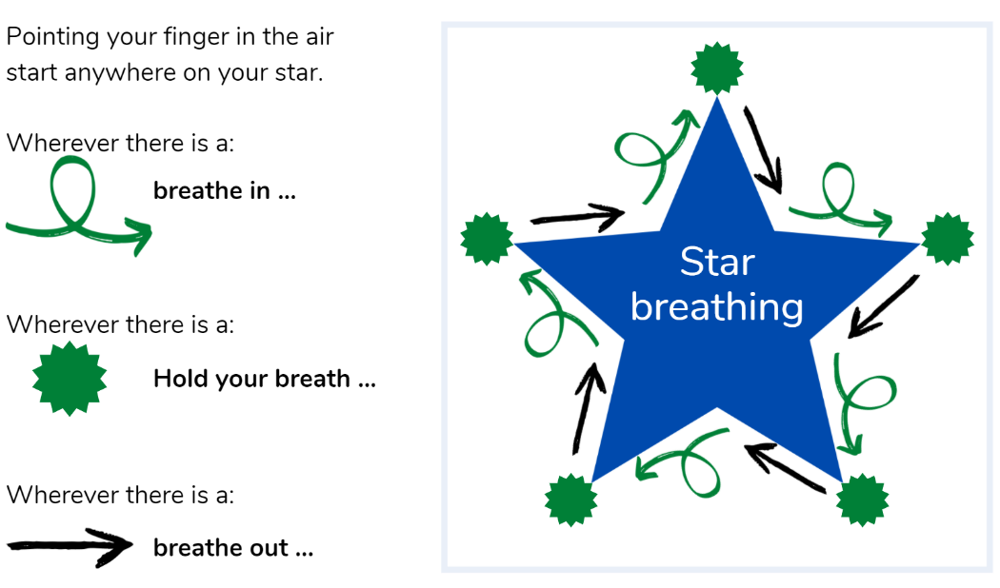
Star breathing
Lie down outside on some soft grass and imagine you are laying under the stars...

He aha tō tae? What is your colour?
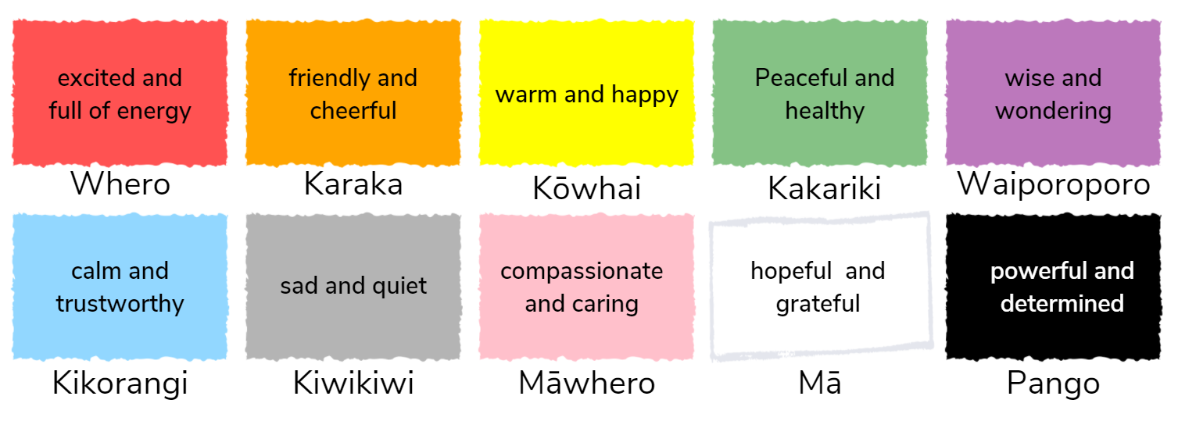
Here we are associating emotions with different colours. This can also be a good way to practice your te reo. For this activity you will assess your emotions in different scenarios or for different times. Your emotions usually change frequently, and this is okay. This exercise helps you to become more aware of how you are feeling.
What colour represents your feelings today?
What colour represented your feelings yesterday?
Complete some of these sentences:
When I wake up, I feel ….
When I finish a project, I feel …
When I help someone, I feel …
When I am late, I feel …
When I play I feel …

Mandala Colouring
Colouring is one of those activities where you can be fully immersed in what you are doing and lose track of time. We call this going with the flow.
Going with the flow means being in the present, people who keep mindful of the present usually experience happiness on many levels. See what colourful patterns you can create whilst completing some mandala patterns.
180s
Taking time to see another person’s point of view can develop our empathy and understanding. This activity helps you take a 180-degree perspective. Find somewhere quiet to sit and imagine the world from another person’s viewpoint. Ask yourself some questions like the following:
- I wonder how my teacher feels when the class isn’t listening?
- I wonder how my classmate feels when he/she was laughed at?
- I wonder how my mum feels when I don’t do what she asks e.g. make my bed?
Record your thinking. You can also ponder what you have in common with others. When we can see our similarities, we can appreciate out differences.
- What do I have in common with Jacinda Ardern?
- What do I have in common with Stan Walker?
- What do I have in common with a book character/a movie star/an athlete etc.?
Mindfulness in Nature
Being in a natural environment can cause a lot of positive feelings such as wonderment and awe. If you feel these feelings when you are outside, it is a clever idea to spend lots of time in that environment. Go outside and sit in a comfortable place:
- Notice 5 natural things you can see
- Notice 4 different colours in these things
- Notice 3 different textures (close your eyes and feel around if that helps)– e.g. a rugged bark, pointed grass
- Notice 2 things you can smell
- Notice 1 favourite thing from any part of today
Stay a moment outside and check how you are feeling.
If you wanted to take your observations further, go inside and write some of the things that stood out for you. You can turn these observations into a poem.

Starting each day
Notes for teachers and whānau:
Starting the same way each day helps create a structure for your learner. Your school might have your own way to do this, for example starting the day together as a class on Zoom. In this pack we provide a karakia to settle into the day. Saying the karakia with your learner a few times will help them be able to do this more independently tomorrow and beyond. As part of the start of the day and setting up the learning environment, help your learner look through the activities suggested for that day and choose a fitness and wellbeing activity. They could fill out their daily timetable and think of other activities they might like to do, like reading.
Remind your learner of when and how to check in with the teacher/you.

Karakia
Here is a karakia to welcome in the day.
Whakataka Te Hau: Karakia video -- https://www.youtube.com/watch?v=_uQqIGt3H2w

Whakataka te hau ki te uru,  Whakataka te hau ki te tonga.  Kia mākinakina ki uta,  Kia mātaratara ki tai.  E hī ake ana te atākura  he tio, he huka, he hauhunga.  Haumi e! Hui e! Tāiki e! | The wind swings to the west  then turns into a southerly.  making it prickly cold inland,  and piercingly cold on the coast.  May the dawn rise red-tipped  on ice, on snow, on frost.  Join! Gather! Intertwine!

Planning my day
- Have you chosen which activities you will do today and in which order?
- Remember to choose a fitness activity (see p. 5)
- Have you chosen a wellbeing activity? (see p. 7)
- Have you done a ‘Wellbeing check-in'?
  - How are you feeling today?
  - How do you feel about your readiness to learn this morning?
  - What do you need extra assistance with today? Who could you get to help you? What strategies could you use to help make your learning more effective?
  - What would you like to do as a quiet time activity to end your day?
- Remember to do your Reflection at the end of the day (see p. 10).

Ending each day
Please ensure your learner does this at the end of each day.
Reflection can be challenging for all learners, but it can also provide them with rich opportunities to think about how their learning is progressing. Use the questions below as prompts to encourage your learner to think about what they have learned so far and help them to plan out their next steps. If you have concerns with their learning or find that your learner is needing more help, contact their teacher for more support.

I am learning to: reflect on my learning, my day and myself.
What do I need?
- A notebook or online doc that you can use each day for your reflection activity. We will call this your “reflective journal”
- Materials for your quiet time activity
Option 1: Reflections about my learning
Take some time to think about how you are feeling after today’s learning activities.
Reflect on the following prompts in your reflective journal.
- What did you enjoy most about today?
- What is one thing you feel you learnt today?
- What is one strategy that helped you with your learning?
- What did you find challenging or distracting? (You ran out of time for some activities, or you finished them quite quickly and wanted to dig in a little deeper.)
- Is there anything you need extra help with? Who can you ask to help you with that?
- Is there anything you want to catch up on tomorrow?
Option 2: Reflections about my day
Choose 3-5 questions to respond to in your reflective journal:
- What was the best part of your day? Why?
- What did you worry about today? Are you still worried?
- What is a problem you had today? How did you solve it?
- Would you want to re-live this day again? Why or why not?
- What is something you learned today that you want to remember tomorrow?
- If you could travel back in time to the beginning of the school day, what advice would you give yourself?
- Were you able to finish all of your work today? Why or why not?
Option 3: Reflections about myself
Choose 3-5 questions to respond to in your reflective journal:
- What does having a growth mindset mean to you? When did you last notice yourself having a growth mindset?
- How can you tell that you're getting angry? What does your body feel like? What are you thinking?
- How are you different from your parents/friends/a famous person of your choice?
- What's something that adults (parents, grandparents, teachers, etc.) say to you that's really stuck with you? Do you think they're right?
- What do you do when people don't seem to like you?
- What is your proudest accomplishment?
- What things are in your control? What's out of your control? How does it feel to notice that some things are out of your control?
- What do you like about your school? What do you dislike?
- What do you do when you're feeling overwhelmed or stressed out? What's something nice you could say to yourself?
- What is your happiest memory?
- What do you do when you're feeling down?
- What is your favourite book? Movie? Band? Food? Animal? Why is it your favourite?

Whakataukī and quotes for the pack
Week 1 | Explanation | Week 2 | Explanation
“It is not the strongest of the species that survive, nor the most intelligent, but rather the one most adaptable to change.” ~ Charles Darwin | This quite literally means that animals who are able to adapt and change to varying conditions are the best able to survive. | “Creativity is thinking up new things. Innovation is doing new things.” Theodore Levitt | This means that the difference between creativity and innovation is that creativity is about generating new ideas while innovation is about making those ideas happen.
Mā te huruhuru ka rere te manu ~ With feathers the bird can soar | Birds can’t fly without feathers, but when it has what it needs, it can thrive. | Haere taka mua, taka muri; kaua e whai - Be a leader not a follower | Go in front, not behind! Take the lead by trusting your ideas and abilities and sharing these with others.
E koekoe te kōkō, e ketekete te kākā, e kūkū te kererū – The parson bird chatters, the parrot gabbles, the wood pigeon coos | This whakataukī speaks to the fact that while we all have different features, being different and unique is what makes us special. | “Intelligence is the ability to adapt to change.” - Stephen Hawking | Adapting to change takes intelligence as it is not always an easy thing to do. Animals that adapt are the ones who survive.
“One thing my pea plants taught me: always do science with things you can make into soup.” ~ Gregor Mendel | This quote is about how we make mistakes when we are learning and that is okay. Also not to waste food! | I orea te tuatara ka puta ki waho - A problem is solved by continuing to find solutions | This whakataukī talks about how critical it is to adapt and be creative with problem solving. We need to persist until we find a solution.
Quote: Iti noa ana he pito mata ~ From a withered tree a flower blooms. | This whakataukī speaks to the fact that if we care for life, it will thrive. | Innovation is the ability to see change as an opportunity, not a threat.” -Steve Jobs | This quote means that we need to welcome change instead of seeing it as a threat to our known way of life. Innovation can help us welcome this change.
Remember to finish with a wellbeing activity and/or your chosen quiet time activity.

Context 1: Adaptation

The next five days investigate the theme of change by looking at adaptations – animals and humans.

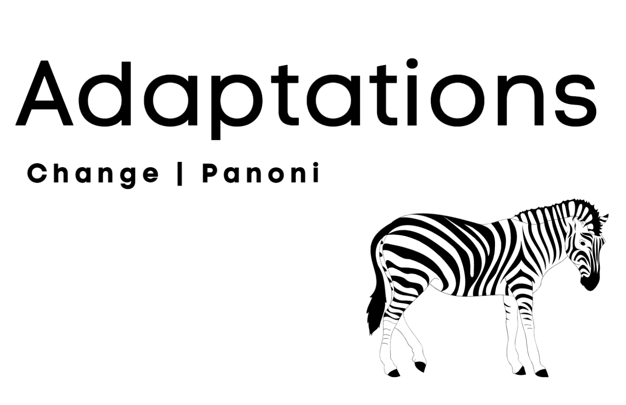

Day 1 activity 1: Inquiry getting started
“It is not the strongest of the species that survive, nor the most intelligent, but rather the one most adaptable to change.” ~ Charles Darwin
Notes for teachers and whānau
Today our learners embark on a new learning journey about adaptation to consider the bigger question ‘is change a good thing?’. They will be introduced to new terminology and concepts around animal adaptations. They will brainstorm, define, and make predictions around this language and have the opportunity to apply what they have learned by categorising animals into the three categories of adaptations – physiological, behavioural, and structural. Learners will be exploring the learning areas of science and literacy.
Note that our Inquiry focus for today is “getting started” which includes generating questions, activating prior knowledge, and introducing the theme.

I am learning to: check my prior knowledge and clarify terminology.
What do I need?
- 30 minutes
- Adapted concept overview from https://scienceonline.tki.org.nz/content/download/835/10174/version/7/file/p5.pdf
- Texts adapted courtesy of the Science Learning Hub
  - https://www.sciencelearn.org.nz/resources/142-adaptations-of-marine-organisms
  - https://www.sciencelearn.org.nz/resources/17-earthworm-adaptations
  - https://www.sciencelearn.org.nz/resources/1162-native-bird-adaptations

Remember to start your day right (see p. 9).

Instructions:
The tasks in this activity will help you clarify what our theme of learning is all about this week. Have your home learning book or digital doc ready to record your thinking and follow the sequence below carefully.

Your task:
Review the concept overview on the next page to help you predict what you think you will be learning about this week.
Record your thinking in your home learning book.
Look at the images of interesting animals on the next page (before you read the text).

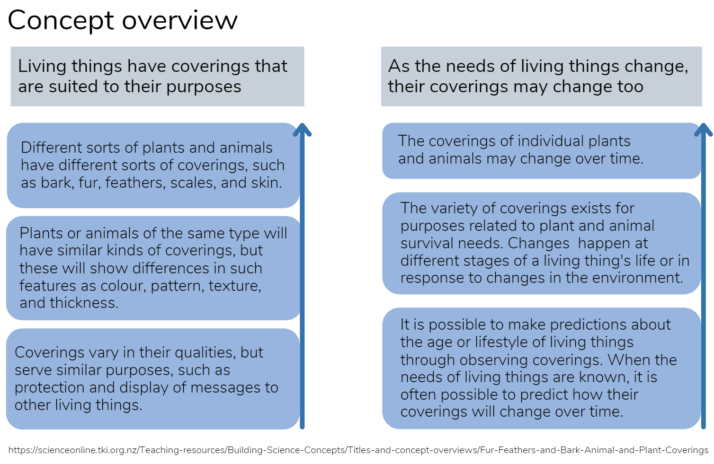
Table of interesting animals
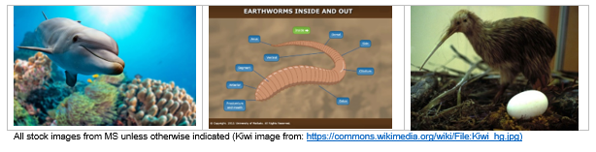
Now think about these questions:
- What do you notice about each animal in terms of its physical characteristics?
- What do you notice about each animal in terms of its environment?
Prepare a table: using a whole page in your home learning book or digital doc, create a simple four column table as shown below, and respond to the two questions above for each animal in the table (in the second and third columns of your table).

 | Animal characteristics I notice… | Environmental characteristics I notice… | My new learning after reading…e.g. types of adaptations
Dolphin
Earthworm
Kiwi
Read the following text adapted from the Science Learning Hub.
Adaptation
Adaptation is an evolutionary process where an organism becomes increasingly suited to living in a habitat. It is not a quick process! Natural selection over generations results in helpful traits becoming more common in a population because individuals with these traits are better adapted to the environment and more likely to survive and breed. Over time, more individuals within the species will have the favoured features until eventually they all have them. Charles Darwin coined natural selection in 1854 in his book On the Origin of Species.
Adaptations can result in the gain of a new or modified feature enabling an advantage in the current environment. Adaptations can also result in the loss of a feature that no longer has a function in the current environment, for example, the loss of wing function when there is no need to fly. The timeframes for different types of adaptation are variable – behavioural adaptation can be a very quick process whereas structural changes may occur over a very long period of time. Adaptation is a common term to describe these helpful traits. Organisms have adapted to the great diversity of habitats and distinctive environmental conditions in their environment. Adaptations are many and varied but they are generally grouped into three main categories: structural, physiological, and behavioural.

Structural (or morphological) adaptations
These are the physical features of the organism. These include things you can see, like its shape or body covering, as well as its internal organisation.
Dolphin – dolphins are mammals and look very different to mammals that live on land. They are adapted to live in water and have a streamlined shape and fins instead of legs, and blowholes on the tops of their heads to breathe rather than through their noses.
Earthworm – each segment on an earthworm’s body has bristly hairs, called setae which provide grip to help it move through the soil. An earthworm has a streamlined body with no antennae or arms or legs. This shape is an adaptation to needing to move through soil and live in narrow underground burrows. Earthworms have circular muscles that surround each body segment and longitudinal muscles that run the length of its body. These two groups of muscles work together to help it move. To get food into its mouth, an earthworm pushes its pharynx out of its mouth to grab its food, then pulls the food into its mouth and wets it with saliva.
Kiwi – this is the only bird in the world to have nostrils at the end of its beak which enables it to search for food by probing its long beak into the earth in search of invertebrates. Kiwi have fine whiskers at the base of their beak to help navigate obstacles in dim light as they have poor eyesight. Takahē and kiwi have vestigial wings. After many years of not requiring the use of flight, they evolved a larger body size and lost the ability to fly. Kiwi plumage blends in with forest undergrowth to camouflage them from predators.

Physiological adaptations
These adaptations enable the organism to regulate their bodily functions, such as breathing and temperature, and perform special functions like excreting chemicals as a defence.
Dolphin – some marine mammals, such as whales and some dolphins, migrate large distances and may spend time in a combination of arctic, tropical, and temperate waters. To cope with temperature changes, they are endothermic or ‘warm blooded’, meaning they can maintain a constant body temperature that is not dependent on the surrounding water.
Earthworm – many earthworms secrete a mucus (coelomic fluid) that helps them to move more easily through the soil. In some burrowing species, this fluid forms a cement-like substance that lines their burrows to keep the walls from collapsing. In the New Zealand native species Octochaetus multiporus, the mucus may also be part of its defence system as it is toxic to soil bacteria. It has another special adaptation – its mucus is bioluminescent! When disturbed, this earthworm squirts mucus from its mouth, anus, and dorsal (underside) pores, and the fluid emits a bright orange-yellow light that glows in the dark. When the conditions in its habitat change, for example, the soil becomes too hot or dry, many earthworms become inactive in a process called aestivation. They move deeper into the soil, coil into a tight ball, excrete a protective mucus, and lower their metabolic rate in order to reduce water loss. They will remain like this until conditions become favourable again.
Kiwi – the kiwi is a nocturnal bird. This helps to reduce its risk of predation and competition for food during daylight.

Behavioural adaptations
These are learned or inherited behaviours that help organisms to survive, for example, the sounds made by whales allow them to communicate, navigate and hunt prey. Crab larvae use sounds to help them find suitable habitats so they can settle and metamorphose (change into an adult form).
Dolphin – Bryozoan colonies are found in high numbers on the continental shelf in New Zealand. They look like plants but are actually made up of hundreds of tiny individual animals that have banded together in order to find food and survive predation more successfully. Similarly, many dolphins hunt and migrate together in pods for safety.
Earthworm – Earthworms cannot see or hear but they are sensitive to vibrations. Birds looking for food or humans collecting earthworms for bait stamp on or vibrate the ground in some manner, causing earthworms to move to the surface. Perhaps this is to escape from moles, whose primary food is earthworms. Earthworms are sensitive to light. Most species spend their days in their burrows or in the soil or leaf litter. In general, you usually find them on the surface at night. Earthworms lose moisture through their skin. They move out of their burrows to migrate or reproduce when the ground is wet with dew – one reason why we may see them in the early morning.
Kiwi – While the nostrils themselves are structural, kiwis have a highly developed sense of smell which helps them smell the tracks of prey or the actual prey which is often found underground for a kiwi. Did you know: chicks hatch with their eyes fully open?!
- Complete the last column in your table after you have read the text.
- Clarify: Adaptation is – the way things change to be able to survive.
- Write definitions for the following in your home learning book or digital doc:
Behavioural adaptation | Structural adaptation | Physiological adaptation
- Brainstorm a list of animal adaptations by category, there is one example here for you (be sure to give at least three examples for each category of adaptation):
 | Behavioural | Structural | Physiological
Animal examples (list at least three for each) | e.g. Venus fly trap – closes leaves so the insect can’t escape. | e.g. Porcupine has a spine. | e.g. Skunk sprays to scare off predators.

Day 1 activity 2: Science and literacy – why adapt?
Notes for teachers and whānau
In this task learners will collate and synthesise information and use new information in relation to what they have already discovered in activity 1. They will consider why animals adapt. Learners will be exploring the learning areas of science and literacy.

I am learning to: identify why animals adapt using reading skills to locate, synthesize, and categorise information.
What do I need?
- 30 minutes
- Texts adapted courtesy of the Science Learning Hub
  - https://www.sciencelearn.org.nz/resources/1126-adapting-to-marine-habitats
  - https://www.sciencelearn.org.nz/resources/953-animal-and-plant-adaptations
  - https://www.sciencelearn.org.nz/resources/326-antarctic-life-and-ecosystems
  - https://www.sciencelearn.org.nz/resources/2447-nocturnal-adaptations-of-moths

Instructions:
In this activity you will further develop your understanding about ‘adaptation’ and change. We know that adaptation means the way things change to survive. More specifically adaptation is the change in the structure or function of something. In this activity, we will explore why animals adapt and what this can ‘look like’. Have your home learning book or digital doc ready to record your thinking.

Your task:
Brainstorm: what are the reasons why an animal may need to adapt? Write all your ideas in a list in your home learning book or digital doc.
Read this text about adaptation (modified from the original):
Being able to adapt is a matter of life or death. In a perfect world, organisms would not need to adapt. However, changes to the environment and food web mean that organisms need to adapt, or they may become extinct.
Behavioural adaptation happens more quickly than structural or physiological adaptation. The more intelligent an animal is, the faster it can learn to make behavioural changes to survive. Structural and physiological adaptations require genetic change which can only occur through mutation or other gene changes over several generations. Organisms adapt for a variety of reasons in order to survive and thrive in their natural habitat. The natural habitat of an organism must meet basic needs like food and water, protection from weather and predators as well as safety for reproduction and from competing species. Therefore, organisms will adapt due to:
- Changes to the environmental and/or climatic conditions of the natural habitat.
- Type and availability of food (and water).
- Competition for food.
- Increased predator population.
Here are some specific ‘natural habitats’ and how some animals have adapted.

Adapting to estuaries
Estuaries are where freshwater from the land mixes with saltwater from the sea. Consequently, salinity levels of the water change over the tidal cycle. Plants and animals living in estuaries must respond quickly to drastic changes in salinity. Organisms capable of dealing with varying salinities are called ‘euryhaline’ (like mangroves), and organisms that can only deal with small changes in salinity are called ‘stenohaline’. Stenohaline animals rely on behavioural adaptations such as moving out of the area, burrowing in the sand, and closing their shells or physiological adaptations such as excreting excess salts. Worms, molluscs, and fish can produce mucus or slime to cover sensitive body parts. Some marine animals have evolved interesting ways to survive the challenges in estuaries. For example, mud snails (tītiko) are like gardeners. They suck in and excrete mud, ploughing it up and improving its properties so plants grow more easily. The snails then feed on these plants. Marine bristle worms or polychaetes use their fine bristles for swimming and holding themselves in their burrows. Some make protective ‘shells’. These shells are tubes made of sand and shell segments held together with a sticky secretion.

Adapting to beaches
Beach habitats are dynamic environments where sand, water, and air are always in motion. The burrowing of animals must be rapid and powerful, so they are not swept away by incoming waves and swash (turbulent water movement). Desiccation (drying out) is not a concern to these animals because they can retreat into the substratum (well below the initial layer of sand) or below the water table. Bivalves such as tuatua live along the beaches. To avoid predation, they burrow deep into the sand or migrate on the tide to a different area. Paddle crabs use the paddles on their rear legs to burrow into the sand for protection, with only their eyes and antennae protruding. They also use their paddles for swimming. They forage for food at night, often preying on tuatua and other shellfish.

Adapting to rocky shores
Desiccation threatens animals living in intertidal zones on the rocky shore. Some adaptive features include migration to an underwater area (if they are mobile), restricting activities (reduced metabolism) and attaching more firmly to the rocks along with resistant shells and the ability to retain water. Molluscs on the rocky shore are mostly univalved (one shell). They cannot burrow into sand like the bivalves for safety so they have very strong shells with an operculum (trapdoor attached to the foot muscle). Limpets are a good example of this. They are particularly well adapted for life on rocky surfaces. Every limpet has a ‘home’ spot on a rock. This is the place they stay when the tide is out. On soft rock, the limpet grinds it with its shell to make an exact fit. On hard rock, the shell is ground down to fit the rock’s shape. The tight fit allows the limpet to trap some water inside its shell to stop it drying out. It has a strong foot muscle that grips onto the rock – making it difficult for birds to prise it off. Dog whelks are active predators. They have special drilling mouth parts used to bore through the shells of other molluscs such as limpets. They can also produce a shell-dissolving acid to help them reach inside the shell. They then suck up the flesh.

Adaptation – being nocturnal
Moths make up the third most diverse insect group in New Zealand, and their day/night habits are also diverse. While most moths are nocturnal (active at night), others are diurnal (active during the day) or crepuscular (active at twilight). Being active at night means less competition for food and being less likely to be detected and eaten, whereas daylight means there is more light to see and more energy from the Sun.
Crepuscular animals can get the best of both worlds. Nocturnal moths first evolved long before humans invented bright lights. They learned to navigate by using distant celestial objects such as the Moon and stars. Moths navigate by positioning themselves and flying on a fixed angle relative to these celestial light sources. If the position of the Moon or stars is not obvious, moths instead use geomagnetic signals – the Earth’s magnetic field.

Adapting to the cold
Antarctica is the coldest, driest, windiest, and highest continent on Earth. Anything living there must survive really extreme conditions. As Antarctica is the last major area of the world to be explored, it is one of the least disturbed ecosystems on the planet. It’s so cold that creatures often retreat to the sea to warm up, and there are 24 hours of darkness during the winter months! Yet, Antarctica has thriving ecosystems on land and in the water. Animals and plants in Antarctica have special adaptations that allow them to survive in the extreme conditions. Penguins have thick, windproof, and waterproof feathers. Penguins, whales, and seals have thick layers of fat called blubber. Blubber acts as an insulator, helping to keep the animals warm. Antarctic animals often have small extremities (flippers and feet) to reduce heat loss.
The many and diverse adaptations of animals can involve changes to:
- body parts e.g. webbed feet, claws, tails, fins, whiskers, teeth, beaks, gills, wings
- body coverings e.g. fur, feathers, hair, plates, quills, skin, scales, pigmentation/ stripes/spots (camouflage), extra fat, antlers, tusks, hooves, and horns.

Copy the table below into your home learning book or online doc and categorise these animals by some of the body types and body coverings mentioned above:
penguin, turtle, moths, polar bear, limpet, jaguar, anaconda, mud snail, moose, seals, macaw, kingfisher, armadillo, rhinoceros, octopus, cheetah, paddle crab, kiwi, tiger, otter, lion, python, deer, grizzly bear, zebra, cougar, kākā, possum, orca, snapper, crocodile, oyster, maui dolphin, whio, whale shark, brown bat, hammerhead shark, rabbit, sperm whale
Webbed feet
Striped/ spotted fur
Sharp claws
Whiskers
Feathers
Sharp teeth
Large beak
Wings
Shell/plates
Hooves
Scales
Blubber
Camouflage
Nocturnal
Check: were some animals in more than one category? What other animals can you add to the table? What categories might be missing?
Extra: categorise each animal in the list as bird, mammal, amphibian, reptile, or fish.

Day 1 activity 3: Science and literacy – peppery moths
Notes for teachers and whānau
Today students will examine an example of natural selection in action. They will use what they learn about the peppered moth to make predictions and draw conclusions. Learners will be exploring the learning areas of science and literacy.
Note: This activity is sourced from SERP and is licensed under a Creative Commons Attribution-Non-commercial-ShareAlike 4.0 International License. Accessed March 21 at https://serpmedia.org/scigen/l4.2.html

I am learning to: explain how natural selection works.
What do I need?
- 30 minutes
- Optional digital: https://askabiologist.asu.edu/peppered-moths-game/ and https://serpmedia.org/scigen/l4.2.html

Instructions:
Today you are going to learn about natural selection to make predictions and draw conclusions. Follow the sequence carefully.

Your task:
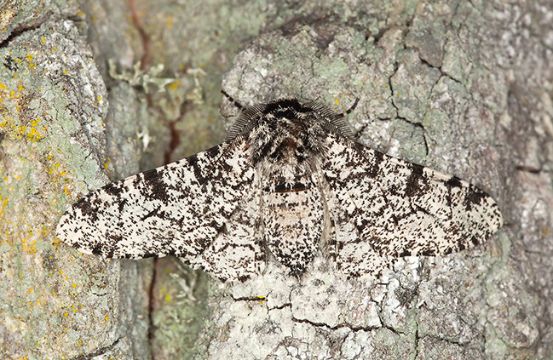
Consider: when you think about your classmates does everyone look the same? We know that we are all part of the same species, homo sapiens, but we have some pretty obvious differences. We have varying heights, weights, skin pigmentation, eye colour, and some of us can run fast, jump high, or are extremely flexible. It is awesome to celebrate our differences as human beings.
Look at this image of a ‘peppered moth’ and think: how would you describe the basic traits of the peppered moth?

Review the panels on the next page to see the basic story of what happened to the population of peppered moths in England during the industrial revolution as they changed from mostly light-coloured moths to mostly dark coloured moths in a relatively brief period of time.
Take notes in your home learning book or digital doc.

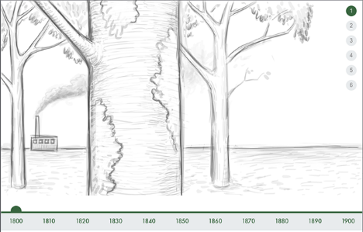 | 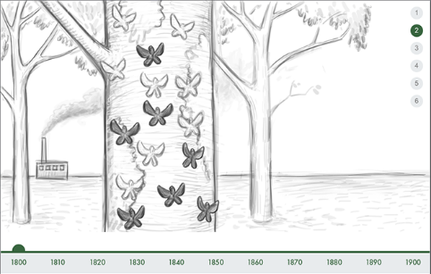
In 1800 England was just beginning the industrial revolution which saw a huge increase in factories that burned coal and created significant air pollution. | On a tree in 1800, you could see many peppered moths.  What do you notice about the tree? The moths? Make a note.
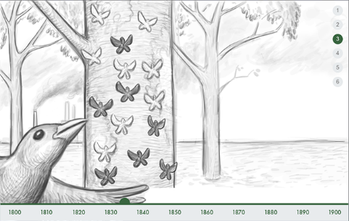 | 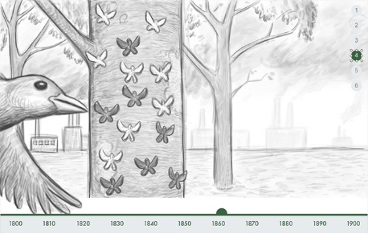
In 1825 there are more and more factories creating air pollution from burning fossil fuels (mostly coal).  What do you notice about the tree? The moths? Make a note. | In 1855, there has been 30 more years of significant and unchecked air pollution. What do you notice now about the tree? The moths? Make a note.
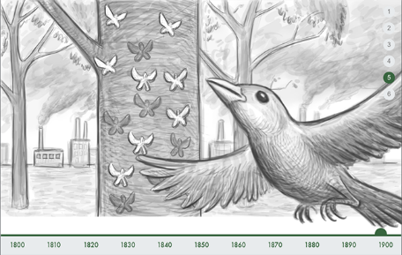 | 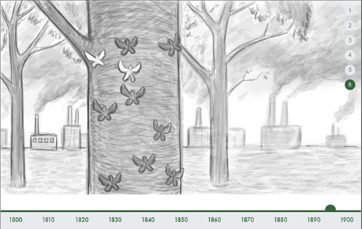
By 1895, there has been almost 100 years of the industrial revolution in action. What do you now notice about the tree? The moths? Make a note. | The bird has eaten.  What conclusions can you draw? Write your conclusions in your home learning book or digital doc.

Read the text and check:
Before the 1800s, nearly all of the peppered moths in England were light-coloured and very hard for birds to see against light-coloured tree bark and lichen. Dark-coloured pepper moths weren’t common at all. The dark-coloured moths that did exist were easy targets for birds to see and eat. Throughout the 1800s, industry was on the rise. Steam-powered factories and commercial railroads burned coal to make energy. Burning coal produced dark soot that coated the tree bark and killed the lichen. The light-coloured moths were now easier for birds to see against the darkened tree trunks, while the dark-coloured moths were harder for birds to see. More dark-coloured moths survived and were able to reproduce, passing their genetic traits on to the next generation. Over time, the population of light-coloured moths decreased. The population of dark-coloured moths increased. By the end of the 1800s, nearly all of the peppered moths in the industrialized areas of England were dark-coloured.
And then…
In 1952, a thick blanket of dark pollution, mostly from the use of coal, covered the London area for five days. At the time, it was estimated that about 4,000 people died as a direct result of the terrible pollution. More recently, researchers believe that the number of people who died was closer to 12,000. As a response to the Great London Smog of 1952, people became increasingly concerned about the quality of air. In 1956, the British Parliament passed the Clean Air Act, with a goal of reducing air pollution. Over time, the quality of air improved. As England’s air quality improved, what do you think happened to the population of peppered moths.

Complete the cloze activity by filling in the blank spaces with appropriate words. Shade in some of the moths on the trees to show the story.
Efforts to clean up the polluted air have begun. Tree trunks are still ______-coloured. There are more ________ moths than ________moths. The birds have an easier time seeing (and eating) the ________ moths. More ________ moths are able to live and reproduce and pass their traits on to their young.
The air is getting cleaner! There is less dark soot on the tree trunks. Light-coloured lichen is beginning to grow back. There is a mix of both _________ and ________ moths on the trunks.
There air is much cleaner! The tree trunks are now light-coloured, and the light-coloured lichen has grown back. The _________ moths are well protected from birds since they’re hard for the birds to see. The occasional ___________ moth is usually snatched away and eaten by a bird. More __________ moths have been able to live and reproduce. There are mostly _________ moths on the tree trunks once again.
Concept check:
Frequently, evolution occurs at a very slow pace. Peppered moths are an example of natural selection working pretty quickly. One reason a change like this one can occur quickly in moths is that they reproduce more frequently than say, humans or tortoises. The sooner a living thing can reproduce, the faster evolution can happen, although it isn’t the only factor influencing the pace of evolution.
Initially, natural selection was proposed by Charles Darwin to explain how new species evolve. All types of living things have small differences between the individuals in the species (just like humans with eye colour, height etc.). If one of those differences allows the individual to live longer, they will be more likely to have more offspring. As that trait is passed on, the population starts to look more like the successful individual. Over time, the species changes.
Predict and conclude:
What conclusions can you make after completing this task? What do you predict will happen in the future regarding peppered moths? Air pollution?
Optional digital for more info and games:
- https://askabiologist.asu.edu/peppered-moths-game/
- https://serpmedia.org/scigen/l4.2.html

Day 1 activity 4: Maths – catching moths!
Notes for teachers and whānau
Encourage your learner to work systematically: to draw, make a list/table and/or use equipment to help them visualise the process as they work through the problems. Learners will be exploring the learning area of maths.

I am learning to: apply problem solving strategies to mathematical word problems.
What do I need?
- 30 minutes
- Digital extras: https://mathsstarters.net/bingo

Instructions:
You will investigate simple situations with elements of chance by comparing your expectations with experimental results. Systematically count outcomes, compare the likelihood of events, and apply different problem-solving strategies like making a list, drawing and/or using equipment to ensure you explore all possible outcomes.

Your task:
#1. You are helping out in a science research lab. The lead scientist asks you to get some moths from a box, but you can’t see inside the box!
There are two dark peppered moths in the box and two light peppered moths in the box.
- Are you more likely to get a pair, or one moth of each colour? How do you know?
#2. The lead scientist now asks you to get more moths from a new box. You can’t see inside this one either!
The lead scientist has told you there are five dark moths and two light moths in this box.
- Are you more likely to get a pair of dark moths or one of each colour? How do you know?
Extension: Complete this Number of the Day problem. Today’s number is 842.
In your home learning book, do the following to practice your maths skills!
 | - Write it in words  - 50 less than  - 20 more than  - Add 62  - Subtract 17  - Next odd number is  - Halve it  - Double it | - Is it a prime or composite?  - Times by 100  - Times by 1000  - Round to the nearest 10  - Round to the nearest 100  - What is the place value for each digit? | - Is it odd or even?  - Is it divisible by 5?  - Complete the pattern: add 9: 842,___,___,__  - List some factors  - Find one tenth  - Write a word problem whose answer is 842
BONUS: if the answer is 842 write 5 questions

Digital Extras: play some Bingo games using this site to practice your math skills https://mathsstarters.net/bingo.
Remember to do your end of day reflection and wellbeing activities (see p. 7&10).

Day 2 activity 1: Literacy – all about biomes
Mā te huruhuru ka rere te manu ~ With feathers the bird can soar
Notes for teachers and whānau
Today learners will investigate and discover more information about adaptation by looking at the characteristics of ecozones and habitats. They will begin to make connections about the need for animals to adapt to their surroundings for survival. Learners will be exploring the learning areas of science and literacy.
Note that our Inquiry focus for today is “explore, investigate, and discover” which includes choosing and evaluating information, and thinking critically.

I am learning to: identify different biomes and describe how animals must adapt to the different biomes on earth.
What do I need?
- 30 minutes
Remember to start your day right (see p. 9).

Instructions:
In this activity you will learn about biomes making connections to your learning from yesterday. Follow the sequence below.

Your task:
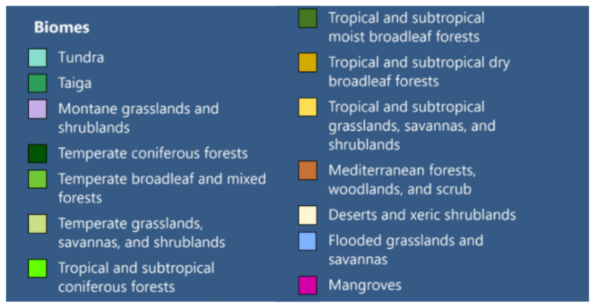
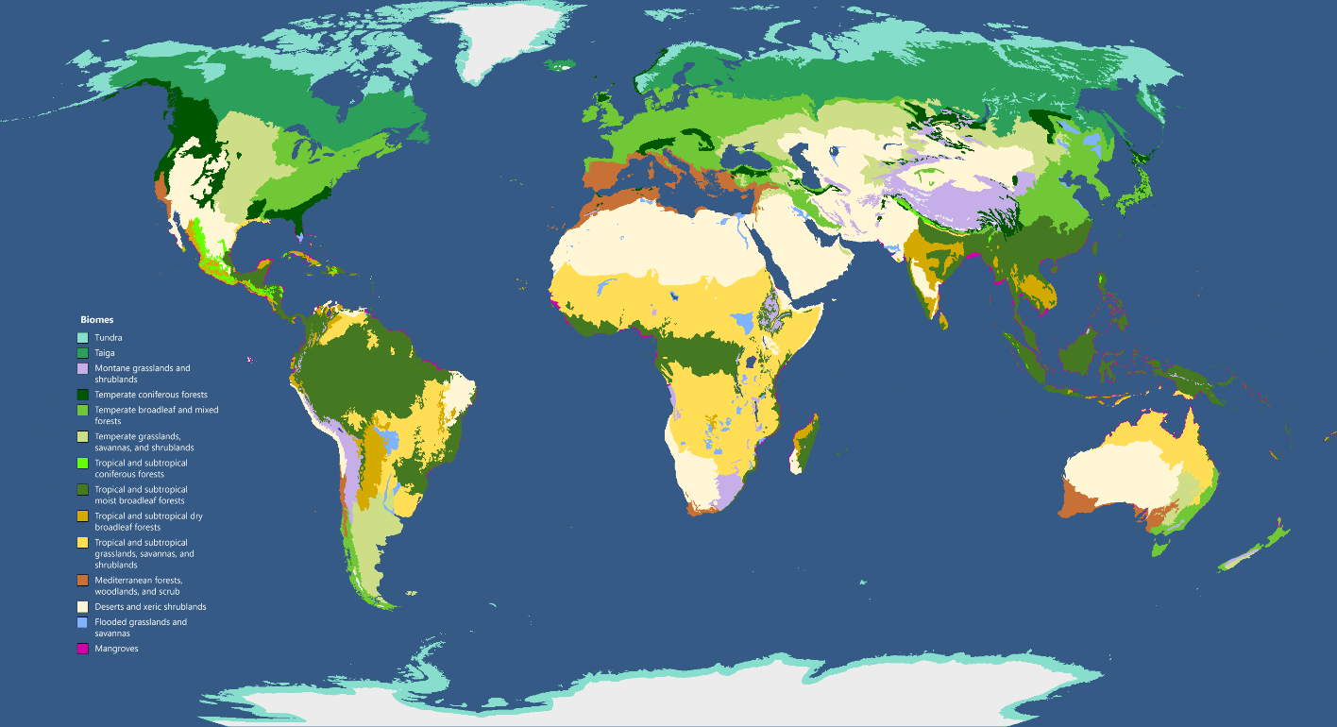
Look at the many different biomes around the world.
Source: https://commons.wikimedia.org/wiki/File:Biomes_of_the_World_-_Retouched.png
Read this:
The term ‘ecozone’, ‘ecoregion’ and/or ‘biome’ has been created to classify different ecological and geographical areas. They cover relatively large areas and the plants and animals in each ecozone share some similarities that make them distinct from flora and fauna in other ecozones. However, there are many different types of habitats within each biome and the habitat for each plant or animal will be much more distinct. Over time, animals adapt in order to survive and thrive in their habitat.
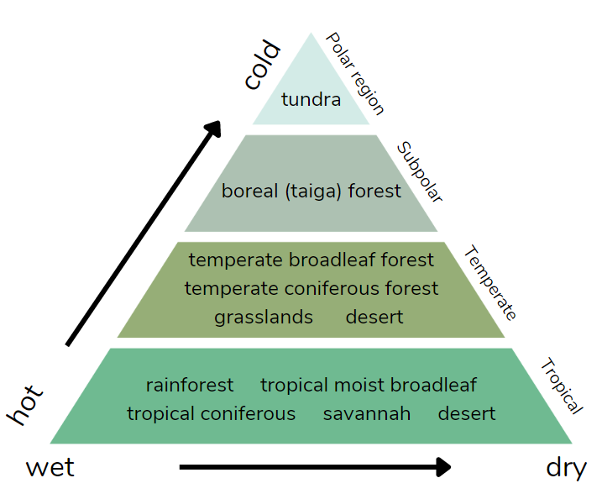
Clarify: Biomes share a similar climate which means the temperature, amount of precipitation, and in many cases, the soil type, is similar. Plants and animals adapt to the conditions in each biome, and their specific habitat within the biome. This diagram shows the different biomes as the temperature and precipitation changes.
Look at the diagram. What do you notice about the biomes as the temperature decreases? As the precipitation decreases (gets drier)?

Complete the table below using what you know about the animals from activity 2 yesterday and make predictions to classify them into some world biomes (ecozones).
penguin, turtle, moths, polar bear, limpet, jaguar, anaconda, mud snail, moose, seals, macaw, kingfisher, armadillo, rhinoceros, octopus, cheetah, paddle crab, kiwi, tiger, otter, lion, python, deer, grizzly bear, zebra, cougar, kākā, possum, orca, snapper, crocodile, oyster, maui dolphin, whio, whale shark, brown bat, hammerhead shark, rabbit, sperm whale
Image sources (next page):
- Tundra https://www.flickr.com/photos/gridarendal/31974534281
- Taiga https://www.flickr.com/photos/gridarendal/32048710436
- Temperate forest https://www.flickr.com/photos/orkomedix/37536468164
- Tropical rain forest https://www.flickr.com/photos/isg-online/218226788
- Grassland https://www.flickr.com/photos/halans/4212583260
- Desert https://www.flickr.com/photos/mandj98/24113937372

Biome | Description | Animals
Tundra  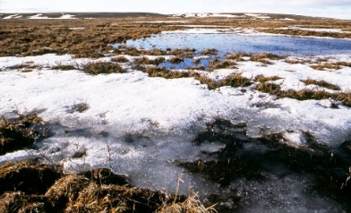 | This is a flat, cold area with low growing plants that can survive the short summer. Permafrost (frozen ground) prevents larger plants from taking root.
Taiga (boreal forest) | Warm, rainy summer; cold, snowy winters with various conifers. Animals must adapt to the seasons.
Temperate forest  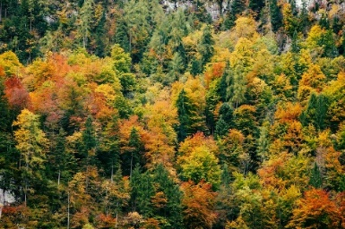 | A forest with four distinct seasons, many plants and animals are inactive in the winter. Many deciduous trees mixed with conifers.
Tropical rain forest  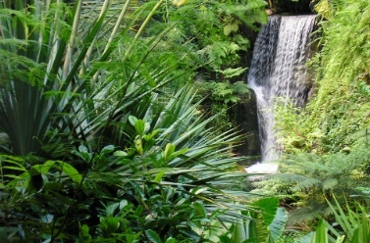 | Often thought of as a jungle – extremely diverse plant and animal life and very warm and rainy. Close to the equator.
Grasslands  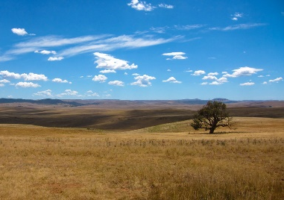 | Referred to as the plains or prairies have few if any trees and mostly long grasses.
Desert | The hottest biome but can be extremely cold at night and in the winter, life must be able to adapt to little water and extreme temperatures.
Extend: can you add some other animals to your table?
Predict: what biome is New Zealand? Describe it in your home learning book or digital doc. What is the climate like? Use the terms temperature and precipitation.
Optional digital: explore some biomes virtually by visiting this site https://askabiologist.asu.edu/explore/Virtual-360-Biomes.

Day 2 activity 2: Connecting ecozones to adaptations
Notes for teachers and whānau
Learners will get creative and draw an animal that is forced to adapt to a new biome. They will label the diagram in English and te reo Māori and describe the adaptations the animal requires to survive and thrive in their new biome. Learners will be exploring the learning areas of science, literacy (including visual language) and te reo Māori.

I am learning to: describe how adaptations are directly connected to the environmental conditions of an ecozone.
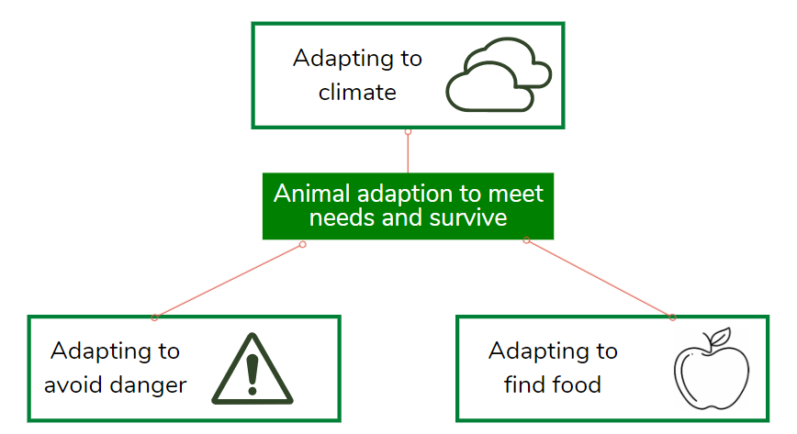
What do I need?
- 30 minutes
- Paper and coloured pencils

Instructions:
Use your knowledge of biomes and animal adaptations to explain how an animal would need to adapt to survive and thrive in a new biome.

Your task:
Choose one of the ideas below or make your own!
- What if a polar bear needed to adapt from the tundra biome to a desert biome?
- What if a kiwi had to adapt to survive and thrive in the boreal forest?
- What if a camel had to adapt to live in the tropical rain forest?
Draw and label a diagram of an animal that has to make some adaptations to survive.
Use some of the te reo Māori kupu below to label your diagram.
Mouth = Waha  Tongue = Arero  Nose = Ihu  Hand = Ringaringa  Face = Kanohi  Teeth = Ngā Niho  Eyes = karu or whatu  Ear = Taringa  Fur = huruhuru  Feather = hou | Elbow = Tuke  Leg = Waewae  Foot = putu  Neck = kakī  Head = ūpoko  Nostril = pongāihu  Teeth = niho  Eyelid = kimo / kimikimo  Chin = kauae | Toe = matimati  Stomach = puku  Back = tuarā  Chest = uma  Throat = korokoro  Hair = huru  Wing = pākau or pariau  Tail = hiku  Body hair = huruhuru

Describe the adaptations of your animal in an explanatory paragraph under your picture and consider using the terminology: physiological, behavioural, and structural adaptation. Consider changes re: food, water, competition, predators/protection, heat regulation etc.

Day 2 activity 3: Science and literacy – curious creatures
Notes for teachers and whānau
Learners will be using their new learning and prior knowledge to do some classification activities. You can help your learner check their answers to the final activity once they have finished categorising using this link: https://contemporaryvcebiology.com/survival-through-adaptations-and-regulation/doc/adaptation-cards-answers.pdf.

I am learning to: corelate adaptations to biomes and categorise by type of adaptation, biome, and species.
What do I need?
- 30 minutes
- Look in your pack for copies of:
Species cards: https://contemporaryvcebiology.com/survival-through-adaptations-and-regulation/doc/species-cards.pdf
Adaptation cards: https://contemporaryvcebiology.com/survival-through-adaptations-and-regulation/doc/adaptation-cards.pdf

Instructions:
For this activity you will explore two very curious creatures and do some classifying and categorising to learn more about adaptations and biomes for different species.

Your task:
Watch the videos and/or read the transcripts:
Blood-squirting lizard
https://www.youtube.com/watch?v=GgB4u6Mgy2M&list=PLPk5dek-yArc9EDCXBhEcX1qLdGBTsoZv
The horned lizard is also known as the horned frog and the horny toad but it's no amphibian. Just a one reptile wrecking crew with a bizarre self-defence strategy. It eats mostly harvester ants, but it doesn't have any fancy hunting methods. When a column of ants crosses its path it laps them up. The ants try to fight back but their mandibles are of little use against the lizard scales no matter how hard they try, but a coyote is a different story and that's when the lizard rolls out its weird defence. It fires its own version of pepper spray! Thin blood vessels around the eyes rupture under pressure and squirt blood out at the attacker. In addition to the ick factor, the blood contains canine repellent chemicals. Disgusted and weirded out, the coyote flees leaving the lizard to wait for more ants.
Adaptations include:
- Blends in or camouflages with environment
- Tough skin/scales on back
- Spiny/horned skin
- Blood squirting out of eyes
- K9 repellent chemicals
Venus fly trap
https://www.youtube.com/watch?v=O7eQKSf0LmY
Like the sun dew, it makes itself very attractive, oozing nectar across the brim of each leaf. But any visiting insect had better watch out for these six tiny hairs. This fly has to tread carefully. If it strikes one hair, it can carry on feeding. But a timer has been set. A second strike in less than 20 seconds and the fly is doomed. An electrical impulse is triggered, and the leaf snaps shut. In just a fraction of a second, the tips lock together like prison bars. If the fly is very big or very small, it may just manage to escape. But most are trapped and die. Ten days later, the trap reopens. All that remains is a husk. The plant has finished its meal and resets itself for its next victim.
Adaptations include:
- Nectar across the brim of leaf
- Six sensory hairs on the inside of leaf
- Biological timer- electrical impulse to close leaves
- Hairs on the tips of the leaf to enclose the insect
- Digestive enzymes to consume prey
- Fast closing leaves so the insect can’t escape
Categorise the blood-squirting lizard and Venus fly trap adaptations listed above into the table below (refer to the day 1 activities if needed):
Structural | Physiological | Behavioural
Look at some other interesting, curious animals that have had to adapt to survive and thrive in their biomes.
Cut out the adaptation cards (print or supplied in your pack).
Categorise by the type of adaptation. You could make a table in your book to do this.
Structural | Physiological | Behavioural
Cut out the species cards (print or supplied in your pack).
Categorise them into their biome categories.
- Tundra
- Taiga (boreal forest)
- Temperate forest
- Tropical rain forest
- Temperate rain forest
- Grasslands
- Desert
Match the adaptation cards to the species cards. Note: your parent or teacher can help you check when you are done.
Source: https://contemporaryvcebiology.com/survival-through-adaptations-and-regulation/sequence-one/ under Creative Commons Attribution-ShareAlike 4.0 International License.

Day 2 activity 4: Maths – measurement
Notes for teachers and whānau
In this activity learners will interpret a tide chart, measure in millimetres, and create a graph to show data. They will need a ruler for this activity.

I am learning to: use correct scales and metric units and interpret scales, timetables, and charts.
What do I need?
- 30 minutes
- Ruler
- Look in your pack for a copy of Claws https://nzmaths.co.nz/resource/claws

Instructions:
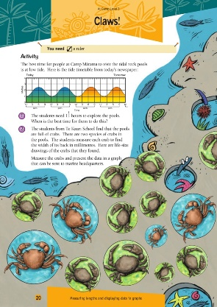
For this activity you will interpret the scale of a tide timetable correctly to work out the actual time for low tide. Follow the sequence in the Claws activity.

Your task:
Follow the instructions in the Claws activity.
Make sure that for question two you remember that the prefix ‘milli’ means ‘one thousandth’, so there are 1000 millimetres in 1 metre. ‘Centi’ means ‘one hundredth’, so there are 100 centimetres in 1 metre. Consider creating a stem and leaf graph, or dot plot. You might like to draw different graphs for the two species of crabs.
Extension: Complete this Number of the Day problem.
Today’s number is 617.
In your home learning book, do the following to practice your maths skills!
- Write it in words  - 50 less than  - 20 more than  - Add 45.  - Subtract 22  - Next odd number is  - Halve it  - Double it | - Is it a prime or composite?  - Times by 100  - Times by 1000  - Round to the nearest 10  - Round to the nearest 100  - What is the place value for each digit? | - Is it odd or even?  - Is it divisible by 5?  - Complete the pattern: add 9: 617,___,___,__  - List some factors  - Find one tenth  - Write a word problem whose answer is 617
BONUS: if the answer is 617 write 5 questions

Remember to do your end of day reflection and wellbeing activities (see p. 7&10).

Day 3 activity 1−2: Animal adaptations
E koekoe te kōkō, e ketekete te kākā, e kūkū te kererū – The parson bird chatters, the parrot gabbles, the wood pigeon coos (we are all unique)
Notes for teachers and whānau
Today learners will have opportunities to make meaning of their learning so far by making connections and building deeper understandings about animal adaptations. Learners will be exploring the learning areas of literacy (including visual language), science and te reo Māori.
Note that our Inquiry focus for today is "making meaning" which includes analysing data, organising, and sorting information, summarising, synthesising, making connections/conclusions, building deeper understandings, and thinking critically.

I am learning to: describe the specific need for types of adaptations.
What do I need?
- 60 minutes
- Paper and coloured pencils
- Optional digital: https://switchzoo.com/
Remember to start your day right (see p. 9).

Instructions:
Some animal adaptations are dangerous for us as humans. In this task you will learn more about the different kinds of adaptations animals have, why they might have adapted in these ways; and consider the type of adaptation each one is. Then you will design, draw, and label a dangerous creature before you create a warning poster to help the public stay safe from your dangerous animal.

Your task:
Read the table below to learn more about reasons for adaptations.
Adaptation | Description
Bird beaks | Birds have different beaks primarily to help them acquire food. Nut eating birds require hard strong beaks, nectar eating birds need long thin beaks, and meat-eating birds need sharp pointy beaks to tear apart their prey.
Funky feet | Animals who have feet adaptations can move better and hunt better in their habitats e.g. ducks have webbed feet for swimming, falcons have sharp claws for catching and carrying prey, and hoofed animals can run faster with extra foot protection.
Camouflage | Animals with camouflage and colour adaptations can blend in with their surroundings. This is to keep them safe e.g. chameleon, octopus, many fish, and tigers with stripes have colouring and camouflage techniques to keep them hidden from predators or prey. Some animals, like a stick insect, camouflage to look like something else and others e.g. skunk colouring, tells other animals to stay away.
Feathers, fur, skin, and scales | Animals have adapted to having different body coverings for a few reasons: the colour can help them camouflage or confuse predators, body coverings also help to regulate temperature, provide waterproofing, or protection from the environment.
Pointy things | Tusks, antlers, quills, spikes, and the like, are external features that animals have adapted to have for the purposes of finding food – e.g. a boar’s tusks; to fight for mating rights – e.g. an elk’s antlers, or to protect from predators – e.g. porcupine quills.
‘Eye’ can see you | Animals have different sized, shaped, and placed eyes to help them stay safe and hunt for food. For example, Owls have big eyes that are far apart so they can scan for prey easily at night. Many nocturnal animals have big eyes as they absorb more light, whereas animals that rely on echolocation, like many bats and whales, have relatively small eyes.

Create: go to https://switchzoo.com/newzoo/zoo.htm and create a crazy, dangerous creature, then use this image or draw your own animal on paper. The animal will have: the head from one animal, the body from another animal, and the tail/rear end of another animal.
Describe: the biome that this animal lives in. What does it eat? How does it stay safe? Is it a herd animal or a lone animal? What does it look like? How has it had to adapt to that biome? What are the behavioural, structural and/or physiological adaptations? What features does it have (use some of the information from the table above to help you imagine and describe). Label it using te reo Māori kupu from yesterday.
Design an informative poster or news article to warn the public about this dangerous creature. Include: why it is dangerous to humans, what they should do if they sight it, and how they can stay safe from the animal. Your poster success criteria include:
- Is your poster effective? Is the message clear? Does it command attention?
- Is the language used on your poster appropriate? Short, succinct, informative?
- Have you evoked emotion in your poster? Will people know why to fear your animal? What to do?
- Is the poster visually appealing? Consider the images, text, and colours?
What could you do to improve it?

Day 3 activity 3: Maths – four 4s!
Notes for teachers and whānau
For this task learners will use prior mathematical knowledge to come up with several ways to solve a problem. They may need some help getting started with this.

I am learning to: apply my number knowledge to think critically.
What do I need?
- 30 minutes

Instructions:
You will create maths problems to make the numbers 1−20 using only the number four. You can use any operation, and multiple operations to do so (remember BEDMAS). Follow the sequence below.

Your task:
This task is called ‘Four 4s problems solving’.
Write the numbers 1−20 on a blank page in your notebook (spaced out so there’s room to record different strategies for each number). Challenge yourself to use the number four, four times in the math problem. Extra challenge: can you make four maths problems for each number?
Number | Maths problems | Number | Maths problem
1 | 4/4 = 1, 4 x 4 / 4 x 4 = 1 | 11
2 | (4+4) / 4 = 2, (4/4) + (4/4) = 2 | 12
3 | (4 + 4 + 4) / 4 = 3 | 13
4 |  | 14
5 |  | 15
6 |  | 16
7 |  | 17
8 |  | 18
9 |  | 19
10 |  | 20
Think: where can you see the number four in nature?
Stretch your thinking: how can you relate the number four to animal adaptations?

Day 3 activity 4: Aotearoa adaptations
Notes for teachers and whānau
Learners will read a text where they will find out about the importance of moa to early Māori. Learners will think critically about the main characters’ actions and motives and be able to identify some of the challenges of life centuries ago in Aotearoa.

I am learning to: make inferences to help me understand the impact humans can have on the environment and other animals.
What do I need?
- 30 minutes
- Look in your pack for a copy of Spirit of the Bird https://instructionalseries.tki.org.nz/content/download/36252/408336/file/Spirit%20of%20the%20Bird-SJ%20L3%20Aug%202015.pdf

Instructions:
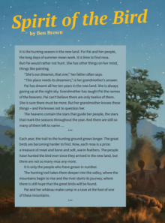
This fictional story about a moa is set in the time of the early Māori moa hunters. Little is known of this era, but the author conveys (often indirectly) the hardships of a subsistence lifestyle and the impact that human settlement had on the moa. The main character Pai, loves birds and drawing. You will need to ‘read between the lines’ to make some inferences.

Your task:
Think about when early Māori arrived and settled here in Aotearoa from Hawaiki (the “homeland”). Did you know that the giant moa became extinct from excessive hunting and/or burning of their habitats? Did you know that humans use different parts of animals for food and other purposes?
Skim and scan the text Spirit of the Bird by Ben Brown.
Create a table like the one below in your home learning book or digital doc and complete it with at least four contributions.
The text says | I know that | I infer that | My question is
e.g. ‘in the new land’ | People sometimes move to a different country, and early Māori migrated here from Hawaiki. | The characters have probably come from a place like Hawaiki. | Is that where they came from? How long ago was this?

Read the text Spirit of the Bird by Ben Brown.

Infer: as you read the story and use your prior knowledge, what else can you understand and/or infer about:
- Family traditions, such as the passing on of wisdom?
- The need to protect endangered species?
- The dilemma of moral decisions when survival is at stake?
- The role of the night sky for early Māori?
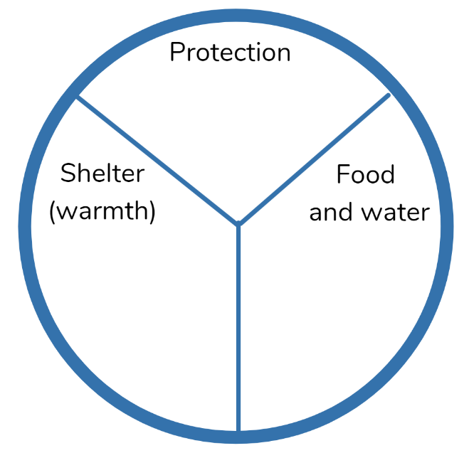
Create and complete a circle table for early Māori settlers to record how they survived when they came to Aotearoa.
Explain/write: in your home learning book or digital doc, from your point of view, how Māori survived when they first settled in NZ? What adaptations do you think they had to make (as humans)? What do you think was their impact on the native animals? The local environment? What impact can humans have on the environment in general? What impact can humans have on other animals?
Extra: do some research on how Māori iwi and organisations work towards animal conservation. You may like to read more:
- https://www.doc.govt.nz/about-us/our-partners/Māori/
- https://www.tpk.govt.nz/en/whakamahia/land-and-environment
Did you know?
Humans have five types of adaptations to keep themselves, and the environment safe – accommodate, protect, avoid, retreat, and attack.
Optional digital: play a game. It is a serious game that helps you see how human decisions can impact the environment: https://adaptivefutures.github.io/seriousgames/game.html

Remember to do your end of day reflection and wellbeing activities (see p. 7&10).

Day 4 activity 1: Adaptation Thinker’s Keys
“One thing my pea plants taught me: always do science with things you can make into soup.” ~ Gregor Mendel
Notes for teachers and whānau
Today learners will have multiple opportunities to explore our theme of ‘change’ through a variety of activities and they will have opportunities to explore questions and discover new knowledge using the ‘Adaptation Thinker’s Keys’. The learners will be applying critical thinking skills and making connections to new learning and prior knowledge. Learners will be exploring the literacy, social science, maths, science, and technology learning areas.
Note that today our Inquiry focus is “going further, deeper”. This may include promoting opportunities to engage further and dive deeper through discussions, provocations, exploring further contexts, taking action, or thinking critically and drawing conclusions.

I am learning to: apply critical thinking skills through Thinker’s Keys activities.
What do I need?
- 30 minutes
- Adaptation Thinker’s Keys (next page)
Remember to start your day right (see p. 9).

Instructions:
You are going to use a task grid called ‘Thinker’s Keys’ for our theme of Change: Adaptations. You have lots of choice with this activity so pick the ones that you think sound fun, or hard if you want a challenge. You will be applying your critical thinking skills.

Your task:
Use critical thinking skills by selecting activities from the Change: Adaptations Thinker’s Keys and complete them in your home learning book or digital doc.
Complete at least four of the tasks from the Adaptation Thinker’s Keys grid in your home learning book or digital doc.

CHANGE: Adaptation Thinker’s Keys (framework based on Tony Ryan’s Thinker’s Keys)
The Reverse Key  List ten animals that you think have not adapted. | The Prediction Key  Choose five animals not native to New Zealand and predict how they would adapt if they had to live in our NZ biome. | The Question Key  The answer is ‘adaptation’. Write five questions. | The Different Uses Key  List all the different uses for each of your legs if you were an animal with six legs. | The Combination Key  Combine the features / body parts of five animals to make a new creature. Draw and describe it.
The Brick Wall Key  What if, as a land animal, you had to adapt to living in the sea? What might you need to adapt? What type of adaptations would you need? | The Interpretation Key  There is a new law stating adaptation is banned. Explain why this is so. | The Inventions Key  Invent a way to save a polar bear trapped on an iceberg using rope, a rack of lamb and a pack of cards. | The Forced Relationship Key  How might a parachute, toothbrush, rope, and a pencil help a penguin adapt to the desert? | The Alternative Key  List ways an animal could survive the cold without fur.
The Ridiculous Key  What would happen if fish could breathe and walk on land? | The Commonality Key  What do a lion and an eagle have in common? OR use a Venn diagram to compare two ecozones. | The Disadvantage Key  What are the disadvantages of living in a marine environment? Or of being a shark? | The Brainstorming Key  Brainstorm all the different animals you can make out of a tiger, eagle, and a fish. | The Alphabet Key  Create an A−Z of animals that have adapted to suit their environments.  Create an A−Z list of Māori kupu related to adaptation or change.
The Variations Key  Suggest five or more ways Māori adapted to survive and thrive in Aotearoa. | The Picture Key  What does this picture have to do with adaptation?  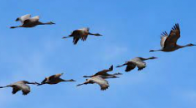 | The What if Key  What if animals couldn’t adapt? What if humans had to adapt without tools? | The BAR Key  Think of your favourite animal’s ecozone? What would make it better? How would you change it? (Bigger, Add, Replace)

Day 4 activity 2: Maths – statistical relationships
Notes for teachers and whānau
Today learners will explore the four key processes of statistical thinking: describing data – connecting the information in a table or graph with a real-life context, organising and reducing data – ordering, grouping, and summarising data, representing data – creating visual representations and analysing and interpreting data – recognising patterns and trends and using them to make inferences and predictions. Learners will be exploring the learning areas of maths and technology.

I am learning to: interpret the results of a statistical investigation.
What do I need?
- 30 minutes
- Look in your pack for a copy of Bird Scarers https://nzmaths.co.nz/resource/bird-scarers
- Twine, plastic bags

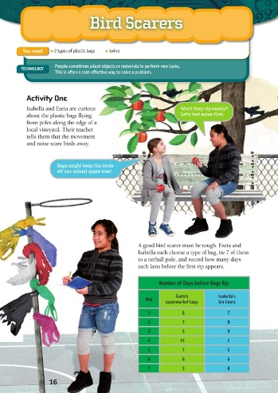
Instructions:
Today you will interpret the results of a statistical investigation and then conduct a similar investigation yourself. For your investigation you will apply the statistical enquiry cycle: problem, plan, data, analysis, conclusion.

Your task:
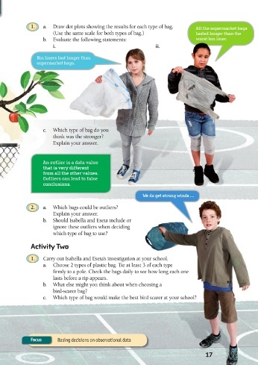
Statistical thinking involves the exploration and use of patterns and relationships in data. You will follow the task as outlined in the Figure It Out document.

For activity two, do this in your own yard but make sure you get permission first!

Stretch your thinking: what do plastic bags and/or ‘bird scarers’ have to do with animal adaptations? Record your ideas.

Day 4 activity 3&4: Infographics
Learners will make sense of an infographic and learn about scientific concepts through images and text. They will develop their visual language skills as they create their own infographic. Learners will be exploring the learning areas of science – making sense of the nature of science through building concepts around how birds live and adapt.

I am learning to: create an accurate infographic about bird adaptations in NZ.
What do I need?
- 60 minutes
- Sources: https://www.sciencelearn.org.nz/image_maps/112-birds-structure-function-and-adaptation?fbclid=IwAR3Ljq3b5U7SInGBNx8VX60sNjq9qmV4IbOyCu2KxL5vjjbZJlYAY1-hNM0
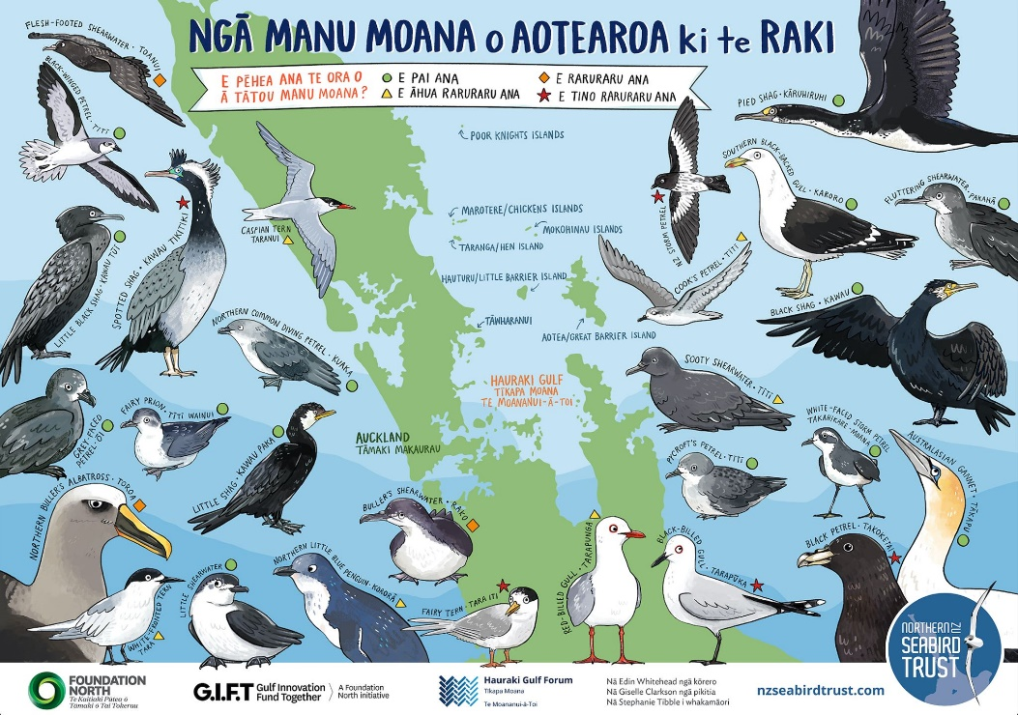
https://www.sciencelearn.org.nz/resources/1169-classifying-bird-adaptations

Instructions:
Look at the examples of bird infographics.

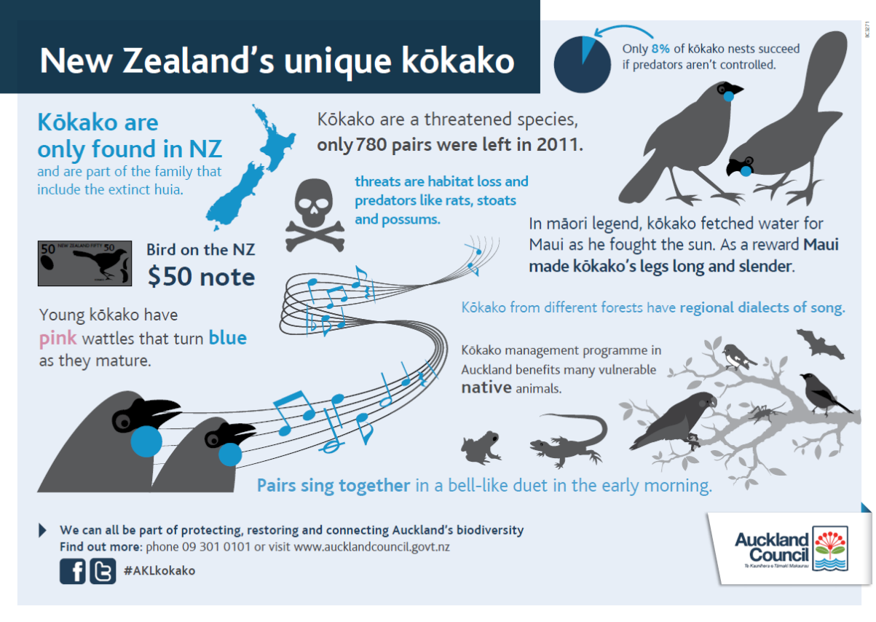
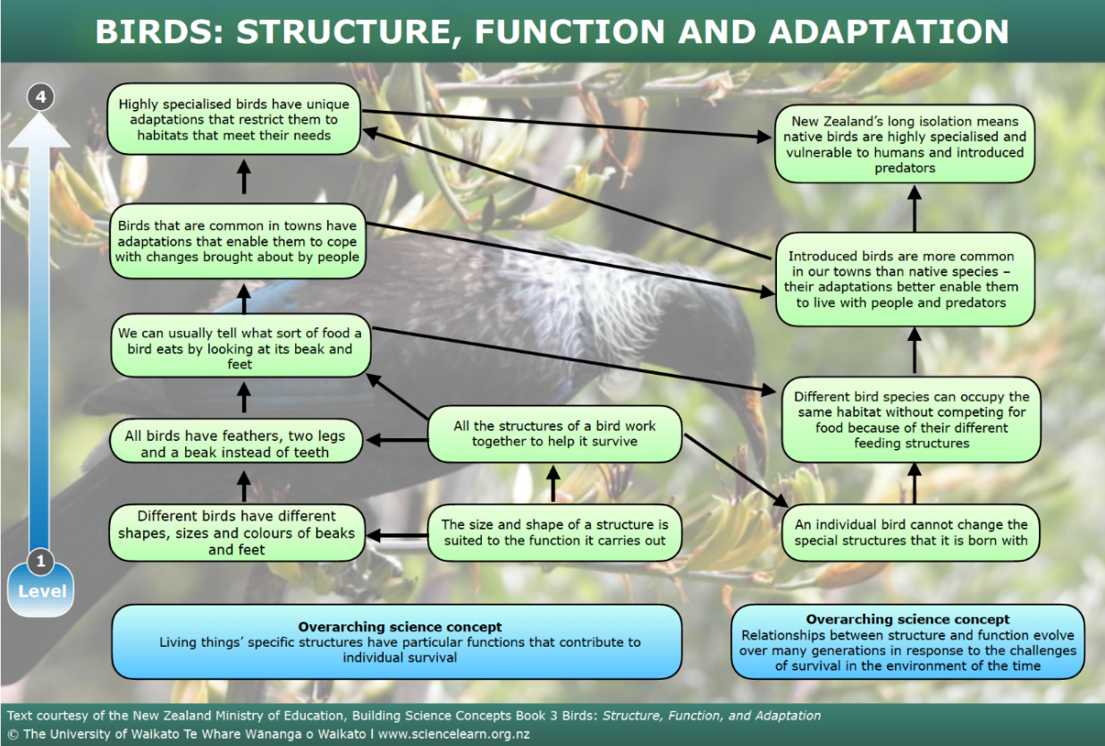

Your task
Create an infographic about bird adaptions in Aotearoa using the information cards.
Consider:
- Who is your intended audience?
- What is your infographic going to communicate? E.g. the knowledge component. How will you ensure this is credible? (Fact checking).
- What visual components will you use? (What images, diagrams, data charts?)
- What content components will you use? (What facts, stats, or information?)
- How will you use colour to amplify the effect?
Birds have different shaped beaks and feet suited to the habitat they live in. | Kākāpō breeding cycle is linked with fruiting of the rimu tree. In good years, often more chicks are born. | Kererū are one of few birds to produce ‘crop milk,’ a protein-rich secretion from the walls of their crops to sustain chicks.
Kiwi and takahē have vestigial wing buds, which are incapable of flight. | Kiwi have fine whiskers at the base of their beak to aid their navigation in the dark. | Kererū fledglings spend 1–2 weeks with their parents before becoming independent.
Kiwi hatch with an internal yolk sac. This sustains the chick in its first week of life. | If there is thick snow cover on the ground during winter, takahē will nest in forested areas to provide shelter. | The kererū has the widest gape of any New Zealand forest bird. This enables it to swallow the large berries of native trees.
Kiwi plumage blends in with the undergrowth to provide protection from predators through camouflage. | Male kākāpō let out a ‘booming’ noise from dug-out bowls in the earth to attract a female. | The tūī has a long-curved beak and a fine brush-tipped tongue that enables it to extract nectar from forest tree flowers.
The bill of the takahē extends onto its forehead as a shield. | Many birds like the kererū and tūī, perform display dives to attract a mate. | Tūī have hollow bones and no teeth, which makes their body light for flight.
Kiwi are nocturnal birds. | Kiwi have nostrils at the ends of their beaks. | The kākāpō has a ‘freezing’ response to danger.
Remember to do your end of day reflection and wellbeing activities (see p. 7&10).

Day 5 activity 1&2: Literacy, inquiry and art
Iti noa ana he pito mata ~ From a withered tree a flower blooms.
Notes for teachers and whānau
Today learners will have the opportunity to select an animal of interest to create a factual information cube about the why, how, and what of its adaptations.
Note that today our Inquiry focus is “present – share learning about the big idea” which includes thinking about who the audience is, and considering different ways of communicating learning – for example, presentation, video, poster, etc.

I am learning to: create a factual information cube.
What do I need?
- 60 minutes
- Look in your pack for a copy of The Moa https://instructionalseries.tki.org.nz/content/download/39560/441069/file/The Moa L4 Nov 2017.pdf
- Look in your pack for a copy of Sharks https://instructionalseries.tki.org.nz/content/download/41167/459236/file/SJL3_2018-Sharks.pdf
- Look in your pack for a copy of Fantastic Penguins https://instructionalseries.tki.org.nz/Instructional-Series/School-Journal/School-Journal-Level-3-November-2019/Fantastic-Penguins
Remember to start your day right (see p. 9).

Instructions:
The School Journals provide three animals that you can select to create an adaptation information cube about: moa, sharks, or penguins. You will select one of these animals and use the accompanying text to help you research and prepare an information cube about this animal and how it has adapted.

Your task:
Choose one of the animals (moa, sharks, or penguins) and read the School Journal accompanying text. Note: You may like to choose a different animal that you have research information on.
Prepare information in six categories – one for each side of the cube, e.g. physical description of the animal, description of the habitat/ecozone/biome, description of adaptations, a drawing or labelled diagram, other animals with similar adaptations, and interesting facts etc.
Create an information cube about how this animal has adapted using language and terminology we have used. Write and draw the info on the six sides of the cube.
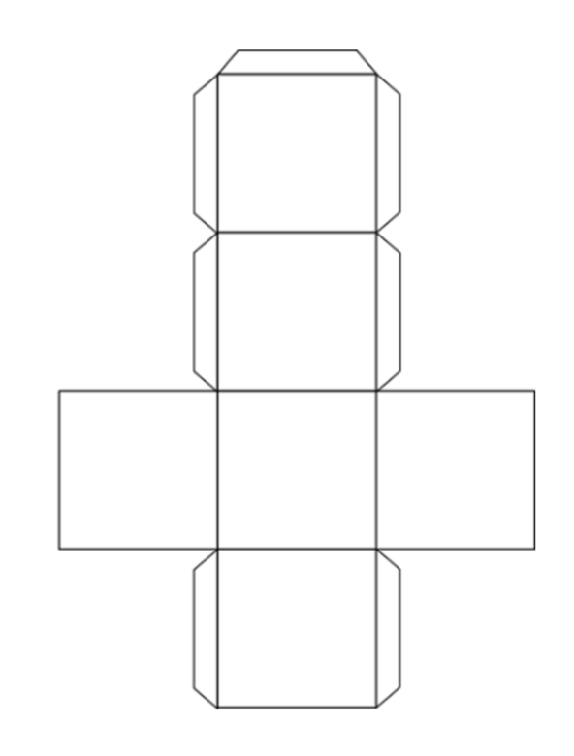

Day 5 activity 3: Gamifying how we share our learning
Notes for teachers and whānau
In this activity the learner will have the opportunity to be creative and to ‘gamify’ the information they have just researched and shared in their information cube. Learners will be exploring the learning areas of technology, literacy, and science.

I am learning to: design a game to use an information cube.
What do I need?
- 30 minutes
- Information cube created in previous activity

Instructions:
You will create a game, using your information cube from yesterday, that provides a learning experience for the players about adaptation.

Your task:
Create a game that uses your information cube and enables you to share your learning with whānau or friends. There are lots of types of games to choose from.

- Board game
- Card game
- Dice game
- Pencil and paper game
- Role playing game
- Strategy game
- Cooperative game
- Skill game
- Video game
- Guessing game
- Singing game

Just remember that the game needs to use your information cube.

Write instructions for how to play, including any rules.

Play the game with whānau and/or friends.

Day 5 activity 4: Think about our Thinker’s Keys
Notes for teachers and whānau
In this task, learners will have multiple opportunities to explore our theme of ‘Change: Adaptations’ through a variety of activities, and they will have opportunities to explore questions and discover new knowledge using the ‘Adaptation Thinker’s Keys’. The learners will be applying critical thinking skills and making connections to new learning and prior knowledge. Learners will be exploring the literacy, social science, maths, science, and technology learning areas.

I am learning to: think critically using the Adaptation Thinker’s Keys.
What do I need?
- 30 minutes
- Copy of Adaptation Thinker’s Keys (see p.37)

Instructions:
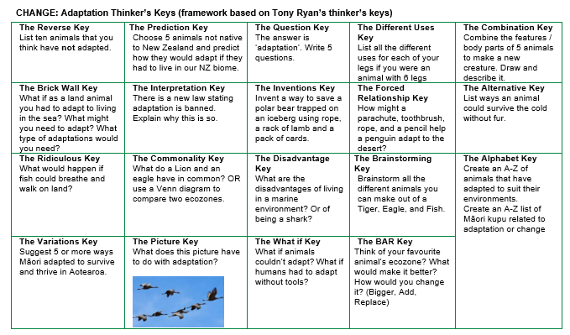
You are going to revisit the task grid called ‘Thinker’s Keys’ for our theme of Change: Adaptations.
You will again get lots of choice with this activity so pick the ones that you think sound fun, or hard, if you want a challenge. You will be applying your critical thinking skills.

Your task:
Finish your week of learning about adaptations by completing four more Adaptation Thinker’s keys activities. Use your critical thinking skills by selecting activities from the Adaptations Thinker’s Keys and complete them in your home learning book or digital doc.
Complete at least four of the tasks from the Adaptation Thinker’s Keys grid.

Congratulations on completing your first week of learning about ‘Change’. So what do you think? Is change a good thing?
Write a response in your reflective journal.
Ka pai! Ngā manaakitanga.
Remember to do your end of day reflection and wellbeing activities (see p. 7&10).

Context 2: Innovation – can I make a better ...?

The next five days investigate the theme of change by looking at innovation, and looking at how to make improvements to something.

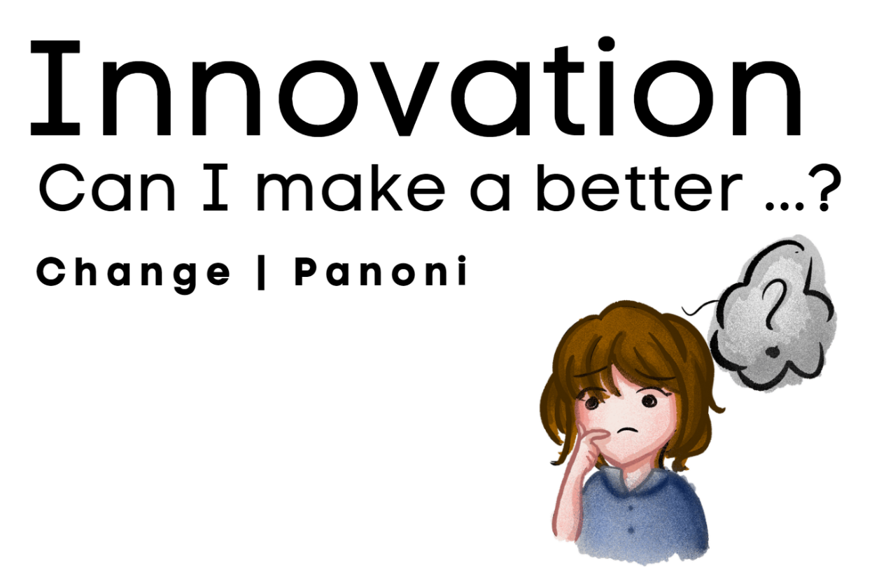

Day 6 activity 1: ‘Can I make a better ... ?’
“Innovation is the ability to see change as an opportunity, not a threat.” ~ Steve Jobs
Notes for teachers and whānau
Today learners will be looking at the many aspects of change we have experienced in our lifetime by exploring some innovations from the past and present. Learners will have the chance to be creative and innovate solutions to problems and scenarios. These activities will help their inquiry into ‘Innovation – can I make a better...?’ Learners will be exploring the learning areas of science, technology, and maths.
Note that our Inquiry focus for today is “getting started” which includes generating questions, activating prior knowledge, and introducing the big idea.

I am learning to: brainstorm and problem solve using different scenarios.
What do I need?
- 45 minutes
- Home learning book, pen/pencil and/or digital doc

Instructions:
Last week we looked at how animals adapt and change to survive and thrive in their environments. Humans cause many changes, and when we make changes to make something better, we improve it – this is called innovating. When we make something completely new – this is called inventing. The tasks in this activity will help you get prepared for your inquiry into innovation. You will see that the tools we use every day were once non-existent. They were invented and improved to make our life easier.

Your task:
Think: if you did not have access to any of these items, how would you open a can, dig dirt, get water, throw away your bodily fluids/waste, store things?
Record what life would be like without each item and ideate what could you do to make it better?
The device | A can opener | A spade | A water tap | A flushing toilet | A container with a lid
Image | 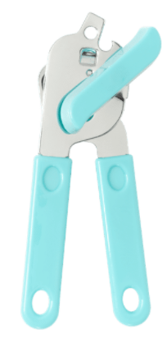 |  |  |  | 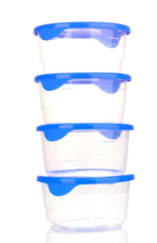
What would you do without it?
How could you make it better?
Brainstorm: using your wildest ideas ‘how might you solve these problems?’

Scenario | Sketch your solution | List: what equipment would you need to build it? (Imagine that you had access to any material you wanted)
Spider Trap:
An oversized spider keeps chasing you – make a trap.
Bird Scarer:
Birds are posing a danger at airports and destroying farm crops. How can we scare them from coming?
Rubbish In Bin:
How can we make sorting rubbish in the bin fun for kids?

Day 6 activity 2: Technology, introduction to design thinking
Notes for teachers and whānau
Today learners will be learning about the design thinking process so they can understand how they can make things better, and how they can impact change. The design thinking process we will refer to is based on the Design for Change FIDS (Feel - Imagine – Do – Share) approach, but there are many others. This is a simple scaffold that will support learners to conduct deep and meaningful inquiries.

I am learning to: outline the design thinking process.
What do I need?
- 30 minutes
- Home learning book, pen/pencil and/or digital doc
- Optional digital: https://www.dfcworld.org/SITE/dfcstory

Instructions:
You are going to learn an approach to design thinking. Design thinking is a way to take the issues that you notice in the world around you and to explore the issue with the intent to enact a change. Today you will look at an example of this process in action so that you can apply it to your upcoming inquiry ‘Can I make a better …?’.

Your task:
Read and learn about design thinking in this table:
Step | FEEL
Other design links | Empathy, ethics, connect, perspectives.
Description | When you ask, ‘Can I make a better…?” you are looking to innovate so it is good to empty your mind of existing assumptions: to start fresh! In this step you will observe and identify opportunities to enact change and to engage with the people it can impact.
Skills you will apply | Observational, self-awareness, communication, critical thinking, interviewing.
Goal | FEEL what bothers me the most and transform helplessness into empowerment.
Step | IMAGINE
Other design links | Ideate, brainstorm, thinktank, current reality – future aspiration.
Description | The critical factor that will determine how successful your ’Can I make a better …?’ innovation will be, is how clearly you define the problem. You can take responsible action only once you are clear of the problem you are trying to solve.
Skills you will apply | Decision making, creative thinking, collaboration, problem solving, ideating.
Goal | IMAGINE ways to take the current situation to a preferred state for self and others.
Step | DO
Other design links | Create, prototype, adapt, tweak.
Description | This step is about creating a bridge between what you think and intent with actual action. This is the stage that enables you to be a change agent and requires clear communication, commitment and follow through. It also requires resilience as your first attempt may fail.
Skills you will apply | Design, decision making, time management, prototyping, creative and critical thinking.
Goal | DO what it takes to bring about change with courage and determination.
Step | SHARE
Other design links | Present, sell, promote.
Description | This is the stage where you can inspire others and let them know that they too can make a difference. It also enables you to communicate your innovation with others so they can benefit from your learning too. Consider how you can use digital technologies to amplify your mahi.
Skills you will apply | Decision making, effective communication, digital literacy, presenting, reflecting.
Goal | SHARE my story to inspire others to be the change.
Table adapted from: https://dtg.dfcworld.org/file/Dtg2018421440402.pdf
Examine the comic strip example on the next page and complete the table below in your home learning book or digital doc.
 | What did the students do in this step of the process? | What else could they have done? What might you have done? | What was the result of this step? How did it help them move to the next step?
Feel
observe, notice, interview, engage with other perspectives.
Imagine
visualise success, brainstorm, ideate, consider ‘what if?’
Do
plan, implement, prototype, implement, reflect, tweak/adapt
Share
present, inspire, reflect

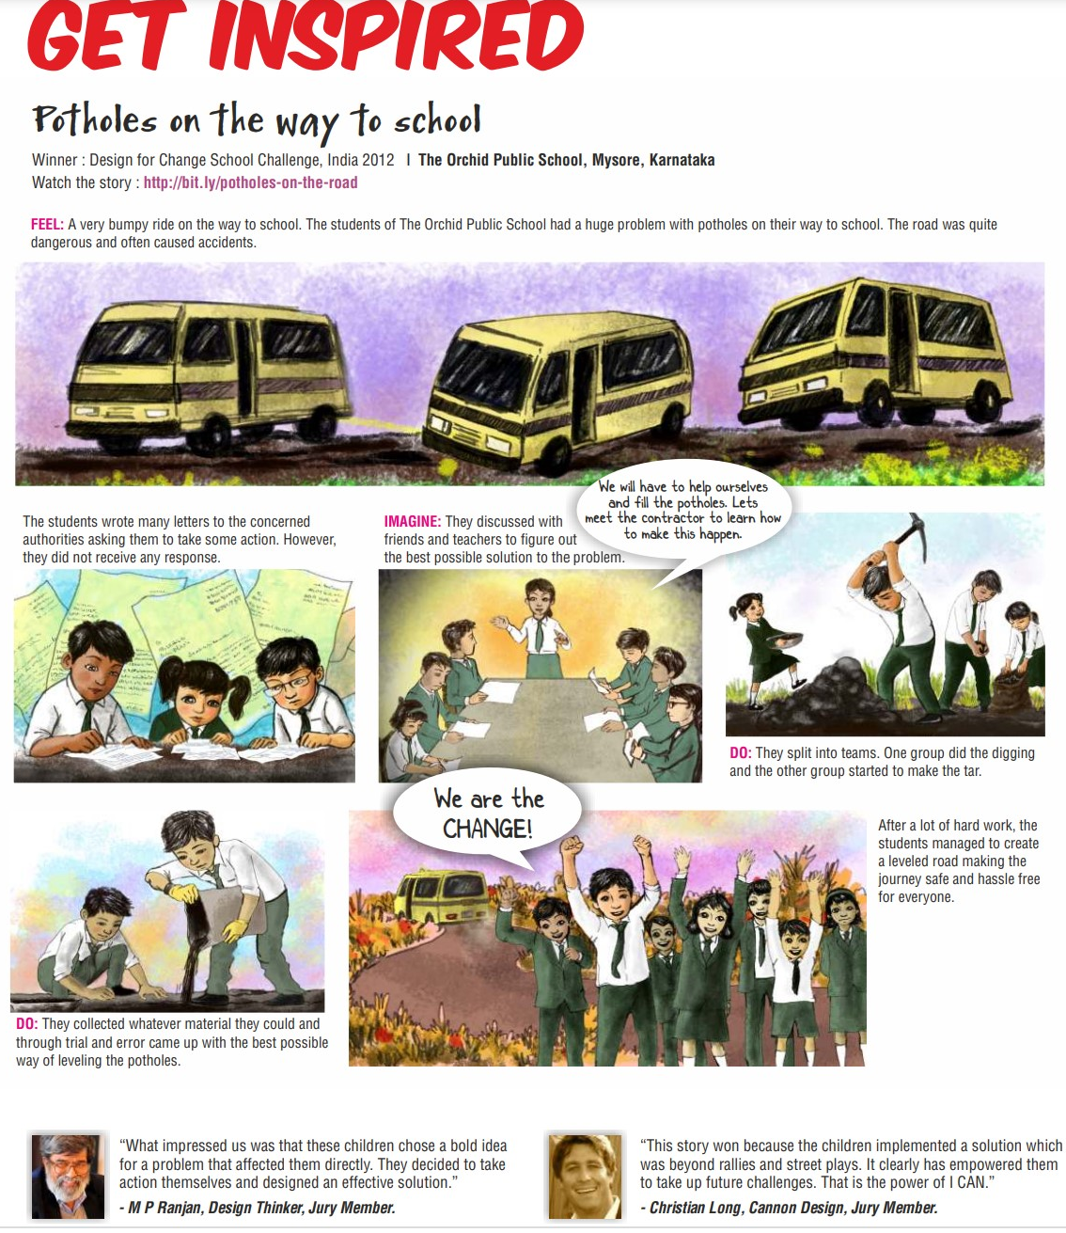
Source: https://www.dfcworld.org/file2015/oneweek_challenge_toolkit.pdf

Day 6 activity 3-4: Literacy, te ao Māori, social science and technology
Notes for teachers and whānau
Today learners will apply what they have learned about the design thinking process using a scaffolded example. The learners require some materials for this task – please help with alternative materials if needed.

I am learning to: explain the steps in the different aspects of design thinking.
What do I need?
- 60 minutes
- Home learning book, paper, or digital document
- Look in your plan for copy of Rātā me te Rākau https://instructionalseries.tki.org.nz/Instructional-Series/Junior-Journal/Junior-Journal-57-Level-2-2018/Rata-me-te-Rakau
- Materials: 15 sheets of newspaper, one roll of sticky tape, 20 ice cream sticks (or strong twigs), scissors (for construction only)

Instructions:
You will learn about Rātā and his quest to build a waka. You are then going to do a BP Challenge and relate it to the design thinking process. This will help prepare you for your own ‘Can I make a better…?’ inquiry using the steps in the design thinking process.

Your task:
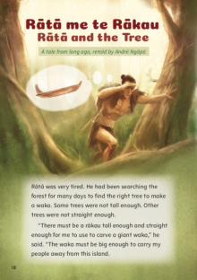
Read or listen to Rātā me te Rākau to set the scene.
Scenario: when you recently visited the Marae you were told of the legend of Rātā. Rātā was famous for building a waka (canoe) and then waking up in the morning to find the manu (birds) and ngangaru (insects) had turned his waka back into a rākau (tree) because he did not show respect. Now that Rātā has shown respect and given thanks to Tāne-mahuta for the gifts of the forest and that he knows to teach others to do the same he must build his waka again.
Your challenge: imagining that you are Rātā, design your new waka as quickly as possible (30 minutes).
Success criteria: your waka must float with the weight of your people (represented by a canned good e.g. canned beans) for one minute, this represents it is safe and strong.
Your materials: 15 sheets of newspaper, one roll of sticky tape, 20 ice cream sticks (or strong twigs), scissors, one canned good (e.g. canned baked beans or soup).
Complete the table below imagining that you are Rātā in your home learning book or digital doc.

 | What did you do in this step of the process for this scenario? | What was the result of this step? Do you think something was missing? | What else could you have done? What might you have done differently?
Feel
observe, notice, interview, engage with other perspectives

Imagine
visualise success, brainstorm, ideate, consider ‘what if?’

Do
plan, implement, prototype, implement, reflect, tweak/adapt

Share
present, inspire, reflect

Remember to do your end of day reflection and wellbeing activities (see p. 7&10).

Day 7 activity 1: Te ao Māori innovations
Haere taka mua, taka muri; kaua e whai - Be a leader not a follower
Notes for teachers and whānau
Today, learners will investigate some innovations of the past, particularly here in New Zealand. They will look at inventions and why they were needed, reflecting on the design process.
Note that our Inquiry focus for today is “explore, investigate, and discover” which includes choosing and evaluating information, and thinking critically.

I am learning to: apply critical thinking to the context of Māori innovations.
What do I need?
- 30 minutes
- Home learning book, pen/pencil and/or digital doc
- Optional digital: http://www.TeAra.govt.nz/en/kohatu-maori-use-of-stone
Remember to start your day right (see p. 9).

Instructions:
Today’s activity uses Blooms Taxonomy – a classification system that implements different ways to think about something. You will use this taxonomy of questioning to look at the way Māori responded to a need and invented tools out of stone.

Your task:
Read the following article summary and answer the questions below.
Kōhatu – Māori use of stone
Māori used a variety of stone materials such as basalt, greywacke, pounamu, chert, and obsidian to make tools, ornaments, weapons, and in fishing and gardening. Stone was a valuable resource and some, like obsidian, were traded throughout the country.
Tools
Stone adzes and chisels were used for cutting and carving wood. The stone adze heads, made from basalt or other rock types, were lashed to a wooden handle.
Adzes were made by breaking up boulders, shaping the pieces with hammer stones, and sharpening the cutting edge on a grinding stone. Sandstone was widely used as a sharpening stone.
Flake tools were used for general cutting and scraping. They were usually made from obsidian (volcanic glass) and chert. Chert (or flint) was also used to drill holes, in making items such as fishhooks.
Tūwiri (drills) had two cords. The tip was a hard, sharp stone. Sand and water were used as an abrasive during drilling.

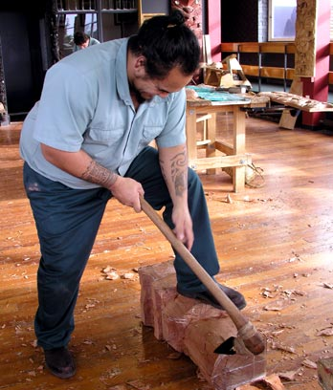
Ornaments and weapons
Early Māori made reels and pendants from serpentine (a soft rock). Reels were threaded to make necklaces, and decorated discs and pendants shaped like whale’s teeth were also worn. Later, Māori made hei tiki (neck pendants) and ear pendants from pounamu.
Shorthand-clubs made from greywacke, volcanic rock and pounamu were used as weapons.

Fishing
Stone lures with bone or shell points were used to troll for fish. Māori formed a groove around pebbles and wound a line around them to make sinkers, and pumice was attached to fishing nets as floats. Large stones were sometimes used as canoe anchors.

Gardening
In some places stones were used to mark the boundary of gardens. Sand and gravel were also mixed with soil to make it loose, keep in moisture, and to keep the soil warm for growing subtropical plants such as kūmara.

Other uses
Using stones, flax was pounded into fibre and made into clothing, mats, ropes, baskets, and nets. Round stones were heated for cooking in earth ovens, and to boil water. These were chosen carefully because some rocks explode when hot.
Source: Phil Moore and Bruce McFadgen, 'Kōhatu – Māori use of stone', Te Ara - the Encyclopedia of New Zealand, http://www.TeAra.govt.nz/en/kohatu-maori-use-of-stone
Complete the following tasks in your home learning book or digital doc:
Remember | Recall some of the tools made out of stone. Make a list.
Understand | Explain the different types of tools made from stone.
Apply | What were three stone tools used for? How do you think Māori might have used a version of the design thinking process as they invented tools out of stone? Choose one of the tools and map it to ‘Feel – Imagine – Do – Share’. What do you notice?
Analyse | Differentiate between the different stones used? What was pounamu used for? What was serpentine used for?  Do you think Māori were innovative with their use of the raw materials available to them? Giving examples, explain why or why not?
Evaluate | Could Māori have survived without stone tools? Explain why/why not? Consider how the inventions would have impacted their daily life.
Create | Create a tool of your own but out of paper (or draw and label the design). What will it look like? What could you use it for? If you had access to any material, what would you use to make it?

Day 7 activity 2: Literacy, innovation reading
Notes for teachers and whānau
Today learners will read a text about innovation. They will practice their ability to make inferences and create a ‘black out poem’. This will give the learners more information about the context of innovation. Learners will be exploring the learning areas of literacy.

I am learning to: make inferences and create a blackout poem.
What do I need?
- 30 minutes
- Home learning book, pen/pencil and/or digital doc
- Text adapted courtesy of the Science Learning Hub https://www.sciencelearn.org.nz

Instructions:
You are going to read some text to learn more about innovation. Read the following definitions of key terms:
An invention can be described as the creation of something new to the world. Many inventions are producer-driven – they are the result of a person following their curiosity, responding to their needs, or working in their area of expertise. Many inventions are patented. To be patented, it must be new or novel, inventive (not obvious to those working in the field) and be capable of being made and used.
Inventors are people who create something new to the world. Inventors are often driven by their own curiosity, their own needs, or their own research interests to find something new. Not all inventions have an immediate application. Not all inventions are economically viable. Not all inventions meet a specific need.
The word ‘innovation’ comes from the Latin word ‘innovatus’ meaning ‘to renew’. An innovation can be described as a result of the creative process of turning an idea into an outcome that creates value for people. An innovation doesn’t have to be new (in the way an invention does) but it does need to be new in its context. The value an innovation brings can be economic, health or social, cultural, or civic wellbeing. Innovation tends to be customer-focused, providing a new product or a new way of doing things that adds value to our lives. The innovation may be prompted by an idea or an insight, or be a response to an issue, a challenge, or a problem. An innovation can be radical, making a major change in an established product, service, or market (for example, the original iPad) or incremental, made by small continuous improvements (for example, iPad 2).
Innovators are people who can see how a new or an existing idea or invention could be exploited to create value for people. They are the ones who can see a situation differently or respond to a challenge in a new way. Innovators draw on their own expertise as well as that of others. Their innovations create change and bring value to society.
The innovation process is the term used to describe the steps involved in the process of generating, exploiting, and applying new ideas. The process is not linear, nor is there just one process. The steps generally include:
- coming up with the idea
- choosing and developing the idea
- researching, developing, and testing
- marketing the product or service based on the idea
- seeing the product or service being used or adopted by others.
Design thinking is a set of skills, competencies or dispositions relating to the highly iterative collaborative process designers employ when conceiving, planning, and producing an object or system.
Text adapted from: https://www.sciencelearn.org.nz/resources/1698-innovation-key-terms

Your task:
- Use each of the bolded words from above in a sentence. Record these in your home learning book or digital doc.
- Make three inferences from the text above. When we make an inference, we are using our schema (background knowledge) and clues from the text we are reading to understand something that the author did not explicitly write.
Number: | Inference: | Scheme + clues in the text:
Example | I think that during this week we are going to use design thinking as part of our inquiry. | I think this because: we are learning all about innovation, design thinking is one of the bolded words and we learned specifically about design thinking in yesterday’s activities.
1
2
3
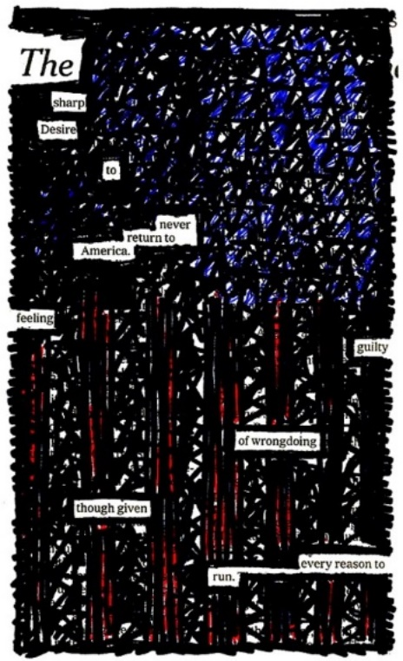
- Create a ‘blackout poem’ using the text below. There is an example to the right.
A blackout poem is a form of ‘found poetry’ and requires you to select the words from a text that catch your interest, ensuring that they make sense and ultimately allow you to create a new poem.
Once you have selected the words that you’d like to keep, you can ‘blackout’ the words you don't need using a black marker or pencil.
You can even try to design an image in the blackout space.

Image source: https://www.flickr.com/photos/deathtogutenberg/2457851787

Alistair Mowat of ZESPRI explains how New Zealand’s unique location in the world presents significant challenges for industry. Our distance from global markets makes it more difficult to interact with consumers and respond to changing needs and opportunities. Innovation is necessary to be able to create products and services that are globally relevant and sought after. Transcript of Alistair Mowat: When we look at the importance of innovation to New Zealand, New Zealand has a unique location in the world, it has a unique diversity of people. They create opportunities. It also has a number of significant challenges. It’s distant from markets, it’s not regularly interacting on a daily basis with people in large global cities who are potential end users of solutions and products and services from New Zealand. We can’t rely on products which historically have been effective at being exported and sold to consumers, because the world around us is changing. The values of the people in the marketplace are changing, the demographics, the culture, their requirements are changing, and so we can’t stand still. Innovation is as critical just from the point of view of keeping our products and services fresh and relevant to global consumers and the issues that they face. But also, we have unique resources, unique people, unique ways of bringing those various elements together, and innovation allows us to do that in a way which is relevant to people globally. We desperately need those skills. We can’t afford to be just inventing new products and services in isolation to that, and so innovation gives you the discipline to be able to create products and services which are globally relevant and sought.

The transcript and video of the above text can be accessed at: https://www.sciencelearn.org.nz/videos/1021-why-innovation-is-important-alistair-mowat

Day 7 activity 3: Technology, design thinking ‘Feel’
Notes for teachers and whānau
Today learners will begin their own inquiry using the design thinking process. They will be scaffolded through the four parts: feel – imagine – do – share. Today they will start with the ‘feel’ aspect and learn to consider multiple perspectives, and to empathize to identify a need. Learners will be exploring the learning areas of technology and literacy.

I am learning to: apply the design thinking process to my own problem.
What do I need?
- 30 minutes
- Home learning book, pen/pencil and/or digital doc

Instructions:
Today you will begin your inquiry around ‘Can I make a better …?’ using the design thinking process. This is an opportunity for you to explore the question ‘Can I make a better …?’ to address an issue that is real in your world today. The first stage of the design thinking process we are using is ‘Feel’. Shall we begin?

Your task:
- Complete the table below by brainstorming ideas of things you’d like to change:
Change area: | A change in my personal life… the issue is: | A change in my school… the issue is: | A change in my community… the issue is:
Examples: | My backpack is too heavy.  My friends don’t know how to play Ultimate frisbee. | The kids aren’t very friendly to visitors.  We are creating too much food waste going to the landfill. | There are too many stray animals.  There is a lot of litter in the local park.
Brainstorm all of my ideas (Ask yourself: what are the issues that I am noticing? What do I want to change?)
- Choose one of your ideas that you wish to act on. Frame it as a ‘Can I make a better …?’ question:
Can I make a better...

- Gain other perspectives: do other people feel the same way? Who might you need to interview? Who else?
Write your interview questions. Remember, you don’t need a lot of questions – you are trying to capture what other people think about the issue you have identified. Frame your questions to consider: how do they feel about this issue? What do they think? Do they agree? What do they think is the reason or cause? How do they think it could be solved?
Conduct your interviews. This information will help you with the next step in the design thinking process.
- Brainstorm causes: in order to solve a problem, you must identify what the cause or causes are of the problem. This will give you multiple pathways to explore when you get to the ‘Imagine’ and ‘Do’ steps of the process.
Brainstorm: use the concept map to complete a ‘cause brainstorm’ detailing all the different causes of this problem that you can think of? Think of all the different reasons you can.
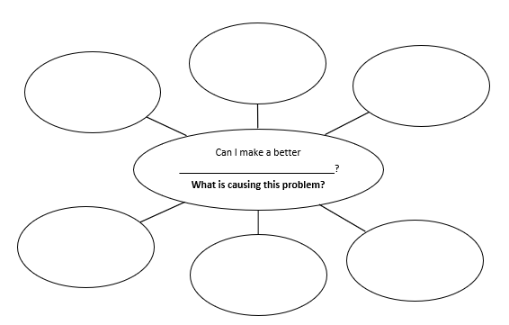

Day 7 activity 4: Maths, inventive thinkers
Notes for teachers and whānau
Learners will complete a Figure It Out maths activity called: Inventive thinkers and make a timeline. Timelines are a useful way to display information. They show the order in which events occurred and the periods of time between them. Timelines follow conventions used in other data displays, in particular, they must have a uniform scale and clear labels. Learners have an optional additional research task as well.

I am learning to: create a timeline and to interpret time-based information.
What do I need?
- 30 minutes
- Look in your pack for a copy of Inventive Thinkers https://nzmaths.co.nz/resource/inventive-thinkers
- Home learning book, pen/pencil and/or digital doc

Instructions:
Today you will use information to make a timeline. Constructing a timeline involves more than placing years in the correct order. You need to see a timeline as a number scale with uniform spacing between consecutive years. In the second activity you may notice that some technological innovations have resulted from “know how”. Sometimes creative leaps have been made from opportune discoveries. Others have been developed over long periods of trialling. Many breakthroughs are inspired by need, but others that start off as a luxury soon become a need.

Your task:
Complete activity 1 of ‘Inventive Thinkers’. Consider:
- What year should the timeline start at? Why doesn’t it need to start at 0?
- What scale did the students use (if any)? How did they decide how long to make the timeline? How did they work out the width for each year?
Complete activity 2 of ‘Inventive Thinkers’ and practice making another timeline.
Optional extra:
- Imagine what life would be like without a particular invention or technology.
- Choose one invention and imagine what prompted the inventor to make it.
- Research the invention to see whether this was the case.
OR
Make a table of inventions and suggest the types of people who rely on them.
Invention | Needed by
Electric fence | Farmers, people wanting additional security
Sunglasses | Pilots, skiers, drivers
...
Remember to do your end of day reflection and wellbeing activities (see p. 7&10).

Day 8 activity 1: Making meaning of innovations
“Intelligence is the ability to adapt to change.” – Stephen Hawking
Notes for teachers and whānau
In this task learners will explore what a patent is and apply their critical thinking skills to identify their significance to innovation and inventions. Learners will be exploring the learning areas of literacy and technology.
Note that our Inquiry focus for today is “making meaning" which includes analysing data, organising, and sorting information, summarising, synthesising, making connections/conclusions, building deeper understandings, and thinking critically.

I am learning to: write an explanation using facts.
What do I need?
- 30 minutes
- Home learning book, pen/pencil and/or digital doc
- Text adapted courtesy of the Science Learning Hub
Optional digital:
- https://www.iponz.govt.nz/about-ip/patents/
- https://www.sciencelearn.org.nz/videos/572-reasons-for-patenting-technology
- https://www.sciencelearn.org.nz/videos/1023-the-importance-of-intellectual-property-revolution-fibres
Remember to start your day right (see p. 9).

Instructions:
The NZ Intellectual Property Office explains:
“A patent is a right that is granted for an invention. You can patent a new product or process, the material it is made from, or how something is made. A New Zealand patent gives protection within New Zealand. To obtain patent protection in another country, a patent application needs to be filed in that country, or in a region including that country. When you apply for a patent, you must describe the invention. Your invention must be novel, involve an inventive step, and be useful.”

Your task:
Watch the videos from the Science Learning Hub or read the transcripts below.
Reasons for patenting technology
https://www.sciencelearn.org.nz/videos/572-reasons-for-patenting-technology
Researchers at Riddet Institute knew there was an opportunity to sell their microencapsulation technology to food companies. Having a patent is important because it proves the technology is unique. Companies who make new technologies look for a patent for this reason.

Dr Harjinder Singh – This project was driven by commercial opportunities. So we thought that we could create this new technology and patent it and then, if it was proven to work, we’ll try to set up a partnership with a New Zealand or an international company and take it forward. That’s what most companies who are going to commercialise university research are looking for. We can only develop knowledge, and to take that knowledge forward, you need someone who knows the commercial world and can deal with the manufacturing. So we came together and formed a joint venture company called Speirs Nutritionals Limited. That is owned by Speirs Group, Massey University, and Bio Commerce Centre. So now they have exclusive rights to this IP, and they’ve built a manufacturing plant in Marton for the emulsion, and they are doing the marketing and distribution.
The procedure usually is – say, in New Zealand, you file for a provisional patent for a year. After 1 year, it goes to the PCT stage when it is published, so you can search on the internet and you can find all the details, all the data. The way the patents are written by the lawyers, they give you a wide range of conditions and as much coverage as possible, but they don’t tell you the exact information. If you’ve gone through the patent procedure, you can claim it is a unique proposition. Patenting seems to be the most important part, and that’s what most companies who are going to commercialise university research are looking for.
The importance of intellectual property
https://www.sciencelearn.org.nz/videos/1023-the-importance-of-intellectual-property-revolution-fibres
Albert McGhee and Iain Hosie, from Revolution Fibres, discuss the importance of intellectual property for their business.

Jargon alert
- IP: intellectual property is often referred to as IP.
- RFID: radio frequency identification. These are technologies that use radio waves to identify people or objects carrying encoded microchips.
- Patent: a document granting an inventor sole right to an invention.
- Trade secret: information that companies keep secret to give them an advantage over their competitors.

Albert McGhee – IP is the lifeblood of any business that’s really focused on innovation. Best way to think of IP is simply knowledge and knowhow about things, and so in that sense, it can be market insights, technology, a whole range of things, it’s really that knowledge. So it’s important to capture that knowledge and keep it within a business and help stop it leaking out. But similarly, you want to share some knowledge, some IP with your clients. So there’s a fine balance between protecting IP and sharing IP.
We have a number of different ways that we protect our IP, primarily as a locked door, RFID keys and everything else, because there are a lot of IP that’s not appropriate to be patented because patents require disclosing what that is. So we keep that behind a locked door. But when it comes to the actual products, that’s when we patent it.
Iain Hosie – The key piece of ownership, the IP that we have in our business, is how we make fibres out of various materials. So it’s not just that production technique but also the solutions – the way in which we create polymer blends in order to create fibres that behave in a certain way. That’s the sort of thing that we hold as a trade secret. We’re not averse to patents, but at the moment, this business is just continually developing techniques, and it might be some time before we actually are in a position to patent some of these.

Complete the following questions in your home learning book or digital doc:
- Explain the difference between a patent and intellectual property.
- Write an explanation about why patents are important for innovation and change.
- Infer: what connection do you make between today’s quote “Intelligence is the ability to adapt to change.” by Stephen Hawking and patenting?

Day 8 activity 2: PE and Health
Notes for teachers and whānau
In this activity learners will explore a particular technological innovation and identify how it has positive implications for our health.

I am learning to: explore how innovation can have positive impact on our health.
What do I need?
- 30 minutes
- Home learning book, pen/pencil and/or digital doc
- Text adapted courtesy of the Science Learning Hub
- Optional digital:
https://www.zephyranywhere.com/system
https://www.sciencelearn.org.nz/videos/1543-innovations-zephyr-technology

Instructions:
You will learn about the Bio-Harness™ developed by Zephyr Technology right here in New Zealand. Then you will apply your critical thinking skills.

Your task:
Read the text below about Zephyr Technology from the Science Learning Hub.
The Bio-Harness™ developed by Auckland-founded company Zephyr Technology is a monitor that measures critical vital signs while you work or work-out. It was initially developed as a ‘lab on a strap’ for athletes. Now it’s being used by emergency workers, first-response teams, soldiers, firefighters, and others.
The Bio-Harness™ is a strap that goes around your chest. It measures critical vital signs (ECG, heart rate, breathing rate, skin temperature) and contextualises the information with the individual’s physical activity using an accelerometer (activity and posture). These vital signs are transmitted wirelessly back to those who are doing the monitoring and need to make critical decisions based on an individual’s physiological status. In 2010, Zephyr Technology’s Bio-Harness™ was worn by all 33 of the Chilean miners throughout their famously successful rescue. Using information provided by the Bio-Harness™, doctors were able to determine the order in which the miners would be rescued. They were also able to determine the immediate treatment each miner received at the surface.
Zephyr Technology is developing the biosensor for use in clothing. This biosensor is being trialled in a biometric shirt developed by Under Armour, a brand of athletic wear for American football players. The Bio-Harness™ technology is opening up the world of ‘connected health’ so patients can be monitored by their doctors wherever they are. This use would transform the expensive technology used to monitor vital signs into a technology that everyone can use.
The text, transcript and video of the above text can be accessed at: https://www.sciencelearn.org.nz/videos/1021-why-innovation-is-important-alistair-mowat

Sense making:
- Write an explanation for how the Bio-Harness™ technology has positively impacted connected health from your perspective. How has this technology evolved since 2010?
- List 10 innovations/inventions positively impacting our health or the health sector.
Design: can you make a better health app?
- Create a smart phone app that will help us be healthier. Consider: fitness, biometrics, nutrition, wellbeing and hauora.
- Describe what it will do and how it will work.

Day 8 activity 3: Technology, design thinking ‘Imagine’
Notes for teachers and whānau
Today learners will continue their own inquiry using the design thinking process. They will be scaffolded through the four parts: feel – imagine – do – share. Today they will use what they learned in the ‘feel’ step to influence their ‘imagine’ step of the process.

I am learning to: apply the design thinking process to my own problem.
What do I need?
- 30 minutes
- Home learning book, pen/pencil and/or digital doc

Instructions:
Today you will continue your inquiry around ‘Can I make a better …?’ using the design thinking process. You will return to your question from yesterday ‘Can I make a better …?’ to address an issue that is real in your world today. Today we will use the information that you collected from your interviews and ‘cause brainstorm’ to begin the ‘Imagine’ step.

Your task:
Select the root cause: there were many possible causes (there could be multiple possible causes) to your ‘Can I make a better …?’ issue. Try to select the one that you think you can most easily act on and/or the cause that you think will enable you to impact the most change. Record below.
The cause of my ‘Can I make a better …?’ issue is:

Desired outcome: now that you have selected the root cause of the issue, take a few moments to identify and describe what the desired outcome is. It is really important to be clear about this. Record below.
Draw and or describe what success will ‘look’ like.

Ideate: come up with at least six ideas for how you could try to solve the issue. Be creative. Even wild ideas can become plausible.
Consider: what will make the quickest impact? What will impact the most people? What will lead to long-lasting change? What will meet the needs of yourself and those who you interviewed?
Think beyond the obvious – draw on the ideas of those you have interviewed, explore how others have worked to enact change around similar issues. Think outside the box!
Force yourself to think ‘and’ instead of ‘but’ and build on your own ideas. You may even want to draw some pictures to demonstrate your ideas. Add more boxes as needed or draw the concept map in your home learning book to create more space for your imaginative creativity! Now…
Complete the concept map.
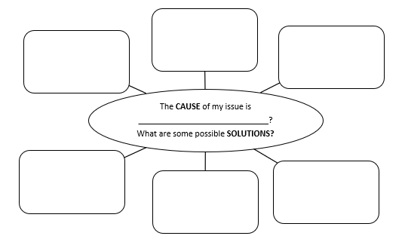
Visualise success: now that you brainstormed all the possible solutions for your ‘Can I make a better …?’ issue, you need to select the best solution. Choose the one that will enable you achieve your desired outcome. In other words, visualise success. Record your solution below.
The solution/action I will take is:

Next time, we will start the ‘Do’ step of the design thinking process.
Day 8 activity 4: Fibonacci maths and visual arts
Notes for teachers and whānau
Today learners will explore Fibonacci’s sequence. The Fibonacci sequence can be found in a varied number of fields from nature to music, and to the human body. Learners will be exploring the learning areas of visual arts and maths.

I am learning to: draw and use the Fibonacci sequence to create a pattern.
What do I need?
- 30 minutes
- Optional – grid paper, coloured pencils
- Optional digital – watch ‘Maths is natures number’: https://www.youtube.com/watch?v=vFRTgr7MfWw

Instructions:
Fibonacci was an Italian mathematician who lived from 1170 to 1240. He is famous for promoting the Hindu-Arabic number system in Europe, his work on algebra, and this famous sequence. Fibonacci’s real name was Leonardo of Pisa. Fun fact: As a young boy Fibonacci would have seen the leaning tower being built.
The sequence of 1, 1, 2, 3, 5, 8, 13, 21, 34…, is known as the Fibonacci sequence.
The Fibonacci sequence is the sum of two numbers preceding it in the sequence. It is used in the grouping of numbers and the brilliant proportion in music generally; coding (computer algorithms, interconnecting parallel, and distributed systems); and numerous fields of science including high energy physical science, quantum mechanics, cryptography, etc.

Your task:
The first 10 Fibonacci numbers are given in the following table.
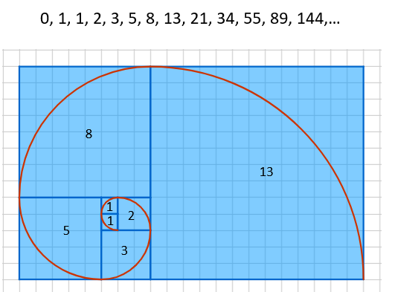
Calculate the missing numbers.
F₀ = 0 | F₅ = 5 | F₁₀ = | F₁₅ =
F₁ = 1 | F₆ = 8 | F₁₁ = | F₁₆ =
F₂ = 1 | F₇ = 13 | F₁₂ = | F₁₇ = 1597
F₃ = 2 | F₈ = 21 | F₁₃ = | F₁₈ = 2584
F₄ = 3 | F₉ = 34 | F₁₄ = 377 | F₁₉ = 4181

The Fibonacci sequence is observed in nature all the time! We can spot the Fibonacci sequence as spirals in the petals of certain flowers, or the flower heads as in sunflower, broccoli, tree trunks, seashells, pineapples, and pinecones. This is sometimes called the ‘golden spiral’.

Note: it is the spirals from the centre to the outside edge that create the Fibonacci sequence.
Draw an example of the Fibonacci sequence in nature. You could draw one of these examples, or a flower, seashell, or another example you can think of. Colour your drawing when you are finished. Note: you may find it helpful to use grid paper.
Activity and resources adapted from: https://nzmaths.co.nz/resource/fascinated-fibonacci

Remember to do your end of day reflection and wellbeing activities (see p. 7&10).

Day 9 activity 1 & 2: Innovative innovators
I orea te tuatara ka puta ki waho - A problem is solved by continuing to find solutions
Notes for teachers and whānau
Today learners will create a timeline of ten important inventions/innovations and learn more about an innovator/inventor of their choice. Note our Inquiry focus is “going further, deeper”. This may include diving deeper through discussions, provocations, new contexts, taking action, or thinking critically and drawing conclusions.

I am learning to: list and describe some important inventions and inventors.
What do I need?
- 60 minutes
- Home learning book, pen/pencil and/or digital doc
Remember to start your day right (see p. 9).

Instructions:
Use the information provided (you could do additional research on the internet) to create a timeline and fact card to demonstrate the significance of an innovator/inventor.

Your task:
Remember: an invention is something that is new, while an innovation is an improvement or modification made to something that already exists to make it better.
Explore some inventions that have changed our world and the innovators behind them.
1963 – audio cassette tape invented by the Philips company | 1888 – Henry Babbage invented the analytical engine | 1939 – Albert Einstein began to research the 1st atomic bomb | 1450 – Leon Battista Alberti invented the 1st mechanical Anemometer | 1817 – first bicycle invented in Germany, the ‘draisine’
1920 – Earle Dickson patented Band-Aids | 1952 – Woodland and Silver patented ‘barcode’ | 1643 – Evangelista Torricelli invented the barometer | 1928 – Alexander Fleming discovered penicillin | 1913 – Mary Phelps Jacob invented the bra
1930 – Richard Drew invented cellophane tape | 1826 – Nicephore Niepce invented the camera | 1888 – Karll Benz invented the first automobile | 1891 – Jesse Reno invented the first escalator | 1600 – Zacharias Janssen invented the microscope
1957 – USSR launches Sputnik the 1st artificial satellite | 1886 – Dr John Pemberton invented ‘Coca-Cola’ | 1440 – Johannes Gutenberg invented the printing press | 1829 – Barthelemy Thimonnier invented the sewing machine | 1989 – the world wide web ‘www’ was invented by Time Berners-Lee
1907 – Leo Baekeland invented plastic | 1921 – John Larson invented the polygraph | 1849 – Walter Hunt invented the safety pin | 1800 – Alessandro Volta invented batteries | 1938 – Ladislao Biro patented the ball point pen
1973 – General Motors invented the 1st car air bags | 1965 – James Russell invented the compact disc (CD) | 1608– Hans Lippershey invented the telescope | 1876 – Alexander Graham Bell invented the Telephone | 1926 – Kenjiro Takayanagi invented the television
- Choose 10 or more inventions from the table above and create a timeline.
- Explain why you think each invention is significant.
- Select one of them, or another significant inventor/innovator, to research.
- Create a fact card to promote their contribution to the history of innovation, with a picture of the inventor, diagram of their invention/innovation and 3 fun facts.

Day 9 activity 3: Technology, design thinking ‘Do’
Notes for teachers and whānau
Today learners will continue their own inquiry using the design thinking process. They will be scaffolded through the four parts: feel – imagine – do – share. Today they will use what they learned in the ‘feel and imagine’ steps to influence their ‘Do’ step of the process. Learners will be exploring the learning areas of technology and literacy.

I am learning to: apply the design thinking process to my own problem.
What do I need?
- 30 minutes
- Home learning book, pen/pencil and/or digital doc

Instructions:
Today you will continue your inquiry around ‘Can I make a better …?’ using the design thinking process. Yesterday, you selected the best solution to address the key cause of your ‘Can I make a better …?’ issue. To choose the optimal solution, you reflected on some questions: what will make the quickest impact? What will impact the most people? What will lead to long-lasting change? What will meet the needs of yourself and those who you interviewed?
Today we will work towards achieving the desired outcome as we engage in the ‘Do’ step of the design thinking process.

Your task:
Let’s take action! It is time to ‘Do’!
Starting with your solution, you will need to make an action plan.
Think about what you need to do in order to reach your desired outcome.
Make a list of these actions.
Consider for each step in your action plan: what resources do you need? How will you get them? How many people need to be involved? How much time will it take? Who is responsible? How will you document the work/results of the work?
Create a timeline for the actions. This clarifies who needs to do what by when. You may like to use the table below to make your action plan.
Action | Materials needed | Who | By when

Day 9 activity 4: Maths and visual art
Notes for teachers and whānau
Today learners will continue to explore Fibonacci’s sequence to create art. Learners will be exploring the learning areas of visual arts and maths.

In this activity I am learning to: use the Fibonacci sequence to create art.
What do I need?
- 30 minutes
- Home learning book, pen/pencil and/or digital doc

Instructions:
You will remember from yesterday that the sequence of 1, 1, 2, 3, 5, 8, 13, 21, 34…, is known as the Fibonacci sequence. The Fibonacci sequence is the sum of two numbers preceding it in the sequence.

Your task:
Using the images below and what you learned yesterday about the Fibonacci sequence, create a new artistic drawing that applies this mathematical principle. The blank ‘golden spiral’ on the next page can be used to launch your creation, or you may wish to start from scratch. Note: if you didn’t have time to finish your drawing yesterday, you could do that instead. 😊

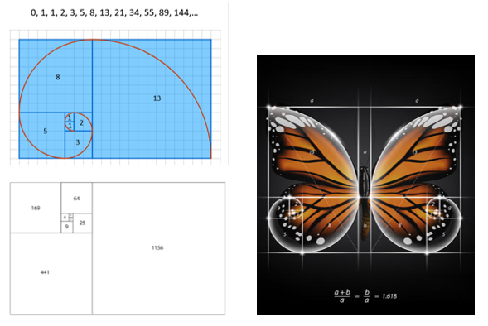

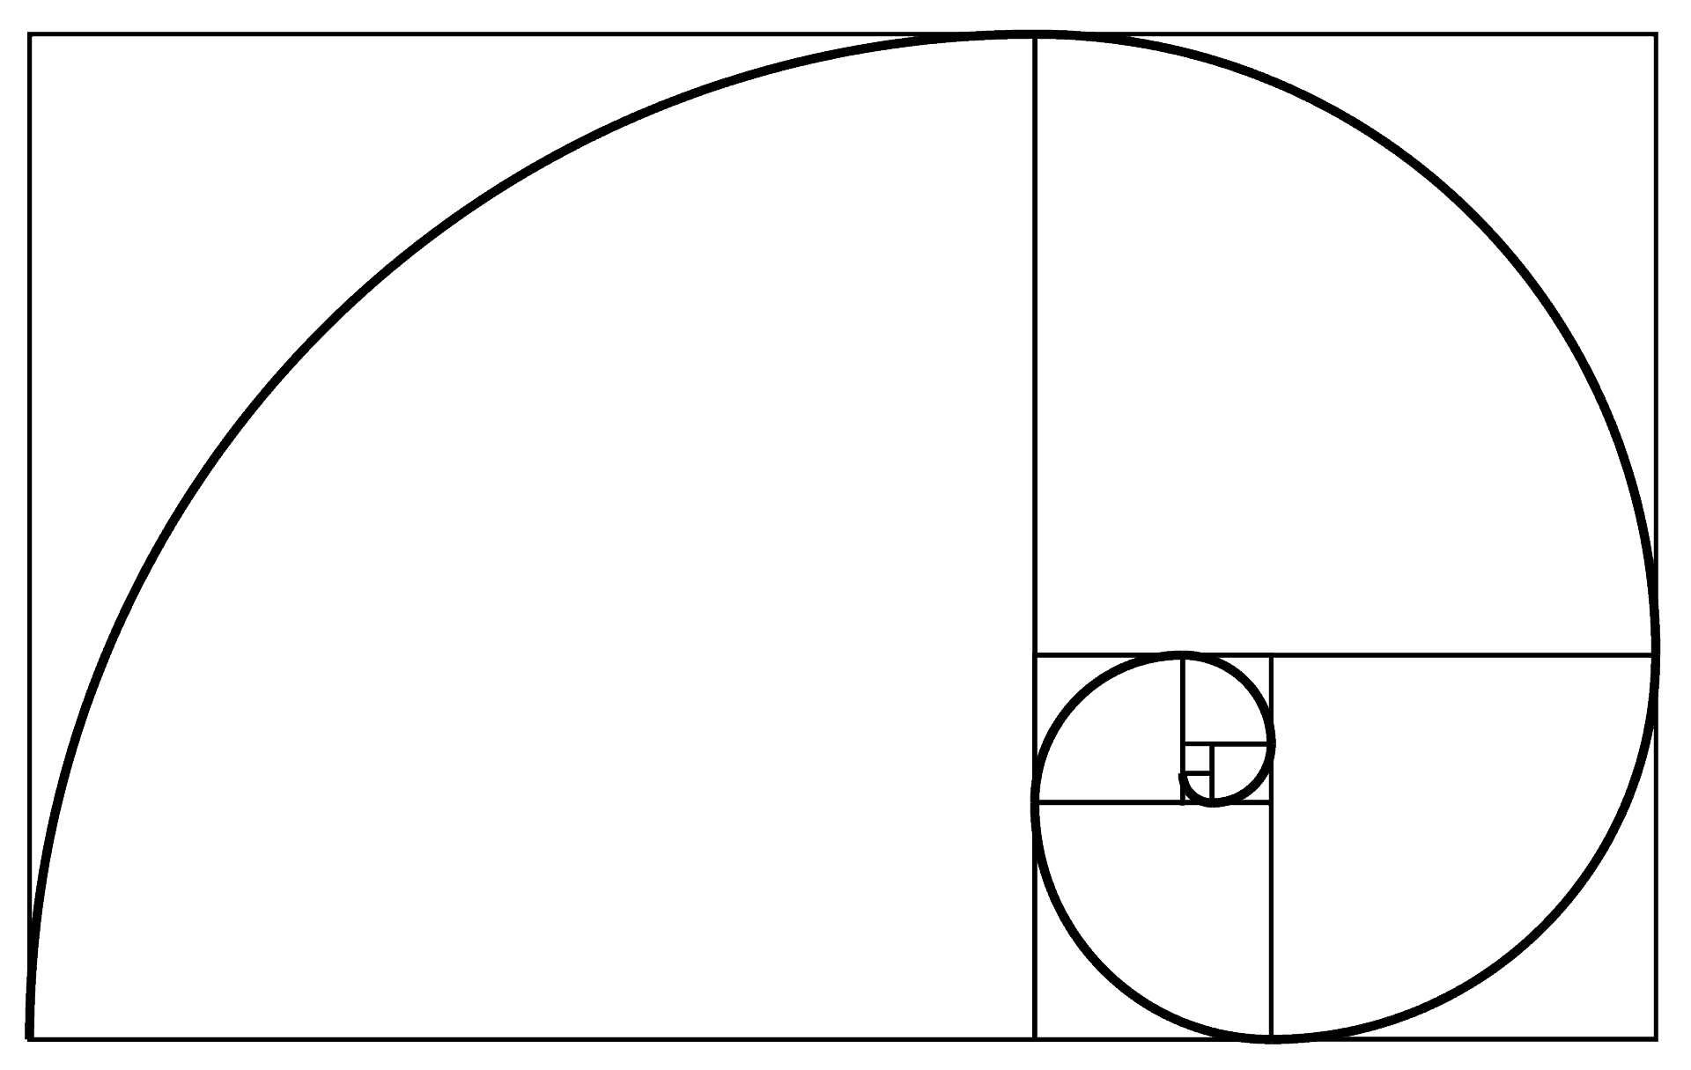
Resources and activity adapted from: https://nzmaths.co.nz/resource/fascinated-fibonacci

Extension: Number of the Day activity.
Today’s number is 1156.

In your home learning book, do the following to practice your maths skills!
 | - Write it in words  - 50 less than  - 200 more than  - Add 92.  - Subtract 87  - Next odd number is  - Halve it  - Double it | - Is it a prime or composite?  - Times by 100  - Times by 1000  - Round to the nearest 10  - Round to the nearest 100  - What is the place value for each digit? | - Is it odd or even?  - Is it divisible by 5?  - Complete the pattern: add 7: 1156,___,___,__  - List some factors  - Find one tenth  - Write a word problem whose answer is 1156
BONUS: if the answer is 1156 write 5 questions

Remember to do your end of day reflection and wellbeing activities (see p. 7&10).

Day 10 activity 1&2: Design thinking ‘Do’
“Creativity is thinking up new things. Innovation is doing new things.” Theodore Levitt
Notes for teachers and whānau
Today learners will continue their own inquiry using the design thinking process. They will be scaffolded through the four parts: feel – imagine – do – share. Today they will continue their ‘Do’ step of the process. Learners will be exploring the learning areas of technology and literacy.
Note that today our Inquiry focus is “present- share learning about the big idea” which includes thinking about who the audience is and considering different ways of communicating learning for example, presentation, video, poster, etc.

I am learning to: apply the design thinking process to my own problem.
What do I need?
- 60 minutes
- Home learning book, pen/pencil and/or digital doc

Instructions:
Today you will continue your inquiry around ‘Can I make a better …?’ using the design thinking process. Yesterday, you selected the best solution to address the key cause of your ‘Can I make a better …?’ issue. To choose the optimal solution, you reflected on some questions: what will make the quickest impact? What will impact the most people? What will lead to long-lasting change? What will meet the needs of yourself and those who you interviewed?
Today we will work towards achieving the desired outcome as we engage in the ‘Do’ step of the design thinking process.

Your task:
Using your Action Plan from yesterday, document your actions (this can be notes, photos and/or video) and as you capture stories, focus on F.A.C.T.S – Feelings, Actions, Changes and Transformations. Be ready to make changes as needed to any prototypes that you develop.
- Feelings: how can you depict the feelings of people as you ‘Do’?
- Actions: capture your work in action.
- Changes and Transformations: how were people changed? How was the community transformed? What was the impact?
This will be important for our last part of the design thinking process ‘Share’.

Day 10 activity 3: Design thinking ‘Share’
Notes for teachers and whānau
Learners will now have the opportunity to complete their design thinking process by ‘Sharing’. Learners will be exploring the learning areas of technology and literacy.

I am learning to: share the results of my design thinking process.
What do I need?
- 30 minutes
- Home learning book, pen/pencil and/or digital doc

Instructions:
You will now have the opportunity to share what you have learned during the application of the design thinking process. This could inspire others too. Be a storyteller and consider the most powerful way to share what you have learned and what your next steps might be.

Your task:
Choose a compelling way to share the results of your ‘Can I make a better …?’ inquiry using the design thinking process.
It is important to share this as a storyteller so you can inspire others.
You may like to:
- Create an information report on each step in the process.
- Design a cartoon to demonstrate your journey.
- Create a poster to demonstrate your journey.
- Make a news clip or movie trailer of your journey.
- Another way of your choice.

Day 10 activity 4: Flinstones fun!
Notes for teachers and whānau
And finally a wee bit of Flintstones fun!

I am learning to: apply critical thinking skills to make a stone age innovation that would make life better.
What do I need?
- 30 minutes
- Home learning book, pen/pencil and/or digital doc
- Optional digital: https://www.youtube.com/watch?v=YaLukzhk74M

Instructions:
The Flintstones was an American cartoon produced by Hanna-Barbera Productions. The setting is the stone-age, and the storyline follows the Flintstones family, and their next-door neighbours, the Rubbles. It was broadcast on TV in the 1960s. The show is all about the lives of Fred and Wilma Flintstone and their pets Dino and Baby Puss, as well as the later addition of baby Pebbles Flintstone. The families use a variety of stone-age innovations such as:

- Dino-eggbeater
- Dictabird
- Javasaurus coffeemaker
- Drago-toaster
- Tyrannosaura-crane
- Tricera-dozer
- The refreshing woolly mammoth shower
- Stego-sposal
- Pelican clothes washer
- Masto-vacuum
- Bedrock Bowl-a-Rama
- Saber-tooth house cat

Your task:
Can you make a better Flintstone’s innovation?
Look at the list above and try to imagine what the invention did and what it looked like (they often used animals to act as machines). To get a sense of their cartoon and the stone-age world, you could watch the Wacky Inventions of the Flintstones: https://www.youtube.com/watch?v=YaLukzhk74M
- Reflect on your learning about animal adaptations and innovation.
- Imagine that you are living in the stone-age.
- Design a new stone-age innovation.
- Draw and label it. Have fun!
Congratulations on two weeks of learning about change.
So, what do you think? Is change a good thing?
Write a reflective response to this question in your home learning book.
Ka pai! Ngā manaakitanga.
Remember to do your end of day reflection and wellbeing activities (see p. 7&10).

