A learning from home pack

For learners in years 4–6

Theme: Change | Panoni – Is change a good thing?

Context 1: Adaptations

Context 2: How humans impact the environment

Layout of the resource
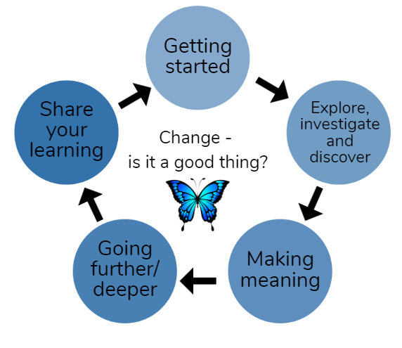
This pack is filled with learning activities that can be used at school or at home. All activities are framed around the theme of change | panoni.
Suggestions are provided for starting the day with a karakia (see p. 9), check in with the teacher, and setting up the learning environment. You can replace these with how you want your learner to start their day. The pack is provided as a Word document so you can adapt it for your learners.
The activities follow an inquiry learning model (figure 1) exploring one theme through two contexts. Each day the learner will be working through one part of the model culminating with sharing their learning on days five and ten.
Figure 1 Inquiry learning model

Realities
You know your learners and have a good understanding of their learning situations. Many learners will be sharing space and materials. Some may have access to the internet and devices, and others may not. Learners will also have varying levels of adult support. This pack contains a mix of activities using materials found in most homes. Some activities will need support while others can be managed independently.

Resources
This pack uses a range of resources from the Science Learning Hub. We would like to acknowledge their contribution.
The pack also makes use of the School Journal and Figure it Out series. You might want to send these home with the learner, along with an exercise book, pencils, crayons, or felts, and some craft materials (glue, scissors, construction paper). Learners can bring their notebook back to class to share. All images have been sourced with permissions for use in this pack. If your learners do not have reliable access to the internet, here are the resources to print and send home to create a paper-based pack.

Resources to send home
- https://instructionalseries.tki.org.nz/Instructional-Series/School-Journal/School-Journal-Level-3-November-2011/Timber
- https://instructionalseries.tki.org.nz/Instructional-Series/School-Journal/School-Journal-Level-3-June-2012/Heartbeat
- https://instructionalseries.tki.org.nz/Instructional-Series/School-Journal/School-Journal-Level-2-May-2012
- https://instructionalseries.tki.org.nz/Instructional-Series/School-Journal/School-Journal-Level-3-June-2012
- https://instructionalseries.tki.org.nz/Instructional-Series/School-Journal/School-Journal-Level-3-September-2014/The-Big-Dig-Clearing-the-Manawatu-Gorge-Slip
- https://instructionalseries.tki.org.nz/Instructional-Series/School-Journal/School-Journal-Level-2-June-2014/Cats-Who-Needs-Them
- https://instructionalseries.tki.org.nz/Instructional-Series/School-Journal/School-Journal-Level-3-May-2017/Designed-for-Good

Resources to print
- https://www.doc.govt.nz/globalassets/documents/getting-involved/activities-with-children/plant-sensory-bingo.pdf
- https://nzmaths.co.nz/resource/clara-s-cowpats
- https://nzmaths.co.nz/sites/default/files/images/fio/FredsRent-a-Fence1.jpg
- https://nzmaths.co.nz/sites/default/files/AllThatPackaging.pdf
- https://nzmaths.co.nz/sites/default/files/AnAppleaDay.pdf
- https://nzmaths.co.nz/sites/default/files/CanYouAffordAPet_CM_0.pdf
- https://nzmaths.co.nz/sites/default/files/2021-09/year-5-week-3-offline-activities.pdf
- https://nzmaths.co.nz/sites/default/files/InventiveThinkers_0.pdf
- https://nzmaths.co.nz/sites/default/files/TivaevaeKarakara.pdf
- https://www.doc.govt.nz/globalassets/documents/getting-involved/students-and-teachers/habitat-heroes/habitat-heroes-education-resource-green-spaces.pdf
  - Green space data collection sheet 1: Five minute bird count
  - Green space data collection sheet 2: Mini beast hunt
  - Green space data collection sheet 3: Plant identification
- Animal pests fact sheets for
  - Rats https://www.doc.govt.nz/globalassets/documents/getting-involved/students-and-teachers/animal-pest-factsheets/rats.pdf
  - Mice https://www.doc.govt.nz/globalassets/documents/getting-involved/students-and-teachers/animal-pest-factsheets/mice.pdf
  - Possums https://www.doc.govt.nz/globalassets/documents/getting-involved/students-and-teachers/animal-pest-factsheets/possums.pdf
  - Cats https://www.doc.govt.nz/globalassets/documents/getting-involved/students-and-teachers/animal-pest-factsheets/cats.pdf
- Power point – Who’s that Introduced predator? (12 slides print 6 to a slide, double sided) https://www.doc.govt.nz/globalassets/documents/getting-involved/students-and-teachers/animal-pest-factsheets/who-is-that-introduced-predator.pptx#slide=id.g1bd2ee9ff1_1_98

Setting up the learning environment
Encourage whānau to support learners to set up a space for learning at home. Learners might like to design their own space as a separate learning activity. Some materials they may need could include pen, pencils, paper, a notebook, colouring pencils, glue, scissors, and a device to access the internet.
Many of the suggested activities and experiences include the optional use of online resources which can be accessed and viewed using a Smartphone.

Overview of the learning in this pack
The theme of change | panoni will be explored through two contexts.
- Days 1–5 look at this idea through the context of adaptation
- Days 6–10 look at this idea through the context of how humans impact the environment
Learners will explore, investigate, discover, and make meaning as they go through each task. There are times where they look a little deeper into the topic. Some of the tasks may be independent hands-on tasks while some may involve connecting and sharing with others.
Day 1 | Day 2 | Day 3 | Day 4 | Day 5
Activate our prior knowledge about the environment around us. | Explore what a good habitat looks like. | Understand why and how animals need to adapt to their environment? | How can we create healthy environments for our native species to thrive? | Why are some species extinct and what can we do help those threatened?
Day 6 | Day 7 | Day 8 | Day 9 | Day 10
Understand how humans can impact the environment. | Investigate how introduced species have impacted the environment | Explore how innovation is helping solve problems both simple and complex. | How can you use technology to help innovate and solve environmental problems? | Create a presentation sharing different perspectives about your learning

Daily timetable
Below is a possible daily timetable. We have allocated 30 minutes for each activity (or indicated where an activity takes longer); your learner may take more or less time than we have allocated for an activity. We suggest your learner takes the time they need to complete an activity. This may mean they choose which activities they will complete for the day, rather than complete them all.
At the start of each day the learner will draw up their timetable for learning. You can adjust the timing to suit the other activities that might be happening the day, such as Zooming with the class/teacher.

Time | Activity
9:00 am | Starting the day
9:30 am | Activity 1
10:00 am | Break
10:30 am | Activity 2
11:00 am | Fitness break
11:30 am | Activity 3
12:00 pm | Lunch time
1:00 pm | Activity 4
1:30 pm | Reflection time
2:00 pm | End of the school day

Daily fitness – Choose something each day
It is important to include a fitness activity every day. Please ensure that your learner includes this in their daily timetable. If possible, it would be great to do the fitness activity with your learner or have them complete it with their siblings where appropriate.
Below are a range of activities to choose from – or you can make up your own ideas! You may prefer to go for a walk or run around your house. Time yourself for fun! Maybe you’d like to go for a bike ride with your whānau? Play a game with whānau? Have a boogie to your favourite song? Or do some yoga? It is up to you.
Please note you can change or modify the exercises (in addition to those outlined) if you are not able to do the ones we have suggested, get creative and change it up.
Mahuru Dance
Go to https://music.youtube.com/watch?v=-BrdaUUTMBY&feature=share and watch Pere Wihongi sing Mahuru (Earth Wind and Fire’s song September in te reo Māori). Practice singing it in te reo and then make up a dance or fitness routine.
- Maybe you have to jump up every time you ‘Mahuru’?
- Maybe you have to squat every time you hear ‘korero Māori’?
Have fun with it and move your body!
Fitness countdown
You don’t need anything for this activity but a positive attitude and a water bottle!
- tekau (10) jumping jacks **modify: right leg step out to the side then left leg
- iwa (9) forward lunges (on each leg) **modify: us a box and step up and down
- waru (8) squats **modify: sit in chair, stand up
- whitu (7) donkey kicks (each leg) – can do standing or sitting
- ono (6) sit ups **modify: touch knees
- rima (5) high knees **modify: lift knees up while laying down on back
- whā (4) push-ups **modify: do on your knees
- toru (3) star kicks (right leg – kick forward, side, back; then left leg)
- rua (2) burpees **modify: walk outs – walk out with your hands and walk back
- tahi (1) superman pose or high plank for as long as you can hold! **modify: on your knees
Take a rest and repeat. Tumeke!
Hikitia te hā
This is “a series of simple te ao Māori breathing exercises that anyone can learn. Focusing on our breathing calms the body and mind and is a very helpful practice for feeling more present and mindful. Hikitia Te Hā was developed by Rawiri Hindle”.
Go to the website and follow along to the videos.
https://www.allright.org.nz/tools/hikitia-te-ha
Tahi – rua – toru – whā fitness challenge
You will need a timer for this activity (alternatively you can count).
Time yourself – how long you can remain in each position during each set? Will you get better/longer?
Tahi – Wall sit. Stand in front of the wall facing away. Slide down the wall until you are sitting. Your knees/thighs should be parallel to the floor. How long can you remain in this position?
Rua – Superman. Lay on the floor with your face towards the floor, relax. Now lift your legs slightly off the floor and put your arms out like superman. How long can you remain in this position?
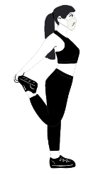
Toru – Tree pose. Standing tall and straight, slide your right foot up your left leg until it reaches either below or above your knee (not on the knee), ensure your right knee is facing outwards, not forwards. At the same time raise both arms straight above your head and bring your palms together. How long can you remain in this position? Try the other side.
Whā – Quad stretch. Standing tall and straight swing one leg behind and catch it with your same arm. Hold the stretch for as long as you can. Try the other leg. Is one side easier to balance on?
Repeat x 3.
Can you beat yourself? Great efforts!

Daily wellbeing – Choose something each day
These activities are good to do at the beginning and end of the day but can be done anytime. They can help you get ready for learning, calm your mind and body, and they can help you to reflect on your learning:
Gratitude Scavenger hunt:
Find something:
- That makes you happy
- That makes you think of someone you love
- That you like to touch
- That makes you feel proud
- To give to someone to make them smile
- You love to smell
- You enjoy looking at
- That is your favourite colour
- You are thankful for in nature
- That you find useful
Make it digital: Complete the Gratitude Scavenger Hunt by taking photos of the items and using Pic Collage to capture them all in one place.
I’m awesome
- Get a jar or container from the cupboard.
- Fold a piece of paper into small squares and either rip or cut these up.
- On each square write down your strengths, things you are good at, your good qualities (e.g. I’m a good friend, I help feed my dog, I can run fast, etc).
- Fold each square and put it in your jar.
- Give some squares to people in your house and ask them to write down things that they appreciate about you.
- Ask them to fold the paper and put it in your jar.
- Each day take a piece of paper out of the jar to remind yourself how awesome you are.
- Keep adding to the jar when you think of new things.
Pathway breathing
We all get overwhelmed sometimes – we get too excited, or we get anxious. Breathing helps us find our calm place. You can build a breathing pathway to calm! You will need a straw, a small light ball shape (could be rolled up paper etc), and some objects to build a course.
- Use things around you to build a pathway (or racetrack) on the table or floor.
- Put your small ball at the starting line of the pathway.
- Use the straw to blow your ball all the way to the finish line.

Clouds and triangles
Find a nice quiet place outside to look up at the clouds. Focus on their shapes and movements. Once you are feeling comfortable, start some triangle breathing.
- Using your finger in the air, start at the bottom left of the triangle.
- Breathe in for three counts as you trace the first side of the triangle.
- Hold your breath for three counts as you trace the second side of the triangle.
- Breathe out for three counts as you trace the final side of the triangle. You have just completed one deep breath.
- Repeat 5 times
- Focus on the clouds in the sky again.
- Repeat more triangle breathing
- Return to your learning once you are feeling relaxed.
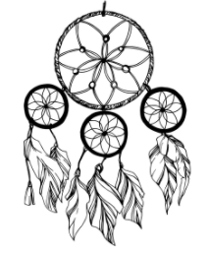
Online ideas:
Dream catcher
https://www.tinyfry.com/make-dream-catcher-kids/
Make a dream catcher and add small pictures or slips of paper that show your hopes for the future.

Starting each day
Notes for teachers and whānau:
Starting the same way each day helps create a structure for your learner. Your school might have a way to do this, for example starting the day together as a class on Zoom. In this pack we provide a karakia to settle into the day. Saying the karakia with your learner a few times will help them do this more independently tomorrow and beyond. As part of the start of the day and setting up the learning environment, help your learner look through the activities suggested for that day and choose a fitness and wellbeing activity. They could fill out their daily timetable and think of other activities they might like to do, such as reading. Remind your learner of when and how to check in with the teacher/you.

Karakia
Here is a karakia to welcome in the day.
Whakataka Te Hau: Karakia video https://www.youtube.com/watch?v=_uQqIGt3H2w
Whakataka te hau ki te uru,  Whakataka te hau ki te tonga.  Kia mākinakina ki uta,  Kia mātaratara ki tai.  E hā ake ana te atākura  he tio, he huka, he hauhunga.  Haumi e! Hui e! Tāiki e! | The wind swings to the west  then turns into a southerly.  making it prickly cold inland,  and piercingly cold on the coast.  May the dawn rise red-tipped  on ice, on snow, on frost.  Join! Gather! Intertwine!

Planning my day
- Have you chosen which activities you will do today and in which order?
- Remember to choose a fitness activity (See p. 5)
- Have you chosen a wellbeing activity? (See p. 7)
- Have you done a ‘Wellbeing check-in' ?
  - How are you feeling today?
  - How do you feel about your readiness to learn this morning?
  - What do you need extra assistance with today? Who could you get to help you? What strategies could you use to help make your learning more effective?
  - What would you like to do as a quiet time activity to end your day?
- Remember to do your Reflection at the end of the day (see p. 10)

Ending each day
Please ensure your learner does this at the end of each day.
Reflection can be challenging for all learners, but it can also provide them with rich opportunities to think about how their learning is progressing. Use the questions below as prompts to encourage your learner to think about what they have learned so far and help them to plan out their next steps. If you have concerns with their learning or find that your learner is needing more help, contact their teacher for more support.

I am learning to: reflect on my learning.
What do I need?
- A notebook or online doc that you can use each day for your reflection activity. We will call this your “reflective journal”
- Materials for your quiet time activity
Take some time to think about how you are feeling and after today’s learning activities.
Reflect on the following prompts in your reflective journal.
- What did you enjoy most about today?
- What is one thing you feel you learnt today?
- What is one strategy that helped you with your learning?
- What did you find challenging or distracting? (You ran out of time for some activities, or you finished them quite quickly and wanted to dig in a little deeper.)
- Is there anything you need extra help with? Who can you ask to help you with that?
- Is there anything you want to catch up on tomorrow?
Remember to finish with a wellbeing activity and/or your chosen quiet time activity

Context 1: Adaptation

The next five days investigate the theme of change by looking at adaptations – animals and humans.

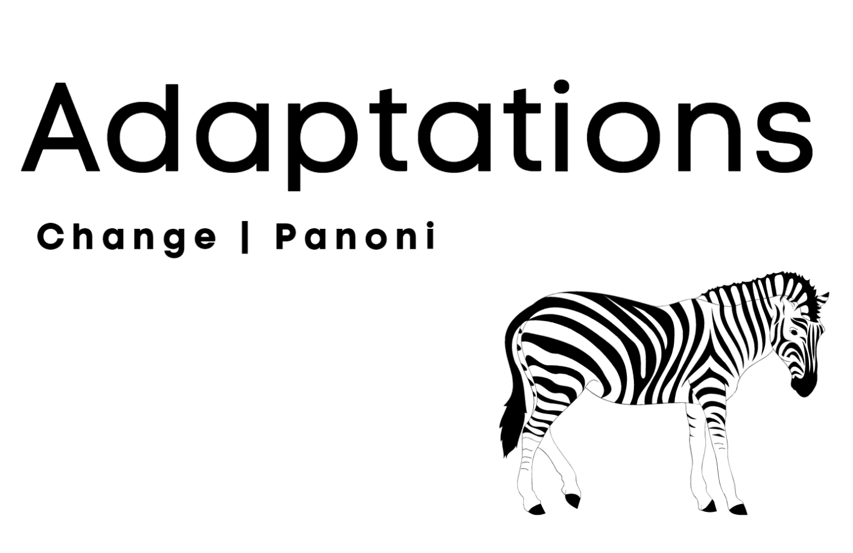

Day 1 activity 1: Inquiry getting started
Notes for teachers and whānau
Today our learners embark on new learning about adaptation to consider the bigger question ‘is change a good thing?’. Learners will be introduced to new terminology and concepts around animal adaptations. They will explore their own backyard, being present, looking carefully to really notice an ecosystem they are a part of. Learners will be exploring the learning areas of science and literacy.
Note that our Inquiry focus for today is “getting started” which includes generating questions, activating prior knowledge, and introducing the theme.

I am learning to: identify and observe elements of a thriving ecosystem
What do I need?
- 30 minutes
- Home learning book
- https://www.doc.govt.nz/globalassets/documents/getting-involved/students-and-teachers/exploring-your-local-environment.pdf
Remember to start your day right (See p. 9)

Instructions:
This activity will help you clarify what our theme of ‘change’ is all about and generate some questions from observations. Have your home learning book or digital doc ready to record your thinking and follow the sequence below carefully.
He nohonga ngātahtanga ahau me te taiāo – We live as one with our natural world

Your task:
Think:
- Who and what lives in your back yard and why?
- Take some time to observe: what do you notice in your natural environment?
- How do we use our senses to experience our environment?
- Compare near, there, and far green spaces
Choose one of these activities to do in your near green space:
- Collect, describe, display, and curate items from your back section to create a Museum of Nature
- Complete the 1–minute challenge: Record all the plants, animals, insects you see or hear in 1–minute in your section in your home learning book or digital doc.
- List the conditions plants and animals need to survive in a table like this one.
 | Plants | Animals
Conditions required for survival
Now choose one or more of these activities:
- Brainstorm birds, plants, and invertebrates that you know live in your back yard
- Identify elements of a thriving ecosystem you can observe in your backyard. Use the ‘Connections in an Ecosystem’ diagram below to notice the elements present in your backyard (Source: Department of Conservation).
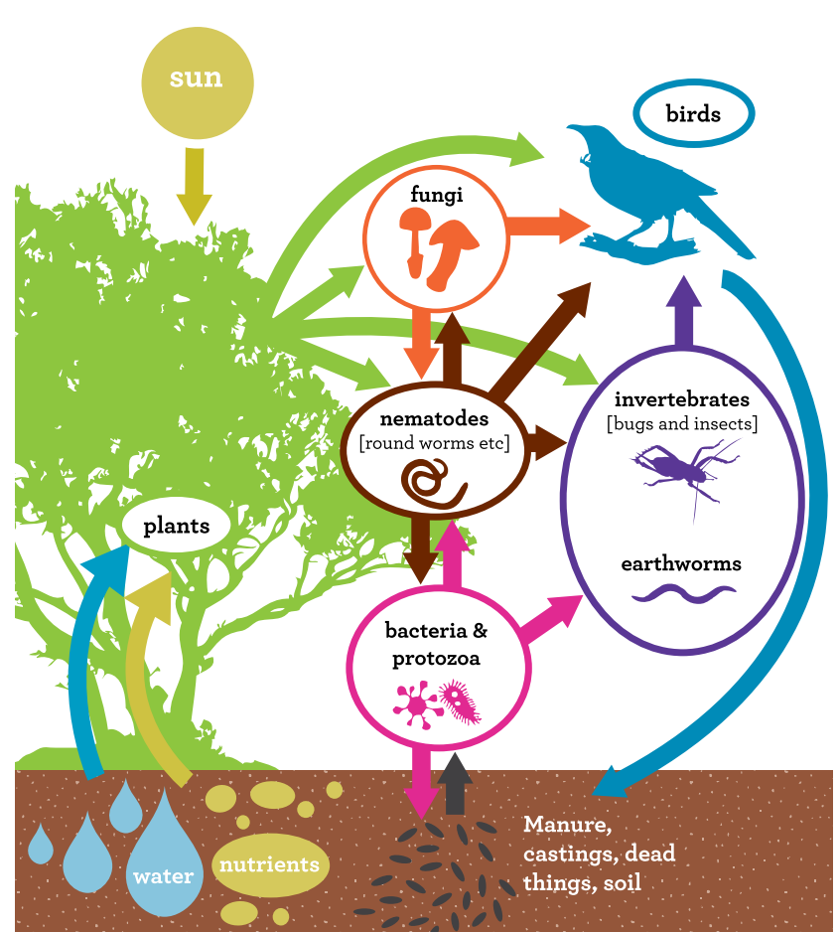
- Create a mind map to illustrate how you are connected to the plants and trees in your local environment
- Record any questions and wonderings you have about this topic in your home learning book or digital doc.
- Create a KWL chart to discover what you know about the plants, birds, and invertebrates in your section and what you would like to learn more about.

Day 1 activity 2: Create your own backyard map
Notes for teachers and whānau
In this activity learners will investigate what’s living in their backyard, diving deeper into identifying the plants and insects they discover. They will create a ‘birds eye’ view map to capture an impression of their garden, viewed from above. Learners will be required to take their time, to sense and feel their immediate or close green space, and become aware of the plants, birds, insects, and animals that inhabit this space.

I am learning to: create a visual map
What do I need?
- 30 minutes
- Grid paper
- Home learning book
Optional digital: If you have a device use this site to help identify bugs
https://www.landcareresearch.co.nz/tools-and-resources/identification/what-is-this-bug/

Instructions:
Look, listen, and explore your outdoor environment. You might discover unexpected critters in dark holes, under logs, beneath trees.
The Plant Sensory Bingo chart from the Department of Conservation can help you find and record objects in your green space. Tick the objects you find.
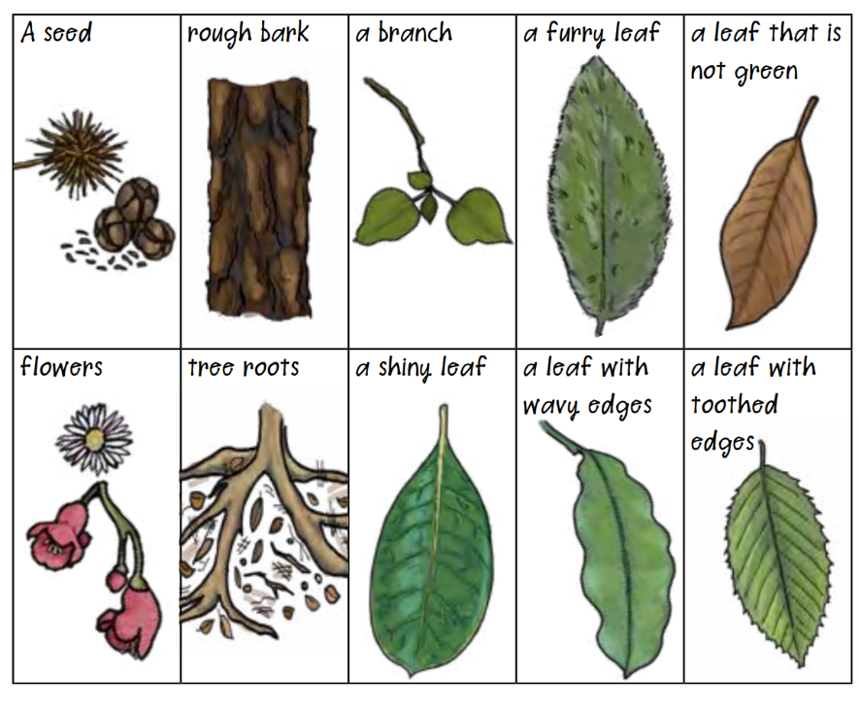
Source: https://www.doc.govt.nz/globalassets/documents/getting-involved/activities-with-children/plant-sensory-bingo.pdf

Your task:
You may be surprised what you uncover, if you take your time to observe and notice – perhaps paw prints, droppings, unusual shapes, and colours of leaves. When you have a sense of what’s living in your backyard, create a map on your grid paper, so others can locate the surprises and big landmarks in your backyard. Don’t forget to label where your discoveries are.
- Find a spot where you can see your section or the green space you have chosen. Think about a ‘birds eye view’ and try to see your space as if you are looking at it from above.
Draw a map of your green space as it would look from above.
Label all of the plants and critters you have found.
- Start with big landmarks like a shed, your house, washing line etc. Then add in all the places in your section that you love the most – your favourite sunny spot, where you like to play, even your pet!

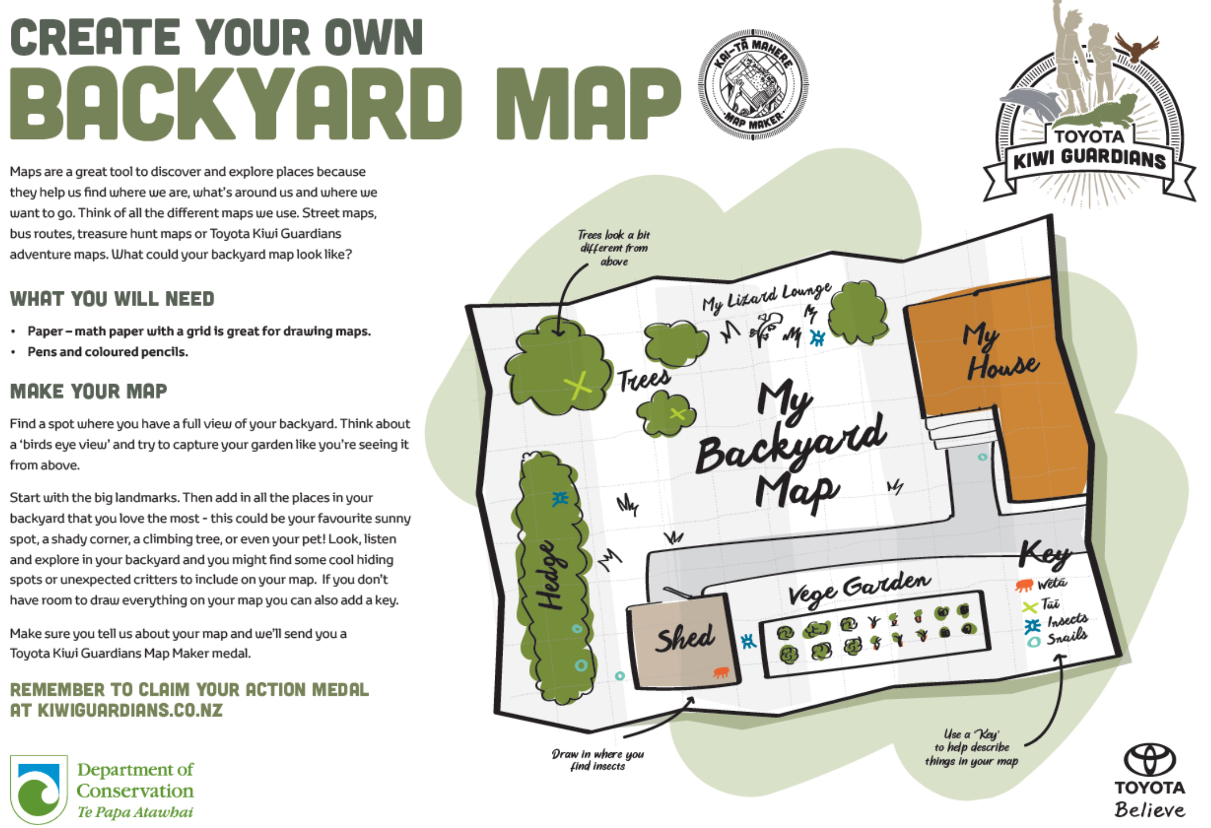
Source: https://www.doc.govt.nz/globalassets/documents/parks-and-recreation/places-to-visit/kiwi-guardians/activity-sheets/map-maker-activity-sheet.pdf

Day 1 activity 3: Plotting positions
Notes for teachers and whānau
This mathematical activity is from the Figure it Out series. Your learner may have seen this problem before, if so, encourage them to give it a go again as a way of practising interpreting simple co-ordinate maps.

I am learning to: interpret simple co-ordinate maps
What do I need?
- 30 minutes
- Look in your pack for a copy of Clara’s Cowpats, Figure it Out activity https://nzmaths.co.nz/resource/clara-s-cowpats
- Square grid paper

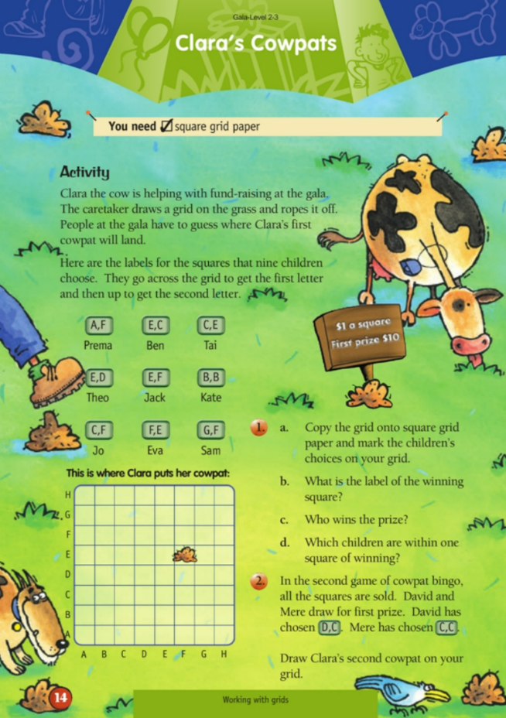
Instructions:
You will gain experience in reading and plotting positions on a grid. The activity explores the idea of using letters to explain the position of something. You will realise the order of the letters is important.

Your task:
Copy the grid onto your square grid paper.
You have two games to play in this cowpat bingo game.
Follow the instructions to complete both activity 1 and 2.

Day 1 activity 4: Literacy, ‘Timber!’
Notes for teachers and whānau
Learners are invited to read and think about how trees have been used in New Zealand and the impact people have had on the native forests. The text shares the perspectives of people involved in the timber industry and of conservationists since the arrival of European settlers. It outlines the events that occurred, the impact on indigenous forests, and the steps taken to sustain them. Learners will encounter a significant amount of vocabulary that is unfamiliar (explained in the text by words or illustrations). They would benefit from engaging in a conversation to answer their questions.

I am learning to: make connections to my knowledge about trees, identify the benefits of trees as a natural resource, and reflect on the impact of deforestation
What do I need?
- 30 minutes
- Look in your pack for School Journal Level 3 November 2011
- Home learning book

Instructions:
We are using our prior knowledge about trees and forests. The story Timber! contains a diagram which shows how much New Zealand has changed as a result of the felling of timber over the years. Use the information in the diagram to summarise the text and share your understanding with your whānau and family.

Your task:
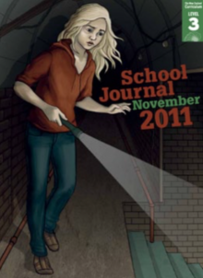
Look closely at the pictures and the title and predict what the story might be about.
Read the first paragraph and discuss with others the benefits of trees as a natural resource.
Decide if you agree with the statement in the first sentence. What information made you agree or disagree?
Identify and record key words, information, and events, in your home learning book in a shortened form. Note any dates and important events.
Reflection: What phrases did you find difficult to understand? What strategies did you use to work out their meaning? How did summarising the text help you? How did using the diagram support your understanding of the text?

Remember to do your end of day reflection and wellbeing activities (See p. 7&10)

Day 2 activity 1: Create a nature journal
Notes for teachers and whānau
Learners build on their knowledge of their outdoor environment to understand how birds, invertebrates, and other native and endemic animals, and plants are part of a healthy ecosystem.
Note that our Inquiry focus for today is “explore, investigate, and discover” which includes choosing and evaluating information, and thinking critically.

I am learning to: use my critical thinking skills and imagination to consider a town or city without green spaces.
What do I need?
- 30 minutes
- Home learning book or digital document
- Cardboard, coloured paper, sellotape, glue, coloured pens
- Create your own nature journal worksheet from the Department of Conservation
https://www.doc.govt.nz/parks-and-recreation/places-to-go/toyota-kiwi-guardians/take-action/create-a-nature-journal/

Remember to start your day right (See p. 9)

Instructions:
Brainstorm what insects, birds, plants, and other animals need to survive in a green space. List these in your home learning book or digital doc.
Now imagine a world without any green spaces in towns and cities. What if we only had buildings, roads, motorways, and other manmade things?

Your task:
Draw a Pros and Cons chart in your home learning book on a full page and list all the pros and cons or benefits and disadvantages you can think of:
Pros  Benefits Of living in a city/town with green spaces (gardens, backyards, parks, and trees) | Cons  Disadvantages of living in a city/town with no green spaces (gardens, backyards, parks, and trees)

Create a Nature Journal, to start a collection of interesting plants and natural materials you discover in your own back yard. You can add to this throughout the week. See the instructions on the next page.

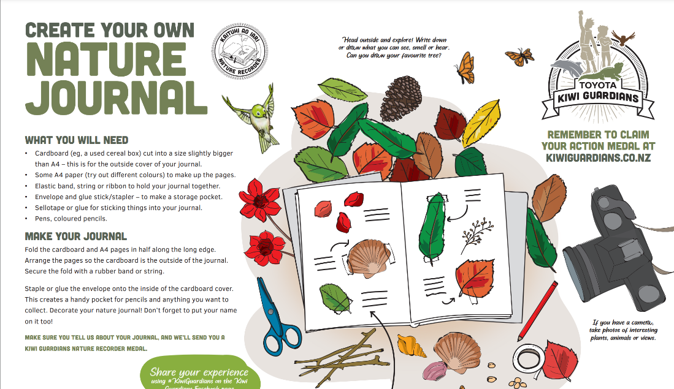
Day 2 activity 2: Maths, fencing an area
Notes for teachers and whānau
This activity is based on the perimeter and area of rectangles. As a general introduction, have your learner look at a rectangle and explain that the side lengths are given as l and w (length and width). They will need this to solve the problem below.

I am learning to: use multiplication to solve area and perimeter problems
What do I need?
- 30 minutes
- Look in your pack for a copy of Fred’s Rent-a-Fence, https://nzmaths.co.nz/sites/default/files/images/fio/FredsRent-a-Fence1.jpg
- Home learning book

Instructions:
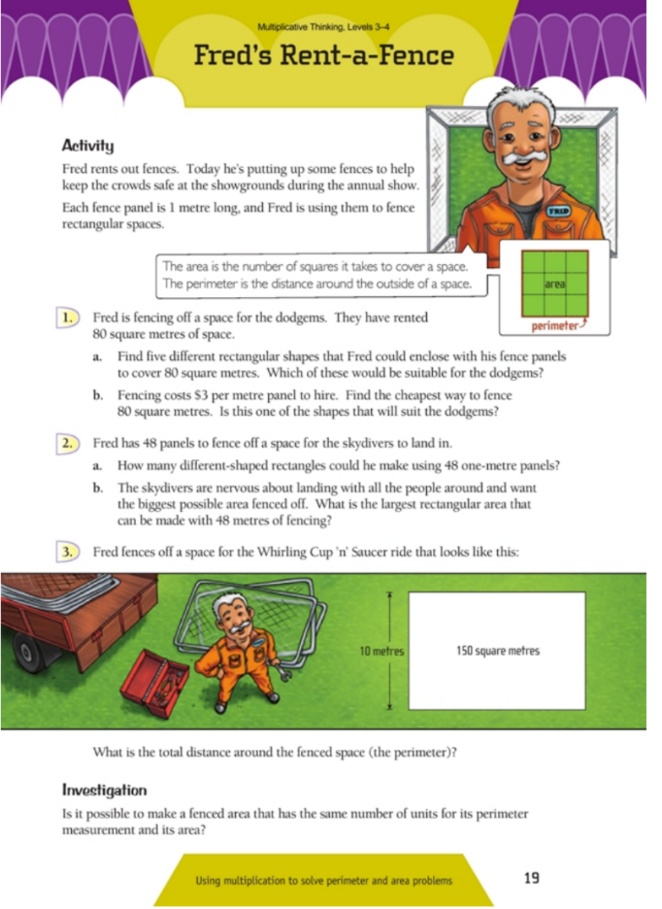
In this activity you will use multiplication strategies to solve perimeter and area problems.
The area can be found by:
area = l x w.
The perimeter can be found by:
perimeter = 2 x l + 2 x w.

Your task:

Work out how many 1 metre panels Fred will need to fence different rectangular spaces.

Extra for experts
Draw a variety of different shapes that would be able to fence in an animal of your choice that each have a perimeter of 24cm.
Which of these shapes has the largest area?
In your home learning book, show how you worked this out and explain to others how you worked this out.

Day 2 activity 3: ’We’re going on a beast hunt’
Notes for teachers and whānau
Today in science learners are collecting data and information about plant and animal pests in their green space. Gathering data and information will help them understand how healthy their green space is.

I am learning to: undertake an investigation like a scientist
What do I need?
- 30 minutes
- Activities adapted from Habitat Heroes. https://www.doc.govt.nz/globalassets/documents/getting-involved/students-and-teachers/habitat-heroes/habitat-heroes-education-resource-green-spaces.pdf
Look for the collection sheets in your pack:
- Green space Data Collection sheet 1 for 5 Minute Bird Count activity
- Green Space Data Collection Sheet 2 for Mini Beast Hunt activity
- Green Space Data Collection Sheet 3 for Plant Identification activity

Instructions:
You are going to think and act like a scientist as you carry out scientific investigations. You will learn about the biodiversity of your local green space, to help determine its health. Scientists make a hypothesis or prediction before undertaking a scientific investigation and then observe and record their observations with accuracy. From their careful observations they then make a conclusion about what they have discovered.

Your task:

Make a hypothesis / prediction about the health of the green space you are investigating and the life within it.
Now choose from one of these activities to collect accurate data and write a conclusion about what you learn.
- 5 Minute Bird Count
- Find a spot in your green space, where you can sit or stand quietly for 5 minutes.
- Set a timer or ask someone to time you.
- Record all the birds you can see or hear.
- Mark a point in the centre of your page. This is the station where you are standing. When you count the birds you see or hear draw a line from your station to each bird you see or hear.
- Write the bird name, the number if more than one, and if it was seen (S) or heard (H).
- Use data collection sheet 1 for your tally count

- Mini Beast Hunt
- Select a tree, bush, or area of leaf litter within your green space.
- Gently shake the branch/bush over a cloth or tray or scoop up some leaf litter into the cloth or tray (remove large leaves). You will notice things dropping onto the cloth/tray.
- Place the cloth on a flat piece of ground and look carefully to see what is on it. Describe or draw the insects you see and don’t forget to count the insects that you see on the data collection sheet.

- Plant Identification
- Select a site in your greenspace.
- Count and list the names of plants you find using data collection sheet 3: Plant Identification to record your hypothesis.
- Take a photo or collect a leaf sample of plants you don’t know. You can call it species X/Y/Z until you find out its name.
- Reflect: Are any of these plants weeds? Are any of them special food/medicine plants for people or animals? Which plants may attract birds? Can you find and use te reo Māori names of each?
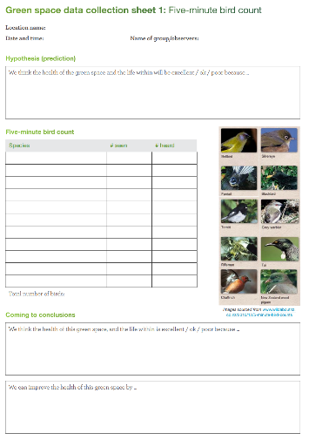
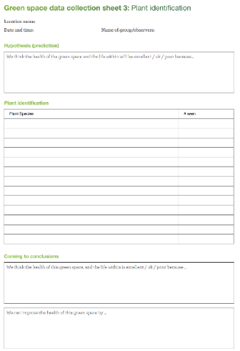
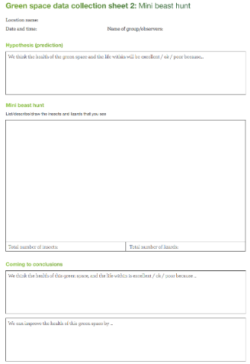
Look for the data collection sheets in your pack.

Day 2 activity 4: People have different opinions about conservation
Notes for teachers and whānau
In the story Heartbeat by Andre Ngāpō, our readers will meet a young girl and her koro as they look out over their forest, Te Rākau, listening for the heartbeat of Tāne Mahuta. The forest shelters many birds and insects, as well as many very old trees. This deceptively simple, evocative story has a strong conservation message. Through the eyes of the young girl, we learn the different opinions that other family members have of the mayor’s plan to allow developers to destroy part of the forest and build houses.

I am learning to: know how a writer uses metaphor and similes to convey feelings and make an emotional impact.
What do I need?
- 30 minutes
- Look in your pack for School Journal Level 3, June 2012, Heartbeat
- Home learning book

Instructions:
As you read this story, try to understand, and relate to the different views about conservation that the characters hold.

Your task:
Read the text and locate any similes or metaphors the writer has used to create emotional impact and convey feelings.
List any similes used for movement or facial expressions and metaphors for the body and health.
Identify any new words you read in the text. Check their meaning with whānau.
Recount a time when members of your whānau had different views about something.
Draw your family members in your home learning book and write their different views in speech bubbles.

Remember to do your end of day reflection and wellbeing activities (See p. 7&10)

Day 3 activity 1: ’A Day in the Life’
Notes for teachers and whānau
This activity will require learners to use their prior knowledge of the living world, green spaces, and the creatures that inhabit their own backyards, to write a narrative story “A Day in the Life of ...” Writers can use literary devices such as similes and metaphors to convey emotions. Our science activity will require learners to practice their developing observation skills, critical thinking, and learn to think and act as a scientist does.
Note that our Inquiry focus for today is “making meaning” which includes analysing data, organising, and sorting information, summarising, synthesising, making connections/conclusions, building deeper understandings, and thinking critically.

I am learning to: use similes and/or metaphors to describe feelings and emotions.
What do I need?
- 30 minutes
- Home learning book
- Optional digital: Life of Py story https://blog.doc.govt.nz/2020/04/29/life-of-py/
Remember to start your day right (See p. 9)

Instructions:
Using your observation skills, select a live animal, plant, or insect to observe closely. We are going to write about the day in the life of your chosen living creature or plant to describe emotions, feelings, habitat, food sources, and risks to their environment.

Your task:
Write a ‘day in the life of…’ story from the point of view of the insect, pet, or creature you found in your back yard. Consider what they would see, hear, feel. What are their concerns, or issues that might impact their lives?
Read the Life of Py story (adapted below) to spark ideas for your story.
Text adapted from Department of Conservation
https://blog.doc.govt.nz/2020/04/29/life-of-py/
In the early days
Hi! I’m Py and this is my story. It’s short as I have only been around since December 2019, and I was a bit of an egg back then! My hatch date was during the last week of January 2020, so that makes me an Aquarius, which is a good sign for an ocean dwelling seabird. I was laid and hatched on Motuora Island in the Hauraki Gulf Marine Park/Ko te Pātaka kai o Tīkapa Moana. Mum and Dad were re-housed here as chicks from Red Mercury Island in 2013 as part of a new colony initiative to protect our species. This is because there aren’t that many of us (Pycroft’s Petrels) and it is thought that we only breed on small offshore islands in New Zealand. A whopping 75% of us come from Red Mercury Island!

In the first wee while Mum or Dad were at home, but never together. Dad said it was because I ate too much, and they needed to go further offshore to find fish and small squid for me. Especially as humans keep taking all the food and not leaving stuff for everyone else. They bring in leaves for me to play with that smell salty and exotic.
The awkward tweens
I have playmates like cockroaches and beetles and sometimes copper skinks which come to say “hi”. I know it’s not friendly behaviour, but sometimes I eat them. Mostly though, I just dream of my next meal. Dinner is always takeaways, mainly regurgitated fish and squid slurry that Mum or Dad bring, an hour or so after sunset. But now that I’m a teenager I don’t get fed every second night anymore and sometimes it can take AGES between meals. Apparently, they’re off flying hundreds or even thousands of kilometres each trip. They tell me not to leave the burrow and as there are scary things out there that might eat me. Mostly I spend time preening and being grumpy when it just doesn’t turn out right.
The talk
It’s early April and Dad comes in and stays the whole day. He mumbles, “your Mum asked me to have a word with you”.
DAD: “It’s time you stretched your wings and legs. It’s ok to go outside the burrow and walk and flap around a bit, just at night though. Meet the other kids. The chick at no. 22 has been out flapping about for a few days now. But don’t take any flying advice from kiwi and keep a lookout for ruru as they ate one of our other chicks while it was walking out last year. Practise climbing one of the big trees.”
PY: “That’s awesome Dad, thanks! But why do I need to practise climbing trees?”
DAD: “Because we climb up to get above the branches so we can launch into the air and fly away. We don’t climb back down though – we just sort of crash land through the vegetation. I suggest you aim for the soft leafy stuff. And Junior, this is your last feed. Your mum has already left, and I won’t be coming back, this will probably be the last time I see you. You need to slim down and build up those muscles so you can leave home as well.”
PY: “But how do I fly, and where do I go, and where is the supermarket?”
DAD: “You will just know. Once you launch yourself into the air, flap like crazy. I found it helped to leave on a day with some sea breeze around. Just circle around and head North. The sea is the supermarket, it is very big and all around you. You’ll be out at sea for around 2–3 years but remember that this is your home and when the time comes and the urge takes you, come back here with the love of your life to make your Mum and I grandparents.”
Well, that left me wishing I had paid more attention during home-schooling classes. Like what is a tree, what is the sea, and where is the North Pacific Ocean, and what shelf do I find the squid and fish on…? Oh yes, hang on, I recall it was “over deep water and beyond the continental shelf.” HEY, WAIT COME BACK I PROMISE I WILL LISTEN THIS TIME…..
By Vonny Sprey, resident DOC ranger on Motuora Island

Day 3 activity 2: Under the ground with earthworms
Notes for teachers and whānau
Learners will consider adaptation as an evolutionary concept, exploring how creatures such as the earthworm adapt to their environment. Although earthworms are classified as animals, their bodies are quite different to animals that live above the ground. Learners will view a video about some of the interesting physical characteristics of earthworms. Learners may require support to enter and participate in the optional activity, the ‘Great Earthworm Survey’

I am learning to: explain how earthworms have adapted to their environment by observing their external features
What do I need?
- 30 minutes
Texts adapted courtesy of the Science Learning Hub
https://www.sciencelearn.org.nz/resources/28-observing-earthworms
- Home learning book
- Earthworms – ideally, a variety of species
- Small jars with lids
- Newsprint, paper towels
- Magnifying glass
- Plastic forceps or tongs, digital camera, digital microscope (optional)
- view the video or read the transcript below: https://www.sciencelearn.org.nz/resources/17-earthworm-adaptations

Instructions:
View the video or read the transcript.
Movement
Earthworms are adapted for life underground. Their streamlined shape and no skeleton allows them to burrow through soil. The earthworm’s body is divided into segments, each with a number of setae or very small bristles that help them grip the soil as they move.
An earthworm uses two different sets of muscles to move. Circular muscles loop around each segment, and longitudinal muscles run along the length of the body. When the circular muscles contract, the earthworm stretches, becoming longer and thinner. The earthworm uses its setae to anchor the front of its body in the soil. Now the longitudinal muscles contract and the earthworm becomes shorter and wider, or it bends from one side to the other, pulling the body forward. The earthworm withdraws the front setae and uses its rear setae to anchor itself at the back. The earthworm uses its circular muscles to lengthen and push itself forward again.
Senses
Earthworms have a head, but no eyes, nose, or ears. The earthworms’ skin provides some of the services we normally associate with our own sense organs. Light-sensitive cells are scattered in their outer skin, mainly at the ends of their bodies, allowing earthworms to detect light and changes in light intensity. Earthworms don’t use a nose, mouth, or lungs to breathe like us. Instead they use oxygen that is dissolved in the moisture on their skin and from the surrounding environment. Earthworms cannot hear but they can sense vibrations.
Reproduction
Mature earthworms have a clitellum or a saddle. The size, shape, colour, and position of the clitellum varies between species. The clitellum means the earthworm is an adult and is ready to mate and lay eggs. Earthworms reproduce by forming a small egg sac – called a cocoon – at the clitellum. The cocoon slides off of the earthworm’s body and is deposited in the soil.

Your task:
Read notes / background information about earthworms.
Hints for finding, housing, and handling earthworms:
Keep the earthworms in their usual medium (soil or compost) until needed. Some earthworm species can be stored and observed in jars of cool clean water. Earthworms breathe through their skin so they do not drown, but they will die once they deplete the oxygen in the water. Change the water daily. Earthworms lose condition after a few days, so limit the time they are kept in the jars. The introduced soil-dwelling species grey worm (A. calignosa), dung worm (L. rubellus), nightcrawler (L. terrestris), blackhead worm (A. longa) and yellow tail worm (O. cyaneum) will survive in water. However, tiger worms (Eisenia fetida) and native species like O. multiporus should not be kept in water for longer than it takes to clean them. Earthworms move differently in water so make sure you also observe them on a flat surface.
Label the containers with the species’ names if more than one type is available. This will help ensure earthworms are returned to the correct containers. Label the jars as well if observing earthworms in water. Just before the observation begins, use flat tongs or your fingers to remove earthworms from the soil and dip them in water to remove soil or compost. Dry on a paper towel if you wish. Lay the earthworms on newsprint. Keep the earthworms out of direct sunlight. Their skin needs to be kept moist so only have them out for short periods at a time. Earthworms can be gently handled. If you run your fingers on the underside of some earthworms (nightcrawlers, in particular), you might feel the setae even if you can’t see them.
Locate some earthworms to observe closely. Jot down notes about what you observe in a table like this:
Earthworm sample | My observations
1
2
3
Optional digital:
Participate in the Citizen Science project: https://www.sciencelearn.org.nz/citizen_science
Join the Great Kiwi Earthworm Survey: www.sciencelearn.org.nz/resources/2926-the-great-kiwi-earthworm-survey

Day 3 activity 3: Earthworms respond to a rumble
Notes for teachers and whānau
This activity involves an investigation so the learners can determine if earthworms respond to vibrations. Your learner may require some guidance for this.

I am learning to: investigate whether there is any evidence that earthworms can respond to vibrations in the ground.
What do I need?
- 30 minutes
- Support of an adult
- A garden fork and an area where worms may be living
Text adapted courtesy of the Science Learning Hub
https://www.sciencelearn.org.nz/resources/577-catching-worms-using-ground-sounds

Instructions:
Read the Introduction/background notes to investigate if there is any evidence that earthworms can respond to vibrations in the ground. Seek a helpful adult and a garden fork to undertake a simple scientific experiment.
Read the Introduction /background notes from the Science Learning Hub below.
In the 1960s, Dutch scientist Nikolaas Tinbergen reported seeing seagulls ‘paddling’ or stamping and noted that this behaviour brought earthworms to the surface. In 1881, the famous evolutionary scientist Charles Darwin wrote about earthworms coming to the surface in response to vibrations.
There are people in the Southwestern United States who catch worms for a living and sell them to fishers for bait. They are called grunters. They go to a recently cleared forest area and drive a stake about 30cm into the ground. Then they rub the top of the stake with a long piece of metal (11 x 7cm) and wait for the worms to emerge.
Scientists have tested to see if worm ‘grunting’ entices worms out of the ground. They were able to measure the best frequency for getting worms to surface and found that sound below 500Hz made the worms react. At these frequencies, worms started to emerge after 1–2 minutes.
But why do earthworms come to the surface? One hypothesis is that they move to the surface when their burrows are flooded, but scientists have shown that earthworms can cope with high levels of flooding.
Darwin suggested that earthworms were escaping moles whose main source of food are earthworms – moles are noisy animals and make grunting sounds. Recent research has shown that earthworms do crawl away from moles and the best place to escape is the surface where moles don’t go. We don’t have moles in New Zealand, and it would be interesting to see if our worms carry this memory of a ‘predator’ and respond by leaving the ground.
There are still unanswered questions about earthworms and sound in the ground. Scientists may have found out that worms can respond to sound, but they don’t know how. Scientists presume that they ‘hear’ the vibrations through their skin – just the way some deaf people can hear sounds through their skin surface. (There is a famous timpanist called Dame Evelyn Glennie who plays drums in the English National Orchestra. She is deaf but is able to use her body to listen to the orchestra playing.)
You are not going to play an orchestra when you do your experiment but instead produce some simple sounds that might make earthworms respond.

Your task:
Read the questions before starting the experiment
- Do our native worms respond to ground sound?
- What type of vibration makes earthworms surface?
- Does the wetness of the soil have any influence on their surfacing response?
- What do earthworms do once they have surfaced, and the vibrations have stopped?
- What birds carry out foot paddling/foot stomping? Where do they do it? What time of the day does this happen? Is it true that the early bird catches the worm?

With the help of an adult:
- Choose a place where worms may be living and set up your own grunter/ vibrator by digging a garden fork into the ground.
- Vibrate the garden fork and wait for the worms to emerge.
Record responses to these questions in your home learning book or digital document after your experiment.

Day 3 activity 4: How many animals in the paddock?
Notes for teachers and whānau
In the mathematical word problem today, the learner will use the multiplication facts of 2 and 4 to solve the problem. The problem also gives students the opportunity to combine the operations of addition and subtraction. As there are many ways to solve this problem it is accessible to a range of learners.

I am learning to: use simple additive fractions with whole numbers and fractions
What do I need?
- 30 minutes
- Home learning book

Instructions:
You are going to solve a story problem using multiplication facts of 2 and 4. You will need to devise and use problem solving strategies (guess and check, guess and improve, act it out, draw a picture). Good luck!

Your task:
Solve the problem in the box below:
- Think about: what would happen if you "turned" one of the pigs into a duck? How many animals? would there be now? How many legs?
- Brainstorm different ways that you can solve the problem (draw, use equipment, guess...)
- Solve the problem.
- Share the solutions and the strategies that you used with someone in your whānau.
Jennie the old sheep dog is lazing around in the paddock near the house.
She counts the number of animals in the paddock.
There are 11 of them – pigs and ducks.
Then she counts the legs. She sees 28 legs.
How many ducks are there?

Extra for Experts: Can you write and solve a new problem by changing the numbers of animals and legs? Work out the answer and then challenge someone in your whānau to work it out.

Remember to do your end of day reflection and wellbeing activities (See p. 7&10)
Day 4 activity 1: If the wētā could talk
Notes for teachers and whānau
Learners will discover one endemic species – the Mountain Stone wētā which has made extraordinary adaptations to its changing environment over a long period.
Note that today our Inquiry focus is “going further, deeper”. This may include promoting opportunities to engage further and dive deeper through discussions, provocations, exploring further contexts, taking action, or thinking critically and drawing conclusions.

I am learning to: convey a message in my story using dialogue
What do I need?
- 30 minutes
- Home learning book
Optional digital:
- Insect Returns from the Dead https://www.youtube.com/watch?v=HtDIqicyDQw
- Using speech marks https://www.youtube.com/watch?v=s8a19kuole0&t=107s
Remember to start your day right (See p. 9)

Instructions:
You are going to think about why the wētā needed to adapt to new environmental conditions. Consider the behaviours the wētā needed to change and if any structural changes were made by the wētā in order for it to adapt to the new harsh environment.
You will need to imagine how the wētā as the main character is feeling about change and the adaptations required. You will need to use your imagination and try using dialogue in your writing, a literary device used also by traditional storytellers. Your wētā can tell the story using their voice. What do you think your wētā might say?

Your task:
Watch the video Insect returns from the dead or read the transcript below.
Transcript: Insect Returns from The Dead | Wild New Zealand | BBC Earth
To survive here you have to be prepared to die here. But the sun can return as quickly as the storm arrived and a rise of just a few degrees is enough to spark a thaw even underground. Frozen solid is a mountain stone wētā. It has the most extraordinary survival technique of all. The ability to come back from the dead. Only in the specialised filming chamber can we capture its extraordinary talent.
The wētā has developed special proteins which prevent ice crystals from forming inside itself a remarkable trick for a creature whose ancestors once lived in prehistoric warm wet forests. When New Zealand's mountains grew up beneath the wētā around five million years ago they were forced to come up with this incredible ability to survive near lethal temperatures.
Defrosting uses up a lot of energy, so mountain snow berries are welcome sight. The wētā needs to stock up while it can, the next Antarctic storm could be the return of winter. The wētā can tolerate over 80% of its body freezing solid and can do so day in and day out for weeks at a time.
Nowhere else in New Zealand does life go to such extremes to survive.

Write a story where the wētā conveys an important message about adapting to his environment. Use dialogue to convey a message. This is a common method used by storytellers in pakiwaitara (the transmitting of traditional knowledge).
- You might need to look at a book and work out how to use the punctuation for when a person speaks in a story. Does each speaker start on a new line? Where do you put the quotation marks (“”)? Be a problem solver and try to work out the rules from looking at another story. You could also watch the YouTube video linked in the ‘what do I need?’ section.
Or
Write a story where your main character changes: e.g. visible to invisible to survive, solid to liquid.
Or
Imagine and write about if ancient creatures thawed from under the Antarctica ice. How might changing matter help animals, plants and invertebrate survive?

Day 4 activity 2: Using a traditional story device to explain a key idea
Notes for teachers and whānau
“Namu and Waeroa” is a pakiwaitara – a traditional Māori story that offers an explanation for natural phenomena or for why something is the way it is. Some pakiwaitara are located in more than one iwi, and they often have subtle differences that reflect their local environments. They often impart tikanga or cultural understandings and may also warn about the consequences of not adhering to tikanga.

I am learning about pakiwaitara and exploring the cultural concepts in the story
What do I need?
- 30 minutes
- Look in your pack for School Journal level 2 May 2012 or access the audio file:
https://instructionalseries.tki.org.nz/content/download/28287/297303/file/Namu%20and%20Waeroa.mp3

Instructions:
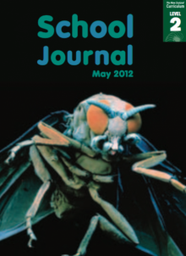
Traditional stories often use metaphors to describe events.
Read the story Namu and Waeroa to learn about Pakiwaitara.
Or listen to the audio while you read.

Your task:
Namu’s words show the reader his and his people’s courage (“we fought bravely”) and their respect for their enemies (“we were no match for the children of Tūmatauenga”).
Namu uses different expressions to describe a defeat in battle: in many pakiwaitara, the storyteller uses a poetic-sounding metaphor to express that many have died. The metaphor “the drifting waters and the mournful wind” helps me to build a picture in my mind of the sad and lonely survivors after so many of their tribe had been killed. By using these words, the writer helps me make links to similar stories I’ve heard.
Create a graphic text or comic based on the story.

Day 4 activity 3: Maths – too much waste?
Notes for teachers and whānau
Learners will explore fractions and percentages in everyday use by comparing statements with the features of simple data displays from statistical investigations.
Learners explore packaging and over-packaging and the reasons for them, including food safety, hygiene, preservation, marketing, price discrimination, tamper-proofing, excluding insects, and ease of transportation.

I am learning to: collect data and interpret graphs
What do I need?
- 30 minutes
- Look in your pack for a copy of All that Packaging! https://nzmaths.co.nz/sites/default/files/AllThatPackaging.pdf
- Home learning book

Instructions:
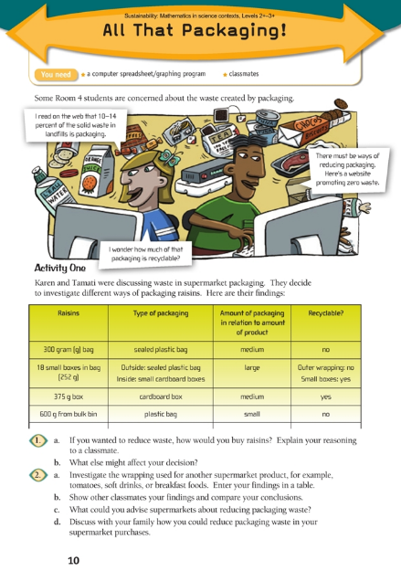
Think about waste and the impact it can have on the environment. Consider alternative methods of packaging food and share your ideas with friends and whānau.
In this activity you will be practicing data collection and graph interpretation. Enter your findings in a table in your home learning book.

Your task:

Investigate one or more everyday supermarket items in your pantry, examine how they are wrapped and record a table of your findings.
Record a statement of recommendation for the supermarket.

Day 4 activity 4: Technology, design a wētā house
Notes for teachers and whānau
NOTE: This is an optional activity that can only be done with adult supervision.
This practical activity requires learners to build using materials like an old log, a saw, and drill. It might not be practical for all learners, and they will need an adult to help. This activity helps learners take action to conserve and protect an endemic species.

I am learning to: protect wētā from predators by creating a suitable habitat
What do I need?
- Materials: small log, plastic or iron for roof, string or wire
- Tools: saw, chisel, drill, hammer, and nails.
Optional digital:
- (Activity source) https://www.doc.govt.nz/parks-and-recreation/places-to-go/toyota-kiwi-guardians/take-action/build-a-weta-motel/
- https://www.sciencelearn.org.nz/videos/1816- wētā-house-design-process
- https://www.youtube.com/watch?v=9408Fx1ohiw

Instructions:
Today you are going to design and make a wētā hotel.

Your task:
There are more than 70 species of wētā, and they only exist in New Zealand. Many species are endangered so it’s very important we look after them. A wētā motel will help protect them from being eaten by predators like rats, cats, and hedgehogs.
Build your wētā motel
Grab your adult helper and work together to build your hotel.
- Saw a small log in half.
- Chisel out some rooms for the wētā
- Drill an entrance tunnel. A tunnel 18mm or slightly smaller is best to stop mice getting in (10 mm is too small). The tunnel should be quite long and sloping down from the top or the side.
- Nail the two halves of the log together and then nail on a roof.
- Hang or tie the motel in a tree in a shady spot at about eye level, out of reach of rats or mice.
Optional digital extras:
- Learn about the wētā and label its parts using the interactive on Science Learning Hub https://www.sciencelearn.org.nz/resources/2843-label-the-insect.
- Want a 5-star upgrade for your wētā, or some handy hints on making your motel? Go to www.kiwiguardians.co.nz
Remember to do your end of day reflection and wellbeing activities (See p. 7&10)

Day 5 activity 1: Pictorial mapping of perspectives
Notes for teachers and whānau
Learners will become aware of different perspectives as they interview elders and whānau about changes to the local land. They will explore the ‘Ake Ake’ model and map their local environment using drawings to represent the past, present and future of the land.
Note that today our Inquiry focus is “present – share learning about the theme” which includes thinking about who the audience is and considering different ways of communicating learning for example, presentation, video, poster, etc.

I am learning to: understand the past, present and future uses of local land by using the ‘Ake Ake’ tool
What do I need?
- 30 minutes
- Home learning book or large chart paper or digital doc
- Coloured pens or felts
Text courtesy of the Science Learning Hub https://www.sciencelearn.org.nz/resources/438-model-for-identifying-cultural-indicators
Remember to start your day right (See p. 9)

Instructions:
When we seek to ensure our green spaces are healthy environments for plants, insects, birds, and animals that inhabit them, it’s important to consider the perspectives of people, and the history of the land or whenua.
Māori place great importance on the stories, ideas, and opinions of their elders particularly about the use of their whenua. Today, we will use a simple tool, ‘Ake Ake’ which is a way to create a map of elders’ perspectives/ opinions, views as they draw a picture connected to our local environment.

Your task
View the video to understand the Ake Ake model or read the text on the next page.
Interview your elders, parents, relatives, or other adults about how your local land is currently used and how it might be used in the future.
Draw what you hear about the local land in the past, now, and what the future might hold. You might like to draw their ideas on a large sheet of paper.
Share your new learning about how different people hold different opinions, knowledge, and hopes for the whenua with your whānau

The Ake Ake model (adapted from the Science Learning Hub)
The Ake Ake model is a pictorial cultural mapping of individual perspectives. Perspectives are considered across five components: environmental, economic, cultural, social, and health and wellbeing. The model is produced in three steps:
- Iwi learn about how the people of the river lived in the past – with reference to each of the five components.
- Iwi identify the present situation – with reference to each of the five components.
- Iwi draw what they want the future to look like for iwi in 50 years’ time.
Researcher Lorraine Dixon developed this model for iwi participation and whānau enjoy it because they’re contributing towards their future and the future of their children.

Working through the steps
The Ake Ake model includes a range of age groups – kaumātua, rangatahi and kōhanga. Firstly, kaumātua visit groups and talk about the past – for example, how the river ran clear and was the source of drinking water. The people lived off the river – tuna filled the boats; whitebait was plentiful, and the watercress was healthy and edible. The people were healthy because they ate healthy food from the river. The river was their transport. People went to the river for healing from illness. The river was the central focus of the people. Rangatahi were taught the ways of their people by kaumātua. This knowledge encompassed the river as the people’s place to live and socialise, their means of support, their health and spiritual wellbeing. Stories are handed down about how people could be identified by their distinctive smell because of the amount of time they spent in their part of the river or lake.
Secondly, the group discusses the present condition of the people and the river. Cultural indicators are identified across the five components.
Finally, the group are asked to make a pictorial representation of the area with the river and marae as they would like to see it in 50 years’ time. Common themes in the pictures are identified for future restoration work. The drawings are then archived to depict iwi thinking for future generations.

Common themes
The Ake Ake model helps iwi to set goals and have aspirations for the future. Common themes emerging include:
- restoring earlier cultural values and generational knowledge and transferring that knowledge to the next generation
- being socially connected to the river – having communal activities around the river to restore a feeling of being one people
- restoring their role as kaitiaki caring for and protecting the environment – this includes working collaboratively with scientists to restore the river and taonga species
- using the natural resources to become economically sustainable.
This model highlights the values of the past and present and helps to maintain values for the future. It combines science and culture in a holistic way.

Day 5 activity 2: An apple a day
Notes for teachers and whānau
Today’s learning in mathematics uses arrays. The array view is probably the most powerful visual model for multiplication. It has important connections to measuring area and volume, and to finding outcomes in probability. Arrays progress in sophistication:
i. One–by–one counting
ii. Skip counting of rows or columns, for example, 4, 8, 12, …
iii. Equal additions, for example, 4 + 4 + 4 + 4 + 4 + 4
iv. Use of multiplication facts, for example, 6 x 4.
Learners will practice using known basic multiplication facts, those that range from 0 x 0 = 0 to 9 x 9 = 81. The division basic facts are the inverse of the multiplication facts. So 6 x 4 = 24, 4 x 6 = 24, 24 ÷ 6 = 4 and 24 ÷ 4 = 6 are all basic facts.

I am learning to: use arrays to solve multiplication facts
What do I need?
- 30 minutes
- Look in your pack for a copy of An apple a day https://nzmaths.co.nz/sites/default/files/AnAppleaDay.pdf

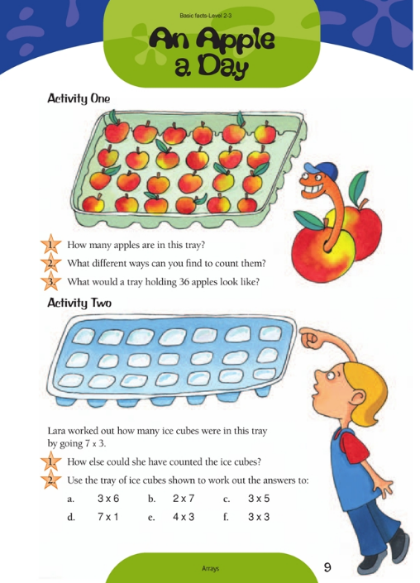
Instructions:
Use your basic multiplication and division facts to answer the questions in an efficient way. It’s a great idea to regularly practice using your basic multiplication and division facts, using arrays.

Your task:
Locate the ‘Apple a Day’ worksheet in your pack and complete the activities.

Day 5 activity 3: Science, Kaupapa Kererū
Notes for teachers and whānau
Although the kererū is a common bird, its numbers are actually declining. The article describes an initiative by Ngāi Tahu that is helping the threatened kererū population on Banks Peninsula. Learners will gain an awareness of the historical and contemporary importance of kererū from environmental and cultural perspectives.

I am learning to: Apply my knowledge from my science inquiry to understand that living things respond to changes in the environment
What do I need?
- 30 minutes
- Look in your pack for a copy of Kaupapa Kererū.
- A device to create a presentation or paper

Instructions:
Use the illustrations, photographs, text boxes, diagrams, maps, charts, and graphs to clarify and extend your understanding as you prepare a presentation on paper or a digital slide presentation to explain to friends and family why kererū are threatened and how they adapt to changes in their environment. Conclude your presentation with ideas that people can act on to protect Kereru from threat of extinction.

Your task:
Skim read the article Kaupapa Kererū.
Examine the photographs and the text.
Record the following in your home learning book or digital doc:
- Make predictions about the text.
- Explore the importance of Kererū in the past and the present to
- Identify the risks for the kererū and what we can do to help them survive.

Day 5 activity 4: Sharing my learning
Notes for teachers and whānau
As learners develop in the middle primary years, their ability to represent what they observe becomes increasingly sophisticated. They benefit from multiple opportunities to draw and express their ideas through the visual arts. This activity requires the learner to observe a living creature closely and use increasingly sophisticated drawing skills including shading, perspective, anatomy, and colour theory. Learners will benefit from supportive adults, noticing and affirming the choices the artist makes.

I am learning to: use basic drawing skills of perspective, shading and anatomy composition
What do I need?
- 30 minutes
- Pencil and paper

Instructions:
You have closely observed birds, insects, or animals including pets in your green space this week. Use your observations, notes, and thinking to draw a living creature to share your learning with others. Think about how your drawing might tell a story.
This activity asks you to think and act like an artist: observe closely, practice using drawing skills and try to extend your skill range.

Your task:
Draw a pencil observational drawing of a living creature using techniques of shading, perspective, and an awareness of the creature’s anatomy. Consider the environment as a possible background to your creature.
Self–Assess using the checklist below. Put a tick next to the things that you can see in your picture. Put more than 1 tick if you think you have done it really successfully. Put a star next to one of the criteria that you would like to focus on in your next drawing. Invite someone to peer assess your drawing when you share your art with others.
Success criteria | How did I do?
I used colour and shading to show feelings
I have included limbs and facial features on my creature
I have placed my creature in its habitat
I have used natural colours I would find in nature
I have clearly defined my creature – you can tell what it is!
I have used a variety of shading styles both light and dark
I have shown near and far distances in my drawing by using smaller and bigger details to show perspective.
Remember to do your end of day reflection and wellbeing activities (See p. 7&10)

Context 2: How humans impact the environment

The next five days investigate the theme of change by looking at how humans can impact the environment.

Day 6 activity 1: Inquiry getting started – We’ve lived here for millions of years
Notes for teachers and whānau
Aotearoa New Zealand is home to many endemic plants and animals. This week’s learning supports learners to know how humans can impact the environment.
They will learn what an introduced predator is, and why they are a problem for New Zealand. With 58 species of native birds that have become extinct, and many more species threatened, learners will develop an understanding how they can help protect threatened species and enhance the biodiversity in their local environment. Learners will discover the work of a community, ‘Mahi Kiwi’ a conservation project led by a group of Wellingtonians committed to restoring a sustainable population of kiwi to Wellington. Their aim is to share their green spaces with our national taonga, the kiwi. Individuals and small groups in communities are making a difference to protect endemic and native species from predators.
Note that our Inquiry focus for today is “getting started” which includes generating questions, activating prior knowledge, and introducing the theme.

I am learning to: think deeply about the impact of introduced species on native species
What do I need?
- 30 minutes
- Home learning book
- Optional digital:
https://predatorfreenz.org/the-big-picture/large-predator-control-projects/key-projects/wellington-projects/
https://www.capitalkiwi.co.nz/
Remember to start your day right (See p.9)

Instructions: Predictions and wonderings
Talk with others about which species are native and endemic to Aotearoa New Zealand and how long they have lived in our country. Your conversations will produce many questions and wonderings about our extinct and threatened species, creatures who have lived on these islands since prehistoric times. You may learn about animals who were introduced and are now predators to our endemic/native species.
If you have access to a device, you can view a video or read about a group of people in Wellington committed to making their green spaces ‘predator free’ with the aim of bringing kiwi into their green spaces. Working together as a community, they are making an impact, catching lots of rats with back yard trapping devices, resulting in lots of tuis warbling in gardens and green spaces around Wellington.

Before you start today’s literacy work, warm up with the vocabulary activity:
Match the key words with their meaning. Check your answers with an adult or a dictionary. The first one has been done for you.
Predator | Living things competing with each other for resources
Threat | Animals that have evolved in New Zealand and are only found here
Endemic | Something that can harm or kill
Introduced | An animal that naturally preys on something else
Competition (in biology) | Living things that are not native to New Zealand and have been brought to an environment where they don’t occur naturally.

Your task:
Record your questions and wonderings about introduced predators and threats to our green spaces in your home learning book.
Select your favourite endemic bird or animal and brainstorm as many reasons why it would be a great idea to build and restore a large population of a threatened species to your town or city’s green spaces.

Optional online:
View video of a mission to make Wellington ‘predator free’ https://predatorfreenz.org/the-big-picture/large-predator-control-projects/key-projects/wellington-projects/ or
Read about the project ‘Capital Kiwi’ on their website https://www.capitalkiwi.co.nz/

Optional extra:
Tony Ryan’s Thinkers Keys are tools designed to help us think about things differently. Inventors and innovators often come up with their new ideas and changes by thinking in ways that other people haven’t done before.
- Choose one or two activities each day from the Threatened Species Thinkers Keys on the next page.
- Record your responses to the keys in your home learning book

The Reverse key  List the names of 10 different animals that are NOT endangered | The What if? key  What if there were no introduced predators in New Zealand? Describe how the green spaces would look and sound in a letter to a friend. | The Disadvantage key  Describe what would be some disadvantages of being a threatened animal or species? | The Combination key  Combine the features of an introduced animal and a native animal. Draw and label the animal. | The Brick Wall key  What are the alternatives to keeping threatened animals in zoos?
The BAR key  Think about a threatened species enclosure. Can you:  make it bigger  add something to it  replace something on it. | The Variations key  Suggest ways to help threatened species | The Inventions key  Invent a way to protect the last remaining kakapo by using:  - a pack of cards  - a sewing machine  - a squash ball | The Prediction key  Predict 5 NZ animals that  will be extinct within 30 years.  Give a reason for each answer. | The Alternative key  List some ways to help  threatened species without spending money
The Ridiculous key  What would happen if every threatened animal had to live in zoos? | The Commonality key  Describe the benefits for a community when they share a common goal like the community of Karori Wellington who experienced commonality with the ‘Capital Kiwi’ project. | The Question key  The answer is  “EXTINCTION”.  Write 5 different questions. | The Brainstorming key  Brainstorm some effects of bringing two extinct Moa to the Zoo | The Alphabet key  Do an A to Z of threatened species

Day 6 activity 2: Coin shake up
Notes for teachers and whānau
Learners will play a simple game in mathematics today, that will help them begin to form an intuitive sense of what chance and possibilities mean. Theoretically, when two coins are tossed the chances for each outcome are 1/2 although with a small number or trials you probably won’t get that exactly. Something the learner may not notice when they first play the game is that a same side toss can be made in two ways (heads – heads or tails – tails) as can a different side.

I am learning to: predict the likelihood of an event based on data collected; use a systemic approach to find all possible outcomes
What do I need?
- 30 minutes
- 4 coins between two people
- Home learning book

Instructions:
This is a game for pairs. Find a partner and take turns, one tossing the coins while the other guesses if the coins will land with the same side up or different sides up. You will need to draw a simple table in your home learning book to record the results of each guess as same or different. As you play observe what is happening to the totals.

Your task:
Players take turns, one tossing the coins while the other guesses whether the coins will land with the same side up or different sides up.
Players record the results of each guess as same or different
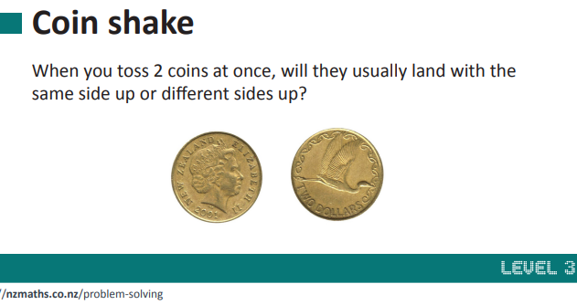
As the game is being played:
Observe what is happening to the totals.
Toss the coins 20 times
Write a statement on the results
Repeat this process after 50 tosses
Answer these questions:
- What can you say about the totals?
- Does one way of landing seem to come up more often than the other?
- Is it better to guess same or different?
- Why are there different totals?
- What are the different ways the coins could land?
Extra for experts: Repeat the game with 3 coins

Day 6 activity 3: Coming to conclusions about green spaces
Notes for teachers and whānau
Today learners will explore that New Zealand’s plants, animals, and ecosystems are unique and special. Green space ecosystems become threatened, damaged, or lost due to increased human use. Humans can impact the environment in negative ways. The loss and damage of ecosystems over time has caused many native animals and plants to become threatened or endangered. Planting, creating habitat, or controlling pests and weeds will increase biodiversity and attract more native animals to your area, improving their chances of survival. Enhancing biodiversity will improve the overall health and appearance of your local environment.

I am learning to: understand a diverse healthy ecosystem can deal with changes and problems more easily
What do I need?
- 30 minutes
- Environmental issues resource
- Optional digital: https://www.youtube.com/watch?v=8u4XgAX3QtY

Instructions:
Understanding what makes a green space healthy or unhealthy is important. If you have access to a device, you can view the ‘Bugman’ Rudd Kleinpaste, talk about how our health, wellbeing and survival depend on the health, wellbeing, and survival of our planet’s ecosystems.
Living things in your green space rely on each other to survive. Living things respond to and are influenced by their environment. Environmental issues can be big or small. Use the images on the ‘Environmental Problems’ resource to rank and discuss with your family the least important to the greatest environmental issues.
A simple ecosystem
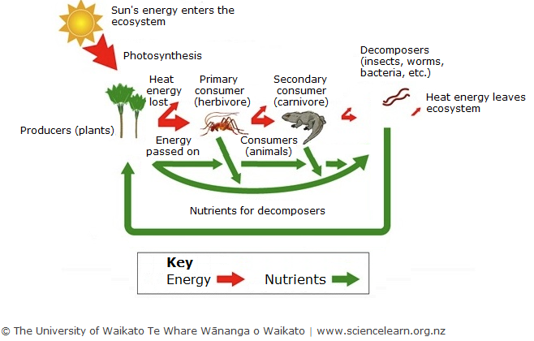
Source: https://www.sciencelearn.org.nz/images/1113-simple-ecosystem-diagram
An ecosystem is a community of living things and their non-living environment and may be as large as a desert or as small as a puddle. An ecosystem must contain producers, consumers, decomposers, and dead and inorganic matter. All ecosystems require energy from an external source – this is usually the sun.

Your task:
View The Big Picture https://www.youtube.com/watch?v=8u4XgAX3QtY
or
Read this information from the Department of Conservation resource:
(source: https://www.doc.govt.nz/globalassets/documents/getting-involved/students-and-teachers/in-the-environment-series/enhancing-biodiversity.pdf)
Healthy green space | Unhealthy green space
- A wide variety of insects, invertebrates, birds, and other animals living in and visiting the area  - Lots of endemic and native animals and plants (lots of biodiversity)  - Soil is rich, dark, and damp (looks like compost)  - Thick layer of leaf litter  - Fresh, clean air  - Clean, unpolluted, cool water  - Noisy at most times with insect and bird calls  - A natural habitat with few signs of human impacts  - Hardly any or no weeds  - No sign of animal pests (droppings etc.). | - Few insects or other animals living or visiting the area (lack of biodiversity)  - Soil is hard and/or dray. Looks like clay or is grey in colour  - Not much leaf litter  - Air smells bad or unhealthy  - Few native plants/trees or there are unhealthy plants  - Dirty or polluted, warm water  - Mostly quiet with no insect or bird noise during the day or night  - Human impacts like rubbish seen  - Lots of introduced animal pests and weeds present  - Signs of animal pests such as droppings and eaten vegetation  - Lack of native seedlings.

Discuss with whānau how humans can impact our environment and rank environmental issues from least to greatest impact using images in the resource.
Consider – can cities and suburbs be part of a healthy green space?
Record a plan to enhance biodiversity in your green space
Plan to enhance biodiversity in your green space by completing the planning document on the next page.

Plan to enhance biodiversity
What is your goal for your green space? | Which plants and animals would suit the conditions in your green space? | Who owns/ manages the green space?  *Public green spaces are usually managed by local councils  Who needs to be asked about any possible changes?
Which native/ endemic animal do you want to see more of in your green space?

What do you know already about this animal? | What connections to trees or other animals does this animal have? | Which issue will you target for this animal?
How can you attract more of these animals to your green space?

How will this help the big picture of restoration/ conservation in your area (or in NZ)?

Source: https://www.doc.govt.nz/globalassets/documents/getting-involved/students-and-teachers/in-the-environment-series/plan-to-enhance-biodiversity-editable.docx

Day 6 activity 4: The big dig
Notes for teachers and whānau
In this reading activity, learners will discover how a major environmental event of heavy rain causing a significant land slip changed and impacted an environment dramatically. Readers will understand that engineers encountered technical problems and relied on technology to solve the many problems they encountered. Learners will need support to understand the meaning of new vocabulary. Learners can be supported with their understanding of timescale and sequence of events. For students who find this text challenging, use the photographs, diagrams, and subheadings to preview the content before the first reading

I am learning to: understand how environmental changes caused by weather events can impact people's lives, animals, plants, and natural biodiversity.
What do I need?
- 30 minutes
- Look in your pack for a copy of The Big Dig https://instructionalseries.tki.org.nz/Instructional-Series/School-Journal/School-Journal-Level-3-September-2014/The-Big-Dig-Clearing-the-Manawatu-Gorge-Slip

Instructions:
Problems for animals and plants can be big or small when their environment is disturbed. Today’s reading activity asks you to think about a major environmental change caused by a large land slip and how technology helped the engineers solve many problems this had on the environment. As you view the images in the text and read about this significant change to the environment think about the damage to animals, plants and the ecosystems affected by the slip. Technology helped

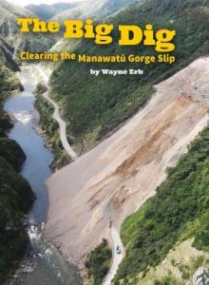
Your task:
Look closely at the photographs, diagrams, and map to build an understanding of the impact of a change caused by a weather event to an environment.
Record as many questions you can think of about the impact this event may have caused to animals, people, plants, and the biodiversity of this environment.
Consider how the impact of human activity in this area could have contributed to this slip?

Remember to do your end of day reflection and wellbeing activities (See p. 7&10)

Day 7 activity 1: Is my cat a pest?
Notes for teachers and whānau
Learners will read about cats and why they are considered by some as a predator to be managed or even got rid of completely. As half of New Zealand homes have a cat as a pet, it will be important to discuss with the learner the different perspectives about how and why cats are viewed positively and negatively when it comes to making an impact on people, plants, and the ecosystem.
Note that our Inquiry focus for today is “explore, investigate, and discover” which includes choosing and evaluating information, and thinking critically.

I am learning to: Identify introduced predators and consider why some people hold different views about a common domestic pet.
What do I need?
- 30 minutes
- Look in your pack for the following:
Cats – who needs them? https://instructionalseries.tki.org.nz/Instructional-Series/School-Journal/School-Journal-Level-2-June-2014/Cats-Who-Needs-Them
Power point – Who’s that Introduced predator? https://www.doc.govt.nz/globalassets/documents/getting-involved/students-and-teachers/animal-pest-factsheets/who-is-that-introduced-predator.pptx#slide=id.g1bd2ee9ff1_1_98
Animal pests fact sheets
  - Rats https://www.doc.govt.nz/globalassets/documents/getting-involved/students-and-teachers/animal-pest-factsheets/rats.pdf
  - Mice https://www.doc.govt.nz/globalassets/documents/getting-involved/students-and-teachers/animal-pest-factsheets/mice.pdf
  - Possums https://www.doc.govt.nz/globalassets/documents/getting-involved/students-and-teachers/animal-pest-factsheets/possums.pdf
  - Cats https://www.doc.govt.nz/globalassets/documents/getting-involved/students-and-teachers/animal-pest-factsheets/cats.pdf
Optional digital activity – http://www.pestdetective.org.nz/
Remember to start your day right (See p.9)

Instructions:
Today’s reading activity gets you thinking about the different opinions and views people have about one of our favourite domestic pets, the cat. Cats make wonderful pets, but they are also very good at hunting and can do a lot of damage to our wildlife. Find out more about introduced predators by reading the animal pests fact sheets will help build your knowledge about animals that are likely to be in green spaces near you.

Your task:
Read: Cats – who needs them?
Talk about the two different views of domestic cats with adults in your whānau. Ask for their opinion about ‘Is my cat a pest?’
People hold different opinions, and they are all valid. People like to debate different positions by presenting facts to back up their opinions.
Record the different opinions of people in your whānau in a table in your home learning book like the example below.

Arguments for the statement “My cat is a pest” | Arguments against the statement “My cat is a pest”
E.g. My cat chases birds | E.g. My cat is important in my life and makes me happy

Read: the animal pests fact sheets and use them to help you solve the mysteries in the ‘Who’s that introduced predator?’ presentation.
Solve the mysteries
Mystery case | Introduced Predator
Case # 1
Case # 2
Case # 3
Case # 4
Case # 5
Consider: What if there were no cats in New Zealand?
Extra optional online activity:
If you have access to a device, check out the online interactive tool ‘Pest Detective’ to help you locate clues and culprits, introduced predators in your environment.

Day 7 activity 2: Join me on my quest!
Notes for teachers and whānau
Today’s learning explores how places influence people and people influence places. Learners will plan a letter to encourage a friend to join on a quest to make your near green space free from predators. The learner will draw on prior knowledge of biodiversity and why predators are a threat to the connections within an ecosystem.

I am learning to: form an opinion and express a point of view
What do I need?
- 30 minutes
- Home learning book
Optional digital:
- Pest detective https://www.doc.govt.nz/pest-detective
- Persuasive Writing https://www.youtube.com/watch?v=hD9arWXIddM

Instructions:
You, the insects, birds and trees, your school, and neighbourhood are part of a bigger ecosystem. Introduced predators can change and disturb the connections between native invertebrates, trees, birds, and the environment. Getting rid of these predators in your green spaces can help enhance biodiversity. Can you encourage a friend to join you on your quest to protect the native and endemic creatures in your green spaces?
Tip: If you can, read the information – Pest Detective – and watch the video to remind you of what a persuasive text is and how you can use a letter as persuasive writing.

Your task:
Plan a letter to convince a friend to join in protecting your green space from predators.
- Brainstorm: your ideas about what you know about introduced predators
- Form an opinion about introduced predators
- Record two or three supporting reasons
- Write a conclusion
Example of planning:
Title: Why you should join me to become a pest detective
Opinion: Taking action to investigate the pests in our green spaces will improve our environment for everyone
Supporting reasons:
- Taking action to become a pest detective will enhance our green spaces
- Creating a tracking tunnel together will be great learning and fun
- Opportunity to collect a ‘Kiwi Guardian’s’ medal
Conclusion:
We built 3 tunnels and tracked a hedgehog in the backyard. We used the NZ Kiwi Foundation website to identify the footprints. Instead of using polythene we wrapped milk containers in masking tape, this helped keep the containers together This has been an exciting and fun project and we learned how to look after our green space.

Day 7 activity 3: Become a pest detective
Notes for teachers and whānau
Today’s learning activity integrates skills and knowledge across the learning areas of technology, science, and reading. Learners will use their close reading of instructions, technology skills, and prior knowledge on collecting statistical data. With easily accessible household items, learners with support from a parent or, with another learner will create a ‘tracking tunnel’ to trap backyard pests such as mice and rats.

I am learning to: use household materials to design a prototype tracking tunnel
What do I need?

- 30 minutes
- 2 large plastic milk bottles,
- A craft knife or scissors
- A piece of wood
- Polythene wrap
- Red food colouring
- A sponge
- A small plastic tray
- Peanut butter or raw meat
- Sheets of white paper

Instructions:
Which introduced predators are in your area?
You can trace introduced predators with tracking tunnels. Tracking tunnels are plastic tunnels with bait, ink pads, and paper/ card inside them designed to collect evidence of introduced predators. Introduced predators are tempted into the tunnel to get the bait, step on the ink, and leave their footprints behind. The ink footprints can be used to identify which animals have been in the tunnel. Find a parent, sibling, or friend to carefully read the instructions and gather the materials to build a tracking tunnel with you. Engineers, innovators, and creatives always start with a problem they want to resolve. They then design solutions after investigating the problem and before they begin the construction of a ‘prototype’.
Before you start designing your tracking tunnel consider the following:
- The tunnel should be waterproof in case of rain, made of something light but strong and big enough for a ferret but not big enough for a cat to get through
- It should also be weighed or pegged down, so it doesn’t blow away.
- Make sure your tunnel is the same width. If using milk containers, cut them and align to make all the same width.
- Tracking tunnels can be placed in different areas of your green space to detect what is living in those areas.
- Human scent (your smell!) can be a deterrent for some introduced predators – wear gloves when putting the bait into the tracking tunnel.

Your task:
Read the instructions of how to build your own backyard tracking tunnel. See website https://www.doc.govt.nz/pest-detective or read the adapted text below:
Instructions
Department of Conservation rangers use tracking tunnels to record the movements of small animals. Pests like tunnels and by stepping on the ink pad they leave an easy track to follow to see were they feed, and what types of pests they are.
Planning:
- Look around your green space and identify some different spots where you will put your tracking tunnel. Think about the critters that might be there and where they might live, use for food, or walk around in.
- Draw a plan for your tunnel. It can be as easy or fancy as you like. Use your imagination! Consider:
  - What materials do I have around the house to build a tunnel?
  - How can I make the tunnel waterproof, the right size, shape, and weight?
  - What can I use for bait? Do I know what the pests like to eat?
Collect the items for your tunnel to follow your plan or follow these instructions:
- Cut off both ends of the large milk bottles
- Slide one bottle into the other.
- Slide in a piece of wood for a base.
- Darken the tunnel by wrapping it in polythene (or masking tape etc).
- Soak a sponge in red food colouring and place it on the plastic tray.
- Put some bait on a leaf and place it in the middle of the sponge. Use peanut butter for rats and mice and raw meat for mustelids like stoats.
- Place the tray in the middle of the tunnel and sheets of paper inside at both ends.
Use your tunnel:
- Put your tunnel in one of the spots you have identified. You can hold your tunnel in place make the piece of wire into a U shape and place it over your tunnel and into the ground.
- Check the paper each morning for footprints. You may need to add new bait and food colouring. After 4–5 days you should have a good idea what small animals are around.
- You can try different spots on different nights or try using different bait to see what is popular. Experiment with disguising your tunnel in the roots of a tree or even cover it with sticks.
Look at your results and try to work out who is visiting your garden. Is it who you thought you would find?
- Optional digital: Visit https://pestdetective.org.nz/clues/footprints-and-tracks/ to see what different footprints look like so you can tell what’s in your backyard.

Day 7 activity 4: How much does it cost to have a pet?
Notes for teachers and whānau
Mathematical learning today is about building financial literacy. Learners need a parent or adult to engage in lots of discussion about the big ideas of financial literacy. How you spend your money now will affect you in the future (financial consequences). Budgets can help you live within your income and make better spending and saving decisions. The decisions you make depend on your goals, needs, and wants and on your budget. Talking with the learner is crucial to the development of the learner’s financial literacy.

I am learning to: understand that choices I make about money have consequences for my future
What do I need?
- 30 minutes
- Adapted from Figure it Out https://nzmaths.co.nz/resource/can-you-afford-pet

Instructions:
Find a willing adult to talk about the words in this maths activity and their meanings. These are important for you to understand as they will help you achieve your goals throughout your life.
Setting the scene
Rawinia’s mother works at an animal shelter Rawinia often helps her look after the animals. She feels sad when some of the animals don’t get adopted – Rawinia would like to take them all home!
Rawinia’s mother decides that Rawinia needs to learn about where their family’s money comes from and why it would cost a lot to look after all the extra animals that Rawinia would like to take home. Rawinia’s mum writes down the words she thinks Rawinia needs to understand, then they talk about what the words mean.
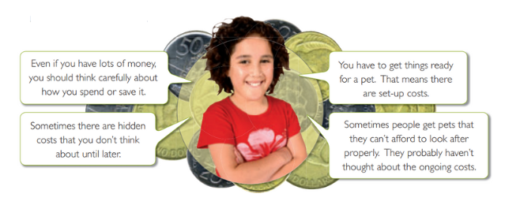

Your task:
Match the words with their meanings.
Talk with an adult about what these words mean.
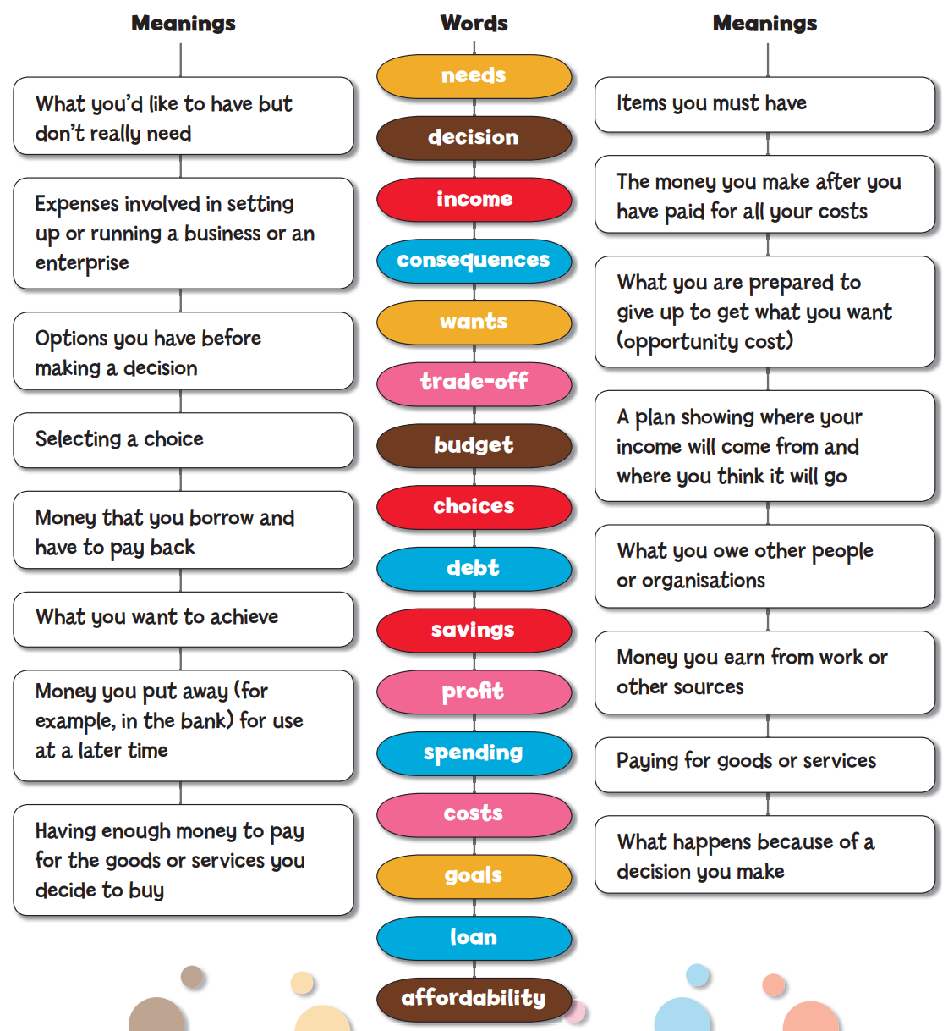

Optional extra:
Investigate the costs of keeping a pet per week. Brainstorm all the things the pet would need including food.

Remember to do your end of day reflection and wellbeing activities (See p. 7&10)

Day 8 activity 1: Designed for good
Notes for teachers and whānau
Our learning today is inspired by people who have used the ‘ideate’ process to solve problems and innovate solutions.
Tapping learners’ imaginative thinking through recognising a problem that they feel is worthy of solving is the first step. Imagining the wildest ideas is the second step of the design thinking process, reaching out to people to support their project, and expanding the learners circle of influence, so that they feel empowered, knowing they can make change happen. Taking action is the third step, using critical thinking, planning and leadership, to test the learners’ ideas, followed by the fourth step. Today’s learning in reading, looks at how three friends followed the process: identified a problem, brainstormed possible solutions, created prototypes, and produced a solution to support the ‘Predator Free project’. Learners will make connections to their prior knowledge relating to the big ideas about adaptation and innovation.
Note that our Inquiry focus for today is "making meaning" which includes analysing data, organising, and sorting information, summarising, synthesising, making connections/conclusions, building deeper understandings, and thinking critically.

I am learning to: connect my prior knowledge with new ideas
What do I need?
- 30 minutes
- Look in your pack for a copy of Designed for good https://instructionalseries.tki.org.nz/Instructional-Series/School-Journal/School-Journal-Level-3-May-2017/Designed-for-Good
Remember to start your day right (See p. 9)

Instructions:
Today’s text builds knowledge and understanding of a design thinking process. Three friends identify a problem, the damage caused to the environment by introduced predators and set out to design an improved pest trap. Having identified a problem, they all agreed was worth solving, they continued to work through a design thinking process. It took a long time and a lot of persistence to finally produce a trap they were happy with.
As a reader today, your task is to make connections to your previous learning and think critically about the process these three friends followed to create their pest trap.

Your task:
Read the key words in the table and see how you may know already and can either write a meaning for the key words in your own words or tell someone the word and its meaning.
Highlight any new keywords you don’t know and find out their meaning by predicting the meaning, asking someone, or looking in a dictionary.
Read the school journal story ‘Designed for Good’
Key word | Meaning
conservation
design
ecological sustainability
ecology
environment
ideas
Innovation
Introduced species
Native bush
Pest control
Pests
Predator free New Zealand
Predators
Prototypes
Technology
traps

Identify the four design steps the three friends went through innovating a solution to their problem. Describe the steps in your own words.
Step One
Step Two
Step Three
Step Four

Day 8 activity 2: Feel, Imagine, do, share
Notes for teachers and whānau
This activity requires the learner to watch two videos online.
Today’s learning dives into the first two elements of an inquiry process, inspired by ‘Design for Change’ an educational organisation founded in India. ‘Design for Change’ has a vision to empower learners to transform the world into how they envision it, to a more compassionate and empathetic world. This activity builds the learner’s ‘I can’ superpower. Learners are asked to think critically about our recent learning and engage in step one ‘Feel’ and step two, ‘Imagine’. Concepts and ideas the learners have encountered include maintaining healthy green spaces, introduced predators, environmental and human impact threats to environment and how species have adapted to change.

I am learning to: use the first two steps of a four–step design thinking process for designing an innovation
What do I need?
- 30 minutes
- Home learning book
- Look in your pack for a copy of Designed for good https://instructionalseries.tki.org.nz/Instructional-Series/School-Journal/School-Journal-Level-3-May-2017/Designed-for-Good
- Optional digital: https://www.dfcworld.org/SITE – feel and imagine videos

Instructions:
The first step towards making change happen is to try to understand how people feel. As we set out to understand a design process, you are asked to ‘think from your heart’. Superheroes don’t exist only in fairy tales and movies; they exist in real life too. Within every person exists an ‘I can’ superpower. If you can, view the video about the first step in the design process of ‘feel’, to help you understand this step.
Your task is to think about the how the three friends in the story ‘Designed for Good’ felt about the damage caused by predators in their outdoor environment.
In step two of the design process, you will use your superpower of ‘Imagine’ visualising the wildest possible ideas to solve their problem.
Your task is to brainstorm every possible idea you have to solve the problems faced by these three friends when placing their pest traps in New Zealand’s hard to access, hilly forests. Their traps need to be ‘set’ by rangers and volunteers, who load them with bait such as peanut butter and sometimes even must use expensive and time-consuming processes such as using helicopters to get the traps and the bait and reset traps into hilly high country, hard to access places.

Your task:
If you can, view the Step 1 process video https://www.youtube.com/watch?v=XKEFMBF0QbA
Write a description in your book of how the three friends, Craig, Stu, and Robbie feel after seeing the damage to their favourite outdoor places. Use emotive words to describe their feelings. These three friends talked a lot about their feelings and agreed to take action. You can use direct speech for impact in your writing. Don’t forget to use “speech marks” to indicate the character speaking.
Set up a full page in your home learning book with a brainstorm template
Your title/topic might be:
‘Getting and setting pest traps into hard-to-reach places’
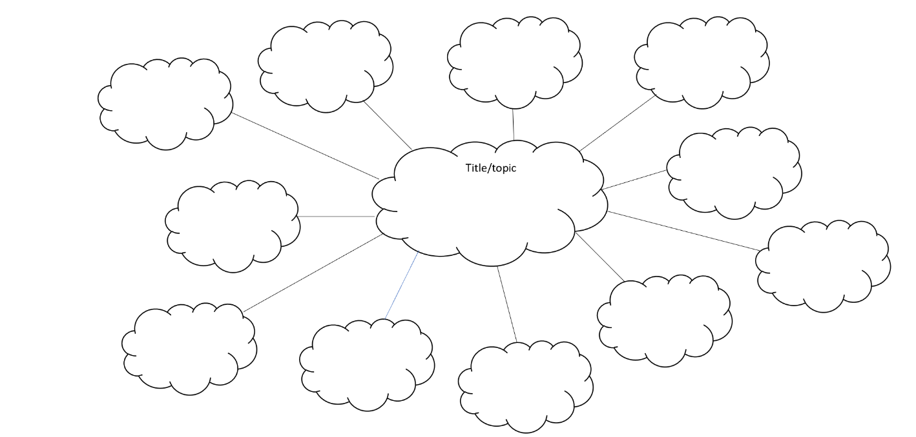
Brainstorm: as many ways as you can think of how these friends, rangers and volunteers might get the pest traps into hard-to-reach places and how they can set the traps less. Every idea you have will be a great idea, e.g.:
- use a drone to drop the traps from the air
- create a perfumed synthetic food that possums like the smell and taste of…
Draw your wildest, best ideas on the next page of your home learning book
Invite others to select and vote on your ideas to choose the best with you.

Day 8 activity 3: How did I feel about solving maths problems?
Notes for teachers and whānau
Learners will solve maths problems using number, basic facts, concepts of time, and perimeter. An important aspect of today’s mathematics learning is to self-reflect. Learners are asked to express their feelings about their maths activities. When learners have completed each activity, ask them to add a mouth to the smiley face to show how they felt about the activity.

I am learning to: use my basic facts and problem-solving strategies to solve word, perimeter, and number line challenges
What do I need?
- 30 minutes
- Look for Learning at Home Activity Sheet #3 in your pack. https://nzmaths.co.nz/sites/default/files/2021-09/year-5-week-3-offline-activities.pdf

Instructions:
Maths activities today ask you to:
- Solve the three number problems,
- Use your basic facts knowledge,
- Complete a number line challenge, a perimeter puzzle, and answer some quick questions.
- Draw your feelings with smiley face mouths.: At the completion of each challenge draw a mouth onto a smiley face that shows your feelings about the maths activity. Was it easy, a bit tricky or hard? Did you enjoy the challenge?

Your task:
Complete the maths challenges on today’s ‘Learning at home activity #3 resource’.
Check how you went with solving each challenge using the answers in the resource
Draw a smiley face for each completed challenge with a mouth showing how you feel your maths challenge went.
Problem 1 | Problem 2 | Problem 3 | Number line challenge | Perimeter challenge

Day 8 activity 4: Developing my sketch into a prototype
Notes for teachers and whānau
Learning in art today requires the learner to revisit their initial drawing of their best idea from Day 8 activity 2 to further develop the idea through detailed imaginative drawing. Sketching or drawing is a powerful and important part of the ‘imagine’ step in the design thinking process, that helps further explore and explain design concepts. Learners are encouraged to understand that innovation is a multiple step process of visiting and revisiting initial ideas. Designers use drawings to share their ideas with others as they refine and improve on their initial concepts. Emphasis is on the process not the final completed product.

I am learning to: add details and labels to a sketch to use to construct a model or prototype of a design idea.
What do I need?
- 30 minutes
- Home learning book
- Pencil or coloured pencils
- An assortment of everyday materials or items collected in the home to build the prototype, e.g., paper, cardboard, bubble wrap, beads, buttons, foil etc

Instructions:

Some of the best ideas start with a sketch. In Day 8 activity 2, you were asked to draw your best, wildest idea on how to get a pest trap into a hard to get to place. In this activity, you are asked to develop your first sketch into a more detailed drawing that you label and use to construct a model or prototype of your design idea. Use your craziest, wildest idea to form inspiration for your drawing. Your drawing is the first step in making a prototype or model of your design from a selection of everyday materials. You will need a table and space to work on your prototype, then ask an adult to help you gather materials available at home to create your prototype.

Your task:
Study your drawing from Day 8 activity 2.
Think about how you might add detail and labels to your first drawing.
Sketch a detailed drawing with labels to help you explain your drawing to others.
Explain to others about what you are planning to achieve building a prototype or model.
Collect base materials, connectors, tools, and treasures if available.
Construct a prototype or model of your detailed drawing.
Remember to do your end of day reflection and wellbeing activities (See p. 7&10)

Day 9 activity 1: Using my ‘I can superpower’ to make a difference
Notes for teachers and whānau
The learner will choose a text about a project of interest and think critically about the importance of the project to them, and how they might take action. We have started to explore a design thinking process. Learners have read about people who identified a problem related to keeping Aotearoa New Zealand pest free to protect the environment. Learners today will choose an issue that reflects how humans have impacted the environment that they wish to explore and understand why they feel this is important to them. This is the ‘feel’ step of the design thinking process. Learners can be inspired to take action as a ‘Citizen Scientist’ or participate in the local and international science programmes through the ‘Citizen Science Project’. To spark interest in becoming a citizen scientist, we will look at what ‘taking action’ looks like. Learners will benefit from discussion with an adult about a project they would like to participate in.
Note that today our Inquiry focus is “going further, deeper”. This may include promoting opportunities to engage further and dive deeper through discussions, provocations, exploring further contexts, taking action, or thinking critically and drawing conclusions.

I am learning to: understand an environmental problem and why I should participate.
What do I need?
- 30 minutes
- Optional digital: https://www.sciencelearn.org.nz/citizen_science
Remember to start your day right (See p.9)

Instructions:
Today’s learning asks you to take action. Your first step is deciding on a problem or project to participate in that you feel is important. You can become involved in a small or more significant way. You can also make a difference by becoming a ‘citizen scientist’. You will need to ‘think like a scientist and take action like a scientist’.
You will be asked to use your skills of observing, noticing, collecting data, documenting with photos, and sharing your findings. These projects are designed to happen over a long time, so you need to consider your commitment. It’s a great idea to talk with whānau to choose a project or problem that is important to you and your family. If you don’t have access to a device decide on another problem or issue you want to solve related to the environment or your local green space.

Your task:
Offline – read the text below about the Myrtle Rust Reporter project
Online – choose a project from the table below, or another project from https://www.sciencelearn.org.nz/citizen_science that you feel is important.
Talk with someone about the project, to make sure it’s important to you and achievable.
Read to discover as much as you can about the project. Use the links to access information or the resources.
Project | Links and resources
Myrtle Rust Reporter | https://www.sciencelearn.org.nz/resources/3065-myrtle-rust-reporter OR read below.
The Great Earthworm Survey | https://www.sciencelearn.org.nz/resources/2926-the-great-kiwi-earthworm-survey
Loss of the night | https://www.sciencelearn.org.nz/resources/2765-loss-of-the-night
The New Zealand Garden Bird Survey | https://www.sciencelearn.org.nz/resources/2732-new-zealand-garden-bird-survey

Text adapted from https://www.sciencelearn.org.nz/resources/3065-myrtle-rust-reporter
Myrtle rust is a serious biosecurity threat, and help is needed to monitor its spread. This citizen science project aims to gather information on the location, hosts, and intensity of this fungal disease.
Scientists urgently need information on the location of myrtle rust in New Zealand as they are at risk of dieback and death. Reporting myrtle rust provides information to help researchers manage the spread of the disease. The project asks you to take photos of disease symptoms and of the host plant. You can take pictures using a smartphone within the app or a camera and upload them via the website later.
Helpful images include:
- close-up images of symptoms (usually yellow powdery spores)
- images of the leaves and any flowers or fruit if present
- view of the plant(s) as a whole to show the surrounding habitat/environment.
When you upload a picture, identify your observation as ‘myrtle rust’ in the ‘What did you see?’ field. The community will confirm your observations. You can add more information about the infection in the form. Repeated observations are welcome – every report helps track changes in the disease. You can add healthy trees too.

Reduce the risk of spreading the disease
When taking part in the project, avoid brushing against plants. Use clean equipment and check it for spores when you leave a site. If you see yellow spores on your clothing, turn them inside out and store in a plastic bag before washing. Clean your hands with soap and water to remove and kill spores and wipe down your gear with alcohol-based products such as hand sanitisers or methylated spirits.
A full list of myrtle rust susceptible host species can be downloaded from the Ministry for Primary Industries website https://www.mpi.govt.nz/dmsdocument/37293/direct

Day 9 activity 2: Make change happen
Notes for teachers and whānau
Literacy learning today is built on the choice the learner has made about the issue that they feel strongly about and that they want to persuade others to join them and to support them, which also reflects how humans have impacted the environment. Learners are asked to list reasons why their project is important, to write a persuasive letter and to create a simple action plan to share with others. Learners will think deeply and critically, building on the science concepts which are the major focus behind the project inspired from the ‘Citizen Science Project’ that they have chosen to action, on a simple scale to a more significant participation.

I am learning to: persuade others in a letter or list reasons for why my chosen project is important for others to join me.
What do I need?
- 30 minutes
- Home learning book

Instructions:
Today you have read about projects or problems relating to the environment and chosen a project that you want to do something about. This activity is an important step in the project, where you unleash your ‘I can superpower’. Now you have decided on your project it’s time to convince an adult to support you or to find friends to come on board with your action plan and become part of your team. One way to convince people to join you is to write them a persuasive letter. Remember to state your opinion at the beginning of the letter, followed by reasons that support your opinion, and have a strong conclusion. You can also use emotive language to help convince your readers. Classmates, siblings, or friends may become members of your team. You will also need to create an action plan to share.

Your task:
Write a list of reasons why your project is important, so that you can convince others to participate in your project.
OR
Write a persuasive letter to others to convince them to participate in your project.
Share your reasons why your project is important with an adult or others to convince them to participate and support you.
Create an action plan for your project. Think about:
- What resources will you need?
- Who can help you? How many people will you need?
- How much time will it take?
- How will you record your work?

Day 9 activity 3: Clever New Zealand inventors
Notes for teachers and whānau
Timelines are a useful way to display information. They show the order in which events occurred and the periods of time between them. Timelines follow conventions used in other data displays, in particular, they must have a uniform scale and clear labels.
Some technological innovations have resulted from “know how”. Sometimes creative leaps have been made from opportune discoveries. Others have been developed over long periods of laborious trialling. Many breakthroughs are inspired by need, but others that start off as a luxury soon become a necessity. New Zealanders have produced many technological innovations. Māori developed effective food production and storage systems, early pioneers invented agricultural mechanisms, and modern Kiwi technologists are well represented in a number of high-tech fields.

I am learning to: use timelines and interpret time-based information
What do I need?
- 30 minutes
- Look in your pack for a copy of Inventive thinkers https://nzmaths.co.nz/sites/default/files/InventiveThinkers_0.pdf
- Home learning book
- Ruler

Instructions:
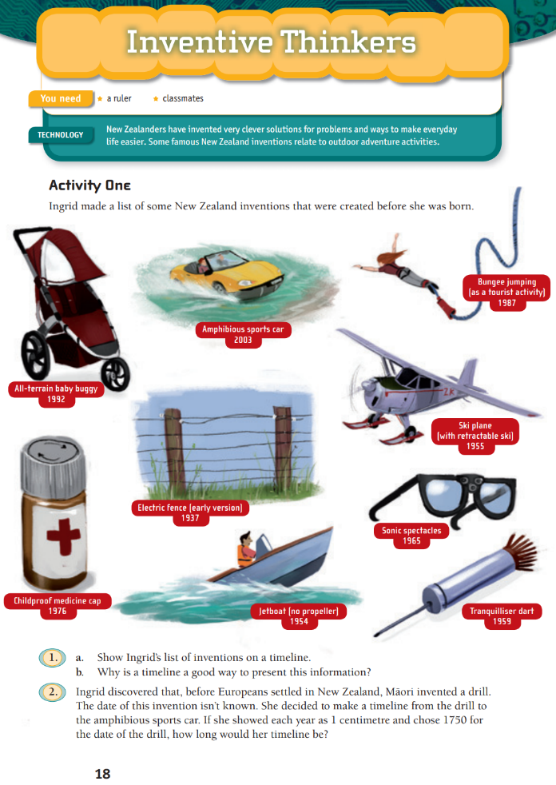
Make a list of inventions created in New Zealand and show them on a timeline. Think about why a timeline is a useful way to present this information. Solve the problem in Activity 1 using a centimetre ruler.

Your task:
List inventions created in New Zealand
Explain to others why using a timeline is a great way to present this type of information
Solve the problem 2 in Activity 1
Check your answers with others, to see how they solved the problem and if your answer is the same

Day 9 activity 4: Helpful inventions
Notes for teachers and whānau
To inspire our learning in art for this activity, learners will need to gather three different objects from around the house and sketch how they could connect the three together to create something that could help prevent a particular negative impact of humans.
Learners can draw these objects with a pencil or coloured pencils, using shading, line, proportion, and perspective knowledge. Learners will need to consider the colour palette they choose to reflect their creation.

I am learning to: use my knowledge of how humans have impacted the environment to invent something that will prevent damage
What do I need?
- 30 minutes
- Home learning book or art paper and pencils or paints

Instructions:
You have investigated and learned about some of the ways that humans have impacted the environment in a negative way. You will use your creativity to innovate or invent something new that will help to prevent further damage. Part of creativity involves having some constraints – that means limiting something, usually access to a particular resource/amount of a resource or a time limit for example.

Your task:
Select 3 objects in your home. Observe them closely, notice what they do, how they look, their shape, weight, length, the type of material they are made of. What else do you notice?
Draw with pencil or coloured pencil, shading, showing perspective and labelling for detail if you wish.
Look at the objects again. Look at your drawings again.
Brainstorm ideas of how the three objects could be combined together to make something new.
Choose one of your ideas.
Create: invent something that will help a human influenced environmental issue that using these three objects in the design.
Draw this design – use shading, line proportion and perspective to make a clear picture.
Remember to do your end of day reflection and wellbeing activities (See p. 7&10)

Day 10 activity 1: Thinker’s Keys
Notes for teachers and whānau
Today learners will have multiple opportunities to explore our theme of ‘change’ through a variety of activities and they will have opportunities to explore questions and discover new knowledge using the ‘Threatened Species Thinker’s Keys’. The learners will be applying critical thinking skills and making connections to new learning and prior knowledge. Learners will be exploring the literacy, social science, maths, science, and technology learning areas.
Note that today our Inquiry focus is “present – share learning about the theme” which includes thinking about who the audience is and considering different ways of communicating learning for example, presentation, video, poster, etc.

I am learning to: connect my prior learning to organise ideas and information for learning
What do I need?
- 30 minutes
- Threatened Species Thinker’s Keys (from p. 44)
Remember to start your day right (see p. 9)

Instructions:
You are going to use your task grid ‘Thinker’s Keys’ for our theme of Change: threatened species from last week.
You have lots of choice with this activity so pick the ones that you think sound fun or hard if you want a challenge. You will be applying your critical thinking skills.
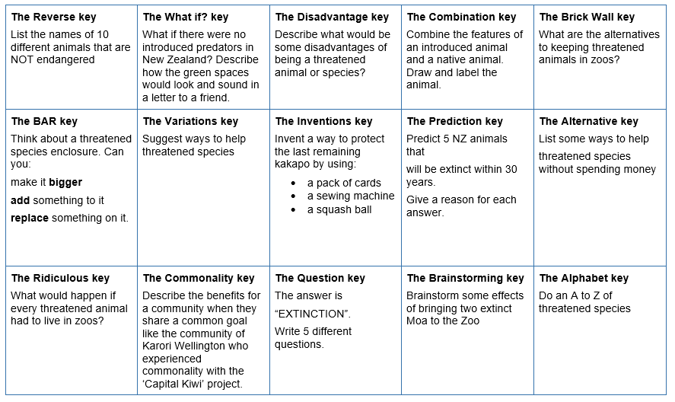

Your task:
Complete at least four of the tasks from the Adaptation Thinker’s Keys grid (p. 44) in your home learning book or digital doc.

Day 10 activity 2: Tivaevae karakara
Notes for teachers and whānau
Today’s mathematics activity asks learners to find areas of rectangles and volumes of cuboids by applying multiplication.

I am learning to: explore units of area
What do I need?
- 30 minutes
- Look in your pack for a copy of Tivaevae Karakara https://nzmaths.co.nz/resource/tivaevae-karakara
- Square grid paper

Instructions:
Activity one provides some area problems for you to solve in the context of the Pacific tradition of Tivaevae Karakara.
You are asked to solve how many pieces of cloth did Mama Tapaeru use to make her tivaevae karakara, how many pieces were needed for the border and for each frangipani flower. Activity two asks you to design your own tivaevae karakara
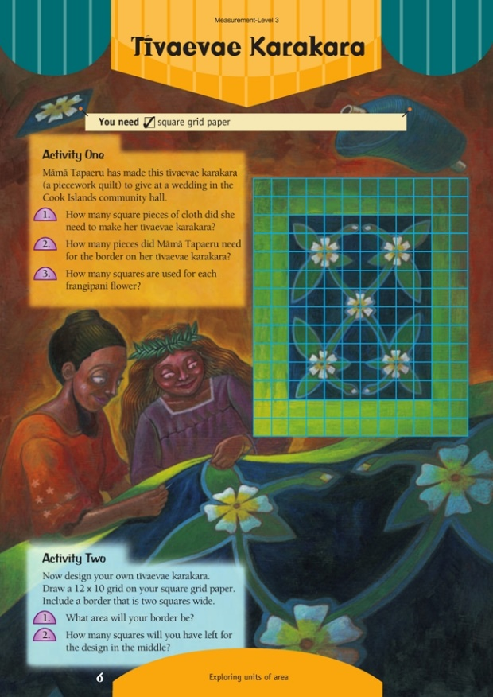

Your task:
Solve the problem described in activity one.
Share how you solved the problem with an adult.
Check if your method to solve the problem is the quickest and most efficient.
Calculate the area of the border.
Answer the questions in activity two.

Day 10 activity 3&4: Ko ahau te awa, ko te awa ko ahau
(I am the river; the river is me)
Notes for teachers and whānau
Learning about kaitiakitanga, the Māori view on how humans relate and are part of their ecosystem, is a valuable way to develop an understanding of our connection to the ecosystem of our environment, and our impact on it. Māori believe people are part of the environment – not superior to it. The condition or health of the people and the environment are intricately related. The saying ‘Ko ahau te awa, ko te awa ko ahau’ (I am the river, the river is me) depicts the relationship between people and the environment. Therefore, if a river is polluted, there is something not right with the people (and vice versa). The role of the assistants or kaitiaki is called kaitiakitanga. Kaitiakitanga involves the protection or guardianship of Papatūānuku and the organisms on her. Māori believe that whoever holds the mana whenua is responsible for it. These are the tangata whenua (people of the land). Tangata whenua have authority in a particular place because of their ancestors’ relationship to it.

I am learning to: understand the concepts of kaitiaki and kaitiakitanga; select a big idea and share my ideas with an audience; and reflect on my learning
What do I need?
- 60 minutes
- Optional digital: https://www.sciencelearn.org.nz/resources/2544-understanding-kaitiakitanga

Instructions:
Interest in kaitiakitanga is growing today. It is seen as a vehicle for applying ideas about preservation, conservation, repair, and use of environments for the present and future generations. It is important for us all. Kaitiakitanga invites people to form and maintain relationships with the environment in which they live. Iwi and hapū are restoring their environment and culture and using traditional ideas about kaitiakitanga in the modern world. Think about how the values of kaitiakitanga, which are based on traditional Māori world views, are a way to safeguard our environment for the future. We have explored lots of ideas and themes this week, including different perspectives and opinions that people hold about the environment.

View the video or read the transcript to understand kaitiakitanga
Transcript https://www.sciencelearn.org.nz/resources/2544-understanding-kaitiakitanga
Apanui Skipper: Kaitiaki means a guardian, a person that has the responsibility to ensure that the natural resources are going to be left in a sustainable way for the community, so that when they do go down to harvest and things like that, there is going to be food there.
Not just food of course, but the natural resources. To ensure that those natural resources are in good nick Those who have been brought up in Māori communities would have a strong sense of kaitiakitanga and are very serious about notions of kaitiakitanga, notions of sustainable ways of working with the environment.
Weno Iti: When I grew up kaitiakitanga was fostered in the bush and in the river but whenever my father and his brothers went pig hunting or to catch tuna there was always a karakia. Kaitiakitanga for me is that guidance to how a person should treat a taonga. A taonga is something beautiful so when we refer to those things, something that is precious to you, then that is how you would look after that. You would give it its appropriate care. Kaitiakitanga is about respecting those things that mean a lot to you.

Your task:

Choose one of the following themes about how humans have impacted the environment that we have explored this week from the list below:
- Extinct or threatened native and endemic species of Aotearoa New Zealand
- Predator free Aotearoa New Zealand
- Healthy green spaces/ Unhealthy green spaces
- Environmental changes and how they can impact people’s lives and the species living in the environment.
- Differing perspectives about cats
- Innovation in technology designed for good
- My ‘I can’ superpower and why you should join me on a project to improve green spaces
- Citizen Science
- Kaitiakitanga and why it is a powerful perspective on the relationship between people and the environment
- Being a Kaitiaki and knowing my role that I can make an impact for good

Create a way to present your information:
- a presentation
- a story board
- a poster
- a video

OR

Reflect Use an app like ‘FlipGrid’ or ‘Explain Everything’

Record your reflections about your learning this week. Include which learning you most enjoyed, what you found tricky or hard and what you would like to learn more about.

Share your perspective and opinion about your chosen big idea or project with others by talking to an audience supported by your presentation.

Congratulations on two weeks of learning about change.
So, what do you think? Is change a good thing?
Write a reflective response to this question in your home learning book.
Ka pai! Ngā manaakitanga.
Remember to do your end of day reflection and wellbeing activities (See p. 7&10)

