A learning from home pack

For learners in years 1–3

Big idea: Change | Panoni – Is change a good thing?

Context 1: Adaptations

Context 2: Innovation – can I make a better ...?

Layout of the resource
This pack is filled with learning activities that can be used at school or at home. All activities are framed around the big idea of change | panoni.
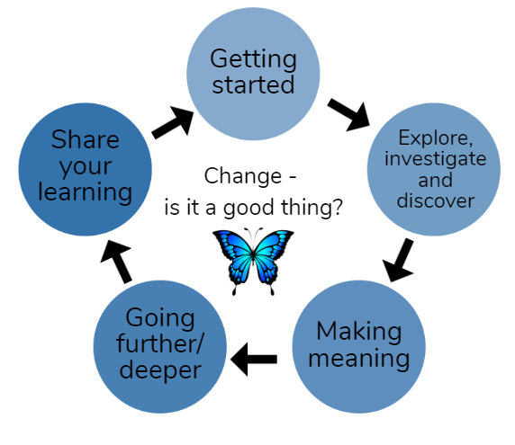
Suggestions are provided for starting the day with a karakia (see p. 8), check in with the teacher, and setting up the learning environment. You can replace these with how you want your learner to start their day. The pack is provided as a Word document so you can adapt it for your learners.
The activities follow an inquiry learning model (figure 1) exploring one theme through two contexts. Each day the learner will be working through one part of the model culminating with sharing their learning on days five and ten.
Figure 1 inquiry learning model

Realities
You know your learners and have a good understanding of their learning situations. Many learners will be sharing space and materials. Some may have access to the internet and devices, and others may not. Learners will also have varying levels of adult support. This pack contains a mix of activities using materials found in most homes. Some activities will need support while others can be managed independently.

Resources
The pack makes use of the Ready to Read, Connected, School Journal, and Figure it Out series. You might want to send these home with the learner, along with an exercise book, pencils, crayons, or felts, and some craft materials (glue, scissors, construction paper). Learners can bring their notebook back to class to share. All images have been sourced with permissions for use in this pack. If your learners do not have reliable access to the internet, here are the resources to print and send home to create a paper-based pack.

Resources to print
- https://nzmaths.co.nz/sites/default/files/ArtyShapes-ShapeSheet.pdf
- https://www.free-for-kids.com/wp-content/uploads/2020/01/Enlargement-Grid-With-Lion.pdf
- https://openclipart.org/detail/222362/black-and-white-butterfly
- https://eng.mataurangaMāori.tki.org.nz/Support-materials/Te-Reo-Māori/Māori-Myths-Legends-and-Contemporary-Stories/Maui-and-the-giant-fish

Resources to send home
- https://instructionalseries.tki.org.nz/Instructional-Series/Ready-to-Read-Colour-Wheel/Rain-Rain
- https://instructionalseries.tki.org.nz/Instructional-Series/Ready-to-Read-Colour-Wheel/Me-and-My-Dog
- https://instructionalseries.tki.org.nz/Instructional-Series/Ready-to-Read-Colour-Wheel/Stick-Insects
- https://instructionalseries.tki.org.nz/Instructional-Series/Ready-to-Read-Colour-Wheel/Butterfly-Day
- https://instructionalseries.tki.org.nz/Instructional-Series/Ready-to-Read-Colour-Wheel/New-Zealand-Birds
- https://instructionalseries.tki.org.nz/Instructional-Series/Ready-to-Read-Colour-Wheel/Fleeb-Makes-Scones
- https://instructionalseries.tki.org.nz/Instructional-Series/School-Journal/School-Journal-Level-2-May-2015/Jump
- https://instructionalseries.tki.org.nz/Instructional-Series/School-Journal/School-Journal-Level-2-May-2020/Kupe-and-the-Giant-Wheke
- https://instructionalseries.tki.org.nz/Instructional-Series/Ready-to-Read-Colour-Wheel/Treasure-from-the-Sea
- https://instructionalseries.tki.org.nz/Instructional-Series/Connected/Connected-2014-level-2-How-Do-You-Know/The-Cardboard-Cathedral

Setting up the learning environment
Encourage whānau to support learners to set up a space for learning at home. Learners might like to design their own space as a separate learning activity. Some materials they may need could include pen, pencils, paper, a notebook, colouring pencils, glue, scissors, and a device to access the internet.
Many of the suggested activities and experiences have the option of using online resources which can be accessed and viewed using a smartphone.

Overview of the learning in this pack
The theme of change | panoni will be explored through two contexts.
- Days 1–5 look at this idea through the context of adaptation
- Days 6–10 look at this idea through the context of innovation – can I make a better …?
Learners will explore, investigate, discover, and make meaning as they go through each task. There are times where they look a little deeper into the topic. Some of the tasks may be independent hands-on tasks while some may involve connecting and sharing with others.

Day 1 | Day 2 | Day 3 | Day 4 | Day 5
How do people and animals adapt to different conditions. | Living things make changes to survive. | Different habitats require different features. | Creating a creature for a particular habitat. | Bringing together our understanding of habitat and adaptation.
Day 6 | Day 7 | Day 8 | Day 9 | Day 10
In the home – purposes and functions of everyday things. | How inventions impact on us and our lives. | Innovating on something familiar to make it better. | Innovating on something familiar to make it better. | Bringing together our understanding of innovation and invention.

Daily timetable
Below is a possible daily timetable. We have allocated 30 minutes for each activity (or indicated where an activity takes longer); your learner may take more or less time than we have allocated for an activity. We suggest your learner takes the time they need to complete an activity. This may mean they choose which activities they will complete for the day, rather than complete them all.
At the start of each day the learner will draw up their timetable for learning. You can adjust the timing to suit the other activities that might be happening the day, such as Zooming with the class/teacher.

Time | Activity
9:00 am | Starting the day
9:30 am | Activity 1
10:00 am | Break
10:30 am | Activity 2
11:00 am | Fitness break
11:30 am | Activity 3
12:00 pm | Lunch time
1:00 pm | Activity 4
1:30 pm | Reflection time
2:00 pm | End of the school day

Daily fitness – Choose something each day
It is important to include a fitness activity every day. Below are a range of activities to choose from – or you can make up your own ideas! You may prefer to go for a walk or run around your house. Time yourself for fun! Maybe you’d like to go for a bike ride with your whānau? Play a game with whānau? Have a boogie to your favourite song? Or do some yoga? It is up to you.
Please note you can change or modify the exercises (in addition to those outlined) if you are not able to do the ones we have suggested, get creative and change it up.
If you can, watch the video: We’re going on a bear hunt: https://www.youtube.com/watch?v=0gyI6ykDwds
If you cannot watch the video, ask someone to read this out while you do the actions.
We're going on a bear hunt; we're going to catch a big one
What a beautiful day, we're not scared. Uh-oh grass long wavy grass
We can't go over it we can't go under it – oh no we’ve got to go through it.
Swishy swashy! Swishy swashy! Swishy swashy!
We're going on a bear hunt; we're going to catch a big one
What a beautiful day, we're not scared. Uh-oh a river a deep cold river
We can't go over it we can't go under it – oh no we’ve got to go through it.
Splash splosh! Splash splosh! Splash splosh!
We're going on a bear hunt; we're going to catch a big one
What a beautiful day, we're not scared. Uh-oh mud thick
We can't go over it we can't go under it – oh no we’ve got to go through it.
Squelch squerch! Squelch squerch! Squelch squerch!
We're going on a bear hunt; we're going to catch a big one
What a beautiful day, we're not scared. Uh-oh at the forest a big dark forest
We can't go over it we can't go under it – oh no we’ve got to go through it.
Stumble trip! Stumble trip! Stumble trip!
We're going on a bear hunt; we're going to catch a big one
What a beautiful day, we're not scared. Uh-oh a snowstorm a swirling whirling snowstorm
We can't go over it we can't go under it – oh no we’ve got to go through it.
Hooo wooo! Hooo wooo! Hooo wooo!
We're going on a bear hunt; we're going to catch a big one
What a beautiful day, we're not scared. Uh-oh cave a narrow gloomy cave
We can't go over it we can't go under it – oh no we’ve got to go through it.
Tiptoe! Tiptoe! Tiptoe
What's that? One shiny wet nose. Two big furry ears. Two big googly eyes
It's a bear! Quick back through the cave – Tiptoe! Tiptoe! Tiptoe!
Back through the snowstorm – Hooo wooo! Hooo wooo! Hooo wooo!
Back through the forest – Stumble trip! Stumble trip! Stumble trip!
back through the mud – Squelch squerch! Squelch squerch! Squelch squerch!
Back through the river – Splash splosh! Splash splosh! Splash splosh!
Back through the grass – Swishy swashy! Swishy swashy!
Down the road. Up to our front door. Open the door. Up the stairs – Doop doop doop.
Oh no! We forgot to shut the door. Back downstairs – Doop doop doop doop
Shut that door – Boom
back upstairs – Doop doop doop doop
Along the passage, Into the bedroom. Into bed. Under the covers.
We're not going on a bear hunt again.
Changes
Use your imagination to change the way you do something – Remember to think about safety before you do anything!
- Put on some music and change the way you dance
- Change the way you move – faster, slower, sideways, upside down?
- Change the way you carry something
- Change the way you hug someone in your family!
What else can you change?
Planks
Have you heard of planking? It’s a great exercise to strengthen your arms and back.
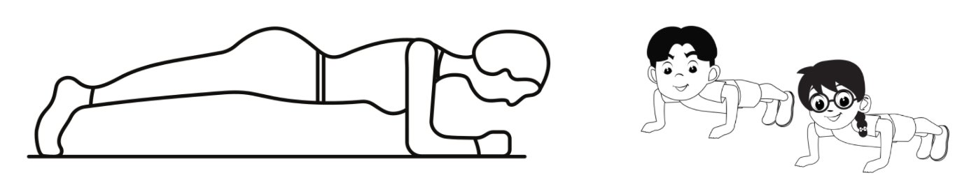
How to
- Rest your forearms on the ground.
- Keep your arms parallel (like train tracks) to the body at a shoulder-width distance.
- Look at a spot on the floor to keep your spine, neck, and head in a straight line.
- Hold your legs and tummy as tight as possible with the tip of your toes on the ground. The tighter and stronger you hold your body the easier it is to stay in your plank.
- Don’t let your bottom stick up too far or for your back to bend – you are being as straight and solid as a plank!
- Hold the position for 10 seconds (or longer if you can). Take a break and repeat.
Jumping
Jumps build muscle strength, cardiovascular fitness, and endurance. Can you find a friend or family member and see who can jump the highest?
Some fun jumps to try include:
- Criss-cross feet: Jump straight up, then cross one foot in front of the other; on next jump, switch feet and continue.
- Hurdle hops: Jump side-to-side or front-to-back over a pretend hurdle.
- Jumping jacks: Stretch arms and legs out to the side like a starfish while jumping; on the second jump, return arms to sides and legs to centre on the landing.
- One-foot hops: Lift one knee and jump on the standing leg; alternate. (This is a great balance challenge, too.)
- Tuck jumps: Bend knees and lift heels high while jumping

Daily wellbeing – Choose something each day
These activities are good to do at the beginning and end of the day but can be done anytime. They can help you get ready for learning; calm your mind and body and they can help you to reflect on your learning:
1. Planning to be GOOD tomorrow
- Goal: What is something you want to achieve tomorrow?
- Options: What are some ways you can make this happen?
- Obstacles: What could get in the way of you making it happen?
- Do: What are you going to do and when?
2. Spidey-Senses – being present
Find somewhere comfortable to sit (can be inside or outside).
Close your eyes and take a deep breath.
Now turn on your ‘Spidey senses’ – your super focused senses of smell, hearing, taste, touch, and sight – just like spiderman.
Think about the air coming into and out of your nose.
- What are 3 different aromas that you can smell? Take another deep breath.
Think about the sounds coming into your ears.
- What are 3 different sounds that you can hear? Take another deep breath.
Think about your tongue and tastebuds in your mouth.
- What can you taste right now? Take another deep breath.
Think about the skin that is covering your body.
- What are 3 things you can feel through your skin right now, without moving? Take another deep breath
Slowly open your eyes.
- What are 3 things that you can see that you haven’t noticed before?
3. Make a small change
Adapted from: https://www.gonoodle.com/videos/eXAzV2/make-a-small-change
Sit down and get comfortable. Close your eyes and take a deep breath.
Even though you might feel the same today as you did yesterday – you learn, you grow, you change, just a little bit every single day.
Take a moment to think of a tiny change you have made recently. A little thing that you did differently.
Every small positive change you make helps you become the very best you.

Starting each day
Notes for teachers and whānau:
Starting the same way each day helps create a structure for your learner. Your school might have your own way to do this, for example starting the day together as a class on Zoom. In this pack we provide a karakia to settle into the day. Saying the karakia with your learner a few times will help them be able to do this more independently tomorrow and beyond. As part of the start of the day and setting up the learning environment, help your learner look through the activities suggested for that day and choose a fitness and wellbeing activity. They could fill out their daily timetable and think of other activities they might like to do, like reading.
Remind your learner of when and how to check in with the teacher/you.

Karakia
Here is a karakia to welcome in the day
Whakataka Te Hau: Karakia video: https://www.youtube.com/watch?v=_uQqIGt3H2w
Whakataka te hau ki te uru,  Whakataka te hau ki te tonga.  Kia mākinakina ki uta,  Kia mātaratara ki tai.  E hī ake ana te atākura  he tio, he huka, he hauhunga.  Haumi e! Hui e! Tīiki e! | The wind swings to the west  then turns into a southerly.  making it prickly cold inland,  and piercingly cold on the coast.  May the dawn rise red-tipped  on ice, on snow, on frost.  Join! Gather! Intertwine!

Planning my day
- Have you chosen which activities you will do today and in which order?
- Remember to choose a fitness activity. (See p. 5)
- Have you chosen a wellbeing activity? (See p. 7)
- Have you done a ‘Wellbeing check-in' ?
  - How are you feeling today?
  - How do you feel about your readiness to learn this morning?
  - What do you need extra assistance with today? Who could you get to help you? What strategies could you use to help make your learning more effective?
  - What would you like to do as a quiet time activity to end your day?
- Remember to do your Reflection at the end of the day. (See p. 9)

Ending each day
Please ensure your learner does this at the end of each day.
Reflection can be challenging for all learners, but it can also provide them with rich opportunities to think about how their learning is progressing. Use the questions below as prompts to encourage your learner to think about what they have learned so far and help them to plan out their next steps. If you have concerns with their learning or find that your learner is needing more help, contact their teacher for more support.

I am learning to: Reflect on my learning.
What do I need?
- A notebook or online doc that you can use each day for your reflection activity. We will call this your “reflective journal”
- Materials for your quiet time activity
Take some time to think about how you are feeling and after today’s learning activities.
Reflect on the following prompts in your reflective journal.
- What did you enjoy most about today?
- What is one thing you feel you learnt today?
- What is one strategy that helped you with your learning?
- What did you find challenging or distracting? (You ran out of time for some activities, or you finished them quite quickly and wanted to dig in a little deeper.)
- Is there anything you need extra help with? Who can you ask to help you with that?
- Is there anything you want to catch up on tomorrow?
Remember to finish with a wellbeing activity and/or your chosen quiet time activity.

Context 1: Adaptation

The next five days investigate the big idea of change by looking at adaptations – animals and humans.

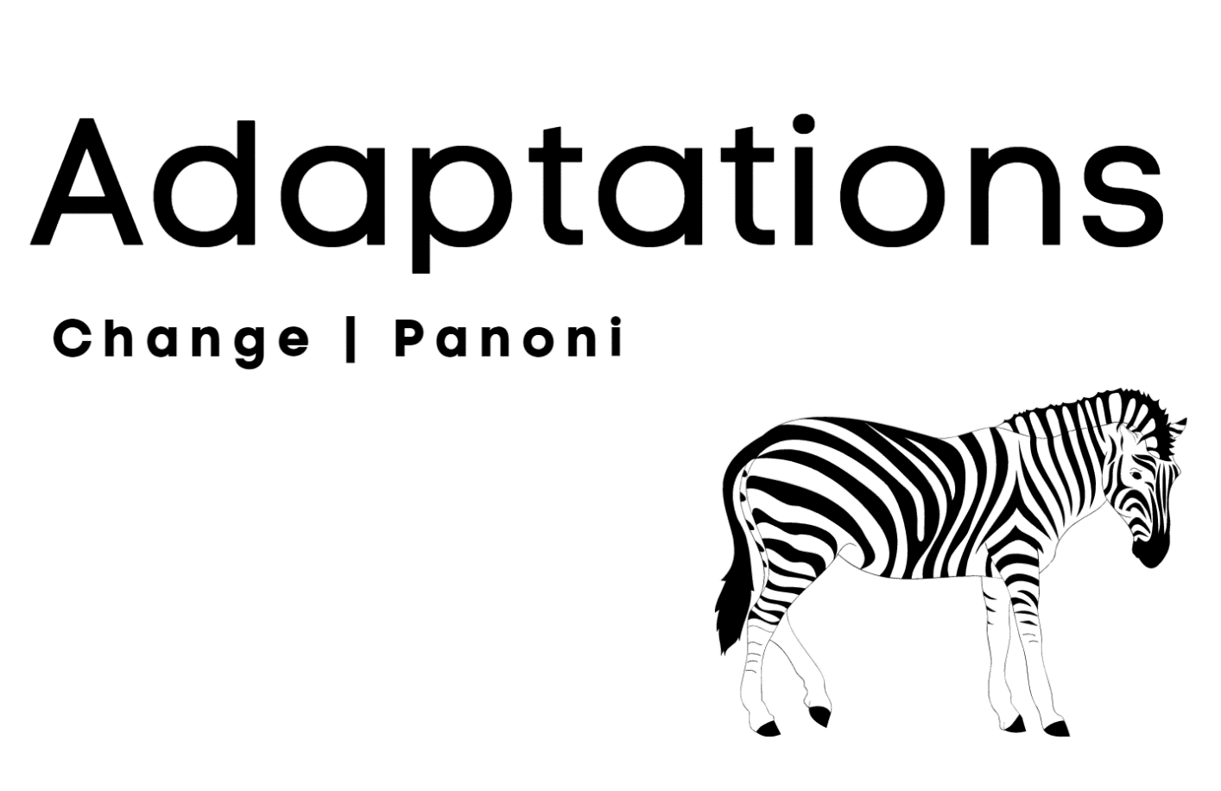

Day 1 activity 1: Inquiry getting started
Notes for teachers and whānau
We will start exploring adaptation by looking at changes we make to suit conditions. We will then look at animals and the changes they make.
Note that our Inquiry focus for today is “getting started” which includes generating questions, activating prior knowledge, and introducing the big idea.

I am learning about how we change things when we need to.
What do I need?
- 45 minutes
- Your home learning book
- Crayons, felts or coloured pencils
- Look in your pack for a copy of Rain, Rain https://instructionalseries.tki.org.nz/Instructional-Series/Ready-to-Read-Colour-Wheel/Rain-Rain

Instructions:
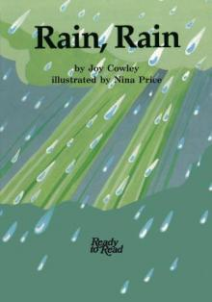
Our weather changes a lot. Sometimes it is hot, sometimes it is cold. Sometimes it rains, snows, or is very windy. Think about how you keep yourself comfortable in different weather.

Your task:
Listen to or read Rain, rain by Joy Cowley. Look at what the people are wearing.
Draw up a grid in your workbook like the one below.
Draw yourself going out on:
- A rainy day
- A very hot day
- A snowy day
- A windy day
Draw and label what you would be wearing. Draw and label what you would take with you.
The weather | What would I be wearing? | What would I take with me?
A rainy day
A very hot day
A snowy day
A windy day

Day 1 activity 2: Literacy
Notes for teachers and whānau
This activity requires the learners to write a list. The task requires them to apply higher order thinking such as application and synthesis when putting the animal into a different context.

I am learning to write a list.
What do I need?
- 30 minutes
- Your home learning book
- Pen or pencil
- Look in your pack for a copy of https://instructionalseries.tki.org.nz/Instructional-Series/Ready-to-Read-Colour-Wheel/Me-and-My-Dog

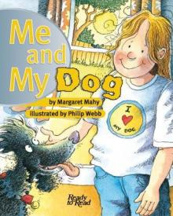
Instructions:
Do you have a cat or dog?
Read or listen to Me and my Dog.

Your task:
Baxter lives in a home with his owner.
Imagine if Baxter decided he wanted to live in a different kind of climate.
Let’s see if you can make a list.

Lists have commas after each item, for example – jacket, hat, gloves
- Make a list of three things Baxter would need if he lived in the sea.
- Make a list of three things Baxter would need if he lived in the desert.
- Make a list of three things Baxter would need if he lived in Antarctica.

Day 1 activity 3: Science and literacy
Notes for teachers and whānau
This task requires the learner to consider the climate of a place and how an animal might survive in that climate. Ask them to look closely to see what features the animal has. You could discuss body covering, beaks, noses, feet, tails etc).

I am learning about what animals have to help them survive.
What do I need?
- 45 minutes
- Your home learning book and a pen or pencil

Instructions:
Animals that live in different climates have things to help them stay alive. Climate is a word for the kind of weather in a place. Another word for staying alive is survive.

Your task:
Look at each of the animal pictures in the table and think about the climate where this animal might live, and what the animal might need to survive.
You can either write or draw what you think the weather/climate is like and what the animal or bird might need to survive. You can write AND draw if you want.
Animal | Where does the animal live? | What does the animal need to survive?
Elephant
Kererū
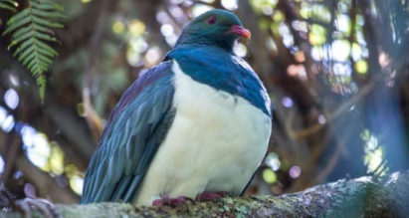
Dolphin
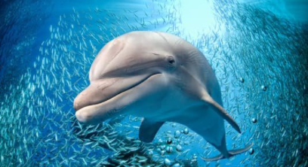
Polar bear

Day 1 activity 4: Mathematics (Geometry)
Notes for teachers and whānau
This activity involves cutting out shapes and making them into another shape. Encourage the use of geometric language when talking about the shapes and laying them alongside each other.

In this activity I am learning to identify shapes.
What do I need?
- 45 minutes
- Your home learning book
- Scissors
- Copy of Arty shapes sheet
https://nzmaths.co.nz/sites/default/files/ArtyShapes-ShapeSheet.pdf

Instructions:
Let's look at some different shapes today.
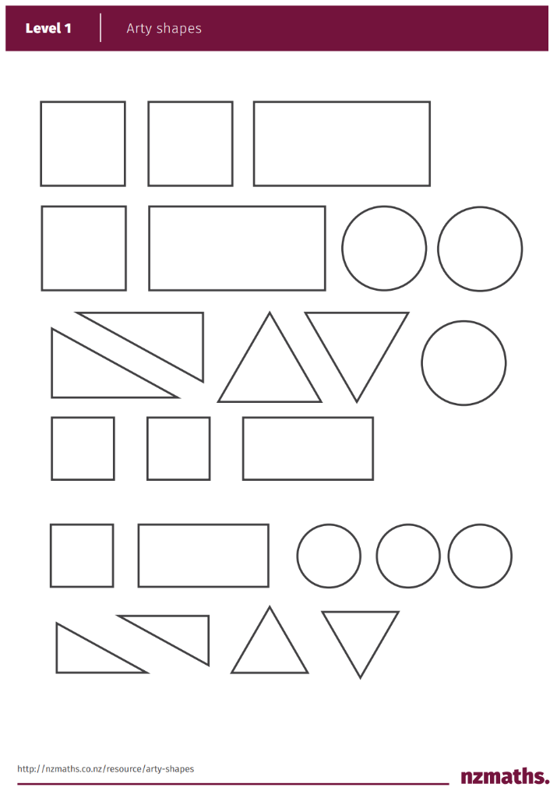
Can you walk around your home and discuss things on the walls, window frames etc. What lines and shapes can you see? Can you name them?
These are some of the things/shapes you might see: sides, corners, curved and straight lines, edges, pointed, rectangle, square, circle, triangle.

Your task:
Using the Arty Shapes sheet, cut out the shapes.
Make an animal of your choice with the shapes – if you haven’t any glue, just lay the shapes on a flat surface.
You might even be able to take a photo of your shape picture and send it to your teacher.

Remember to do your end of day reflection and wellbeing activities (See p. 7&9).

Day 2 activity 1: Science and literacy
Notes for teachers and whānau
This activity requires learners to consider the different ways animals make adaptations – not just the physical features but also the ways they behave and interact with other creatures. Note that our Inquiry focus for today is “explore, investigate, and discover” which includes choosing and evaluating information, and thinking critically

I am learning to identify adaptations.
What do I need?
- 45 minutes
- https://www.youtube.com/watch?v=vnmPdHmRv9o
- Snail image https://www.maxpixel.net/Mollusk-Line-Art-Shell-Antennae-Animal-Snail-5812983
Remember to start your day right (See p. 8)

Your task:
Yesterday we talked about places with different climates and surviving in those places. Habitat is another word for place; the home or surroundings where something lives.
Animals develop features to help them stay alive and healthy, to survive in their habitat.
Animals can make adaptations in different ways.
- Behavioural – the things the animal does
- Physiological – things the animal’s body does – e.g. makes venom
- Physical or structural – things about the animal’s body e.g. claws, fur.
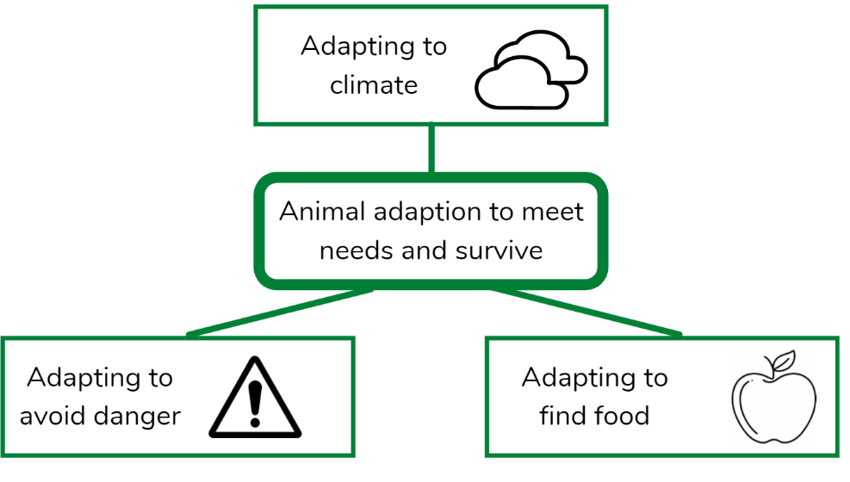

Instructions:
Watch this video (or have someone read the transcript to you).
https://www.youtube.com/watch?v=vnmPdHmRv9o
Transcript
An adaptation is a feature of an organism that gives us some sort of benefit or advantage. They could help it build a shelter, find food, protect itself, or compete against others for mates, food, and resources. Adaptations can be categorised into three main groups: structural or physical, behavioural, and physiological. Let's now look at the differences between these by looking at some examples.
Structural adaptations are physical features of the body that help with survival or reproduction. Some examples include having horns to defend against predators and to compete against others; having fins for aquatic animals who need to swim efficiently; and having armour to defend against predators. Having camouflage that helps you blend in with your environment is a useful adaptation to have, it can help you hide from predators who might be looking for a quick snack, it can also make your prey find it harder to see you which allows you to get in close and get a sneak attack. Having brightly coloured flowers is a structural adaptation of plants which attract insects and assists with the pollination process.
Behavioural adaptations are things that the organism does which gives it some sort of benefit, and for the most part they are born with the ability. Herding is a great example of a behavioural adaptation. Not only does it help you find food easier as a group, but it also helps you spot predators and raise the alarm. Socialisation is another adaptation that's observed in a lot of species. It allows behaviours to be taught to other members of the same species, it allows opportunities for relationships to develop, and it promotes cooperation. Setting a trap, like a spider spinning a web, is a strategy to try and catch some food. The octopus, the most intelligent invertebrate, is capable of mimicking other animals in order to get closer to its prey.
Physiological adaptations are things that the organisms body does without necessarily having to consciously tell it to do so. For example, a feature of mammals is that the females produce milk which is a nutrient-rich food source for their offspring. It doesn't choose to produce the milk, but it just does, and in doing so that's helping the survival of the next generation. Producing poison or venom is an example of a physiological adaptation. A toad's body producing poison will help deter its predators.
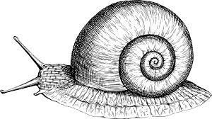
Let’s use what we have learned in this video, have a look at this snail.
Write down an example of each kind of adaptation the snail has to enable it to survive:
- Behavioural:
- Physiological:
- Structural:
Image source: https://www.maxpixel.net/Mollusk-Line-Art-Shell-Antennae-Animal-Snail-5812983

Day 2 activity 2: Science and visual art
Notes for teachers and whānau
This activity requires learners to think about the kinds of features an animal would need to be able to survive i.e. get food, protect itself, hide.

In this activity I am learning about animal features that help it survive.
What do I need?
- 30 minutes
- Your home learning book
- Crayons, felts or coloured pencils

Instructions:
Let’s think more deeply about the kinds of adaptations or changes that animals have to survive.

Your task:
In your workbook, draw an animal that matches each of these examples:
- An animal that could quickly dig a tunnel to get away.
- An animal that has a covering strong enough to stop teeth biting into it.
- An animal that has a way of warning off its enemies.
- An animal that has spines or stingers.
- An animal that can move quickly to get away.
- An animal that would blend in with its surroundings.

Day 2 activity 3: Science and literacy
Notes for teachers and whānau
This activity explores ideas of camouflage, and protection more deeply. It is also a comprehension task to foster deeper thinking about what the text is telling them.

I am learning to answer questions from text.
What do I need?
- 45 minutes
- Stick Insects text
- Your home learning book
- Look in your pack for a copy of Stick Insects https://instructionalseries.tki.org.nz/Instructional-Series/Ready-to-Read-Colour-Wheel/Stick-Insects
- Pen or pencil

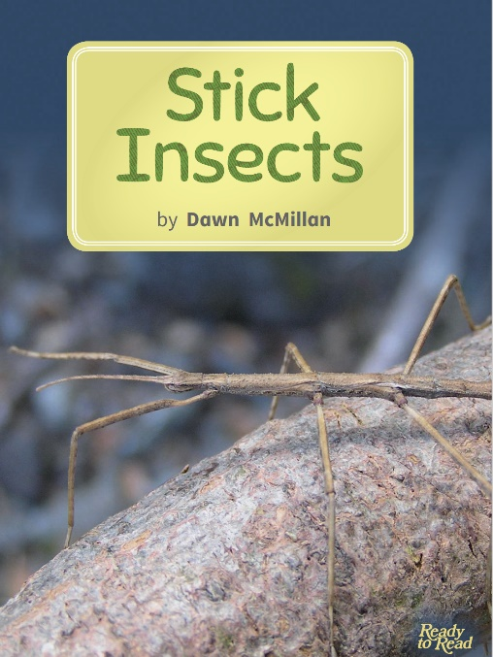
Instructions:
Read or listen to Stick Insects.

Your task:
From the description in the story:
Draw a stick insect in your home learning book.

Answer these questions:
- What do stick insects eat?
- How do stick insects keep safe?
- What does camouflage mean?
- What is a young stick insect called?
- What do you think the spines on the stick insect are for?

Day 2 activity 4: Mathematics
Notes for teachers and whānau
This activity uses the context of the different stages of the monarch butterfly to further develop ideas about physical features for survival. It then uses the butterfly shape to explore lines of symmetry.

I am learning about lines of symmetry.
What do I need?
- 45 minutes
- Look in your pack for a copy of Butterfly Day
https://instructionalseries.tki.org.nz/Instructional-Series/Ready-to-Read-Colour-Wheel/Butterfly-Day
- Look in your pack for a copy of the butterfly image
https://openclipart.org/detail/222362/black-and-white-butterfly
- Your home learning book
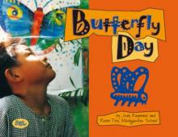
- Pen or pencil, crayons, felts, or coloured pencils.

Instructions:
Read or listen to Butterfly Day.

Your task:
In your home learning book, answer this question:
How does the monarch butterfly keep safe when it is a:
- Caterpillar
- Chrysalis
- Butterfly
Let’s have a close look at a picture of a butterfly.
Look for the butterfly worksheet in your pack. Colour in this monarch butterfly.
A line of symmetry is a line that cuts a shape exactly in half where both halves are exactly the same).
Draw a line where you think the line of symmetry would be for this butterfly (the line that cuts the shape exactly in half).
Draw in what the other side of the butterfly would look like. Colour it in.

Remember to do your end of day reflection and wellbeing activities (See p. 7&9).

Day 3 activity 1: Science and literacy
Notes for teachers and whānau
This activity requires the learner to look closely at the different legs and beaks of birds and wonder why they might be different.
Note our Inquiry focus for today is "making meaning" which includes analysing data, organising, and sorting information, summarising, synthesising, making connections/conclusions, building deeper understandings, and thinking critically.

I am learning to identify features that birds have to survive.
What do I need?
- 45 minutes
- Your home learning book and a pen or pencil
- Look in your pack for a copy of New Zealand Birds https://instructionalseries.tki.org.nz/Instructional-Series/Ready-to-Read-Colour-Wheel/New-Zealand-Birds
Remember to start your day right (See p. 8)

Instructions:
Can you name the birds in the table? Choose from kiwi, kākā, tūī, kererū.
Draw a table like the one below.
- In the beaks row, draw the beak of each bird.
- In the legs row, draw the legs of each bird.
 | 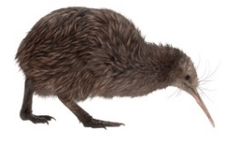 | 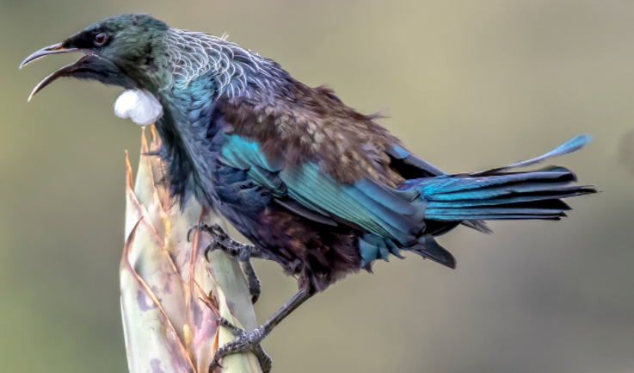 | 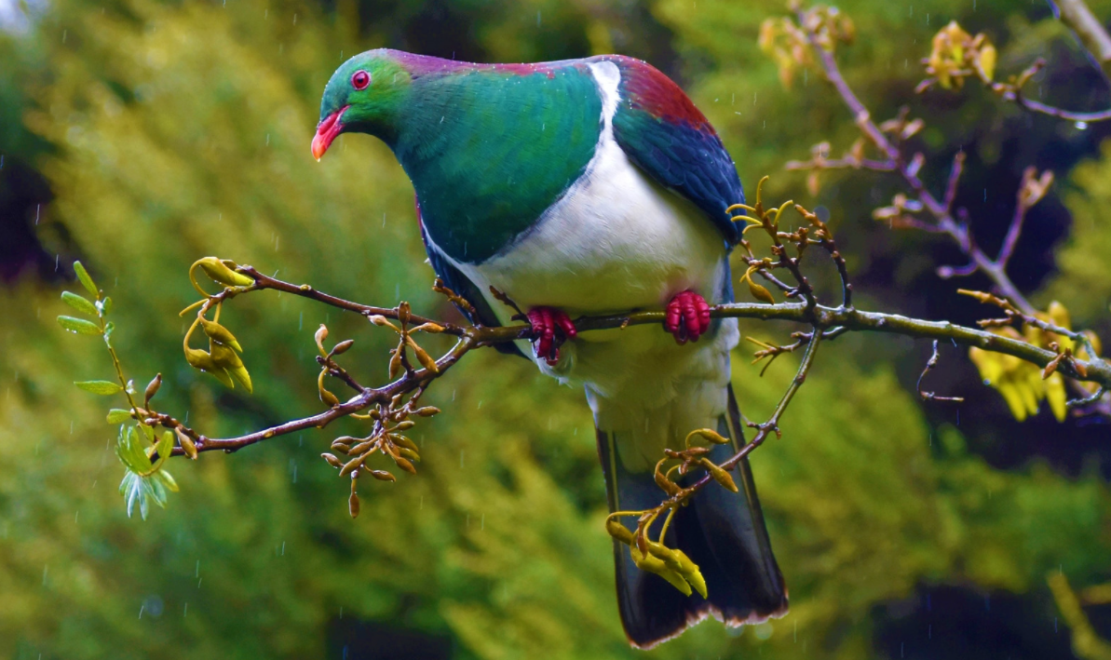 | 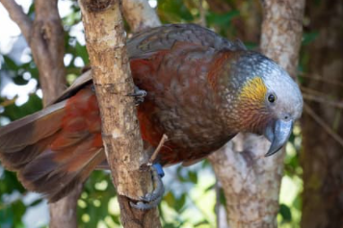
Name
Beak
Legs

Your task:
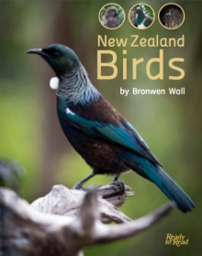
Listen to or have someone read the book New Zealand Birds to you.
Answer the questions:
- How does the kiwi use its strong, sturdy legs?
- Why is the kākā’s beak shaped the way it is?
- Why does the kererū have a short beak?
- How does the tūī use its beak?
- Why do you think birds don’t have the same shaped beaks or legs?
In your home learning book, draw and label your favourite New Zealand native bird.

Day 3 activity 2: Literacy – writing
Notes for teachers and whānau
This activity asks the learner to bring their imagination to their knowledge of features and animal behaviours and create a story to explain a feature of the kiwi.

I am learning to write a creative story.
What do I need?
- 30 minutes
- Your home learning book
- Pen or pencil

Instructions:
Think about the New Zealand Kiwi.

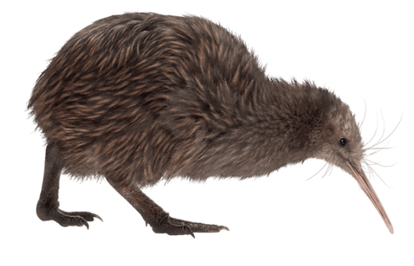

Your task:
Write a story and tell us how the kiwi got its big, long beak.
Some words you might want to use:

Kiwi, legs, beak, feathers, feet, bush, insects, forest, dirt, scratch, claws, undergrowth, night-time, nocturnal, hiding, camouflage

Day 3 activity 3: Mathematics
Notes for teachers and whānau
Using a different animal – the lion, learners are asked to consider its features closely and suggest how they might help it live in its habitat. Learners then use the lion image to explore the mathematical concept of enlargement.

I am learning to make a picture bigger (enlarge it).
What do I need?
- 30 minutes
- Your home learning book
- Pen or pencil
- Look for a copy of the enlargement grid worksheet in your pack
https://www.free-for-kids.com/wp-content/uploads/2020/01/Enlargement-Grid-With-Lion.pdf

Instructions:
Lions live in hot places.
Take a look at this lion image.

Your task:
What do you think that big mane is for?
I wonder why they are the colour they are?
Why would the lion have such a big nose and a rough tongue?
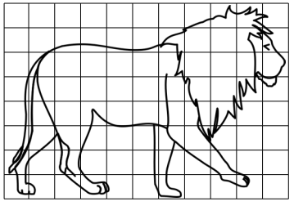
Look in your pack for the grid worksheet. See if you can enlarge the lion above using the grid squares to help you.

Day 3 activity 4: Science, literacy and visual art
Notes for teachers and whānau
To deepen learners’ understanding of habitat and extend their imaginative thinking, this activity asks learners to start with a habitat and consider what kind of creature might be able to survive there and what it might look like.

I am learning to about habitats and features.
What do I need?
- 30 minutes
- Your home learning book
- Pen or pencil

Instructions:
What might an animal need for living in different kinds of places/habitats?

Your task:
In your home learning book, complete the chart below (you can draw or write your thoughts).
Habitat | What would their bodies need to have to survive? | What kinds of things would they have to do to survive?
Hot
Not much water
Not much shade
Cold
Ice and snow
No trees or plants
Water
Lake, ocean, or river
Jungle
Lots of tall trees, plants
Fruit high up in the trees

Remember to do your end of day reflection and wellbeing activities (See p. 7&9).

Day 4 activity 1: Science and visual art
Notes for teachers and whānau
This activity requires the learner to apply their knowledge of features/adaptations as they design a creature that can live in a habitat of their choice.
Note today our Inquiry focus is “going further, deeper”. This may include promoting opportunities to engage further and dive deeper through discussions, provocations, exploring further contexts, taking action, or thinking critically and drawing conclusions.

I am learning to show what an animal needs to survive in a habitat.
What do I need?
- 30 minutes
- Your home learning book
- Pen or pencil
- Crayons, felts or coloured pencils.
Remember to start your day right (See p. 8)

Instructions:
Choose a habitat from the ones in the chart from the last activity, for example hot, cold, water, jungle.

Your task:
Design an animal or bird that could survive in that place.
Think about:
- What shape it would be.
- What it might eat – so the kind of teeth it would need.
- What might it need to help it catch or gather its food?
- What might its feet look like?
- Would it have wings or a tail? What would they need to look like?

Draw your animal in your home learning book.

Day 4 activity 2: Literacy – poetry
Notes for teachers and whānau
This activity enables learners to be creative as they build a haiku poem. They may be able to include a feature of an animal in their poem.

I am learning to write a haiku poem.

What do I need?
- 45 minutes
- Your home learning book
- Pen or pencil
- Optional video to explore syllables: https://www.youtube.com/watch?v=0QcPb5bku70

Instructions:
Haiku poems have 3 lines.
There are 5 syllables in the first and last line.
There are 7 syllables in the second line.

Here is an example:
Deep and dark jungle
Monkeys swinging by their tails
High in the treetops.

Your task:
Think about the place where your designer animals live.
Can you describe it in a haiku poem?
If you can, see if you can include a special feature of the animal that your poem is about e.g. in the poem above it talks about how the monkey uses its tail to swing high in the treetops.

Day 4 activity 3: Literacy – poetry
Notes for teachers and whānau
This activity builds on the last one by using haiku poems to help the learner make connections between their knowledge of animals and their characteristics.

I am learning to work out what the writer is describing.
What do I need?
- 30 minutes
- Your home learning book
- Pen pencil
- Crayons, felt pens or coloured pencils

Instructions:
Read these other haiku poems.
Write down what the animal might be.
Draw the animal.

Your task:
 | What is it? | Draw it?
Sneak up on their prey
very silent and deadly
don't get in their way.
Pitter patter paws
A cosy warm place to sleep
Purring up a storm
Strong teeth like a steel
Moves with great agility
King of the forest
Crawling silently
Binding its prey with poison
Venom is flowing

Day 4 activity 4: Mathematics: problem-soving
Notes for teachers and whānau
This activity uses a nursery rhyme to engage learners with a mathematical problem.

I am learning to solve mathematical problems.
What do I need?
- 30 minutes
- Your home learning book
- Pen or pencil

Instructions:
Watch the video or read the poem about the three little kittens.
https://www.youtube.com/watch?v=m0VW5f8iezs
The three little kittens have lost their mittens!
Three little kittens they lost their mittens, and they began to cry,
Oh, mother dear, we sadly fear, our mittens we have lost.
What! lost your mittens, you naughty kittens!
Then you shall have no pie.
Mee-ow, mee-ow, mee-ow. No, you shall have no pie.
The three little kittens they found their mittens, and they began to cry,
Oh, mother dear, see here, see here, our mittens we have found!
Put on your mittens, you silly kittens,
And you shall have some pie.
Purr-r, purr-r, purr-r, oh, let us have some pie.
The three little kittens put on their mittens, and soon ate up the pie;
Oh, mother dear, we greatly fear, our mittens we have soiled.
What! soiled your mittens, you naughty kittens!
Then they began to sigh,
Mee-ow, mee-ow, mee-ow. Then they began to sigh

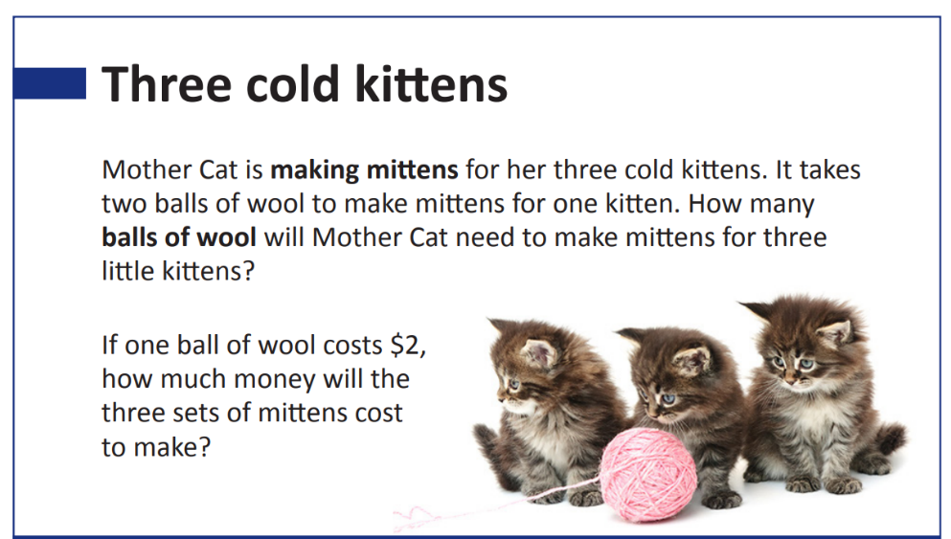
Your task:
Solve this maths problem.

Remember to do your end of day reflection and wellbeing activities (See p. 7&9).

Day 5 activity 1: Higher order thinking – metacognition
Notes for teachers and whānau
This activity requires the learner to bring their understanding of habitat and adaptation to a creative task. They then imagine the world around that creature – its behaviours, features, and other characteristics.
Note that today our Inquiry focus is “present – share learning about the big idea” which includes thinking about who the audience is and considering different ways of communicating learning for example, presentation, video, poster, etc.

I am learning to think about my thinking.
What do I need?
- 30 minutes
- Your home learning book
- Pen or pencil
Remember to start your day right (See p. 8)

Instructions:
You have learnt about:
- Habitat: the place an animal lives
- Adaptation: the things an animal has to help it survive in its habitat.
In a previous activity you designed your own animal or bird that lived in a chosen habitat.
Go back and have another look at your animal or bird.

Your task:
Can you answer these questions?
- What is the name of my animal or bird?
- How does my animal or bird get food for itself?
- How does my animal or bird defend itself against enemies or predators?
- How does my animal or bird keep warm/cool depending on its habitat?
- What behaviours would my bird or animal have to keep itself alive e.g. ability to hide, run fast, fly away etc.

Go back and add things to your design if you need to.

Day 5 activity 2: Literacy and visual art
Notes for teachers and whānau
Building on their creative endeavours the learner is asked to think what a day would look like for their designed creature. This asks them to apply their knowledge and understanding of how the creature functions and survives.

I am learning to show how my animal lives.
What do I need?
- 30 minutes
- Pen or pencil
- Crayons, felt pens or coloured pencils
- Comic strip template

Instructions:
In your home learning book, use a comic strip to make up a visual story of a day in the life of your bird or animal. Make sure your story shows how your bird/animal uses its adaptations.
Think about how many pictures you are going to draw to tell your story and draw a comic strip like the one below with the right number of boxes for your drawings. Draw your picture in the top part of the comic strip and write about the picture in the bottom section.
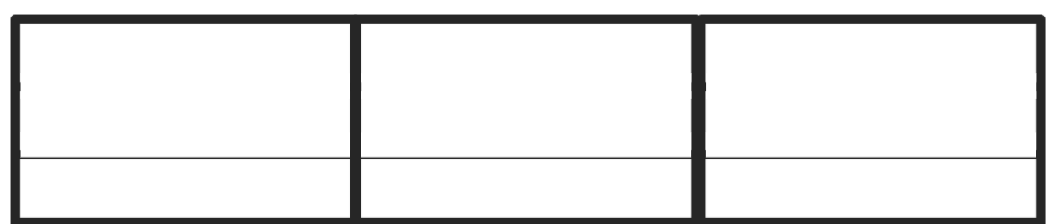

Your task:
A day in the life of my bird/animal
Include:
- getting and having a meal
- an encounter with an enemy
- doing something it enjoys
- resting or sleeping

Day 5 activity 3: Mathematics – problem solving
Notes for teachers and whānau
This is a mathematical problem-solving activity using the context of an animal showing some of its survival features.

I am learning to solve mathematical problems.
What do I need?
- 30 minutes
- Your home learning book
- Pen or pencil
- Crayons, felt pens or coloured pencils

Your task:
Problem solving
A problem is something we try and solve.
We read the problem and work out what it is asking us to find out. Here is an example:
A bear was using his giant claws to catch salmon to eat.
On Monday he caught three salmon.
On Tuesday he caught two salmon.
On Wednesday he caught one salmon.
How many salmon did the bear catch altogether?

This problem is asking us to find out how many salmon the bear caught altogether. That is 3 on Monday, 2 on Tuesday and 1 on Wednesday.
If I add them together I get 6 salmon in total.

Instructions:
Draw a picture to show this problem. Show how many salmon the bear caught each day so that you can add them all up.
Can you make up some of your own maths problems using other animals or birds e.g. kiwi and worms, bat, and insects?

Day 5 activity 4: Literacy: writing
Notes for teachers and whānau
This activity requires the learners to apply their knowledge of key vocabulary used through this unit to write an explanation of adaptation.

I am learning to write an explanation.
What do I need?
- 30 minutes
- Your home learning book
- Pen or pencil

Your task:
Write a short explanation to tell someone what adaptations are. Try to use some of these words:
- Habitat
- Survive
- Adaptation
- Features
- Climate
- Camouflage
- Predator
You might start with:

Adaptations are...

Remember to do your end of day reflection and wellbeing activities (See p. 7&9).

Context 2: Innovation – can I make a better ...?

The next five days investigate the big idea of change by looking at innovation, and looking at how to make improvements to something.

Day 6 activity 1: Inquiry getting started
Notes for teachers and whānau
Last week we looked at how people and animals change or adapt over time to suit their environment and what is happening around them. Another way we can make changes is to make things better. This can be called improvements or innovations. Sometimes something completely new or different is created and that can be called an invention. This week we are going to explore being innovators or even inventors of something new or different to make something better.
Note that our Inquiry focus for today is “getting started” which includes generating questions, activating prior knowledge, and introducing the big idea.

I am learning to: observe and make a list
What do I need?
- 30 minutes
- Your home learning book and a pen/pencil

Instructions:
Let’s start by looking in our own home at all the things we use on a daily basis. Go for a walk through your kitchen and lounge.

Your task:
Write (you could practise making a list like last week) or draw all the things you can see that are used to make life easier for you and your whānau.
Kitchen
What I can see:
- In the cupboards
- On the bench
- On the table
- On the walls
Lounge
What I can see:
- Around the room
- On the coffee table
- On the walls
Some things you might have seen:
Kitchen: eggbeater, toaster, kettle, knives, forks, spoons, pots and pans, stove/oven, sink, food processor, grater, rubbish or compost bin, fridge, microwave...
Lounge: remotes for TV etc, chairs, coffee or side table, foot stool, TV, stereo, video game console ...

Day 6 activity 2: Purpose and function
Notes for teachers and whānau
This activity is designed to encourage the learner to look more closely at the purpose and function of items in our home.

I am learning to: complete a table and use my imagination
What do I need?
- 30 minutes
- Your home learning book
- Pen/pencil

Instructions:
Think about the purpose or functions of some of the things you saw in your kitchen or lounge. What do we use it for? If you don’t have one of these things in your home, leave it out. You might like to add more rows to add more items to your list.

Your task:
- Complete the table below:
The thing | What do we use it for?
Grater
Egg beater
Microwave
TV remote
Toaster
Sofa/couch

2. Choose two of the items above and think about how you could combine them into a new invention. You want to combine the different functions to come up with a new use for the item.
Draw and label your new invention.
Give it a new name
Write a description of what it does and how you would use it.

Day 6 activity 3: Literacy (reading and writing)
Notes for teachers and whānau
This activity explores the idea of having a robot to do things for you. It asks your learner to imagine what their robot could do.

I am learning to: find key ideas in text; write an explanation
What do I need?
- 30 minutes
- Your home learning book
- Pen/pencil
- Look in your pack for a copy of Fleeb makes scones https://instructionalseries.tki.org.nz/Instructional-Series/Ready-to-Read-Colour-Wheel/Fleeb-Makes-Scones

Instructions:
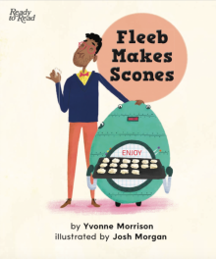
Have you heard of a robot?
Read Fleeb makes scones

Your task:
In your home learning book, draw three things that Fleeb does that help to make the scones, then answer these questions:
- Why do you think this whānau has a robot?
- How does Fleeb make life easier for this whānau?

What would it be like to have your own robot at home?
Design a robot that you would have at home. Draw and label its parts.
Write a story about your robot.
- What would it be called?
- What would it look like?
- How would it help you? Describe your robot’s purpose or function?

Day 6 activity 4: Mathematics and digital technology
Notes for teachers and whānau
This activity uses the robot idea to explore basic coding through giving instructions. It also encourages the use of positional and directional language.

I am learning to: give directions
What do I need?
- 30 minutes
- Your home learning book
- Pen/pencil

Instructions:
Robots need to be told how to move around.
Imagine you have to give your robot instructions to do things. You would use words like turn around, right, left, forward, backward, steps
You could use one of your toys as a robot (or a family member!)

Your task:
Give your robot instructions of how to get from:
- a chair in the lounge to their bedroom
- the kitchen to the bathroom
- the front door to the back door
Go outside and set up an obstacle course or describe a path for your robot to take a walk around the yard.
In your your home learning book, write the instructions and draw the paths taken for each instruction you gave.
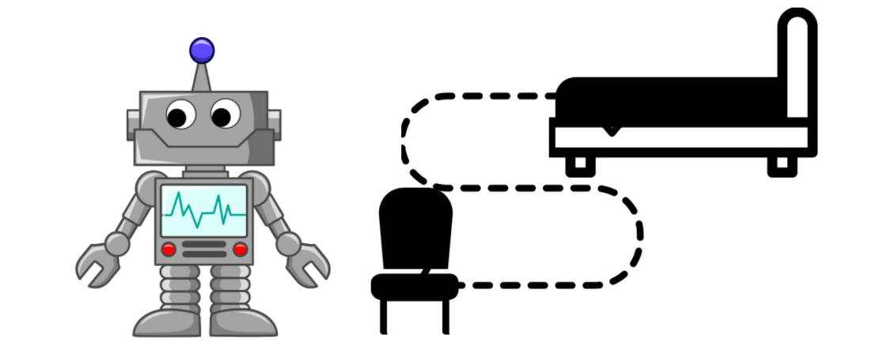
Optional extra: – https://beebot.terrapinlogo.com/

Remember to do your end of day reflection and wellbeing activities (See p. 7&9).

Day 7 activity 1: Literacy and visual art
Notes for teachers and whānau
Today we will further the idea of making something better through improvement, innovation, or invention.
Note that our Inquiry focus for today is “explore, investigate, and discover” which includes choosing and evaluating information, and thinking critically.

I am learning to: draw an everyday object and brainstorm
What do I need?
- 30 minutes
- Your home learning book and a pen/pencil
Remember to start your day right (See p. 8)

Instructions:
Everyday things in our homes make everyday tasks and our lives easier.
Yesterday we listed some everyday things found in the lounge and kitchen. Think about what it would be without some of the things that we use to make life easier.
What would life be like without:
- toothbrush
- toilet
- bed
- cars
- electricity – e.g. lights, heaters, machines

Your task:
In your home learning book, select one of these items:
Draw it.
Around it, write down all the things that would be different without it.
Think about what you could do to improve the item. Write this on your page.
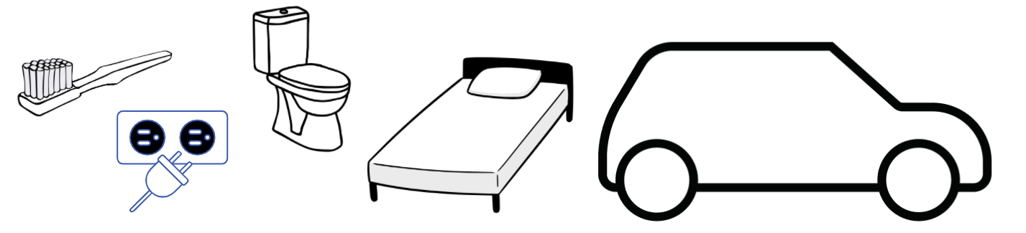

Day 7 activity 2: Literacy (reading, writing) and visual art
Notes for teachers and whānau
This activity explores some inventions by New Zealanders in response to a purpose.

I am learning to: draw, and write a description
What do I need?
- 30 minutes
- Your home learning book and a pen/pencil
- New Zealand inventions that changed the world https://www.youtube.com/watch?v=891gpAqf6Dg

Instructions:

People have invented things to make our lives easier. They have seen a need or a problem and found a solution by making something new. We call these people inventors.

Watch the video New Zealand inventions that changed the world (or have someone help you read the adapted transcript below).
New Zealand's been responsible for some surprisingly important and some not so important inventions. Here's a few of them.
- The disposable hypodermic syringe invented by Colin Murdoch in 1956.
Murdoch was a pharmacist and veterinarian from Christchurch. He saw that reusable glass hypodermic syringes posed a risk of infection, so he designed a plastic single-use hypodermic syringe that at first, was called too futuristic by the NZ Ministry of Health! He eventually patented the design anyway and to date it's one of the most important developments in human medicine. Later he invented the tranquiliser gun.
- The referee whistle invented by William Atack in 1884.
It makes sense that the referee's whistle was pioneered in New Zealand! Until this revolutionary idea, referees simply shouted at players. As a referee in Canterbury, Atack got tired of shouting so one day he got two teams to agree to play to a whistle he would pull from his pocket. Rugby lawmakers in England got wind of this revolutionary concept and it quickly spread there as well as well as onto other sports.
- The eggbeater invented by Ernest Godward in 1900.
Dunedin resident and champion rower, cyclist, and swimmer, Ernest Godward had ten children. He became obsessed with making every day domestic chores easier and looked to improve household tools. He patented a hand-powered eggbeater that could prepare eggs in three minutes instead of the usual fifteen!
- The aeroplane invented by Richard Pearse in 1902–1903.
The Wright brothers are known for being the first people to achieve powered flight in 1903 but were they actually the first? In March 1903 Richard Pearse of Waitohi in South Canterbury achieved powered flight, eight months before the Wright brothers! Pearse didn't record his early attempts and even downplayed his efforts saying that he didn't achieve proper flight, but several eyewitnesses that day state that Pearse achieved flight for 50 yards before crashing into his own property's gorse fence.
- Nuclear physics by Ernest Rutherford.
It might be a surprise to some to learn that the father of modern nuclear physics was New Zealander Ernest Rutherford from Nelson. His most famous achievements were the discovery of alpha and beta rays. He won a Nobel prize in chemistry in 1908 which was the first ever Nobel prize won by someone from the Southern Hemisphere. His work laid the foundations for nuclear physics and the first ever splitting of the atom by his two students, John Cockroft and Ernest Walton in 1937.
- Jogging by Arthur Lydiard In1960.
It's hard to believe but before 1960, jogging as a tool for athletic training and health wasn't really a thing. In fact running for extended periods of time was considered dangerous by many in the health profession. That was until a marathon runner from Auckland, Arthur Lydiard popularised jogging as an athletic training method and as a tool for cardiovascular health. Lydiard coached several of New Zealand's best ever distance runners such as Peter Snell and Murray Halberg. His successes in fitness coaching led to Runners’ World magazine calling him the greatest running coach of all.
- Bungy jumping by AJ Hackett in 1987.
In the early 1980s AJ Hackett and fellow adventurer Chris Sigglekow developed bungy jumping after seeing the Vanuatu ritual of land diving. In 1987 Hackett jumped off the Eiffel Tower in Paris which he also earned a short jail term for. When he returned to New Zealand, everyone was talking about bungy jumping and in 1988 he created the world's first commercial bungy jumping company. The business quickly expanded world-wide, and the name AJ Hackett became synonymous with the term bungy jumping. He's often credited for starting New Zealand's adventure tourism industry.
So there you go – those are revolutionary inventions from New Zealand. Do you know of any other great New Zealand inventions?

Your task:
In your home learning book, select one of these inventions and:
Draw a picture which includes the invention.
Describe how the thing is being used in your picture.
- Hypodermic needle
- Referee whistle
- Egg beater
- Flight
- Nuclear physics
- Jogging for training
- Bungy jumping

Day 7 activity 3: Literacy and health
Notes for teachers and whānau
Looking at a New Zealand invention, the bungy jump, this activity takes a health perspective and asks learners to explore the physical and emotional response to an invention and experience.

I am learning to: identify feelings and emotions
What do I need?
- 30 minutes
- Your home learning book and a pen/pencil
- Look in your pack for a copy of Jump https://instructionalseries.tki.org.nz/Instructional-Series/School-Journal/School-Journal-Level-2-May-2015/Jump
Optional: Auckland Sky Tower bungy jump https://www.youtube.com/watch?v=5EHX1rk0cCk

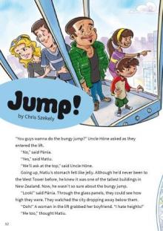
Instructions:
Read Jump.
Have you ever seen someone do a bungy jump?
What did they look like beforehand?
How do you think you would feel if you had to do one?
If you can, watch the video of Jack doing a bungy jump at Auckland Sky Tower.
How did Jack look?
Do you still feel the same way? What surprised you in the video?
Doing new things can make us feel lots of different things: excited, happy, scared, nervous...

Your task:
In your home learning book, finish the sentences:
I feel nervous when I...
I feel excited when I...
I feel scared when I...
I feel pumped when I...
Find a mirror and make a face to show the different feelings. How does your face change when you are nervous, excited, scared etc? See if you can draw the differences.

Day 7 activity 4: Mathematics and literacy
Notes for teachers and whānau
This activity takes an invention i.e. Morse Code and allows learners to use it to make familiar words.

I am learning to: use code to make words
What do I need?
- 30 minutes
- Your home learning book and a pen/pencil
- Image source: https://www.offgridweb.com/survival/morse-code-why-you-should-learn-it/

Instructions:
Morse code was invented by Samuel Morse in the late 1830s as a way to communicate using electricity. What a great invention! Every letter is made up of a combination of dots and dashes.
To send a message the dot would be a short electrical pulse and the dash, a longer one, sent to a receiver through a wire.
Can you put some simple words together and you might even be able to play them using something like a drum, whistle, recorder, flute, harmonica...
Here’s a word you might know:
Mum - - . . - - -

Your task:
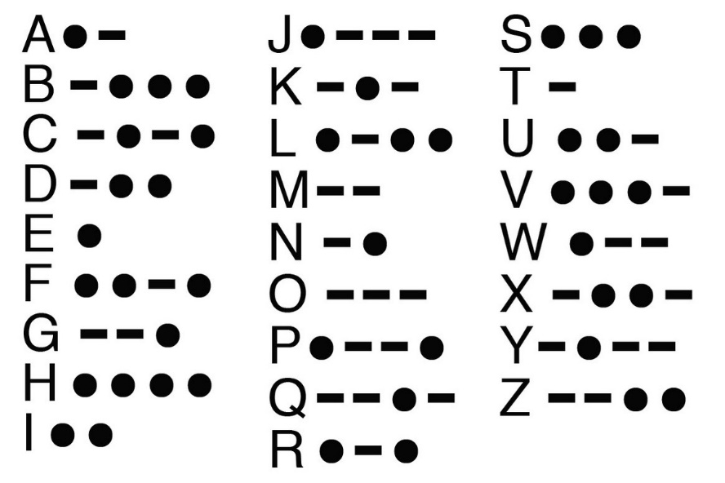
In your home learning book, write this sentence as Morse code:
Making new things is fun.

Challenge yourself and write your name in Morse code and practice tapping it out.
Write more words and/or sentences in Morse code.

Remember to do your end of day reflection and wellbeing activities (See p. 7&9).

Day 8 activity 1: Literacy (writing)
Notes for teachers and whānau
Day 8 gives opportunities to further explore designing something to meet a need and to use the imagination to make familiar experiences or places better through innovation.
Note that our Inquiry focus for today is "making meaning" which includes analysing data, organising, and sorting information, summarising, synthesising, making connections/conclusions, building deeper understandings, and thinking critically.

I am learning to: identify a need and complete a table
What do I need?
- 30 minutes
- Your home learning book and a pen/pencil
- Optional digital: https://www.kiwiplanet.co.nz/new-zealand/nz-great-new-zealand-inventors/08.html
Remember to start your day right (See p. 8)

Instructions:
Over the last two days we have explored the idea of making something better or inventing something new to meet a need.
Can you think about the need that might have led to the invention of the things in the table below?

Your task:
In your home learning book, draw and complete this table.
In the empty rows you might like to think of a couple of your own examples of where something has been invented to meet a need.

Invention | What was the need?
Morse code
False teeth
Matches
Mousetrap
 | Making butter out of cream was very slow using a spoon.
 | Lanterns and candles blew out in the wind when being used to light the way.

Day 8 activity 2 and 3: Health and PE/literacy
Notes for teachers and whānau
This activity requires learners to work to a brief and use criteria to form their design.

I am learning to use a brief to design a game.
What do I need?
- One hour
- Your home learning book and a pen/pencil
- Colouring pencils/felts/crayons
- Optional: large piece of cardboard

Instructions:
Can we make a better game?
Let’s see if we can design something to meet a need.
When we go back to school after the holidays as winter sets in, we spend more time inside the classroom.
Our classroom doesn’t have many good games that we can play indoors.
We decide to make some new games for our cold, wet days.
We decide our games have to have these things:
- can be played by two or more players
- has clear playing instructions
- fits with our school rules about inside behaviour (for example, the game could require walking and sitting but no running or jumping)
- be made to last (durable)

Your task:
In your home learning book:
- Describe your game.
- Draw your game.
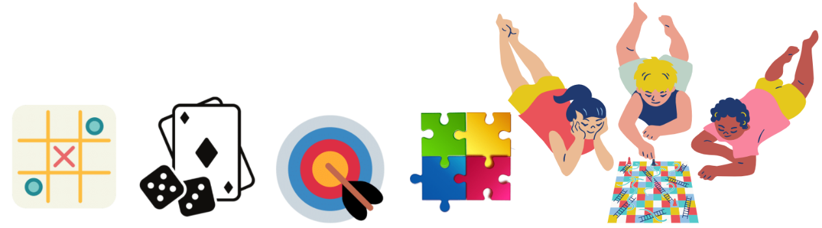
- Write the rules of your game.
- If you have the materials at home, make your game.

Day 8 activity 4: Mathematics
Notes for teachers and whānau
This activity requires learners to manipulate geometric shapes to make something new.

I am learning to: identify and manipulate shapes
What do I need?
- 30 minutes
- Shape worksheet
- Scissors

Instructions:
Let’s make something new out of a pile of shapes.

Your task:
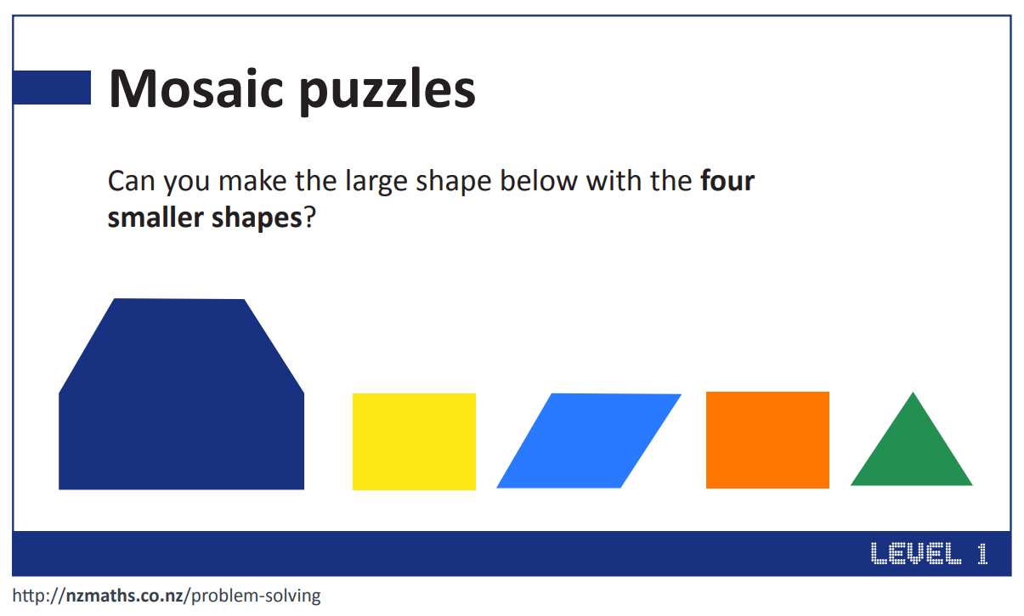
Cut the small shapes out and see if you can make them into the big shape.
What else can you make out of these shapes?
Can you use these shapes to make a game?

Remember to do your end of day reflection and wellbeing activities (See p. 7&9).

Day 9 activity 1 and 2: Literacy (reading)
Notes for teachers and whānau
Learners are asked to look at how a way of doing things has evolved, exploring how a need was met in the past and how this has changed over time. There are three readings for this activity. Consider whether to read to or with your learner and whether to read one or more of them. The key is to generate interest, engagement, and curiosity.
Note that today our Inquiry focus is “going further, deeper”. This may include promoting opportunities to engage further and dive deeper through discussions, provocations, exploring further contexts, taking action, or thinking critically and drawing conclusions.

I am learning to: listen to, or read a story then respond through drawing.
What do I need?
- One hour
- Your home learning book and a pen/pencil
- Colouring pencils/felts/crayons
- Look in your pack for copies of
Maui and the Giant Fish https://eng.mataurangaMāori.tki.org.nz/Support-materials/Te-Reo-Māori/Māori-Myths-Legends-and-Contemporary-Stories/Maui-and-the-giant-fish
Kupe and the Giant Wheke https://instructionalseries.tki.org.nz/Instructional-Series/School-Journal/School-Journal-Level-2-May-2020/Kupe-and-the-Giant-Wheke
Treasure from the Sea https://instructionalseries.tki.org.nz/Instructional-Series/Ready-to-Read-Colour-Wheel/Treasure-from-the-Sea
Remember to start your day right (See p. 8)

Instructions:
Fishing is important in Māori tradition. Tangaroa is the god of the sea and all the fish. It was important for fishermen to stay in favour with Tangaroa. They had rules about when to fish, and how to make nets. Here are three stories – you can read one or more of them.
Read or listen to Maui and the Giant Fish (online or provided in your pack)
Read or listen to Kupe and the Giant Wheke
Read or listen to Treasure from the Sea

Your task:
In your home learning book, write down or draw treasures you might find walking on the beach.
Can we make a better fish catcher?
Choose one of those treasures and draw something you could make with that treasure that might help you catch fish.

Day 9 activity 3: Literacy (think critically about text)
Notes for teachers and whānau
This activity requires learners look closely at images, listen to a text, and compare and contrast the ways fishing was done in the past to now.

I am learning to: find key information from text.
What do I need?
- 30 minutes
- Your workbook and a pen/pencil
- Colouring pencils/felts/crayons
For more information you can watch:
- https://www.youtube.com/watch?v=vfW6JVdLnfU
- https://www.youtube.com/watch?v=yVLVIFVqSbY

Instructions:
Let’s think about how Māori caught fish in the early days. They had a need to catch fish to eat – what did they design or make to meet that need?
Nets were made of green flax. Some were big enough to catch sharks. Fishermen tied hooks onto strong flax lines to catch fish, and sometimes caught flounder using spears. They trapped crayfish in woven pots. Experts knew when the good fishing days were, and each tribe guarded their fishing grounds using tall poles to mark their place.
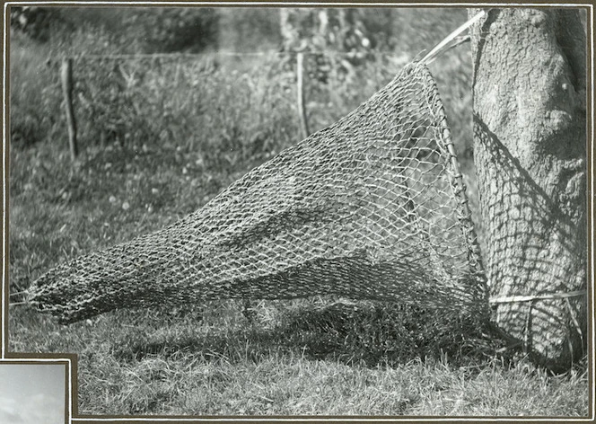
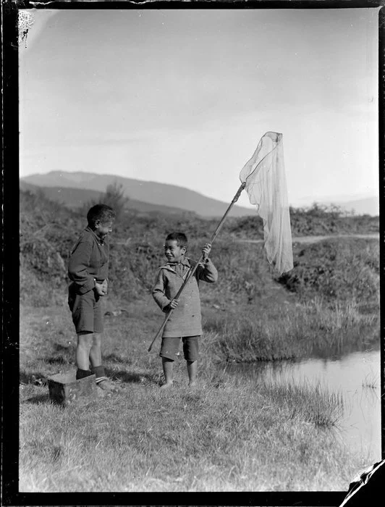
Below: Two boys net fishing, Waikato. Whites Aviation Ltd: Photographs. Alexander Turnbull Library, Wellington, New Zealand. https://natlib.govt.nz/records/23114651
Above: Māori fishing net to be used with a hinaki or eel trap. Adkin, George Leslie, 1888–1964. Alexander Turnbull Library, Wellington, New Zealand. https://natlib.govt.nz/records/23139477

Your task:
Look at the two different types of nets.
Draw each net and write a sentence to describe:
- how you think it would be used.
- how has fishing changed over time?
Draw people out fishing nowadays. Can you label the equipment they use to catch fish?

Day 9 activity 4: Mathematics
Notes for teachers and whānau
Using the fishing theme, learners engage in a mathematical activity around estimation.

I am learning to: estimate
What do I need?
- 30 minutes
- Your home learning book and a pen/pencil

Instructions:
Look at this underwater scene
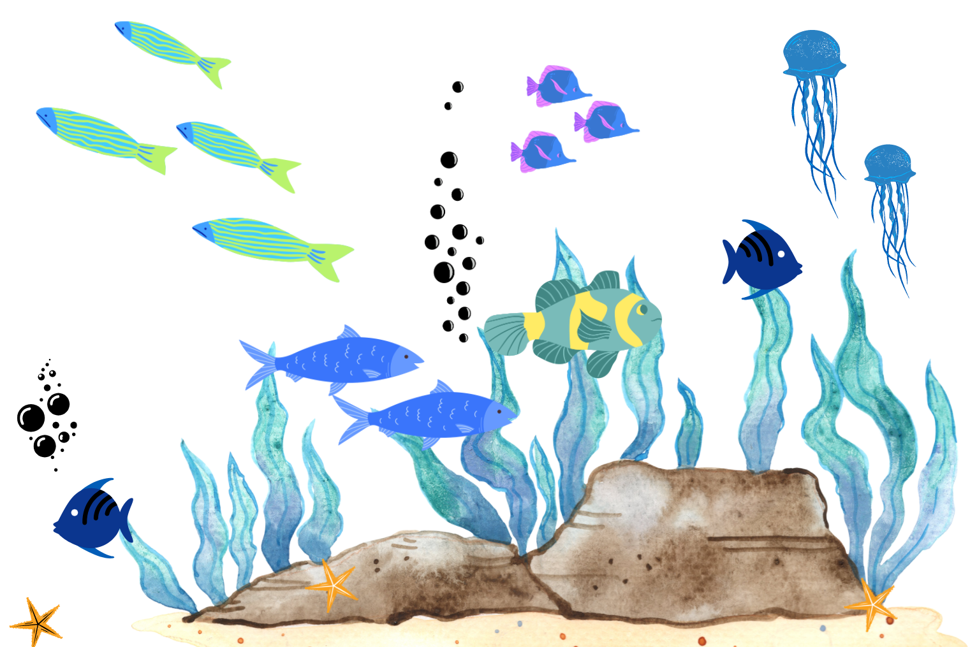

Your task:
Guess how many fish are in this picture (don’t count!) ________________.
Now count the fish. How many are there? ____________
How close was your guess?
Extension:
Look in your cutlery drawer. Guess how many spoons there are __________
Now count the spoons, how close was your guess?
Challenge someone else in your whānau to guess – you could hold a competition for the right guess.
Remember to do your end of day reflection and wellbeing activities (See p. 7&9).

Day 10 activity 1: Writing instructions
Notes for teachers and whānau
This day gives opportunities for the learner to innovate on something familiar to them and to select one of their innovations/ inventions to tell someone about.
Note that today our Inquiry focus is “present – share learning about the big idea” which includes thinking about who the audience is and considering different ways of communicating learning for example, presentation, video, poster, etc.

I am learning to: write instructions
What do I need?
- 30 minutes
- Your home learning book and a pen/pencil
Remember to start your day right (See p. 8)

Instructions:
We have invented a rainy-day game this week.
But there are lots of games out there already.
Take a game you love to play (some ideas: Heads Down, Thumbs Up; Seaweed; Tag; Rugby; Hockey: Basketball; Fruit Salad; ...)
How could you make this game better?

Your task:
In your workbook:
Write the instructions of how to play your favourite game.
Make up at least two changes you can think of that would improve the game – make it better.
How would the game be better with your changes?
Play the game and see if there are any other changes you could make. Play the game with someone else and get their opinion about your changes.

Day 10 activity 2: Literacy (reading and writing)
Notes for teachers and whānau
Relating to making something new in response to an event, learners are asked to consider how they might redesign their home.

I am learning to: make a list; respond to questions from the text.
What do I need?
- 30 minutes
- Look in your pack for a copy of The Cardboard Cathedral https://instructionalseries.tki.org.nz/Instructional-Series/Connected/Connected-2014-level-2-How-Do-You-Know/The-Cardboard-Cathedral
- Your home learning book and a pen/pencil

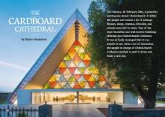
Instructions:
Read The Cardboard Cathedral
Can we make a better whare?
Use your imagination and design and new whare for your whānau.

Your task:
Make a list or draw all of the things you would want in your new house.
What would your new whare look like on the outside?
Draw the outside of your whare.
- Would you have a garage or sheds?
- Do you need somewhere for your pets to sleep?
- Do you need somewhere to dry your washing?
- Do you have some shady spaces to sit outside so you don’t get sunburnt?

Day 10 activity 3: Mathematics/art
Notes for teachers and whānau
Taking a different perspective on design, this activity asks learners to look down on their whare using the idea of a floor plan.

I am learning to: draw a floorplan
What do I need?
- 30 minutes
- Your home learning book and a pen/pencil

Instructions:
Now let’s think about the inside of your whare.
Here is an example of a floor plan. A floor plan is drawn from a ‘birds eye view’ perspective. That means how it looks if you are up high looking down.
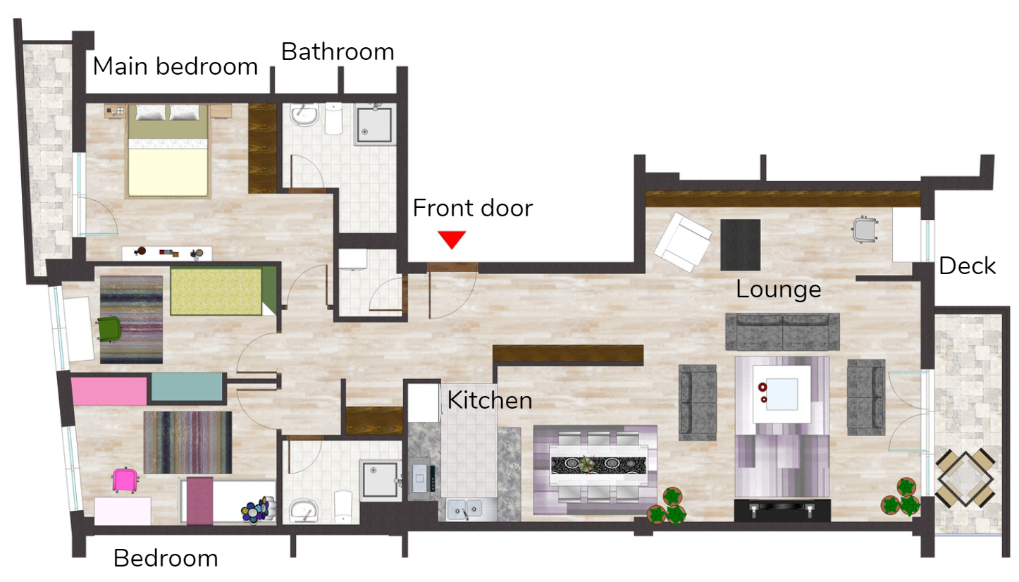

Your task:
Draw a floor plan for the inside of your whare.
Imagine you have a ‘birds eye view’ of your new whare. How many rooms do you have? What are these rooms used for? Where will you put your windows and doors? How can you make it better?

Day 10 activity 4: Literacy (oral language)
Notes for teachers and whānau
This final activity provides an opportunity for learners to critically reflect over their week’s activities and ideas about responding to a need or purpose through innovation/ invention. It asks them to share their understanding of what innovation/invention mean.

I am learning to: reflect on my learning and share my ideas.
What do I need?
- 30 minutes
- Someone to talk to.

Instructions:
This week you have read and thought about a lot of things:
- Inventions or innovations that make life easier
- The purpose or function of things we see and use everyday
- What life would be like without some innovations or inventions
- Designing to a need: game for a rainy day; new house; fishing
- Making something better

Your task:
Take some time to share something you have enjoyed thinking about or making with a family member or friend.

Tell them:
What is an invention or innovation?
Why do they happen?
Something you designed this week.
What need or purpose did that invention meet?

Remember to do your end of day reflection and wellbeing activities (See p. 7&9).

