A learning from home pack

For learners in years 9–10

Curiosity | Māhirahira

Context 1: What if ...?

Context 2: How does that work?

Layout of the resource
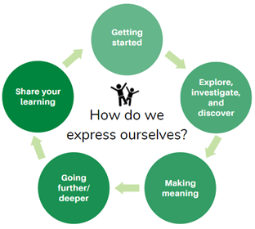
This pack is filled with learning activities for your learners that can be used at school or at home. All activities are framed around the theme of curiosity | māhirahira.
Suggestions are provided for starting the day with a karakia (see p. 8), check in with the teacher, and setting up the learning environment. You can replace these with how you want your learner to start their day.
The activities follow an inquiry learning model (figure 1) exploring one theme through two contexts. Each day the learner will be working through one part of the model culminating with sharing their learning on days 5 and 10.
Figure 1 Inquiry learning model

Realities
You know your learners and have a good understanding of their learning situations.
Many learners will have siblings at home, as well as whānau who share the same space and materials. Some may have access to the internet and devices, and others may not. Learners will also have varying levels of adult support.
There are a mix of activities in this pack that use materials commonly found in most homes. Some activities will require adult support while others can be managed independently. This resource is provided as a Word document so that you can adapt it for your learners.
We suggest starting each day with a karakia (see p. 8), check in with the teacher, followed by setting up the learning environment. The pack contains suggestions, but you can replace these with however you want your learner to start their day.

Resources
You might want to send these home with the learner: a “my home learning” exercise book, pencils, crayons, or felts, and some craft materials (glue, scissors, construction paper). Learners can bring their notebook back to class to share.
If your learners do not have reliable access to the internet, here are the resources to print and send home with this to create a paper-based pack.

Resources to print and send home
- https://nzmaths.co.nz/resource/boxed-bisuits
- https://nzmaths.co.nz/resource/worms-work
- https://nzmaths.co.nz/sites/default/files/BirthdayTreat.pdf
- https://www.roadshow.org/content/resources/NZscientists/illingworthNorris.php)
- https://teara.govt.nz/en/Māori-foods-kai-Māori/page-2
- https://nzmaths.co.nz/sites/default/files/WindPower.pdf
- https://nzmaths.co.nz/sites/default/files/2020-01/RollerCoasting.pdf
- https://nzmaths.co.nz/sites/default/files/BungyJumpEnergy.pdf
- 2 pieces of graph paper

Setting up the learning environment
Encourage whānau to support learners to set up a space for learning at home. Learners might like to design their own space as a separate learning activity. Some materials they may need could include pen, pencils, paper, a notebook, colouring pencils, glue, scissors, and a device to access the internet.
Many of the suggested activities and experiences include the use of optional online resources which can be accessed and viewed using a Smartphone if necessary.

Overview of the learning in this pack
The theme of curiosity | māhirahira will be explored through two contexts.
- Days 1–5 look at this idea through the context of what if…?
- Days 6–10 look at this idea through the context of how does that work?
Learners will explore, investigate, discover, and make meaning as they go through each task. There are times where they look a little deeper into the topic. Some of the tasks may be independent hands-on tasks while some may involve connecting and sharing with others.
Day 1 | Day 2 | Day 3 | Day 4 | Day 5
What is curiosity? Use prior knowledge to define the concept of curiosity | Investigate and discover using ‘what if’ questions | Being curious about food and our kitchens | Think of a problem/challenge in the kitchen to overcome. | Share your learning – find out ways you can be successful in presenting and put these skills to practice!
Day 6 | Day 7 | Day 8 | Day 9 | Day 10
Tap into our curiosity and prior knowledge about how different man made and living organisms ‘work’. | Explore and investigate how rollercoasters work | Explore how bungy jumping works | Investigate the variables that effect bungy jumping and research further into a related area e.g. adventure sports, heart rate | Explore the different ways we communicate information to an audience and present our work.

Daily timetable
Below is a possible daily timetable. We have allocated 30 minutes for each activity; your learner may take more or less time than this for an activity. We suggest your learner takes the time they need to complete an activity. This may mean they choose which activities they will complete for the day, rather than complete them all.
At the start of each day the learner will draw up their timetable for learning. You can adjust the timing to suit the other activities that might be happening the day, such as Zooming with the class/teacher.
Time | Activity
9:00 am | Starting the day
9:30 am | Activity 1
10:00 am | Break
10:30 am | Activity 2
11:00 am | Fitness break
11:30 am | Activity 3
12:00 pm | Lunch time
1:00 pm | Activity 4
1:30 pm | Reflection time
2:00 pm | End of the school day

Daily fitness – Choose something each day
It is important to include a fitness activity every day. Please ensure that your learner includes activities at their fitness and ability level in their daily timetable. If possible, it would be great to do the fitness activity with your learner or have them complete it with their siblings where appropriate. Below are a range of activities to choose from – or you can make up your own ideas!
Create your own fitness circuit:
Select 5 or more of these exercises and create your own fitness circuit in your home or outside. Repeat your circuit multiple times.
- Running on the spot  - Skipping  - Galloping  - Slip stepping  - Brisk walking  - Marching on the spot  - Astride jumps/Straddle jumps  - Double foot jumps – side to side – forward and back | - Hops – on the spot – forward  - Jumping  - Knee Lifts  - Heel to Bottom kicks  - Step Ups  - Shuttle Runs/Line Sprints  - Abdominal Crunchies  - Push Ups  - Lunges
Tahi–rua–toru Fitness challenge – Crabwalk–superman–bear crawl
You will need a water bottle and your ‘can do’ attitude!
Tahi – Crab walk. Start sitting down on the floor and then use your legs and arms to lift up your torso and walk around like this for as long as you can.
- Rua – Superman. Lay down on the floor with your face towards the floor, relax. Now lift your legs slightly off the floor and put your arms out like superman. How long can you remain in this position?
Toru– Bear crawl. Start the bear crawl in a push up position. Your hands should be beneath your shoulders, your back is strong, and your core is engaged. Your feet should be hip distance apart with heels off the floor.
- Move forward by simultaneously (at the same time) moving the right hand and the left leg in a crawling motion. **Your knees never touch the ground.
- Switch sides immediately after placing weight on the right hand and left leg, moving the left hand and right leg forward.
- Continue in a crawling motion, moving forward for as long as you can.
Repeat the three sets of exercises three times.
Can you beat yourself? Great efforts!

Ball challenge countdown
You need a small ball, like a tennis ball for this activity.
- Tekau − Toss the ball in the air and catch x 10
- Iwa − Toss the ball in the air and clap and catch x 9
- Waru − Toss the ball in the air and clap three times and catch x 8
- Whitu − Toss the ball in the air and clap behind your back and catch x 7
- Ono − Toss the ball in the air and clap behind and clap in front and catch x 6
- Rima − Toss the ball in the air, snap and clap and catch x 5
- Whā − Toss the ball in the air, clap behind, snap, clap in front and catch x 4
- Toru − Toss the ball in the air clap under each of your knees and catch x 3
- Rua − Toss the ball in the air, touch head, shoulder, knees & toes and catch x 2
- Tahi − Toss the ball in the air and turn around and catch x 1, and you’re done!
Mahuru Dance
Go to https://music.youtube.com/watch?v=-BrdaUUTMBY&feature=share and watch Pere Wihongi sing Mahuru (earth Wind and Fire’s song ‘September’ in Te reo Māori).
Practice singing it in te reo and then make up a little dance or fitness routine.
Maybe you can dance with lower body when you hear ‘Mahuru’?
Maybe you can dance with your upper body every time you hear ‘kōrero Māori’?
Have fun with it and move your body!
Māori Movement
Start with a warmup here: http://www.Māorimovement.co.nz/warm-up
TŪMATAUENGA is the Māori God of War. Māori Movement is Manu waewae – focusing on isometrics and balance through ‘peruperu’. You will use your waewae (leg/feet) to build your understanding of ‘ihi’ which is your essential force and builds self-control by holding the position of Tū Tane (known as the war stance).
1.You will practice 3 levels of ‘peruperu’.
2.The challenge is to hold the position of Tū Tane for 30 seconds.
Here is your challenge
http://www.Māorimovement.co.nz/courses/ruaumoko/level-1-ruaumoko

Daily wellbeing – Choose something each day
These activities are good to do at the beginning and end of the day but can be done anytime. They can help you get ready for learning; calm your mind and body and they can help you to reflect on your learning:
Relaxation routine
Plan a routine that might help you to relax before bedtime. Ask people in your house what they do to relax before going to sleep? Try your routine out for a week and observe any changes in your sleep patterns.
Time Capsule
Make a time capsule that includes information about your life today. Which people are important to you? What are you most grateful for? What are your favourite things? What goals do you have for the future? Keep this somewhere safe and write a date on the top that you plan to open it in the future. Don’t forget where you put it!
Gratitude: Overlooked blessings
Being grateful can help increase your happiness and reduce stress.
Take a moment to think …
- What does it mean to be grateful?
Feeling grateful isn’t always easy and might not come naturally. It’s pretty easy to compare yourself to others or focus on any challenges or frustrations in your life.
Gratitude is a muscle you can build, just like learning any skill or strength, through practice.
Take another moment to think …
- What are some things in your life that you take for granted but when you stop and think about it – you are grateful for them (e.g. Running water, electricity,
- What are some things about your health and the way your body works that you take for granted and are grateful for?
- What are some things about the people you know that you take for granted but you are really grateful for?
Breathe in and be curious about how you are feeling after finding your overlooked blessings.
Wellbeing checklist
Have you:
- Drunk water? Do you have a water bottle with you? Staying hydrated is important.
- Taken mini breaks to stretch/walk around? Keep your brain alert and your heart pumping.
- Stopped to think of something you are grateful for?
- Connected with someone to have a chat, korero?
- Planned time to do your favourite activity?
- Planned my fitness activity for today?
- Got healthy snacks ready for the day? Healthy food for a healthy body and mind!
- Made your bed? Tidied your workspace/bedroom?
- Been outside? Even for a brief walk? You need vitamin D and fresh air!
- Paid it forward? Have you done something nice for someone else?
Smile Scrapbook
Make a scrapbook or collage to show things that make you smile or things that you are proud of.

Starting each day
Notes for teachers and whānau:
Starting the same way each day helps create a structure for your learner. Your school might have your own way to do this, for example starting the day together as a class on Zoom. In this pack we provide a karakia to settle into the day. Saying the karakia with your learner a few times will help them be able to do this more independently tomorrow and beyond. As part of the start of the day and setting up the learning environment, help your learner look through the activities suggested for that day and choose a fitness and wellbeing activity. They could fill out their daily timetable and think of other activities they might like to do, like reading.
Remind your learner of when and how to check in with the teacher/you.

Karakia
Here is a karakia to welcome in the day
https://www.otago.ac.nz/cs/groups/public/@Māori/documents/webcontent/otago667429.mp3
Whakataka te hau ki te uru  Whakataka te hau ki te tonga  Kia mākinakina ki uta  Kia mātaratara ki tai  E hī ake ana te atakura  He tio, he huka, he hau hū  Tīhei mauri ora! | Cease the winds from the west  Cease the winds from the south  Let the breeze blow over the land  Let the breeze blow over the ocean  Let the red-tipped dawn come with a sharpened air.  A touch of frost, a promise of a glorious day.

Planning my day
- Have you chosen which activities you will do today and in which order?
- Remember to choose a fitness activity (see p. 5).
- Have you chosen a wellbeing activity (see p. 7)?
- Have you done a ‘Wellbeing check-in’?
  - How are you feeling today?
  - How do you feel about your readiness to learn this morning?
  - What do you need extra assistance with today? Who could you get to help you? What strategies could you use to make your learning more effective?
  - What would you like to do as a quiet time activity to end your day?
- Remember to do your Reflection at the end of the day (see p. 9).

Ending each day
Please ensure your learner does this at the end of each day.
Reflection can be challenging, but it can also provide rich opportunities to think about how learning is progressing. Use the questions below as prompts to encourage your learner to think about what they have learned and to plan out their next steps. If you have concerns or find that they are needing more help, contact their teacher for support.

In this activity I am learning to: reflect on my learning.
What do I need?
- A notebook or online doc that you can use as your “reflective journal”
- Materials for your quiet time activity
Option 1: Reflections about my learning
Reflect on the following prompts in your reflective journal.
- What did you enjoy most about today?
- What is one thing you feel you learnt today?
- What is one strategy that helped you with your learning?
- What did you find challenging or distracting? (You ran out of time, or you finished quickly and wanted to dig in a little deeper.)
- Is there anything you need extra help with? Who can you ask to help you with that?
- Is there anything you want to catch up on tomorrow?
Option 2: Reflections about my day
Choose 3–5 questions to respond to in your reflective journal:
- What was the best part of your day? Why?
- What did you worry about today? Are you still worried?
- What is a problem you had today? How did you solve it?
- Would you want to re-live this day again? Why or why not?
- What is something you learned today that you want to remember tomorrow?
- If you could travel back in time to the start of the day, what advice would you give yourself?
- Were you able to finish all of your work today? Why or why not?
Option 3: Reflections about myself
Choose 3–5 questions to respond to in your reflective journal:
- What does having a growth mindset mean? When did you last notice yourself having one?
- How can you tell you're getting angry? How does it make your body feel and your mind think?
- How are you different from your parents/friends/a famous person of your choice?
- What's something adults say to you that's really stuck with you? Do you think they're right?
- What do you do when people don't seem to like you?
- What is your proudest accomplishment?
- What things are in your control? What's out of your control? How does it feel to notice that some things are out of your control?
- What do you like about your school? What do you dislike?
- What do you do when you're feeling overwhelmed or stressed out? What's something nice you could say to yourself?
- What is your happiest memory?
- What do you do when you're feeling down?
- What is your favourite book? Movie? Band? Food? Animal? Why is it your favourite?
Remember to finish with a wellbeing activity and/or your chosen quiet time activity

Context 1: What if...?

The next five days indulge our curiosity by asking ourselves the question what if...?

Day 1 activity 1: Inquiry getting started
Notes for teachers and whānau
Activity 1 requires the learner to identify what they already know about what the word ‘Curiosity’ means. They might ask you for your definition, or you might like to discuss with them what you think it means and see if your definitions are similar.
Learners will be exploring the literacy, science, and technology learning areas.
Note that our Inquiry focus for today is “getting started” which includes generating questions, activating prior knowledge, and introducing the theme.

In this activity I am learning to: activate my prior knowledge of the meaning of the word ‘Curiosity’ and find a source to define it correctly.
What do I need?
- 30 minutes
- Home learning book
- Pen/pencil

Instructions:
“The important thing is not to stop questioning. Curiosity has its own reason for existing” Albert Einstein
Read the quote above and think about the message Albert Einstein is trying to say. What does the word curiosity mean? Why do you think asking questions like “what if” is important?

Your task:
In your home learning book copy the following table and complete each box to show your prior knowledge of the word ‘Curiosity’.
Define ‘curiosity’ in your own words: |  | Draw a picture of what you think ‘Curiosity’ is/means
Definition from proper source e.g. dictionary:
Identify the root word:
List synonyms (words which mean the same):
List what you are curious about?

Day 1 activity 2: Food Science
Notes for teachers and whānau
Activity 2 requires the learner to watch a video (or read a transcript) about Food Science and Innovation. You might like to join them, come up with “what if” questions together and discuss food innovations to help them with creating their poster/collage.

In this activity I am learning to: get curious about food science and innovation by asking ‘What if?”
What do I need?
- 30 minutes
- Home learning book
- https://www.youtube.com/watch?v=mnoCy0j7DNs or transcript

Instructions:
This task will get you curious about the changes that will occur to food and in food science over the next 10 years.

Your task:
Watch ‘Future Food – the menu of 2030’ https://www.youtube.com/watch?v=mnoCy0j7DNs
Or read the transcript
Future food – the menu of 2030
The world’s population has been increasing faster than food production, even with modern agricultural technology. There will be 9 billion people to feed by 2050. Researchers have been looking at new food sources, tweaking existing ones, and even creating entirely new foods. We examine what could be on our dinner table 20 to 30 years from now.
Critters
A 2013 UN Food and Agricultural report reminds us that there are 1,900 insect species out there that 2 billion humans already regularly consume – beetles, butterflies, moths, bees, and locusts. Insects are abundantly available and rich in low fat protein, fibre, and minerals.
Lab meat
Scientists came up with synthetic meat grown in the lab as early as 2013. Scientists have already cultured ground beef from cow stem cells. Although that lab patty cost $330,000 to make and tasted quite bland, experts predict it will only take a decade or two for an affordable product that looks, cooks, smells, and tastes like ground beef.

Algae
While this is already used as a biofuel, algae is seen as a solution for the problem of food shortages as it can feed humans and animals alike. Algae is the fast-growing plant on earth and has long been cultivated in Asia. Food experts predict algae farming could become the world’s biggest crop industry as it can be grown in both the oceans and fresh water. It is a good source of vitamins and minerals.
Farmed fish
3.5 billion humans today depend on the oceans for their primary food source. That figure will double in 20 years. Fortunately humans are aware of this and have implemented sustainable commercial fishing practices and turned to cultivating fish. Aquaculture is going big with 35 countries producing more farmed fish than fish caught in the world. A milestone was reached in 2011 when for the first time more fish was farmed than beef. A trend that has continued.
GMO chow
Genetically modified food is nothing new. We first re-engineered the DNA of plants in the 80s to make them disease resistant. By the 90s GM foods were commercially available. Several food items we consume – fruits, crops, livestock, even fish – have undergone genetic modification. These are generally safe and went through strict standards.
3D printed dishes
Straight from the printer and onto the plate. You will be able to fully customise food shapes, textures, tastes, and forms. You can order online your favourite chocolate bar or snack and 3D print it with a machine at home. The food you’re craving will just be a print away.
Write down five “what if” questions in your home learning book or digital doc after watching the video – e.g. “what if we ate insects instead of meat?” “What if we didn’t have enough food for the world?”
The title of this YouTube clip is ‘Future Food – the menu of 2030’.
Based on the information, create a collage/poster/drawing of what you think a menu would look like in 2030.
- Clear title?
- Effective use of visuals? Colour?
- Clear and succinct text?
- Consideration to how food items would change is reflected.

Day 1 activity 3: ‘What if? ...’ food science and production
Notes for teachers and whānau
This task gets learners thinking about changes that have happened or could happen in the way we eat/produce or use food. It might be good to discuss consequences of these changes with the learner and see what you come up with!

In this activity I am learning to: activate my prior knowledge and define Curiosity
What do I need?
- 30 minutes
- Home learning book

Instructions:
Many changes might take place in the types of food and the ways we produce food in the future. This task asks us to get curious about what would happen if changes to how we use/produce/eat food happened/didn’t happen and to practise our literacy skills by writing a persuasive piece of writing.

Your task:
Choose 2 or more of these scenarios, and in your home learning book or digital doc write a paragraph for each about the consequences of ‘what if?’
- What if agriculture and domestication of animals never happened?
- What if humans never harnessed the use of fire – what would it mean for cooking?
- What if we allowed Genetically engineered food sources?
- What if the microwave was never invented?
You can use the following sentence starters
- The consequences of <given scenario> would be.... because.......
- Another consequence would be......due to the fact........
Try to use evidence in your statement from reputable sources.
Here is an example that may help. (Remember that this is an example, and the opinion here won’t necessarily be shared by all)
“What if there was no law enforcement (Police) in New Zealand?”
In my opinion, the consequences of not having any police would be dangerous, because it would then become an individual's job to hold others accountable for their actions. How would we all have the same idea of what is a fair consequence? What if someone felt unsafe but had no support to call? The New Zealand Police site https://www.police.govt.nz/ says police do the following things:
- keeping the peace and maintaining public safety
- law enforcement and crime prevention
- community support and reassurance
- national security and participation in policing activities outside New Zealand
- emergency management.
A consequence, if there were no police, would be that some people could feel like they had the ability to be reckless and not have consequences, and it would also cause many more road accidents because there would be no-one checking for speeding or drink driving.

Day 1 activity 4: Numeracy – boxed biscuits
Notes for teachers and whānau
This task requires learners to explore fractions and review their understanding of factors. It could be handy for learners to use coloured counters or something equivalent to help with their understanding.

In this activity I am learning to: identify factors of different numbers, find fractions of a whole number, and find equivalent fractions.
What do I need?
- 30 minutes
- Copy of the “Boxed Biscuits’ task https://nzmaths.co.nz/resource/boxed-bisuits
- Coloured counters or the equivalent (optional)

Instructions:
This task requires you to review your understanding of ‘factors’ and then use this information to work out different combinations of fractions that make a whole.

What is a Factor?
A factor is a number that divides another number leaving no remainder. In other words, if multiplying two whole numbers gives us a product, then the numbers we are multiplying are factors of the product because they are divisible by the product. There are two methods of finding factors: multiplication and division. In addition, rules of divisibility may also be used.

Your task:
Before completing the work sheet ‘Boxed biscuits’ it will be helpful to work out the factors of each “box” of biscuits 24,27,36,100.
Then use these factors to work out the different combinations of packets of biscuits in each box. The ‘24’ box has been done below for you as an example.
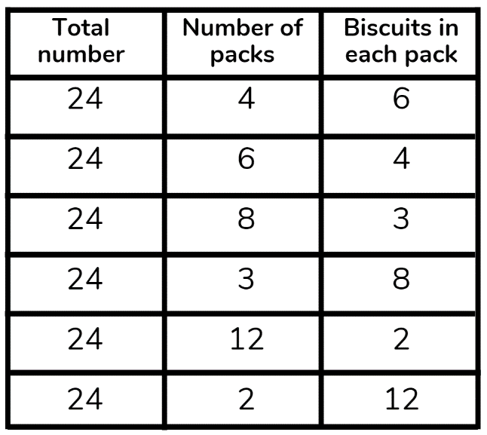
Complete tables like this one for 27,36 and 100. What do you notice?
Explanatory note: If we think about the number 8 we can determine that 8 can be a product of 1 and 8, and 2 and 4. As a result, the factors of 8 are 1, 2, 4, 8.
Therefore, when we are looking for solutions or solving problems that involve factors, only positive numbers, whole numbers, and non-fractional numbers can be considered
Complete the worksheet ‘Boxed Biscuits’ using the above information and applying your learning.
Remember to do your end of day reflection and wellbeing activities (see p. 7&9).

Day 2 activity 1: What if we could spread butter?
Notes for teachers and whānau
This activity explores the invention of spreadable butter. If ingredients are available, you could help the learner make their own butter.
Note our Inquiry focus for today is “explore, investigate, and discover” which includes choosing and evaluating information, and thinking critically.

In this activity I am learning to: use information from an article to answer questions and design a comic strip showing a sequence of events.
What do I need?
- 30 minutes
- Access to this article https://www.roadshow.org/content/resources/NZscientists/illingworthNorris.php

Remember to start your day right (see p.8).

Instructions:
New Zealanders are famous for their curiosity and innovation. Sir Edmund Hilary was curious about whether a human could scale the heights of Mt Everest, Ernest Rutherford got curious about the atom – what if we could split a particle so small?
But did you know New Zealand Scientists, Robert Norris, and David Islington, also got curious about if you could get butter to spread, and hence developed the first spreadable butter!
This task will require you to read about the history behind spreadable butter, create a comic strip, and perhaps even try your hand at making your own butter!

Your task:
Read the following article (check your pack for a copy or access online here: https://www.roadshow.org/content/resources/NZscientists/illingworthNorris.php)
Design a comic strip that shows the sequence of events to creating spreadable butter. Showing how curiosity led to this invention!
Draw a table in your book (you may need more or less squares depending on how many pictures in your comic). The top squares are where you could write a brief description and the white part is where you can draw a picture.
As an extra – if the ingredients are available in your household – have a go at making butter! https://www.roadshow.org/downloads/Classroom_Activities/makingButter.pdf

Day 2 activity 2: Darwin, earthworms, and compost
Notes for teachers and whānau
Learners will read an article about the famous biologist Charles Darwin and put themselves in his shoes – thinking like a Scientist!
There is also a numeracy task to finish with, so if there is a calculator available in the home they may need it to complete the maths worksheet.

In this activity I am learning to: read an article on a research
What do I need?
- 30 minutes
- Copy of or access to: https://www.sciencelearn.org.nz/resources/22-charles-darwin-and-earthworms
- Copy of https://nzmaths.co.nz/resource/worms-work
- Calculator

Instructions:
The tasks up to this point have been related to food – so why earthworms?! Well did you know earthworms are the great recyclers of nature – and as humans we have used earthworms for our own recycling of food scraps. More and more people are using worm farms as creators of compost.
To start with we are going to look at a famous Biologist – Charles Darwin who got curious about these the creatures beneath your feet.
You will read an article and get curious!

Your task:
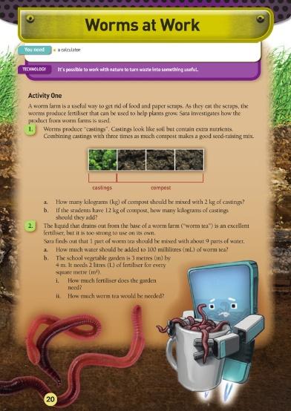
Read the article from Science Learning Hub on the next page. It explores Charles Darwin’s experiments and curiosities around earthworms.
After reading the article come up with 5 ‘What if’ questions you think Darwin wanted to know or tried to find answers for when investigating earthworms e.g. what if earthworms could hear?
Write your ‘what if’ questions in your home learning book or digital doc.
Complete the questions on the Figure it out task ‘Worms at Work’. You will need a calculator.

Charles Darwin and earthworms
https://www.sciencelearn.org.nz/resources/22-charles-darwin-and-earthworms
Charles Darwin is best known for his theory of evolution as set out in his book On the Origin of Species. He was a naturalist – an expert in geology, botany, and biology – whose interest in all things natural was apparent from a young age. His father wanted Charles to follow in his footsteps and become a doctor. However, Darwin couldn’t bear dissecting cadavers or watching surgery, so he quit.
His father remarked, “You care for nothing but shooting, dogs, and rat-catching and you will be a disgrace to yourself and all your family.” Darwin, of course, went on to prove his father wrong and became one of history’s most famous scientists.
Darwin’s association and interest with earthworms came shortly after his famous voyage on the HMS Beagle. His uncle showed him a spot in his garden where he had spread ashes and lime several years before. Darwin was amazed to see how soil cast up by earthworms had buried the substances. He went home and began a series of earthworm experiments that would go for the next 40 years. Darwin conducted both lab experiments in his study and billiard room and field investigations in his extensive gardens. He published his findings in 1881 in a book titled The Formation of Vegetable Mould through the Action of Worms, with Observations of their Habits. The book sold 6,000 copies in its first year, selling faster than On the Origin of Species had when it was first published.
Charles Darwin was fascinated by earthworm behaviour. He experimented with different types of food, placing the food on pieces of tinfoil to make sure the earthworms did not accidentally come upon the food by burrowing from below. He recorded that they preferred wild cherry and carrots, that raw fat was preferred to raw meat and that, “judging by their eagerness for certain kinds of food, they must enjoy the pleasures of eating”.
He tested their senses by exposing worms to lamps or candlelight and their sensitivity by holding “a poker heated to dull redness near some worms”. Earthworms do not have ears, but Darwin still tested their sense of hearing. He used a metal whistle and had his son play his bassoon loudly. Darwin even shouted at the worms but found that, if care was taken that his breath did not strike them, they were indifferent to noise. The earthworms also remained quiet when set on a table close to a piano, which was played as loudly as possible. That all changed, however, when the earthworm pots were placed on top of the piano. Darwin noted that earthworms are extremely sensitive to vibrations.
Darwin was curious to know if such lowly creatures were intelligent. He spent considerable time observing how earthworms pulled leaves into their burrows. They plugged the burrow openings, in Darwin’s opinion, to keep out chilled air. Darwin found they most often pulled leaves in by their tips, which is the most efficient method. When he substituted paper triangles for leaves, he noted the majority of earthworms drew them down their burrows by the apex. This led Darwin to state that worms have some degree of intelligence. He wasn’t convinced that all earthworms were equal, though. He placed leaves on the surface of pots kept in a warm room. These worms worked in “a careless or slovenly manner … they did not care about plugging up their holes effectually”. Darwin covered the pots with nets and left them outdoors for several nights. He wrote, “and now, 72 leaves were all properly drawn in by their bases”.
Darwin’s book also chronicled early New Zealand earthworm research. He mentions that worms appear to act in the same manner in New Zealand as in Europe, referring to earthworms’ ability to slowly cover objects left on the ground with their casts.

Day 2 activity 3: Science – earthworm investigation
Notes for teachers and whānau
This task requires the learner to find and observe earthworms. You may want to help them find a place in the garden that would be suitable for digging to find earthworms.

In this activity I am learning to: identify physical characteristics of earthworms; Discuss how observations and experiences can mirror those of real scientists
What do I need?
- 30 minutes
- Earthworms in the garden if you can find some
- Small jars or containers with lids, tongs, tweezers or small forceps
Texts below courtesy of the Science Learning Hub
- https://www.sciencelearn.org.nz/videos/3-physical-adaptations-for-life-underground
- https://www.sciencelearn.org.nz/image_maps/24-inside-of-an-earthworm
- https://www.sciencelearn.org.nz/image_maps/27-outside-of-an-earthworm
- https://www.agresearch.co.nz/earthworms

Instructions:
Observation is essential for being a Scientist. Observation is more than just looking at something. It may involve multiple senses and the use of instruments to go beyond human capabilities. This activity encourages you to take your time and observe how earthworms move and identify their physical attributes. You are encouraged to think about how real scientists use observation to extend or modify their existing knowledge.

Your task:
Find earthworms in the yard. Keep them in their usual medium (soil or compost) and out of direct sunlight until needed. Their skin needs to be kept moist so only have them out for short periods at a time. Earthworms can be gently handled. If you run your fingers on the underside of some earthworms you may be able to feel the setae even if you cannot see them. Observe them for a few minutes in their natural soil or compost so they don’t dry out. Jot down notes in your home learning book about what you have observed.
- Watch Physical adaptations for life underground, explore: Inside of an earthworm and Outside of an earthworm, and read The Great Kiwi Earthworm Survey.
- Write down any scientific terminology that may be new or unknown.
- Observe a second time, adding to your observation notes. Did you make changes to your initial observations? Did the additional information from the video or interactive change the way you made your observations or recorded your information?
This is how scientists work! They build their science knowledge through observation, with information from books or journals and discussions with the scientific community. When new evidence becomes available, scientists test it and, with time, may modify existing science knowledge. These changes are often very small!

Day 2 activity 4: Traditional knowledge and use of fungi
Notes for teachers and whānau
This task is a reading task for learner that helps them identify key ideas and vocabulary in a text.

In this activity I am learning to: process key ideas and vocabulary from information.
What do I need?
- 30 minutes
- Access to: https://www.sciencelearn.org.nz/image_maps/72-matauranga-Māori-fungi-as-food-and-medicine or the transcript below

Instructions:
This activity will see you finding out the different uses early Māori had for fungi growing in the forest. Not only was it a food source it also had very important medicinal properties.

Your task:
Read the information ‘Mātauranga Māori fungi as food and medicine’ some information is found in the interactive graphic, or you can simply read the transcript below.
Copy the grid below into your home learning book and complete after reading the article.
3 most important ideas | 3 things I already knew | 3 questions about this text | 3 key/new words
Mātauranga Māori: Fungi as food and medicine
https://www.sciencelearn.org.nz/image_maps/72-matauranga-Māori-fungi-as-food-and-medicine
Images from Manaaki Whenua – Landcare Research
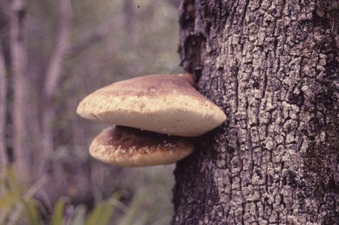
Te pūtawa, Laetiporus portentosus (pūtawa)
The pūtawa fungus feeds on the wood of living beech trees in Tāne-mahuta. Its fruitbodies are bracket shaped and often form high up on trunks. They grow quickly to a large size, but only last a few weeks to months before becoming old and falling. When collected on the ground, they need to be dried out before they can be used.
For medical use, pūtawa was cut into flexible strips and used to protect wounds. A hole larger than the wound was cut in the strip, and the pūtawa was tied in place as a protective pad.
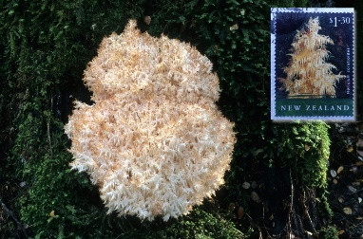
Fungus icicles, Hericium sp. (pekepekekiore)
Pekepekekiore has soft and fragile fruitbodies that look like hanging coral or icicles. This fungus feeds on dead wood, and its fruitbodies form only on softened, well-rotted trees. There are few reports of our ancestors eating pekepekekiore, but a closely related fungus in Asia is widely eaten. Hericium erinaceus is a delicious and popular mushroom grown on sawdust in several Asian countries. Small trials have recently started in Hawke’s Bay to cultivate pekepekekiore for restaurants. Recent research suggests that Hericium sp. may have potential as an extract for modern medicines and health. They were featured on a NZ$1.30 stamp in 2004.
Usnea species, (angiangi, hawa)
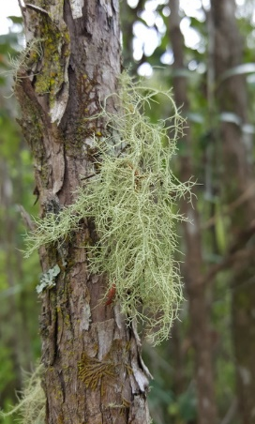
IMAGE: Mikey Watson, CC BY-NC 4.0
A number of lichens (fungi) and mosses (plants) were collected by our ancestors for use as a soft covering for wounds and to stop bleeding. Angiangi and hawa are names that may refer to several different kinds of lichens and mosses found in Tāne-mahuta. A lichen is a fungus that has partnered with tiny cells of algae. The fungus gives a home to these plant cells that can use light to produce sugars for use by both the algae and the fungus. So lichens can live in harsh places, even on concrete footpaths, fence posts, and roads, where neither the fungus nor the algae could live on their own. Mosses are not fungi at all. They are plants.
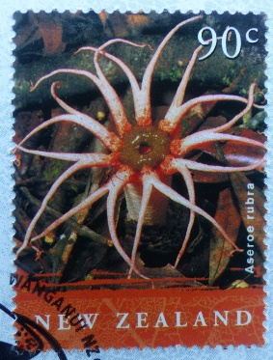
Flower fungus, Aseroe rubra (puapuatai)
Looks pretty, smells awful! This bright red fungus looks like a flower or maybe a starfish? It is found on the ground in Tāne-mahuta and probably was not eaten often. When fully formed, the red arms of puapuatai are covered at their base by a dark slime that smells like rotten meat – this is one of the stinkhorn fungi. The slime attracts flies that feed on it and so spread the spores. It is likely that puapuatai was only eaten in its young egg-like stage before the egg hatches and the smelly red arms expand.
Today, puapuatai is not common, but a related red stinkhorn fungus has become common on mulch in home and public gardens. This also has red arms and a bad smell. It is not native to Aotearoa, however, and is probably not edible. Why do you think the fruitbody of this fungus, the puapuatai, is red and has long petals or arms?
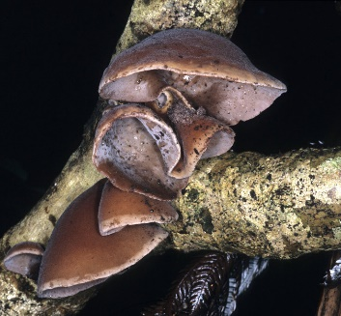
Wood ear, Auricularia cornea (hakeke, hakeka)
Fruitbodies of hakeke grow on wood and look like a thin soft rubbery ear. There is no stalk or gills. Instead, the upper surface is hairy, and spores form on the smooth lower surface. In Tāne-mahuta, hakeke is common on many kinds of dead wood, like tawa and māhoe, and can be collected during spring, summer, and autumn. When old, it dries out and becomes hard. Its taste is not much, though it does have a soft crunch when cooked and eaten. It was often cooked with vegetables and other foods to give it flavour. It is thought that this was only eaten when other foods were scarce as is suggested by a waiata by Sir George Grey in Ko nga moteatea, me nga hakirara o nga Māori in 1853.
A song about famine, what, what shall we eat?
Wood ear fungus that clings to the karaka or, convolvulus that stretches over the land?
Who will dig the convolvulus in the winter?
Hakeke is the only fungus from Tāne-mahuta that has been collected and exported overseas. Our ancestors including women and children collected and dried it for the export fungus trade to China. It thus became an important source of income, especially from 1870–1900. From 1872–1883, almost 2,000 tons (dry weight) was exported – an enormous amount considering that hakeke loses 90% of its fresh weight on drying. Like tawaka, hakeke was also sometimes given to invalids who were “recovering from poisoning by karaka or tutu”.
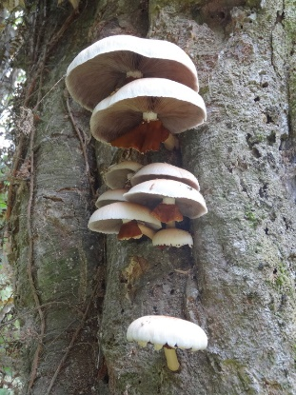
In Chinese and Asian medicine, hakeke has multiple uses including for colds and fevers by reducing the heat of the body and to strengthen blood vessels and the cardiovascular system. Forests in China also contain hakeke, and a method for cultivation was developed there on sawdust in bags. As a result, the export trade of hakeke from Aotearoa to China has been replaced by importation of hakeke from China and other Asian countries where it is now commercially cultivated. Today, it is rarely collected in Tāne-mahuta but is readily available in Aotearoa in Asian food shops.
Poplar mushroom, Agrocybe parasitica (tawaka)
This large mushroom (up to dinner-plate size) grows on living tawa and other trees, often appearing high up on the tree trunk in late summer to autumn. The mushroom has a long stalk with a hanging skirt that is coloured brown because it is coated with brown spores. When the mushroom is young in the button stage, this skirt is also attached to the edge of the cap covering the brown gills.
In addition to its use as a food, cooked tawaka was also considered to have medicinal benefit, reportedly being given to patients suffering fever and for health of expectant mothers. Tawaka was also given to invalids who were “recovering from poisoning by karaka or tutu”. On the other hand, there was an alleged negative impact of those who had eaten tawaka who then entered a garden growing gourd plants, apparently causing gourds to decay or fail to mature. Fishing success was also reduced for those who had consumed tawaka.
Puffball, Lycoperdon utriforme and Calvatia gigantea (pukurau)
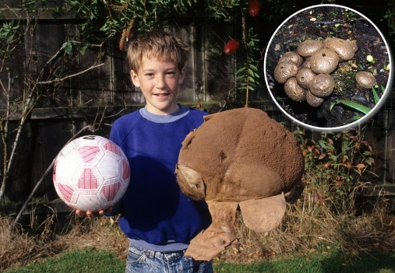
There are different kinds of pukurau, some growing in Tāne-mahuta and others on farmland. Their hyphae feed on plant matter in the soil. When the moisture and temperature is right, the puffball fruitbody grows rapidly above the soil surface – sometimes up to a very large size. Edible kinds were eaten when young and firm and when the inside of the puffball is white. Later, the inside part softens and turns brown and powdery as thousands of spores develop. The spores are spread in the wind after being puffed out of the puffball by the impact of raindrops or an animal. Pukurau were also used by our ancestors in medicine, for example, to stop bleeding from wounds and for pain relief from scalds and burns. Recent research suggests that Calvatia gigantea may have potential as an extract for modern medicines and health.
Pukurau grows widely in Aotearoa but may have been especially common around the Tukituki River in Hawke’s Bay. The name of the Hawke’s Bay town Waipukurau is linked to the fungus pukurau. Tūpuna tell of pukurau growing on a nearby hill pā. These were collected and taken to a pool known as Te Waipukurau-a-Ruakūhā to soften or treat the flesh.
Remember to do your end of day reflection and wellbeing activities (see p. 7&9).

Day 3 activity 1: What if we changed this food
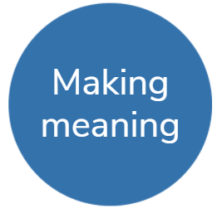
Notes for teachers and whānau
This is a fun activity for learners to use their creative thinking and come up with a way to modify a common food item.
Note that our Inquiry focus for today is "making meaning" which includes analysing data, organising, and sorting information, summarising, synthesising, making connections/conclusions, building deeper understandings, and thinking critically.

In this activity I am learning to: Use creative thinking to come up with ways we can change common food items - physically and chemically.

What do I need?
- 30 minutes
- Coloured pens/pencil/crayon
- Device/access to internet for finding a food item
- Optional: https://www.youtube.com/watch?v=ErDkRerNKvQ

Remember to start your day right (See p. 8)

Instructions:
Molecular gastronomy is the branch of food science that focuses on the physical and chemical processes that arise when cooking and often sees chefs create some very cool (sometimes literally!) meals.
This task will require you to get thinking about ways you could change the physical and chemical attributes of common foods to come up with something new!

Your task:
Find an example of a dish or food that is made using molecular gastronomy – if you have access to a device you could google this or maybe ask a household member, friend, sibling if they know of any.
Describe the food item and how it was made– can you identify what chemical or physical changes had taken place?
Choose a common food item of your choice e.g. blueberries, ice cream, sandwiches.
Get curious about how you could use these foods to create something amazing by using out of the square thinking e.g. What if we made powdered ice cream?
In your home learning book
- Describe your new food item, what it was originally and what it is now
- Explain the physical and chemical changes that the food item has undergone
- Draw a picture of your food item.
Watch this you tube clip for inspiration https://www.youtube.com/watch?v=ErDkRerNKvQ

Day 3 activity 2: Traditional cooking and preserving
Notes for teachers and whānau
In this activity learners will read an article and complete an Anticipation guide. This helps the learner establish what they know and what they need to learn before they read a text.

In this activity I am learning to: establish what I know and need to learn before reading a text
What do I need?
- 30 minutes
- https://teara.govt.nz/en/Māori-foods-kai-Māori/page-2

Instructions:
Your task is to make meaning from a text, and strategies such as the table below can help you identify what you know and what you might need to learn before reading. It also helps you think about whether you agree or already know the facts you are reading and how to re write something into your own words. When reading this text, consider that some of these customs have evolved over time, and many are still practiced today.

Your task:
Before reading
- Read the following statements in the grid below
- Decide whether you agree with them or not
- Tick ‘agree’ or ‘disagree’ in the opinion columns
After reading https://teara.govt.nz/en/Māori-foods-kai-Māori/page-2
- Decide whether what you have read supports your opinions
- Tick ‘agree’ or ‘disagree’ in the finding columns
- Provide evidence but in your own words.
Statement | Opinion  Agree Disagree | Finding  Agree Disagree | Evidence  Explain in your own words
- Early Māori never cooked in the same building they slept in
- Hangi has in some places been cooked using geothermal steam
- The moon has no impact on how food is cooked or prepared
- Fermented food would not be very nice or appealing to eat
- Early Māori used wooden bowls on the fire to boil water
- Early Māori would waste very little food sources

Day 3 activity 3: Numeracy – birthday treat
Notes for teachers and whānau
This is a worksheet from the NZ maths – Figure it out series. Learners will be solving addition, subtraction, multiplication, and division of money problems.

In this activity I am learning to: solve problems using addition, subtraction, multiplication, and division of money.
What do I need?
- 30 minutes
- Copy of https://nzmaths.co.nz/sites/default/files/BirthdayTreat.pdf

Instructions:
This activity encourages you to develop your problem-solving abilities.

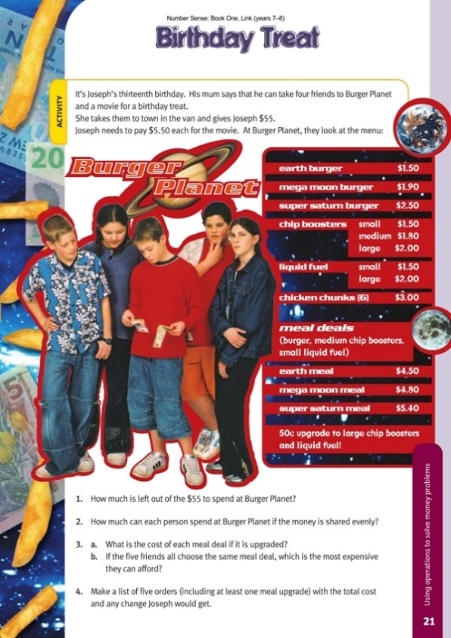
Your task:
Complete the worksheet “Birthday Treat”.
Write your answers in your home learning book.
Extra: Develop some new types of burgers for the burger planet menu, along with different prices. Use these new burgers to work out different options for the 5 boys.

Day 3 activity 4: Food science – making Ice cream
Notes for teachers and whānau
This activity will require a few ingredients below and the use of the kitchen.
If these ingredients aren’t available learners can watch a video of the process and identify the physical and chemical changes taking place.

In this activity I am learning to: follow a recipe; observe and identify physical and chemical changes during a process
What do I need?
- 30 minutes
- Equipment: Measuring spoons and measuring cup, tea towel, timer
- Ingredients: Sugar, milk or cream, vanilla essence/extract, salt, ice cubes
- Small zip lock bags or equivalent (x2) and large zip lock bag or equivalent (x2)
- Optional video https://www.youtube.com/watch?v=5ub_5_b6yOQ

Instructions:
Everyone loves ice cream right?! But did you know there is actually a lot of science involved in making ice cream. This activity will require you to make your own ice cream and investigate which temperature and factors makes it into a creamy treat!

Your task:
If you don’t have ingredients or equipment watch the video https://www.youtube.com/watch?v=5ub_5_b6yOQ and answer the questions in your book:
- What was the role of the salt in this recipe?
- What factors do you think are important in making ice cream?
- What are some physical and chemical changes occurring during this recipe?

Instructions
- In each small bag, place one tablespoon of sugar, ½ cup of milk or cream, and ¼ teaspoon of vanilla extract. Seal both bags well.
- Add 4 cups of ice cubes to one of the larger bags. Add ½ cup of salt to the bag.
- Put one of the small bags you prepared into the large bag with the ice cubes. Be sure both bags are sealed shut.
- Wrap the bag in a tea towel, shake the bag for 5–6 minutes. Feel the smaller bag every couple of minutes while you shake it, observe what is happening.
- Now add 8 cups of ice cubes to the other large bag, but this time do not add any salt to it. What do you think will happen without using salt?
- Put the other small bag you prepared into the large bag. Seal both bags.
- Using a tea towel shake the bag for 5–6 minutes, as you did before. Again, feel the smaller bag every couple of minutes while you shake it, and observe it.
- Compare how cold the ice cube bags feel. Does one feel colder than the other?
- If you successfully made some ice cream, enjoy!
Remember to do your end of day reflection and wellbeing activities (See p. 7 & 9).

Day 4 activity 1: STEM and inquiry – brainstorming
Notes for teachers and whānau
This task involves asking household members about their cooking experiences and brainstorming ways to make cooking easier in the home. During today’s activities we are encouraging the learner to take photos of their learning journey so they can use them for the final presentation
Note today our Inquiry focus is “going further, deeper”. This may include promoting opportunities to engage further and dive deeper through discussions, provocations, exploring further contexts, taking action, or thinking critically and drawing conclusions.

In this activity I am learning to: identify challenges/problems in an everyday situation e.g. cooking
What do I need?
- 30 minutes
- Home learning book

Remember to start your day right (See p. 8)

Instructions:
Are there any challenges in the kitchen when cooking/preparing meals? When we are cooking, especially for multiple people, we often encounter problems/challenges that hinder the process. Cherry pitter, nut grinder, egg slicer – over time, people have come up with some interesting devices to make cooking easier, faster of just more enjoyable. This task will require you to unpack an example of one of these devices and come up with some of your own interesting kitchen helpers!

Your task:
Look at the photos of the gadget. Write your answers to the questions in your book.
- What was the problem/challenge that it was trying to solve?
- How do you think it works?
- Why is this useful/not useful?
- Who do you think this was intended for?
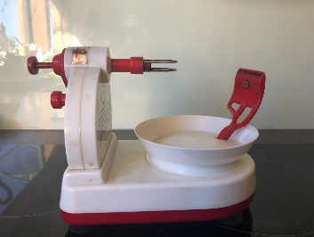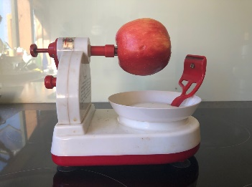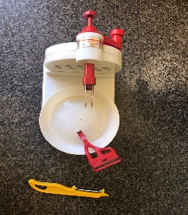
Brainstorm some things that could be made easier for cooks in the kitchen – think of things you could potentially create or design.
Gather ideas from household members or those that usually do the cooking!
e.g. “What if we had a device that could slice a whole block of cheese in one go...”
Write your ideas in your home learning book.

Day 4 activity 2: STEM and inquiry and literacy – plan
Notes for teachers and whānau
Learners will design and plan something that will help in the kitchen – choosing something they brainstormed above. This ‘project’ and presentation of the project will continue over into day 5 as well.
Projects can be defined as a planned undertaking to accomplish a specific aim and have been a valuable part of learning for a long time. Projects are often part of a larger body of work, with other types of learning building towards the final project. https://elearning.tki.org.nz/Teaching/Future-focused-learning/Project-based-learning

In this activity I am learning to: design and plan a gadget that has a specific purpose or could be used to overcome a particular challenge
What do I need?
- 30 minutes
- Home learning book

Instructions:
This task requires you to go deeper and come up with a plan for a gadget you brainstormed above that could make life easier in the kitchen.
Planning is an important part of any project as good planning and organisation will more likely result in a successful outcome of what you are trying to achieve!

Your task:
Choose one of your ideas from your above brainstorm – e.g. ‘what if we had a device that could slice a whole block of cheese in one go’
Write a list of materials for your idea
Draw (or design digitally) a labelled diagram of your idea.
Write three paragraphs in your home learning book which answer the following questions.
- 1.What was the problem/challenge the gadget could help overcome?
- How will it work?
- What are some key attributes that have been considered – is it safe to use? Portable?
- Why will it be useful? Who will use it?
Reflect on your planning process – what could be helpful when planning? Having a flow chart or tool to show progression? Talking and discussing it with others?

Day 4 activity 3: STEM, inquiry and literacy – create
Notes for teachers and whānau
In this activity learners can try and either make their gadget or a model – whatever they can manage to do at home. They made need your help accessing materials that could be useful for the object itself or the model – e.g. cardboard, plastic lids and containers, ice block sticks, blue tack, cellotape, glue etc.
If they are using sharp objects this may need to be done under supervision– so please ensure safe practice.

In this activity I am learning to: make a gadget or model of a gadget that is useful to overcome a problem or challenge.
What do I need?
- 30 minutes
- Craft or building materials – cardboard, plastic lids and containers, ice block sticks, blu tack, cellotape, glue, stapler, craft knife, scissors (consider safety) etc.
- A space to construct
- Smartphone to take photos (optional)

Instructions:
Can you create your gadget? If you don’t have the actual materials can you create a model/prototype using cardboard, plastic, arts and crafts, wood any bits and pieces around the house. You may need glue, stapler, sticky tape etc to create.
Ask a household member to help you source materials and construct.

Your task:
Have a go at constructing your actual design or simply a model out of simple materials.
Use any material you have available
Ensure safe practice when you are using any sharp objects e.g. scissors, craft knives etc.
If available, take a photo using your phone camera and upload your photo to your home learning book. This will be helpful for day 5 activities.

Day 4 activity 4: STEM and inquiry – Improve
Notes for teachers and whānau
This task requires access to Home Learning TV online or on TVNZ.
This task requires the learner to evaluate and improve their original gadget. They may ask someone in the household/ whānau for feedback.

In this activity I am learning to: evaluate my model or gadget; gather and use feedback to improve my model or gadget; refine my model or gadget if needed
What do I need?
- 30 minutes
- Your gadget/model from above
- Video from Home learning tv https://www.tvnz.co.nz/shows/home-learning-tv/episodes/sage-9-11-e283
- whānau or household member to give feedback

Instructions:
From the last activity you will have made a gadget or model of a kitchen gadget that could be used to overcome a challenge.
This task requires you to evaluate your gadget or model, gain feedback and revise or modify if needed.

Your task:
Write the answers to these questions in your home learning book.
- Did your gadget work or come together as you hoped? Why/Why not?
- How could you make improvements?
- What would you do differently?
Watch this video from home learning tv on “Using feedback to step up our innovations” (15 minutes)
After watching this video, Gather feedback from a member of your household or whānau about your device/creation/model.
Remember to do your end of day reflection and wellbeing activities (see p. 7&9).

Day 5 activity 1–2: Presentation
Notes for teachers and whānau
Learners will be creating a poster (or equivalent) to summarize their learning and design process from the above activities. They may require some paper and materials to physically make the poster if they are available. Some may prefer to create it digitally.
Note that today our Inquiry focus is “present – share learning about the theme” which includes thinking about who the audience is and considering different ways of communicating learning for example, presentation, video, poster, etc.

In this activity I am learning to: create a poster or presentation which communicates a learning process to others
What do I need?
- 30 minutes
- Resource or link on how to put together an informative poster
- Poster paper (A3 size if available), or white paper
- Computer or device (optional)

Remember to start your day right (See p. 8)

Instructions:
Having an amazing design is no use unless it is communicated to others. The next two activities will help you to develop effective presentation skills and then put together a presentation based on your learning this week. A poster/PowerPoint/brochure can convey a message or report your journey or process to others.

Your task:
Create an informative poster, PowerPoint, brochure about your learning process and journey over the last couple of days to creating your kitchen gadget or model.
Your poster/presentation needs to include the following
- Appropriate background information: challenges in the kitchen, history of cooking/preparing, using tools – you can use any of the information from previous day’s activities for this aspect.
- The aim of the project
- The initial planning (this can be copied/pasted from the activity above)
- Any photos you have taken/drawings/diagrams
- Evaluation and Feedback you gathered
Along with this information your poster will have to
- Look appealing
- Display your information simply but effective
- Contain the right balance of text and visual data

Day 5 activity 3: Present!
Notes for teachers and whānau
It would be great if learners could have some time with whānau, household members, teachers, and peers (online if appropriate/available) to present their work from the last week.
Talk to the learner and set aside a time to engage with them and listen to their presentation.

In this activity I am learning to: present confidently to an audience
What do I need?
- 30 minutes
- Poster or presentation from above

Instructions:
There is no point learning, researching, creating if you can’t share it with anyone. Presentation is a key part of the design process so this task will require you to find someone or an audience to present your poster (or equivalent) to.

Your task:
Present your poster or presentation you finished to a member of your household/ whānau/class.
Remember the following
- Practise makes perfect set some time aside before presenting to an audience to run through your presentation. This will give you confidence that you know your stuff!
- Create a story – what is the necessary background information and what do you want the audience to know? What led you to your design?
- Be welcoming – stand beside your poster/presentation and engage with your audience with a smile
- Engage with your audience – be enthusiastic about your learning. If you find your project interesting so will your audience
- Ask your audience if they have any questions about your work/design/process

Day 5 activity 4: Reflecting
Notes for teachers and whānau
This final task is simply learners reflecting on the learning from the week. What they learnt, what they enjoyed, what they would do differently. They will do this in the form of a letter to someone who cares about their learning.

In this activity I am learning to: reflect on the week’s learning in the form of a letter
What do I need?
- 30 minutes
- Home learning book
- Pen or pencil
- Paper for writing a letter

Instructions:
There are people in your life who really care about your learning, that could be a grandparent, parent, sibling, family friend, neighbour, teacher, or friend.
Reflect on your learning this week by way of a letter to this special person.

Your task:
Think of someone in your life who cares about your learning. Write a letter about your week of learning, expressing what you enjoyed, didn’t enjoy, what worked well, challenges and problems etc.
Use these prompts to help you write your letter.
- I feel good about…
- I used to… but now I…
- Two things I will remember about what I have learnt over the last week is..
- A strategy that really helped me learn better is…
- If I could do something again differently, I would…
- One thing I will remember to do in the future is…
- One thing I really want to learn is...

Remember to do your end of day reflection and wellbeing activities (See p. 7&9).

Context 2: How does that work?

The next five days indulge our curiosity by looking at how different things work.

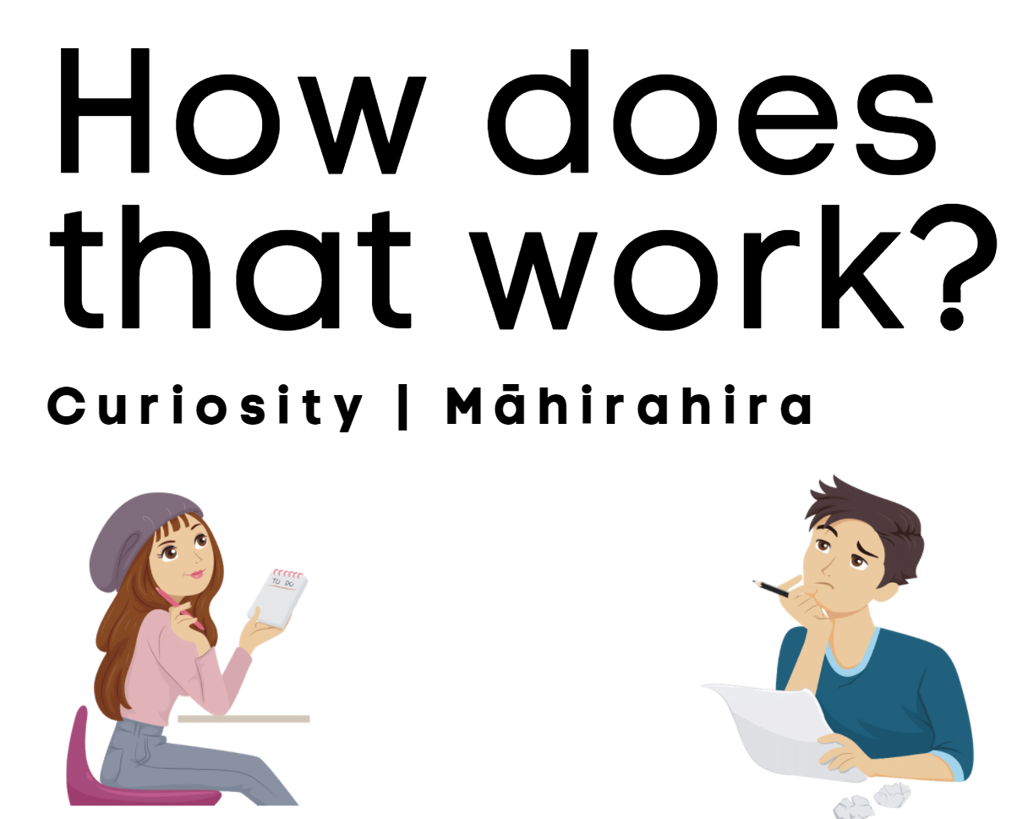

Day 6 activity 1: How things work
Notes for teachers and whānau
This brainstorming activity helps learners organise their ideas into themes and start them getting curious into how things work.
Note that our Inquiry focus for today is “getting started” which includes generating questions, activating prior knowledge, and introducing the theme.

In this activity I am learning to: brainstorm ideas to activate curiosity and organise our ideas into themes
What do I need?
- 30 minutes
- Pen/pencil
- Home learning book

Instructions:
Often, we can have a large number of ideas when asked to brainstorm. Sometimes it can be a struggle to organise these ideas and make sense of them. This activity will help you organise your ideas and identify what you are curious to find out more about.
Pongkaew, CC0, via Wikimedia Commons

Your task
- Study the picture of the levitating metal above
- What questions do you have when looking at this photo? List 5 questions you have about this invention in your home learning book.

How does … work?
Brainstorm all the things you can think of when you wonder how things work? E.g. how does a microwave work? How does a clock work?
Group all your ideas into themes – possible themes could be man-made, natural, people orientated, food related, sport related, etc.
Identify specific themes – what are the types of things you are mainly curious about finding out? List them in your book.

Day 6 activity 2: Science, literacy and art – ‘How does bioluminescence work?’
Notes for teachers and whānau
In this activity, the learner enquires into a natural phenomenon called ‘bioluminescence’. This literacy activity will help to extend their vocabulary and practice their literacy skills by way of a cloze activity. If there are any art supplies available this would enable the learner to carry out the first part of the activity.

In this activity I am learning to: create a visual representation of a natural phenomenon (bioluminescence); and make meaning from a text
What do I need?
- 30 minutes
- Optional article: https://theconversation.com/what-is-bioluminescence-and-how-is-it-used-by-humans-and-in-nature-100472

Instructions:
Some extraordinary sea creatures have an amazing ability to produce their own light. This is known as bioluminescence. You will discover some examples and how bioluminescence works by reading the text below. You will define some important vocabulary to help your understanding as well as complete the missing words in a text – a cloze activity.

Your task:
“The sea was luminous in specks and in the wake of the vessel, of a uniform, slightly milky colour. When the water was put into a bottle it gave out sparks” (Charles Darwin, after seeing bioluminescent sea creatures from HMS Beagle)
- Draw a visual representation of the quote above – you could do it in any way you wish and with any materials you have available e.g. painting, drawing, sketch, sculpture
- Below is a cloze activity. Insert words where the underlined gaps are – in order to complete the article. You can choose to test yourself by using your own knowledge to fill in the gaps or if you need a helping hand see the Notes section below and use those words to fill in the underlined gaps. (**they are not in the correct order).
- Define the bolded words and write these words and definitions for each one in your home learning book.

Notes:
- Words to fill in the gaps (not in order): lives, against, produce, resembling, using, produced, were, enough, through
- Words to define: emission, symbiosis, nocturnal, camouflage, counter-illumination, ingenious
Bioluminescence, the production ______________ emission of light by living organisms. More than 75% of deep-sea creatures are estimated to _____________ their own light. The anglerfish, for example, uses bioluminescent lures, ____________ fishing rods, to attract prey towards their large mouths. Intriguingly, the anglerfish’s light is actually______ by Photobacterium, a bacterium that lives in symbiosis with the fish inside its esca (lure).
The nocturnal Hawaiian bobtail squid – Euprymna scolopes – which ____________ in shallow waters, also has a symbiotic relationship with a bioluminescent bacterium, Aliivibrio fischeri. At night, these bacteria begin to glow, and the squid uses their light to camouflage itself ____________ the night sky. This counter-illumination strategy is akin to an invisibility cloak.
At dawn, the squid expels around 95% of the glowing bacteria from its light organ and supplies the remaining 5% with ______ nutrients to grow throughout the day. A critical mass is reached once again by dusk, at which point the light switches on.
Throughout history, humans have devised ingenious ways of _____________ bioluminescence to their advantage. Glowing fungi have been used by tribes to light the way _____________ dense jungles, for example, while fireflies ______________ used by miners as an early safety lamp. Perhaps inspired by these applications, researchers are now again turning to bioluminescence as a potential form of green energy. In the not-so-distant future, our traditional streetlamps may be replaced by glowing trees and buildings.
Text adapted from: https://theconversation.com/what-is-bioluminescence-and-how-is-it-used-by-humans-and-in-nature-100472
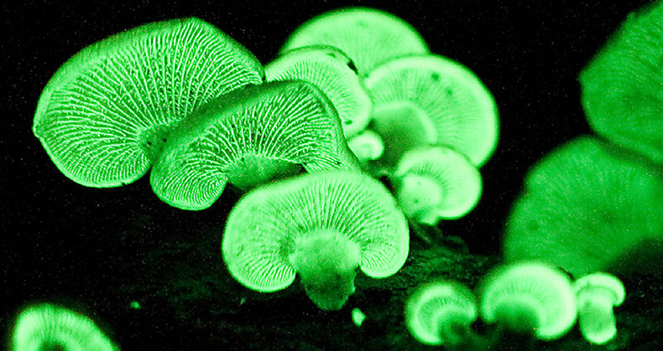
File: PanellusStipticusJuly5_2010.jpg Ylem, Public domain, via Wikimedia Commons
Day 6 activity 3: Thinking and asking questions
Notes for teachers and whānau
This task activates the prior knowledge of learners – in particular what they already know about wind turbines. It all gets them to check their understanding from a reputable source. Encouraging them to check their understanding is an excellent skill as it clears up any gaps or misunderstandings in what they already know.

In this activity I am learning to: make predictions and check my understanding
What do I need?
- 30 minutes
- Text below adapted courtesy of https://www.sciencelearn.org.nz/
- Home learning book
- Pen/pencil

Instructions:
This activity taps into your prior knowledge by requiring you to write down what you already know about how wind turbines work. You can then check your understanding by reading the article below. It is important we check our understanding of what we already know to check for misconceptions or gaps in our knowledge in a topic. Reading from a wide variety of sources can also help clarify things.

Your task:
Think about this question (before you read the text)
- How does a wind turbine work?
Respond to the question in the second column of your table (do this before you read the text or visit the website):
Prepare your table using a whole page (leave enough room for your answers) in your home learning book or digital doc as follows:
 | What I think… | What I learned….
How does a wind turbine work?
Other questions to answer:
Who invented the wind turbine?
What does electricity have to do with the wind turbine?
What are the advantages of the wind turbine?

Read the following text from the Science Learning Hub or read it on their website using this link https://www.sciencelearn.org.nz/resources/1565-wind-power

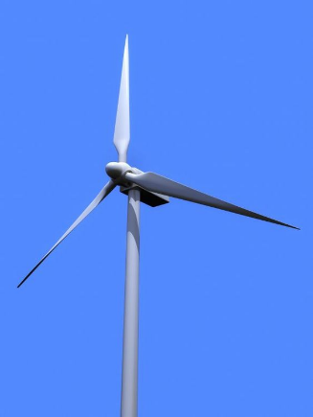
Harnessing the wind to make work easier is not a new technology. People have been using wind to mill grain, draw water and to power their boats for thousands of years. As we become increasingly concerned about the impacts of fossil fuels on climate change, the idea of electricity generated through wind has much appeal.
Wind power uses the kinetic energy from the wind to turn large turbines, transforming the energy into electricity that we can then use. The most common type of turbine consists of a number of long blades, with the turbine attached to a pole many metres above the ground. The location of a turbine (or many turbines together, called a wind farm) is vital – they need to be in an area of constant wind.
Currently, there are 17 wind farms throughout New Zealand. Like those in the Tararuas and in Wairarapa, these wind farms are ideally situated to capture good levels of wind. The Tararua wind farm near Palmerston North in the North Island, for example, operates 90–95% of the time. In 2007, overall wind-generated power only accounted for about 2% of power generated in New Zealand, in 2018 it increased to 6%, although there is potential for higher levels.
There are many benefits to using wind power. It is a green renewable resource because we will not run out of wind, and wind produces no harmful wastes. Wind farms have little running cost once built compared to traditional electricity producers, and the time taken to build a wind farm is usually short. Plus, once built, additional turbines can be added as supply grows.
One of the biggest problems facing wind powered generation is that they are considered to be an eyesore. While we may want the electricity generated by a wind turbine, few of us want one in our back yard! Some people living in the vicinity of wind farms also find the noise the blades generate can be problematic. Another problem associated with wind farms is the possibility that they may be detrimental to wildlife. Studies continue to be carried out to see if wind turbines interfere with the sonar of bats and the migration pathways of birds. Both of these problems are taken into consideration when resource consents are being sought. This process allows people near proposed sites to argue for or against wind farms.

Day 6 activity 4: Numeracy – Wind power
Notes for teachers and whānau
This is a numeracy activity that continues on from the last activity in terms of wind turbines and wind power. It is a good example of how subjects cross over in the real world. Graph paper may be needed, or learners can use the graph grid below.

In this activity I am learning to:
- Convert metric units for speed
- Interpret line graphs and scatter plots
- Use location, wind speed and gale frequency data to recommend a location for a wind farm

What do I need?
- 30 minutes
- Copy of https://nzmaths.co.nz/sites/default/files/WindPower.pdf
- Graph paper (this should be supplied with your pack)

Instructions:
This activity will require you to make decisions about where to locate a new wind turbine farm based on different variables (mean wind speed, gale days and costs) and data representations. You will need to combine information from a line graph, a scatter plot, a table, and your own ideas and research to come up with your recommendation.
Your task:
Complete the maths work sheet and write your answers in your home learning book.
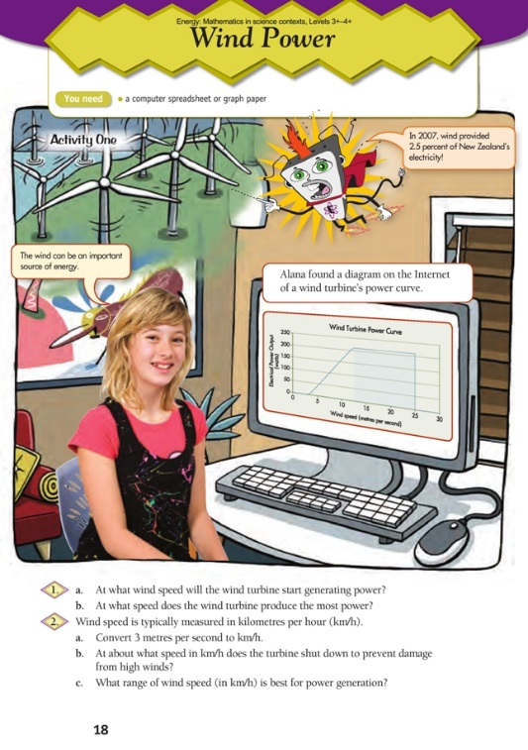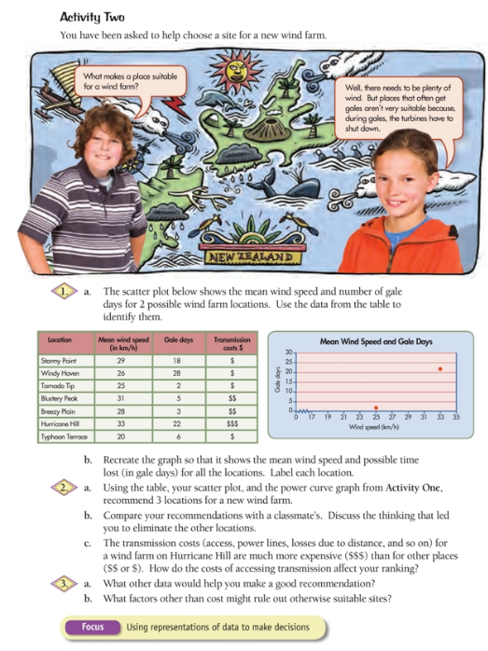
Remember to do your end of day reflection and wellbeing activities (See p. 7&9).

Day 7 activity 1: Science and literacy – How does a roller-coaster work?
Notes for teachers and whānau
This activity begins the inquiry into adventure activities. Learners define key words and then test their brain power and memory by watching a video and trying to remember the answers to 4 questions.
Note that our Inquiry focus for today is “explore, investigate, and discover” which includes choosing and evaluating information, and thinking critically.

In this activity I am learning to:
- Identify key words in an article and define them
- Use our Reticular Activating System (RAS) to identify key information
What do I need?
- 30 minutes
- Device to access the video: Why roller coasters are awesome at: https://www.youtube.com/watch?v=VcRFh-dCxWE (or read transcript)
- Optional digital: https://www.schooltube.com/media/Time+warpA+roller+coaster/1_wn78kpgw

Remember to start your day right (See p. 8)

Instructions:
Read the article below or visit this link https://www.wonderopolis.org/wonder/how-do-roller-coasters-work and follow the sequence below.

Your task:
      - Create a table (like the one below) to record the key words and then find them in the text and write down their definitions.
Key word | Definition
Inertia
Motorised
Resistance
Potential energy
Kinetic energy
Acceleration

Read the text:
Text adapted from: https://www.wonderopolis.org/wonder/how-do-roller-coasters-work
Have you ever looked closely at a roller coaster? Did you realise it doesn't have an engine? Have you ever stopped to WONDER how a roller coaster operates at such high speeds without one?
Roller coasters are pulled by a motorised chain to the top of the first big hill. As the roller coaster rises higher into the air, its potential energy keeps growing until it reaches its maximum potential energy at the crest of the hill. Potential energy is also known as positional energy. Potential energy represents the amount of work the roller coaster can do with the energy it builds up from falling down the other side of the hill.
When a roller coaster crests the first big hill, gravity takes over, causing the roller coaster to fall down at a constant rate of 9.8 metres per second squared. All that stored potential energy changes to kinetic energy, which can also be called moving energy.
As the roller coaster falls, it accelerates and builds up enough kinetic energy to propel it through the remainder of the ride. No engine is required because of inertia. Inertia is one of the laws of physics described long ago by Sir Isaac Newton. The law of inertia holds that an object in motion will stay in motion until acted upon by an equal but opposite force.
In the case of a roller coaster, this means that the kinetic energy built up from the fall down the first hill could keep it going forever. We all know, though, that roller coaster rides don't last forever. That's because the roller coaster loses energy to other forces as it does loop-the-loops, curves, and hills along the way.
These other forces eventually bring the roller coaster to a stop, with some help from air brakes at the end of the ride. So what are these other forces? Two of the most significant are friction and air resistance. As you ride a roller coaster, its wheels rub along the rails, creating heat as a result of friction. This friction slows the roller coaster gradually, as does the air around the ride.
Roller coaster rides are exciting for some people because of the other forces at work on your body during the ride. The forces of gravity and acceleration that move the roller coaster along the track also affect your body in the same ways. For example, when you go around a sharp curve or a loop-the-loop, special forces of acceleration push you in different directions. Not only do these forces keep you in your seat, but they also are responsible for the exhilarating feelings you get that some people call a “rush."
Some people also love the weightless feeling you get briefly at the top of a loop-the-loop. That feeling is caused by two forces countering one another: gravity is pulling you toward the ground at the same time as inertia is pulling you toward the top of the loop.
If you want to ride the world's fastest roller coaster, you'll need to catch a flight to Ferrari World in Abu Dhabi, which is part of the United Arab Emirates. There you can ride the Formula Rossa, which reaches an amazing top speed of 149.1 miles per hour. The ride is so intense that passengers must wear goggles to protect their eyes!
      - This next task puts your Reticular Activating System (RAS) into use. There are a couple of steps so follow them carefully.
First read through the questions below
- What is a force?
- what force makes the rollercoaster move?
- What is gravity’s role in keeping a roller coaster moving?
- Explain what friction is and how it works to stop the rollercoaster moving
Now watch Rollercoasters are awesome (or read the transcript) through once – DO NOT WRITE ANY ANSWERS DOWN but make a mental note of when you hear an answer to any of the questions.
https://www.youtube.com/watch?v=VcRFh-dCxWE
Transcript
Squeaks was just asking about how roller coasters work and I thought that was a great question because they are not at all like the cars we drive on the street. Instead roller coasters have cars that run on a track and the ways they work is the same reason that they are so much fun – because of forces.
You can think of a force as a push or a pull on something. That is how you make things move or speed up or slow down. For example bikes start moving when we put forces on the pedals with our legs which turn the wheels. And things like cars, planes, and trains work because of the forces made by their motors.
But rollercoaster cars don’t have motors so the force that starts them moving has to come from somewhere else. Most of the time the force comes from a strong chain attached to the tracks. The ride starts when the chain pulls the rollercoaster up to the top of a big hill. But when the cars start to go over the top of the hill the chain lets go and the cars keep going anyway. Usually all the way to the end.
That’s because a different force takes over. One you might have heard about before. It is the same force that makes a ball fall back down when you throw it into the air – the force is gravity.
Gravity pulls everything on Earth down towards the ground and it is gravity that pulls the rollercoaster cars down over the hill and along the track. And once those cars get moving downhill they can keep going.
Rollercoasters which have just gone down a big hill are going so fast they can get up to the top of the next hill. If they didn’t have enough speed they wouldn’t make it over the top and they would just slide down to the bottom and get stuck there.
The people who design and build rollercoasters know just how fast the cars are going to go and whether they will be able to get over the next hill. And if they find out that the cars don’t have enough speed, they change the design to make sure the cars will be able to get over the top, or they sometimes add another chain in the track to pull them up over the top of the hill. Then once the cars get to the top of that second hill, gravity takes over again, and it pulls them down and to whatever bend or hill comes next.
But even though rollercoaster rides can be really fun, they don’t last forever. And that’s because of another kind of force. This force is called friction and it pulls on things that are moving, slowing them down. Have you ever tried to slide across the floor in your socks? If the floor is made of carpet, your socks scrape along it so roughly that there is a ton of friction, and you probably won’t slide at all. If it is made of something a little more slippery like wood you might slide a little but eventually you stop because there is friction when your socks scrape along the floor slowing you down.
The same thing happens with the rollercoaster cars. The track is slippery enough that the cars can slide along it for a while, but friction is still pulling on the cars slowing them down, and eventually they stop.
So you can use the science of forces to make some awesome rides, but all good things must come to an end.

- Read the questions again – DO NOT WRITE ANY ANSWERS DOWN – say your answers aloud or make a mental note if you remember any.
- Watch the clip (or read the transcript) again – do not write anything until the end.
- Once you have finished watching/reading the second time you may write your answers to the questions above in your home learning book or digital doc.
- Reflect on the process – did you take more information in since you weren’t allowed to write. Was it more/less difficult than writing answers as you go?
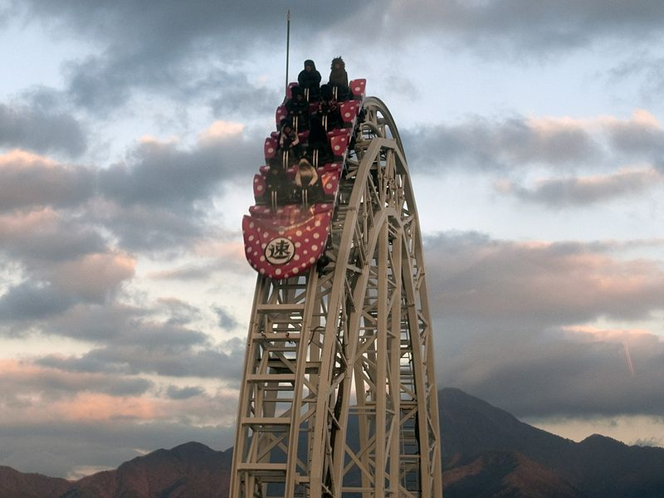
Nikm, Public domain, via Wikimedia Commons

Day 7 activity 2: Maths – Roller coasting
Notes for teachers and whānau
This activity continues to allow learners to work on their graphing skills and also inquiring further into the concept of ‘what makes a roller coaster work?”.
If there is access to a device – it may be easier for learners to enter their data on a spreadsheet and create a graph from there.

In this activity I am learning to:
- Make a graph from a data table
- Interpret a relationship shown on a graph
- Extend my knowledge on how rollercoasters work
What do I need?
- 30 minutes
- Graph paper (should be supplied with your pack)
- Copy of NZ Maths – figure it out ‘roller coasting’ https://nzmaths.co.nz/sites/default/files/2020-01/RollerCoasting.pdf

Instructions:
In this task you will identify factors that influence the speed of rollercoasters. This will help you with your overall understanding of how rollercoasters work. If you have a device available you can enter the data from the table into a spreadsheet and create a graph. Otherwise use the data to create your own graph on the graph paper below.

Your task:
Complete the Figure It Out task and create a graph.
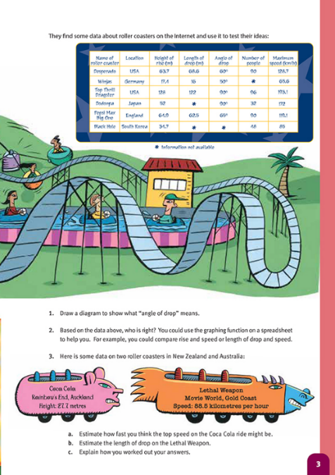
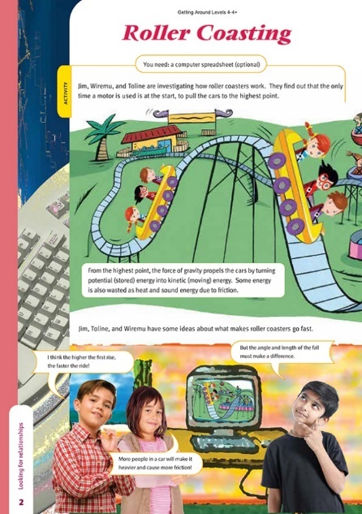

Day 7 activity 3&4: Science – How does our heart rate work?
Notes for teachers and whānau
In this we explore what happens to our heart rate after exercise or a fright.

In this activity I am learning to:
- Measure my pulse, find my resting heart rate, and find out how different activities including being scared might affect my heart rate.
- Use a variety of tools, equipment, materials, and models to conduct a scientific investigation
What do I need?
- 60 minutes
- Timer, stop watch, watch with a second hand etc
- Device to listen to music

Instructions:
The heart is an amazing machine that can change the rate it pumps oxygen-containing blood around our body when we need it, such as times of exercise or when the ‘flight or fight’ part of our brain kicks in when we get a fright or are fearful. This activity will check your prior knowledge of the heart and heart rate and then get you to carry out a practical task to investigate the relationship between heart rate and exercise.

Your task:
- Create a word map of what you already know about the heart, heart rate, exercise, and response to fear.
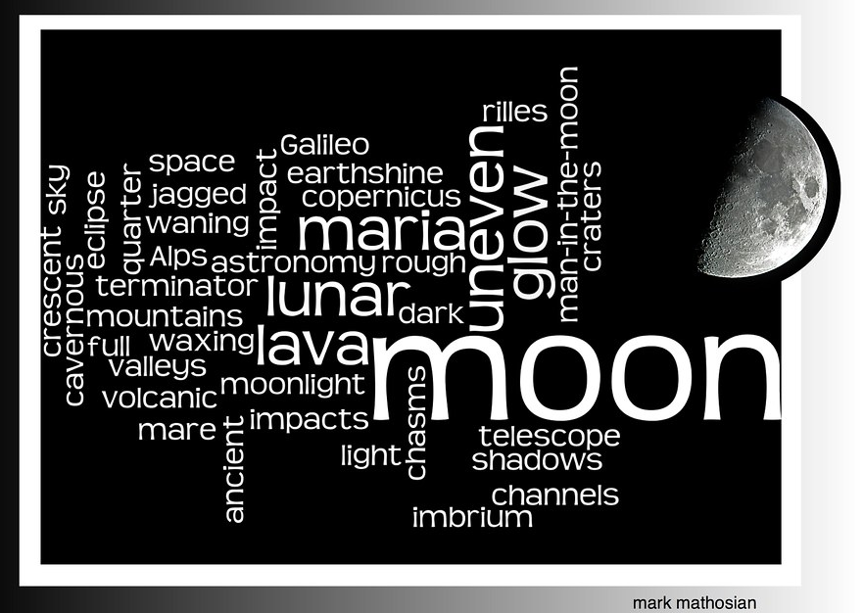
You can use an online tool such as https://wordart.com/ or http://www.tagxedo.com/ OR if you do not have access to these websites you can simply create your own word map by creating a visual map on the subject of ‘the heart and heart rate’. Below is an example of a word map using a word art tool about the moon.

"moon word art" by MarkGregory007 is marked with CC BY-NC-SA 2.0.

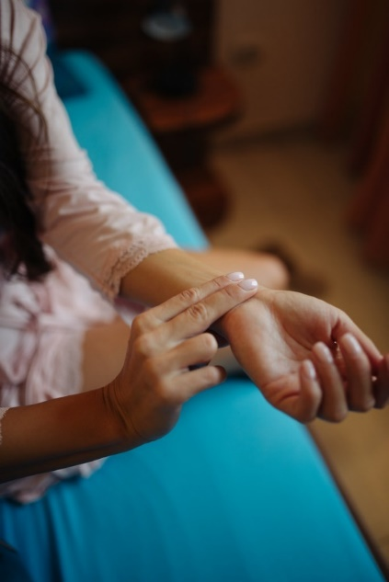
- Heart rate and exercise Investigation
Do you know how to measure your heart rate (pulse)?
We can measure heart rate (beats per minute) by feeling for the surge of blood through an artery. You can do this by feeling with slight pressure on the wrist using your middle and forefinger.
While resting or sitting. Practice counting your pulse over 15 seconds and then multiplying this by 4 to get beats per minute. Do this a couple of times to get the hang of it. This is known as your resting heart rate.
"Woman sitting on bed and checking her heart rate." by shixart1985 is marked with CC BY 2.0.
Once you have the hang of it calculate it below.
Resting Heart Rate
To calculate your resting heart rate use this formula:
________ (number of beats in 15 seconds) x 4 = ____________ (beats per minute)
Do each activity and complete the table:
Type of Activity  (Conducted for 1 minute) | Predicted effect of activity on heart rate  (Increase or decrease or same?) | Heart rate immediately after exercise  (Beats per minute) | Difference between resting heart rate and rate after activity. (Increase or decrease or same?)
Listen to soft, slow, music
Listen to fast music
Breathe deeply
Walk briskly around the room
Do jumping jacks
Think about riding a roller coaster
Something of your choice
Write a conclusion about what happens to our heart rate after exercise/activity.
Predict -- what do you think happens to our heart rate when on a rollercoaster ride?
Optional digital extra – watch the video https://www.youtube.com/watch?v=v8ptFlof1sI to see what happens to our bodies during a roller coaster ride and check whether your thinking above is correct.

Remember to do your end of day reflection and wellbeing activities (See p. 6 & 8).

Day 8 activity 1: Literacy – concept circle
Notes for teachers and whānau
This activity explores literacy in the context of “riding a rollercoaster”.
Note that our Inquiry focus for today is "making meaning" which includes analysing data, organising, and sorting information, summarising, synthesising, making connections/conclusions, building deeper understandings, and thinking critically.

In this activity I am learning to:
- Use a concept circle to check my understanding of key words
- Unpack how key words may relate to each other
- Create similes to describe the key words

What do I need?
- 30 minutes
- Home learning book

Remember to start your day right (See p. 8)

Instructions:
A concept circle is a strategy to unpack words that are important in a subject/topic. It can be used to check your prior understanding and knowledge of these key words and find out where they may be gaps. We will also look at a whakataukī which describes fear or excitement, and then you can have a go at creating your own simile.

Your task:
Write each of these 4 words into one segment of the circle – excitement, exhilaration, energy, fear. This is called a concept circle.
Examine and reflect on the words in the concept circle above and write answers to the following questions in your workbook
- Are the words related in some way? How?
- Are there any words in the circle you don’t think belong? Explain why.
- Could you think of 3 more words that might also relate to these group of words?

Me he manu au e kapapa nei – I am all a-flutter like a bird.
The whakataukī above describes excitement in someone, the racing and fluttering of the heart – like a pīwakawaka flying from branch to branch in the forest.
This whakataukī is an example of a simile. When we compare two things using “like” or “as” to describe them we are using a simile. e.g. She was as brave as a lion. He was full of energy like the energizer bunny.
Write 5 of your own similes to describe any of the above words/feelings or using any of the above words as the context.

Day 8 activity 2: Science and literacy – bungy brainstorming
Notes for teachers and whānau
This activity investigates a similar but different concept of “how things work” using Bungy jumping as the context. This theme continues for the next 2 days inquiring into the science concepts involved and developing a model of a bungy jump.

In this activity I am learning to: unpack prior knowledge and write an acrostic poem
What do I need?
- 30 minutes
- https://www.youtube.com/watch?v=mmrVJq4uJ0E. or read transcript below

Instructions:
Consider ‘what do I already know about how a bungy jump works?’ Bungy jumping is another adrenaline-inducing activity like riding on a rollercoaster. Over the next 2 days, we will work on this theme, but first let’s start with what we already know!

Your task:
- List facts about bungy jumping. You might include science, safety, history, places, etc
- Watch the video or read the transcript of ‘Bungy History’. Tick off ideas already in your list and add any new information.
Bungy History (edited transcript)
AJ Hacket and Henry Van Asch started Bungy in 1988. Their inspiration came from an ancient ritual called land diving. Originally the women were the only ones to jump to celebrate fertility. When the Christian missionaries arrived they banned women and made the men take over.
Kiwis are renowned for pushing the limits, living upside down on the bottom of the world – got to have a spirit of adventure. AJ and Henry met in their early twenties and together developed a safe, predictable bungy system. Before they knew it, they were jumping with friends off amazing bridges all around NZ, and eventually around the world. AJ even jumped off the Eiffel Tower (not really legal, and he was arrested!)
One of the most common questions they are asked is where did the name come from? They used to tie their surfboards to the roof of their car with bungee cords, so that’s where it came from, and they changed the spelling to bungy.
Some people ask if you can compare it to parachuting. In a way you can. With bungy it’s not from the same height but the speed is very fast, so you get the wind, the rush and you get the ground rush. So it is a much more intense compact burst – You go from nervous to completely elated within about 5 seconds. Physically no harm will come to a jumper. The system is very gentle on a person who jumps. You can be any size or shape, it’s no problem. People challenge themselves to jump. They are never pushed.
- Write an acrostic poem using ‘Bungy Jumping” as your phrase. In an acrostic poem letters in each line spell something out when read vertically. Most often it's the first letter of each line but can be placed anywhere on the line. Each line is on the topic – e.g.
Streaming through the leaves
Up high in the sky
Nice and warm on my face

Day 8 activity 3: The science behind bungy jumping
Notes for teachers and whānau
In this activity the learner will unpack new scientific vocabulary and use this new knowledge to compare and contrast the science of how rollercoasters and bungy jumping works.

In this activity I am learning to: define key topic and use a Venn diagram to compare and contrast the science behind bungy jumping and roller coasters

What do I need?
- 30 minutes
- A device to access this video ‘Science questions: about the physics of bungee jumping’ https://www.youtube.com/watch?v=FhopiDA43bs or read the transcript.

Instructions:
This task requires you to find out how Bungy jumping works, and why the jumper does not suffer injury or worse death when jumping? What is the Science behind it?

Your task:
Watch (or read the transcript below) the YouTube clip “Science questions: about the physics of bungee jumping” https://www.youtube.com/watch?v=FhopiDA43bs
Transcript
Let’s talk a little bit about the physics of bungy jumping. There’s a couple of forces that you have to think about – the elasticity of the rope and the weight of the object tied to the rope – in this case a person. People usually go bungy jumping for fun but there are a lot of safety requirements and that’s where the physics comes in.
The weight of the person and the rigidity of the bungy cord determine how far the person will drop. The rigidity of the bungy cord is called the spring constant. The higher the spring constant the more rigid the bungy cord is, the lower the spring constant the less rigid. So once you’ve taken into account the weight of the person, you take into account the rigidity of the bungy cord then you can determine how far down a person is going to travel when they jump. You can use different bungy cords for different sizes of people to make sure they don’t hit the ground, and everything goes smoothly.
You will notice there three key terms discussed in the video: Elasticity, weight, rigidity.
Define each term and use it in a sentence in your home learning book.
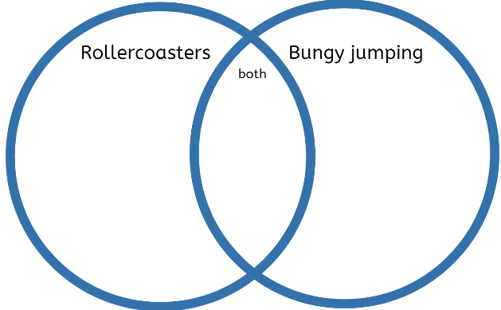
“The rigidity of the cord in a bungee jump affects the distance the person falls” Can you explain this statement in writing after watching the video?
Using your knowledge of the science behind rollercoasters and bungy jumping, complete a Venn diagram comparing the two activities.

Day 8 activity 4: Social studies and literacy – traditional Vanuatu bungee jumping
Notes for teachers and whānau
In this activity the learner practices summarising skills using a strategy called 3-2-1.

In this activity I am learning to: summarise information using the 3-2-1 strategy
What do I need?
- 30 minutes
- Home learning book
- Pen/pencil
- Device to Access the National Geographic video Vanuatu’s land divers https://www.youtube.com/watch?v=l0Mq6rCfYtU or read the transcript below

Instructions:
This activity uses the 3-2-1 strategy where you read an article and summarise it by outlining 3 key points, 2 things you disagree with, and 1 question you have.

Your task:
Read the text sourced from: PISA Style Scientific Literacy Question https://studylib.net/doc/18053990/pisa-style-scientific-literacy-questiony
Complete the 3-2-1 strategy for this text in your home learning book
Bungee jumping is thought to have originated on Pentecost Island in the South Pacific. It has become the tradition for the men of the island to tie long vines or lianas to their ankles and jump from a tall wooden tower in their village. Modern day bungee jumping began on 1st April 1979 when four members of the Oxford University Dangerous Sports Club jumped from the 80-metre-high Clifton Suspension Bridge in Bristol, England, using an elastic cord.
A bungee jump involves two phases: The first phase is free falling. This happens in the initial phase of the jump when the cord has not extended to its full length. The second phase of the jump involves the elastic cord extending like a spring.
The English scientist, Robert Hooke described the extension of a spring in 1670. He said in Latin ‘Ut tensio, sic vis’ or translated into English ‘As the extension, so the force’. This is now referred to as the Law of Elasticity, or most commonly, Hooke’s Law. Hooke’s Law tells us that the elastic bungee cord will stretch by a known amount for each person depending on their weight. Elastic objects stretch by the same amount each time we add the same amount of weight or force until it reaches its elastic limit. During the jump there is an exchange of energy between the person jumping and the bungee cord, in line with the principle of conservation of energy.
Watch the National Geographic video about Vanuatu’s land divers or read the transcript. https://www.youtube.com/watch?v=l0Mq6rCfYtU
Transcript
The tiny South Pacific Island of Pentecost is home to the most dangerous test of faith in the world. Every year village elders organise a ritual designed to secure the god’s favour. In a spectacular and frightening display called land diving young men and boys, some just 5 years old literally risk their necks. Only two fragile vines save they from crashing into the ground.
It’s the ancient precursor of bungy jumping, but here it is considered a sacrifice for the survival of the community.
By some estimates land diving dates back 15 centuries. It’s exact origin is obscured but it is tied to the local religion of animism. People here believe in a world of spirits that demand offerings. Originally divers would perform just after the yam harvest to thank the gods and ensure another fruitful crop.
One village holds these rituals every April and May. By jump day nine men have volunteered to dive. The vine breaks but the diver is lucky. In the past a broken vine has resulted in a fractured hip, others have resulted in broken collarbones.
Traditionally islanders believe that the higher the jump, the greater the blessing. Men brave enough to jump from the top secure a good yam crop and the prosperity of the community.
Complete another 3-2-1 strategy in your home learning book
- 3 key points from the video above
- 2 controversial ideas (or 2 things I disagree with) OR 2 things I need to find out more about
- 1 question I have

Remember to do your end of day reflection and wellbeing activities (See p.6 & 8).

Day 9 activity 1 & 2: Maths, Bungy jump energy
Notes for teachers and whānau
This activity is both using your numeracy skills and a practical investigation. There are a few materials needed to set up the bungy model, but you could substitute others if those listed are not available. Having a hand from someone in the household would be helpful.
Note that today our Inquiry focus is “going further, deeper”. This may include promoting opportunities to engage further and dive deeper through discussions, provocations, exploring further contexts, taking action, or thinking critically and drawing conclusions.

In this activity I am learning to:
- Find the relationship between mass and stretch
- Measure, record, and average data for 2 variables
- Plot a scatter graph using appropriate scales
- Use the slope of the graph to make predictions
What do I need?
- 60 minutes
- Copy of https://nzmaths.co.nz/resource/bungy-jump-energy
- Equipment: Rubber bands, drawing pin, sticky tape, marbles, and a clip (preferably a bull dog clip if available)
- Graph paper
- Ruler or measuring tape

Remember to start your day right (See p. 7)

Instructions:
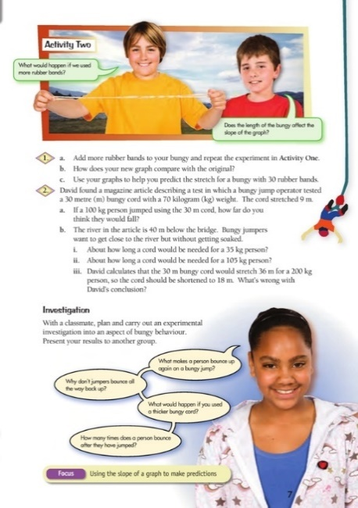
This task requires you to make a ‘bungy’ out of the materials above and explore how elasticity and mass can affect how much a bungy stretches.

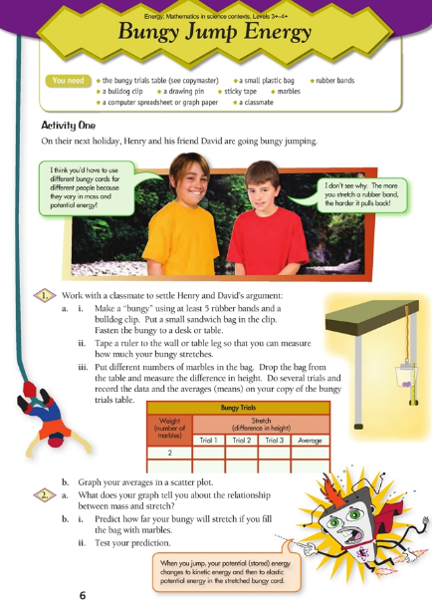
Your task:
Complete the FIO worksheet ‘bungy jump energy’

Day 9 activity 3: Choose your activity – what do you know? What do you want to explore?
Notes for teachers and whānau
This activity requires the learner to choose something they now have some background knowledge on (from previous activities) and expand on it by doing their own research or presentation.

In this activity I am learning to: Inquire further into “how something works” based on previous activities.
What do I need?
- 30 minutes
- Home learning book
- Pen/pencil

Instructions:
Today you are going to ‘go deeper’ on what you know about roller coasters and bungy jumping, research something new, or come up with something entirely new. Going deeper on a topic of inquiry requires you to engage further and dive deeper through discussions, provocations, exploring further contexts, taking action, or thinking critically and drawing conclusions.

Your task:
Choose from the following options:
Option 1: Select either a roller coaster or bungy jump make a 1-page poster or pamphlet to explain ‘how it works’. | Option 2: Research another adventure activity (e.g. sky diving, base jumping) and write an explanation of how it works. You might like to include a diagram.
Option 3: Expand on the activity on heart rate and research further on how the human body reacts to fear. Create a poster or pamphlet to explain to an audience. | Option 4: Use what you know about roller coasters and bungy jumping to create your own adrenaline-pumping theme park ride. Draw and label it.

Day 9 activity 4: Oral language – would you rather?
Notes for teachers and whānau
This activity requires the learner to create a dice and with a household/family member/friend play a game of ‘would you rather’. This is a good chance for learners to practice their oral literacy skills and explaining and justifying their opinions.

In this activity I am learning to: form an opinion and justify it with reasons
What do I need?
- 30 minutes
- A4 Paper for Dice template

Instructions:
Would you rather jump out of an aeroplane at 10,000 feet or bungy jump off the highest bridge in the world? This activity will enable you to practice your persuasive powers by choosing an option and justifying your reasons why.

Your task:
Create a ‘would you rather’ dice.
- Make the dice using this template on A4 paper.
- On each side of dice write down an adventure activity e.g. scuba diving, shark cage diving, paragliding etc
- Find a member of your household to play with
- Each person rolls the dice and must decide whether they would rather bungee jump or do the task on the dice and justifies their choice with reasons why.
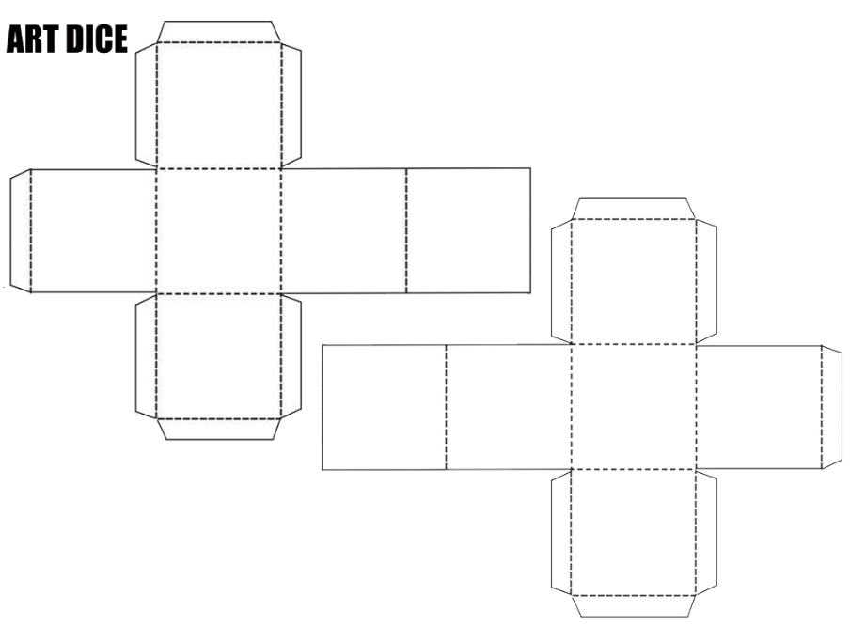
E.g. I would rather bungee jump than scuba dive because.......

"File:Small Art dice templates.jpg" by Barry neeson is marked with CC BY-SA 4.0.

Remember to do your end of day reflection and wellbeing activities (See p.6 & 8).

Day 10 activity 1: Analysing advertisements
Notes for teachers and whānau
This activity requires the learner to consider ways in which advertisements are used to communicate with an audience. Learners will analyse an advertisement and then create their own. They could ask a household member for feedback on their own work. Further activities look at other ways that information can be presented to an audience (through infographics, posters etc)
Note that today our Inquiry focus is “present– share learning about the theme” which includes thinking about who the audience is and considering different ways of communicating learning for example, presentation, video, poster, etc.

In this activity I am learning to: analyse an advertisement and evaluate what it is communicating
What do I need?
- 30 minutes
- Home learning book
- A4 or poster paper

Remember to start your day right (See p. 7)

Instructions:
In today’s modern world advertisements are everywhere – billboards, television ads, radio ads, social media advertisements – you can’t escape them!
Advertisers use many techniques to persuade an audience to engage with what they are selling or promoting. The persuasive strategies that advertisers use can be broken up into 3 categories:
- Pathos: An appeal to emotion – this technique tries to evoke an emotional response in the consumer
- Logos: An appeal to logic or reason – this technique gives evidence and statistics to the audience to fully understand what the product does
- Ethos: An appeal to credibility or character – this technique is used to persuade the audience that this product/service is the most honest, reliable, and credible therefore you should buy their product over others.

Your task:
- Analyse (study) the advertisement on the next page and answer the following questions in your home learning book.

- What is this advertisement selling?
- Does your advertisement include a slogan? If so, what is it?
- Does your advertisement include a logo? If so, what is it?
- Can you identify examples of pathos, logos, or egos (see above for definitions) in this advertisement? If so, provide some examples.
- Does your advertisement use descriptive language? If so, provide some examples – similes, metaphors, adjectives etc
- Who do you think is your target audience of your product? What makes you think this? How do you think this advertisement tries to persuade this audience?
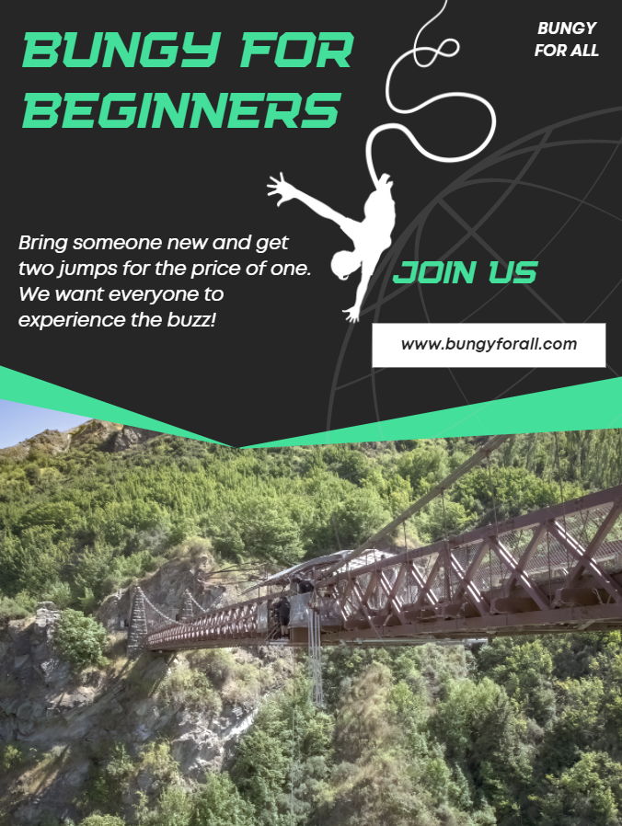
- Now try and create your own advertisement – this time for a cool new rollercoaster. Try and include the following
- A catchy slogan
- An eye-catching logo
- Descriptive language
- A primary target audience
How about asking a household or whānau member for their feedback on your advertisement – ask them the same questions as above –see if you can teach them about elements of advertising and get them to identify them on your example.

Day 10 activity 2: Analysing infographics
Notes for teachers and whānau
For this first task the learner is going to investigate how to make and use infographics to represent data and information visually to help others understand ‘how things work’. Learners will be exploring literacy, science, and visual language.

In this activity I am learning to: Analyse the elements of an infographic
What do I need?
- 30 minutes
- Home learning book

Instructions:
Infographics are different and they are a powerful way to communicate information because they can depict a variety of things in one document. They are often used for scientific topics. They are also able to show relationships between pieces of information. They are visual, simple and have limited text. They are usually used to supplement an article, essay, or opinion piece.
Today you are going to look at an infographic to understand what they are and how they work.

Your task:
Infographics generally have 3 parts: a visual component – the graphics and colour, content component – statistics and data and a knowledge component – the insights or conclusions that come from the data.
Examine the infographic on the next page and write your answer to these questions:
- What are the visual components? How do the graphics help you understand the message?
- What are the content components? What content is being shared? How do you know it is true?
- What are the knowledge components? What is the main message being communicated?
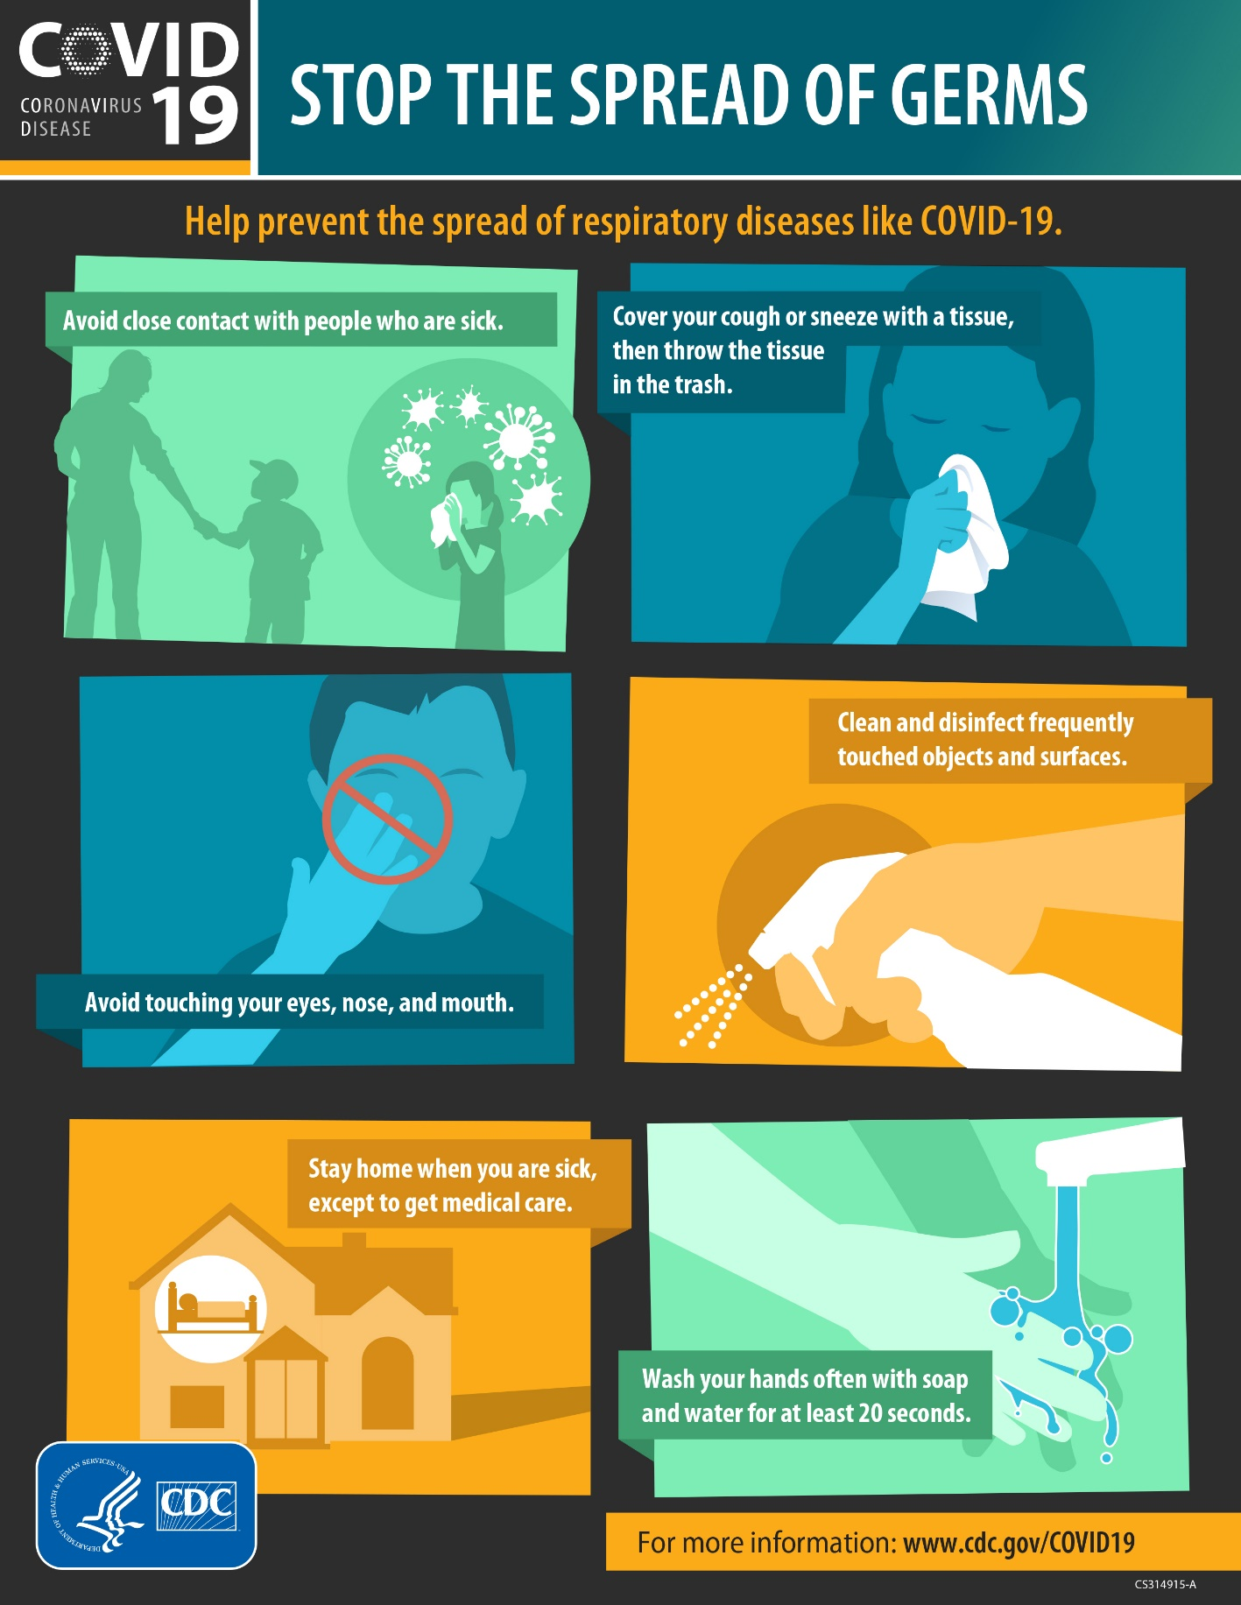
United States Department of Health and Human Services, Public domain, via Wikimedia Commons

Day 10 activity 3: Create my own infographic
Notes for teachers and whānau
The learner is going to demonstrate ‘how things work’ by creating an infographic about forces and speed. They will use their knowledge from the previous activity and apply it to new knowledge. Learners will be exploring the literacy, science, and technology.

In this activity I am learning to: use my new knowledge on infographics to create my own based on an informative article.
What do I need?
- 30 minutes
- paper etc for creating an infographic
Text courtesy of the Science Learning Hub
https://www.sciencelearn.org.nz/resources/1343-forces-and-speed

Instructions:
Using what you now know about infographics from the last activity – you are going to create your own infographic using an article about “forces and speed”.

Your task:
Read the article https://www.sciencelearn.org.nz/resources/1343-forces-and-speed
NZ’s elite cyclists spend time in the wind tunnel at Canterbury University to find ways to reduce aerodynamic drag (air resistance). At high speeds, this drag is the main force that opposes motion. Reducing aerodynamic drag is a way to go faster without any extra effort.
Speed changes until forces become balanced
A force is anything that pushes or pulls on something else. When biking on a level road, your forward force comes from pushing and pulling on the pedals to make the back tyre push backwards against the road. The two main forces that oppose your motion are aerodynamic drag (air resistance) and rolling resistance of the tyres against the road caused as the tyre is compressed. When the forward forces are bigger than the opposing forces, you speed up.
As you go faster, the force of air resistance pushing back on you increases. Eventually, the forces become balanced (the forward forces are the same size as the opposing forces). Once the forces become balanced, your speed stays the same.
The speed reached as forces become balanced is called the terminal velocity (It is like when a skydiver jumps out of a plane – speed will keep increasing until forces become balanced.)
Two ways to cycle faster
- Pedal harder to increase the force pushing you forwards. Speed will increase until the opposing forces increase to balance your larger forward force.
- Reduce aerodynamic drag. With less drag at a certain speed, you will be able to reach a higher speed before the opposing forces balance out the forward force.
Some ways to reduce aerodynamic drag
- The rider causes about 70% of the drag, so finding the body position and equipment that works best for each rider is important.
- Body suits are designed to minimise friction due to air resistance. Some designs also use a kind of dimpled effect to reduce the drag of air flows around the arms and legs.
- Armrests on handlebars (aerobars) – allow the rider to get into a lower position and reduce frontal area so that there is less air being pushed against.
- Aero helmet – allows air to flow more smoothly over the head and back. (These helmets are used mostly in track or individual time trial events. Most helmets for road cycling still have gaps for air to pass through to cool the cyclist).
- Adjust seat and handlebar height or extension, reduce front area, make the back flatter.
- Frame and wheel design – carbon fibre construction on modern bikes allows designers to try different shapes to reduce drag. For example, teardrop shapes that are rounded at the front with a narrow taper at the back have much less drag than square shapes.
- Smooth tyres – less air resistance caused from the tread pushing on the air (tyre design and pressure is also important to reduce rolling resistance).
Typical drag and rolling resistance values
As speed increases, rolling resistance of the tyres stays nearly the same, but aerodynamic drag increases a lot. At high speeds, 80–90% of effort can go into fighting aerodynamic drag. Rolling resistance of the tyres and friction in the bearings and chain are small by comparison. If you can improve your aerodynamics, you can reach a faster speed before the opposing forces balance your forward pushing force.
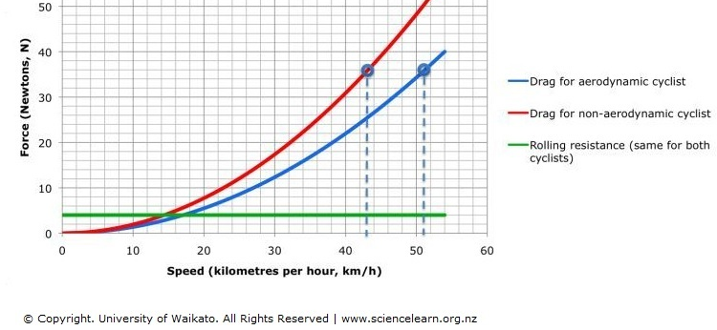
Comparing aerodynamic drag and rolling resistance
Aerodynamic drag increases greatly at faster speeds. At 40N forward force (36N drag plus 4N rolling resistance), this aerodynamic cyclist will travel at 51km/h. The non-aerodynamic cyclist will only travel at 43km/h.

Create an infographic to display the information you have just read – using your knowledge of infographics from the previous activity. You can do this on paper or use an online tool like Canva https://www.canva.com/ or Piktochart: https://piktochart.com/.
Consider the following:
- Who is your intended audience?
- What is your infographic going to communicate? E.g. the knowledge component. How will you ensure this is credible? (Fact checking).
- What visual components will you use? (What images, diagrams, data charts?)
- What content components will you use? (What facts, stats, or information?)
- How will you use colour to amplify the effect?

Day 10 activity 4: Sharing my learning
Notes for teachers and whānau
This activity enables whānau and household members to engage with the learners work, giving positive feedback and next steps for the learner. It should be a celebration of the great work the learner has done!

In this activity I am learning to: present my work to others and gain feedback.
What do I need?
- 30 minutes
- Your previous presentations of your information (from activity 1 and 3 day 10 and Day 9 activity 3)

Instructions:
You have looked at a variety of ways to share information with an audience over the last 2 days of activities – these could have been in the way of advertisements, posters, pamphlets, and infographics.
This activity requires you to set up a display gallery of your work for your household members to examine and admire.

Your task:
Ask your household members/siblings or even online class members to take a look at all your pieces of work.
Set up your work in a place where it can be displayed. Invite members of your household to walk past your pieces and write some notes using a pen and paper.
For each piece of work observers should answer the following questions
- What is one thing they like about the work
- One thing they wonder
- One thing they think the creator could do differently or improve
Collect in their feedback and take a look!

Remember to do your end of day reflection and wellbeing activities (See p. 6 & 8)

