A learning from home pack

For learners in years 4–6

Curiosity | Māhirahira

Context 1: What if ...?

Context 2: How does that work?

Layout of the resource
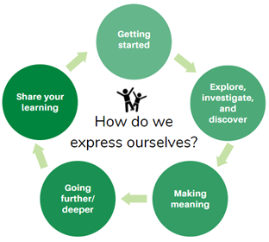
This pack is filled with learning activities for your learners that can be used at school or at home. All activities are framed around the theme of curiosity | māhirahira.
Suggestions are provided for starting the day with a karakia (see p. 7), check in with the teacher, and setting up the learning environment. You can replace these with how you want your learner to start their day.
The activities follow an inquiry learning model (figure 1) exploring one theme through two contexts. Each day the learner will be working through one part of the model culminating with sharing their learning on days five and ten.
Figure 1 Inquiry learning model

Realities
You know your learners and have a good understanding of their learning situations.
Many learners will have siblings at home, as well as whānau who share the same space and devices. Some may have access to the internet and devices, and others may not. Learners will also have varying levels of adult support.
There are a mix of activities in this pack that use materials commonly found in most homes. Some activities will require adult support while others can be managed independently. This resource is provided as a Word document so that you can adapt it for your learners.
We suggest starting each day with a karakia (See p. 7), check in with the teacher, followed by setting up the learning environment. The pack contains suggestions, but you can replace these with however you want your learner to start their day.

Resources
The pack uses a range of books from the Figure it Out and School Journal Series. You might want to send these home with the learner, along with a “my home learning” exercise book, pencils, crayons, or felts, and some craft materials (glue, scissors, construction paper). Learners can bring their notebook back to class to share.
If your learners do not have reliable access to the internet, here are the resources to print and send home with this booklet to create a paper-based pack.

Resources to print and send home
Figure it Out:
- https://nzmaths.co.nz/resource/snails
- https://nzmaths.co.nz/resource/space-zapper
- https://nzmaths.co.nz/resource/how-many-strips
School Journals/Connected:
- https://instructionalseries.tki.org.nz/Instructional-Series/School-Journal/School-Journal-Level-2-October-2015/My-What-If-Planet
- https://instructionalseries.tki.org.nz/Instructional-Series/School-Journal/School-Journal-Level-3-May-2017/Becoming-a-Martian
- https://docs.google.com/presentation/d/1ghNSAL_nDm3EBpQQEr8miXijqonUcB-iwrOiD729WRQ/present?slide=id.p (Connected – Digital space)

Setting up the learning environment
Encourage whānau to support learners to set up a space for learning at home. Learners might like to design their own space as a separate learning activity. Some materials they may need could include pen, pencils, paper, a notebook, colouring pencils, glue, scissors, and a device to access the internet.
Many of the suggested activities and experiences include the optional use of online resources which can be accessed and viewed using a Smartphone.

Overview of the learning in this pack
The theme of curiosity | māhirahira will be explored through two contexts.
- Days 1–5 look at this idea through the context of what if…?
- Days 6–10 look at this idea through the context of how does that work?
Learners will explore, investigate, discover, and make meaning as they go through each task. There are times where they look a little deeper into the topic. Some of the tasks may be independent hands-on tasks while some may involve connecting and sharing with others.

Day 1 | Day 2 | Day 3 | Day 4 | Day 5
Big Picture  A chance to think, wonder, discuss. | Exploring  What if humans could travel the solar system...? | What would it take?  A journey into the solar system takes preparation. | Researching  Curiosity and the solar system – let’s dig a little deeper. | Curiosity builds knowledge  Sharing what you have learnt.
Day 6 | Day 7 | Day 8 | Day 9 | Day 10
Thinking time  What do you already know, what’s to explore? | History  Exploring and investigating rockets. | Take care  Making meaning of adventures to space. | Prototypes  Going deeper with what works and doesn’t work. | Small steps  The power of collaboration.

Daily timetable
Below is a possible daily timetable. We have allocated 30 minutes for each activity; your learner may take more or less time than this for an activity. We suggest your learner takes the time they need to complete an activity. This may mean they choose which activities they will complete for the day, rather than complete them all.
At the start of each day the learner will draw up their timetable for learning. You can adjust the timing to suit the other activities that might be happening the day, such as Zooming with the class/teacher.

Time | Activity
9:00 am | Starting the day
9:30 am | Activity 1
10:00 am | Break
10:30 am | Activity 2
11:00 am | Fitness break
11:30 am | Activity 3
12:00 pm | Lunch time
1:00 pm | Activity 4
1:30 pm | Reflection time
2:00 pm | End of the school day

Daily fitness – Choose something each day
It is important to include a fitness activity every day. Please ensure that your learner includes this in their daily timetable. If possible, it would be great to do the fitness activity with your learner or have them complete it with their siblings where appropriate. Below are a range of activities to choose from – or you can make up your own ideas!
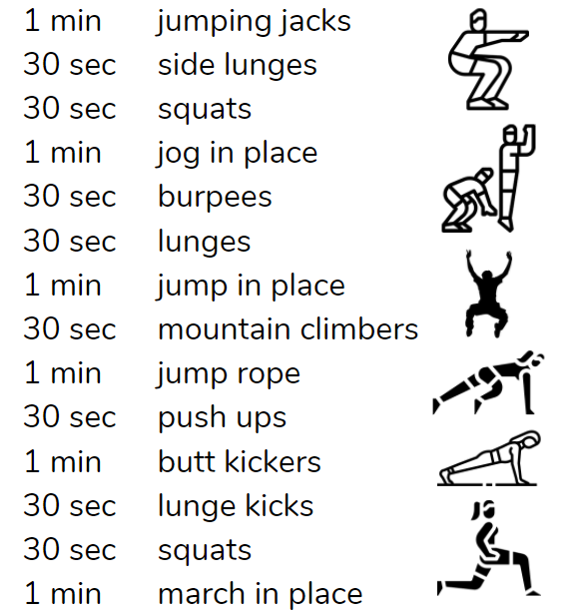
10-minute super kid workout

Move like a…
- Write the names (or draw pictures) of 6-10 animals, each on a separate card.
- Turn some music on, skip, jog, run, walk around a large indoor/outdoor space
- When you pass the cards turn one up and then move like that animal,
- Complete a loop moving like that animal and then return to the pile of cards for the next one.
Involve someone in your whānau to make it fun.
Slow…fast…slow…fast
- Use shoes to mark out a circular or square course with equal distances between the shoes.
- Challenge yourself to go as fast as you can between two shoes
- Then slowly to catch your breath between the next two shoes,
- Then fast again. Repeat going fast and slow until you finish the course.
How many laps can you do?
Online exercise workouts for kids
This Auckland for kids website has links to ‘the best free exercise workouts for kids’
https://www.aucklandforkids.co.nz/staying-home/the-best-free-exercise-workouts-for-kids-on-youtube/

Daily wellbeing – Choose something each day
These activities are good to do at the beginning and end of the day but can be done anytime. They can help you get ready for learning; calm your mind and body and they can help you to reflect on your learning:
Gratitude scavenger hunt
- Find something that makes you happy
- Find something to give someone else to make them smile.
- Find one thing that you love to smell.
- Find one thing you enjoy looking at.
- Find something that is your favourite colour.
- Find something that you are thankful for in nature.
- Find something that you can use to make a gift for someone.
- Find something that is useful for you.
Challenge someone in your whānau to go on the hunt with you and share what you find.
Energy rollercoaster
- How do you feel when you have a lot of energy?
- How do you feel when you have no energy?
- What’s it like when you’re tired but someone else is energetic?
- What’s it like for people in your house when you’re energetic and they’re not?
On the ground outside write the numbers 1 to 5 in a row. 1 is low energy and 5 is high energy.
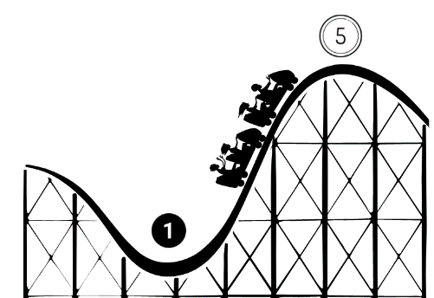
- Sleeping, lying on the ground, not moving.
- Sitting up, reading, slower breathing.
- Standing up, little arm movements, some stretches, hanging out with people.
- Walking around, dancing, hand claps, normal breathing, talking.
- Hyped up! Jumping, making noise, high fiving, swinging arms above head.
Now act each of these out in turn as you head up the rollercoaster and down the other side.
Favourite spaces
Draw your favourite space. Illustrate it with words to describe your connection to that favourite place.
5 senses poetry
Sit comfortably. Spend a couple of minutes thinking about what you can see, hear, smell, taste, and feel. Now turn what you have noticed into a poem.
I see…
I hear …
I smell …
I taste …
I am feeling …

Starting each day
Notes for teachers and whānau:
Starting the same way each day helps create a structure for your learner. Your school might have your own way to do this, for example starting the day together as a class on Zoom. In this pack we provide a karakia to settle into the day. Saying the karakia with your learner a few times will help them be able to do this more independently tomorrow and beyond. As part of the start of the day and setting up the learning environment, help your learner look through the activities suggested for that day and choose a fitness and wellbeing activity. They could fill out their daily timetable and think of other activities they might like to do, like reading.
Remind your learner of when and how to check in with the teacher/you.

Karakia
Here is a karakia to welcome in the day

Whakataka te hau ki te uru
Whakataka te hau ki te tonga
Kia mākinakina ki uta
Kia mātaratara ki tai
E hī ake ana te atakura
He tio, he huka, he hau hū
Tīhei mauri ora!
Cease the winds from the west
Cease the winds from the south
Let the breeze blow over the land
Let the breeze blow over the ocean
Let the red-tipped dawn come with a sharpened air.
A touch of frost, a promise of a glorious day.
Audio for this karakia can be found here https://www.otago.ac.nz/cs/groups/public/@maori/documents/webcontent/otago667429.mp3

Planning my day
- Have you chosen which activities you will do today and in which order?
- Remember to choose a fitness activity (See p. 5)
- Have you chosen a wellbeing activity? (See p. 6)
- Have you done a ‘Wellbeing check-in'?
  - How are you feeling today?
  - How do you feel about your readiness to learn this morning?
  - What do you need extra assistance with today? Who could you get to help you? What strategies could you use to help make your learning more effective?
  - What would you like to do as a quiet time activity to end your day?
- Remember to do your Reflection at the end of the day (see p. 8)

Ending each day
Please ensure your learner does this at the end of each day.
Reflection can be challenging for all learners, but it can also provide them with rich opportunities to think about how their learning is progressing. Use the questions below as prompts to encourage your learner to think about what they have learned so far and help them to plan out their next steps. If you have concerns with their learning or find that your learner is needing more help, contact their teacher for more support.

In this activity I am learning to: Reflect on my learning.
What do I need?
- A notebook or online doc that you can use each day for your reflection activity. We will call this your “reflective journal”
- Materials for your quiet time activity

Take some time to think about how you are feeling and after today’s learning activities.
Reflect on the following prompts in your reflective journal.
- What did you enjoy most about today?
- What is one thing you feel you learnt today?
- What is one strategy that helped you with your learning?
- What did you find challenging or distracting? (You ran out of time for some activities, or you finished them quite quickly and wanted to dig in a little deeper.)
- Is there anything you need extra help with? Who can you ask to help you with that?
- Is there anything you want to catch up on tomorrow?
Remember to finish with a wellbeing activity and/or your chosen quiet time activity

Context 1: What if...?

The next five days indulge our curiosity by asking ourselves the question what if...?

Day 1 activity 1: Inquiry getting started
Notes for teachers and whānau
For this first task the learner is going to be completing a KWLH chart to get them started thinking about everything they already know about the solar system.
A KWLH chart is a graphic organiser the learner can use to document their learning progress from start to finish. We will revisit this KWL chart on day 5. The ‘K’ is for what the learner already knows. The ‘W’ is for what the learner would like to know, and the ‘L’ is the reflection column for what they learnt (completed at the end of the week). Some learners may already know a lot about the subject and therefore fill the ‘K’ column, some may know very little and therefore mostly fill in the ‘W’ column. Please reassure them that it does not matter how full the columns are so long as they have had a chance to think about the subject before beginning the inquiry.
Note that our Inquiry focus for today is “getting started” which includes generating questions, activating prior knowledge, and introducing the theme.

In this activity I am learning to: use a graphic organiser (KWL chart) to record knowledge and wonderings.
What do I need?
- 30 minutes
- Home learning book
- Ruler and a pen/pencil

Instructions:
Using a whole page in your home learning book draw a KWL chart.
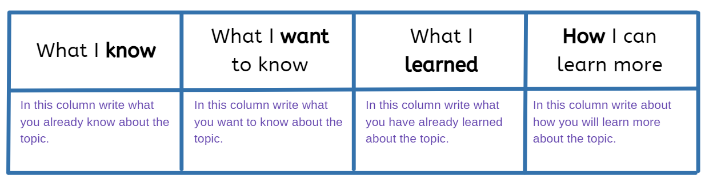

Your task:
Use the KWLH chart you have drawn up/downloaded to write down everything you know (K) about the solar system and everything you would like to know (W) about the solar system. You can write or draw your knowledge or wonderings. Note - The ‘L’ column will be completed at the end of the week.

Day 1 activity 2: What are you curious about?
Notes for teachers and whānau
This activity builds on activity 1. The learner will use another graphic organiser (Y chart) to write or draw things they are curious about when they think of the solar system. You may like to encourage them by talking aloud ‘space’ vocabulary such as rocket, asteroid, stars, comet etc. They may need help initially setting up the Y chart.
This is a really great video to kickstart your learner’s curiosity about space https://www.youtube.com/watch?v=kOIj7AgonHM. So if your learner has access to a device encourage them to watch this before completing their Y Chart.

In this activity I am learning to: use a graphic organiser (Y chart) to explore an idea.
What do I need?
- 30 minutes
- Home learning book
- Ruler and a pen/pencil
Optional: a device to watch https://www.youtube.com/watch?v=kOIj7AgonHM

Instructions:
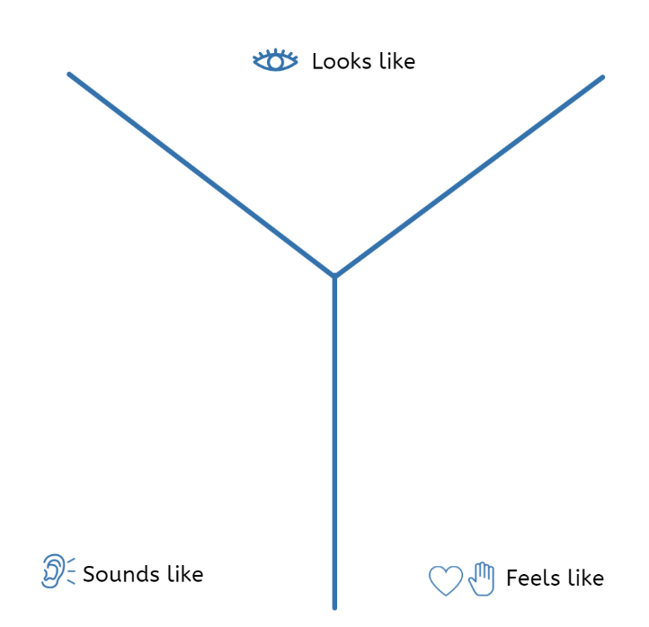
Using a whole page in your home learning book draw a Y Chart (a large Y which stretches out to the top corners of the page and down to bottom of the page in the centre).

Your task:
What if humans could travel the solar system? Using your Y chart, label the three sections with these curiosity headings:
- What would it feel like to travel around in the solar system?
- What would it sound like to travel around in the solar system?
- What would it look like to travel around in the solar system?
Draw or write your curiosities/wonderings in each of the sections. Remember there is no right or wrong answer, this is simply what you are curious about when you think about the solar system.

Day 1 activity 3: Art lens
Notes for teachers and whānau
Your learner may love to doodle or sketch. This learning task allows them to select something from their Y chart to draw or sketch. If they have access to different art media they may like to use that otherwise a simple pencil/pen will be sufficient.

In this activity I am learning to: develop a sketch or drawing in response an idea I had.
What do I need?
- 30 minutes
- Home learning book
- Pencil/crayons/felts/charcoal

Instructions:
Using the Y Chart you completed in activity 2, select one word/phrase/drawing you would like to sketch or draw. To help you scan your Y Chart may like to get a piece of card and cut out the centre of it to make a view finder then slide this around your ideas on the Y Chart until you settle on one thing you would like to create a sketch/drawing of. Later in the week you may use your sketch/drawing as part of sharing your learning.

Your task:
Create a sketch/drawing of one of the things you’re curious about when you think of the solar system. You can make this as small or as large as you like, it is up to you! You may like to use a double page in your home learning book if that would suit.
Art and music go so well together so you may like to turn on some music while you draw, or you may even like to go sit outside and listen to nature on planet Earth while you sketch/draw.
If you have access to the internet you may like to search your idea for images to use as an exemplar as you sketch/draw.

Day 1 activity 4: Maths
Notes for teachers and whānau
This activity is from the Figure it Out series. Your learner may have seen this problem before, if so, encourage them to give it a go again as a way of practising their measurement skills. We will build on our measurement skills as the week progresses.

In this activity I am learning to: measure using cm, solve a problem using minutes as the unit, devise and use problem solving strategies to explore situations mathematically.
What do I need?
- 30 minutes
- A copy of the Snails, Figure it Out activity https://nzmaths.co.nz/resource/snails
- Ruler (or cut out copy below), pencil
- Home learning book

Instructions:
We are going to explore how much time it will take for Sally the snail to crawl to a flower by measuring distance in centimetres (cm).
Use a ruler (or cut out the ruler below) to measure Sally’s path on the next page.

As you solve how to work out the problem, think about the strategies you are using.

Your task:
Sally the snail crawls 2cm each minute. She needs to rest at each dot for 5 minutes. She wants to take the shortest time possible to reach a plant. Which path should she take?

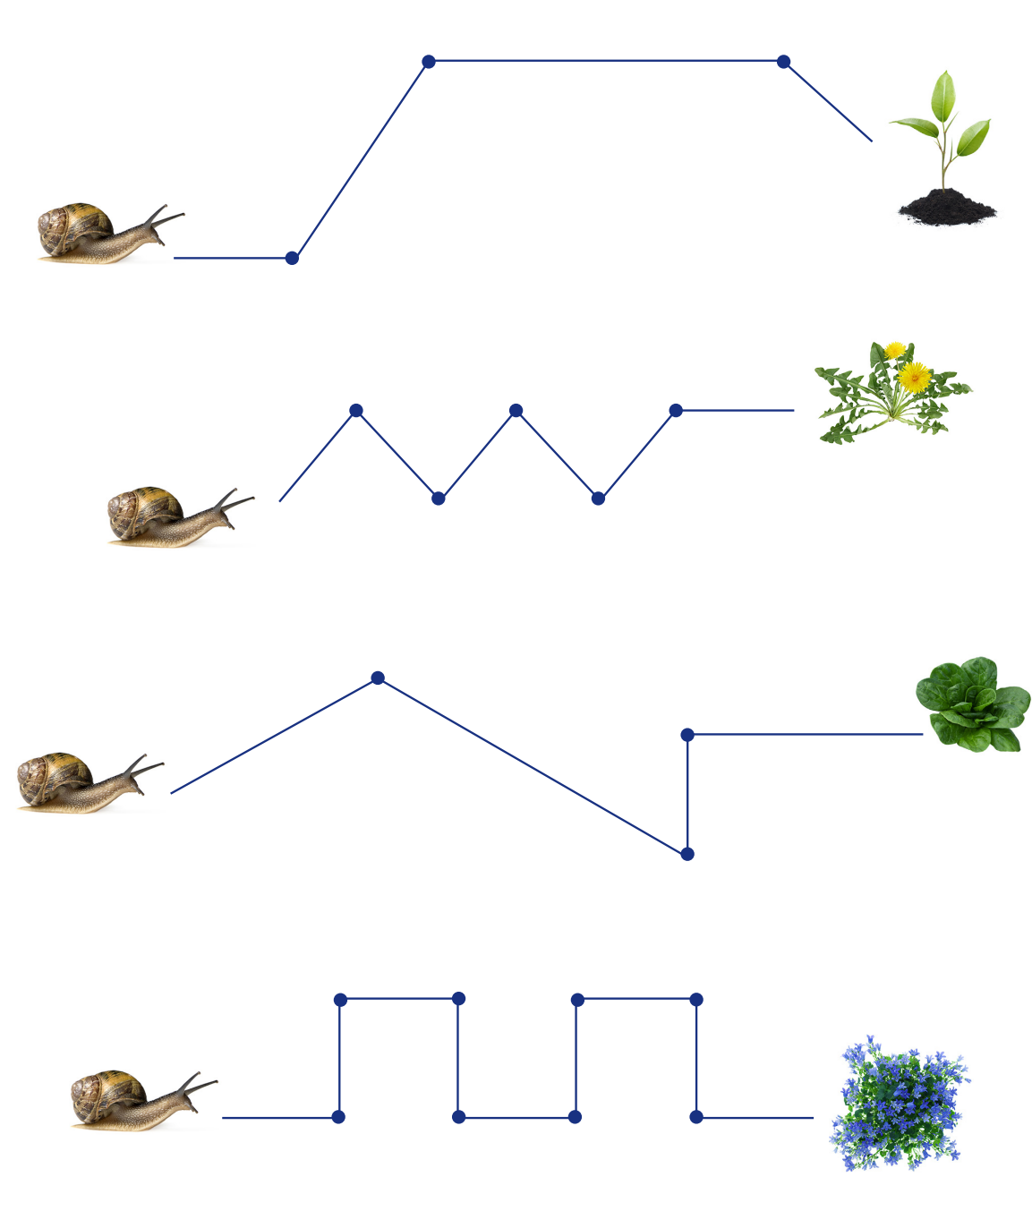

Extension activity:
Can you create your own snail problem for others to solve? You can even change the speed that Sally moves.
Remember to do your end of day reflection and wellbeing activities (See p. 6 and 8).

Day 2 activity 1: What do scientists think?
Notes for teachers and whānau
Your learner would benefit from working with an adult to view the websites, discuss their wonderings to the questions posed, and build their curiosity about what scientists have discovered about the solar system.
Note that our Inquiry focus for today is “explore, investigate, and discover” which includes choosing and evaluating information, and thinking critically.

In this activity I am learning to: respond to questions to explore my wonderings.
What do I need?
- 30 minutes
- Access to a device to watch/explore - https://www.sciencelearn.org.nz/videos/921-life-on-other-planets
https://www.nasa.gov/kidsclub/index.html
- Home learning book

Remember to start your day right (see p. 7)

Instructions:
In this activity you are going to respond to questions by exploring some digital resources or by reading the transcript. The questions may even prompt you to write down your own questions to explore later in the week.

Your task:
In your home learning write down your thoughts to these three questions:
- Is there life on other planets?
- Are humans unique?
- What if we could travel to other planets?
Now watch the video in the link above or read the transcript below. As you read and explore add your new learning to the three questions.
Will we ever see life on planets outside our Solar System? Professor Denis Sullivan, from Victoria University of Wellington, suggests that we may never know for sure.
Transcript: Professor Denis Sullivan
Science is about why, and a fundamental question really is, “Are we unique?” Anybody who thinks about it will want to know some answers. If we are unique that would be a surprise because there are so many stars, so many galaxies, so just trying to understand why planets form and are there enough of them to produce life?
My personal guess is we will never see such life forms. These planets around other stars are just so far away that it’s impracticable to go, so one has to be careful making predictions in science. I suspect it we’ll end up with not much more than identifying some planets around some stars that aren’t so far away and there’s definite signatures of chemicals in the atmosphere that can only produce by life, but that’s likely to be where it will stop.
https://www.sciencelearn.org.nz/videos/921-life-on-other-planets

Day 2 activity 2: Reading and writing poetry
Notes for teachers and whānau
In this activity the students are going to read a short poem which uses humour to explain the solar system. Your learner will be encouraged to explore other topic related vocabulary and try their hand at a few lines of poetry.

In this activity I am learning to: read and explore the vocabulary used in a poem.
What do I need?
- 30 minutes
- A copy of the poem My ‘What If’ Planet, School Journal Level 2 October 2015
- Home learning book

Instructions:
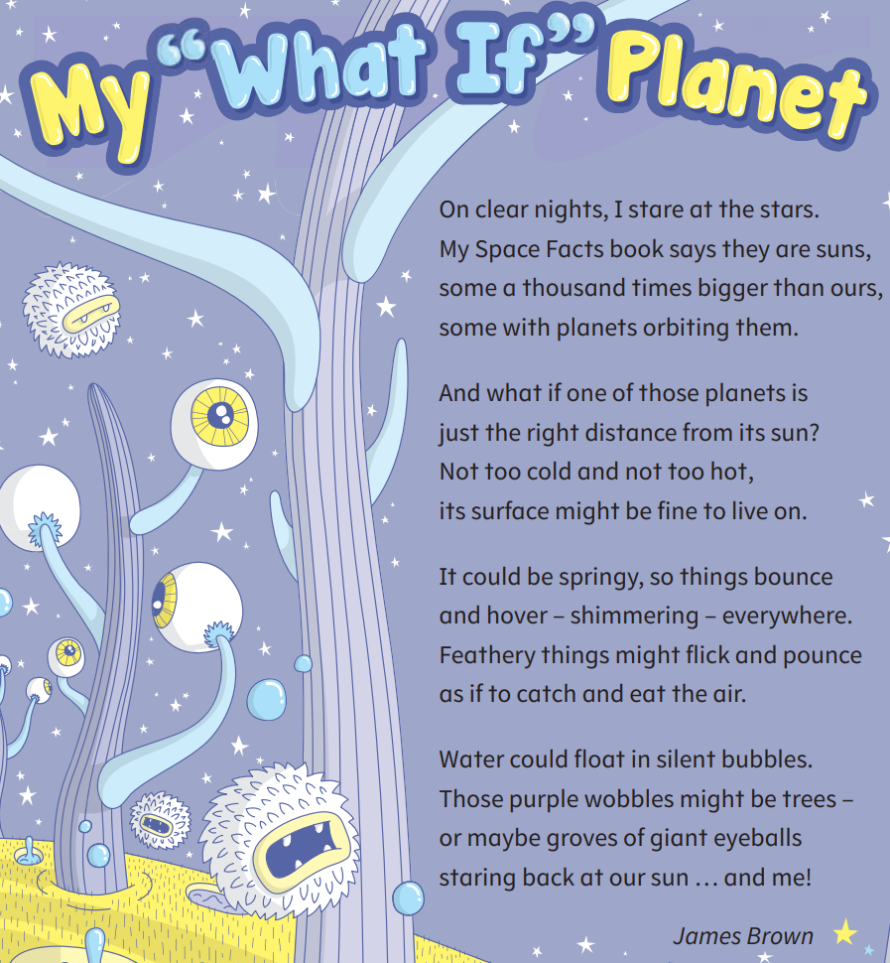
Read My ‘What If” Planet poem. You may like to read it a few times – first in your head, then out loud, then to someone in your whānau. As you read each verse you may like to close your eyes and imagine the planet the author is creating.

Your task:
In this poem the author has created a fictional (imaginary) description of what one of the planets might be like in our solar system.
Write down three things you like about this poem and one thing you find interesting.
Your second task is to create a new verse for this poem. You are using your imagination about what the planet would be like so you can get as creative as you like, there is no right or wrong.
Enjoy playing around with words, use your senses to describe what you might see, hear, smell, touch.

Day 2 activity 3: Drawing the moon
Notes for teachers and whānau
In this lesson your learner is going to explore what the moon looks like by sketching it. Don’t worry about having too many art resources available, a simple HB pencil will allow them to create an amazing piece of art.

In this activity I am learning to: explore shape and shading using visual art techniques
What do I need?
- 30 minutes
- Home learning book
- Pencil, colouring pencils, crayons
Optional: https://kids.nationalgeographic.com/space/article/what-is-a-supermoon

Instructions:
Study the images of the moon below or use your device to explore the images on the webpage listed above. What do you notice as you look closely at image of the full moon? How could you use the art materials you have available to recreate this? You may even be able to go outside at night and study the moon.

Your task:
Using a blank page in your home learning book and the resources of the moon you have available draw a full moon. Is it egg shaped? Perfectly round? Where is there shading? Where is it brighter? Enjoy your learning time today sketching and shadowing. Share your finished art piece with someone in your whānau.

(Image source: Luc Viatour, CC BY-SA 3.0 <http://creativecommons.org/licenses/by-sa/3.0/>, via Wikimedia Commons)
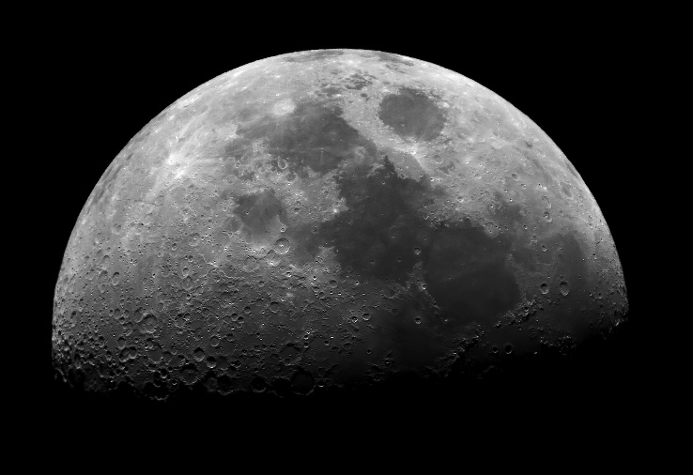
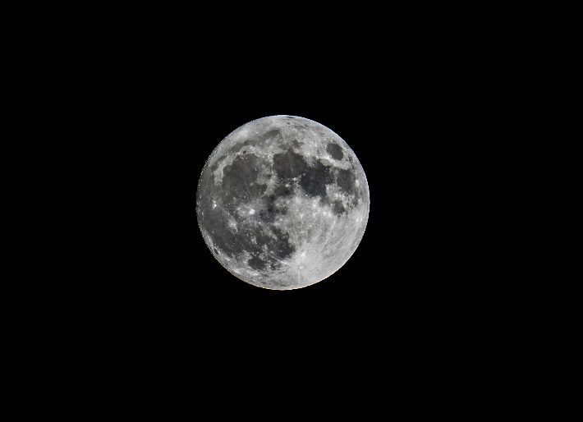

Day 2 activity 4: Space Zapper
Notes for teachers and whānau
This game encourages learners to develop addition or subtraction strategies for combining hundreds and thousands. As you play the game, talk about their thinking strategies. Questions that will encourage thinking may include “How many points do you have so far?” followed by “How did you work that out?”

In this activity I am learning to: add hundreds (and have fun playing a game of strategy!)
What do I need?
- 30 minutes
- Dice
- 2 different coloured counters
- Someone to play with
- Game board (next page)

Instructions:
- Start by putting your counter on the base station.
- Take turns to throw the dice and move the number of spaces shown on the dice. You can move across or up and down from one square to another in the same turn.
- Each player tries to get to the space station and back to the base station, scoring as many points as they can
- You score points according to where you land at the end of your turn
Land on | Score
Blue alien ship | 1000
Yellow alien ship | 500
Red alien power source | 200
Green alien power source | 100
First person back to base station | 5000
- The game finishes as soon as one player gets back to the play station.
- The player with the highest score wins.

Your task:
- Colour in the game board on the next page.
- Play the game with someone in your house (you could even play it with a friend over Zoom if you both have the game board.
- After the first game, see if you can make up some new rules/scoring to add to the game.
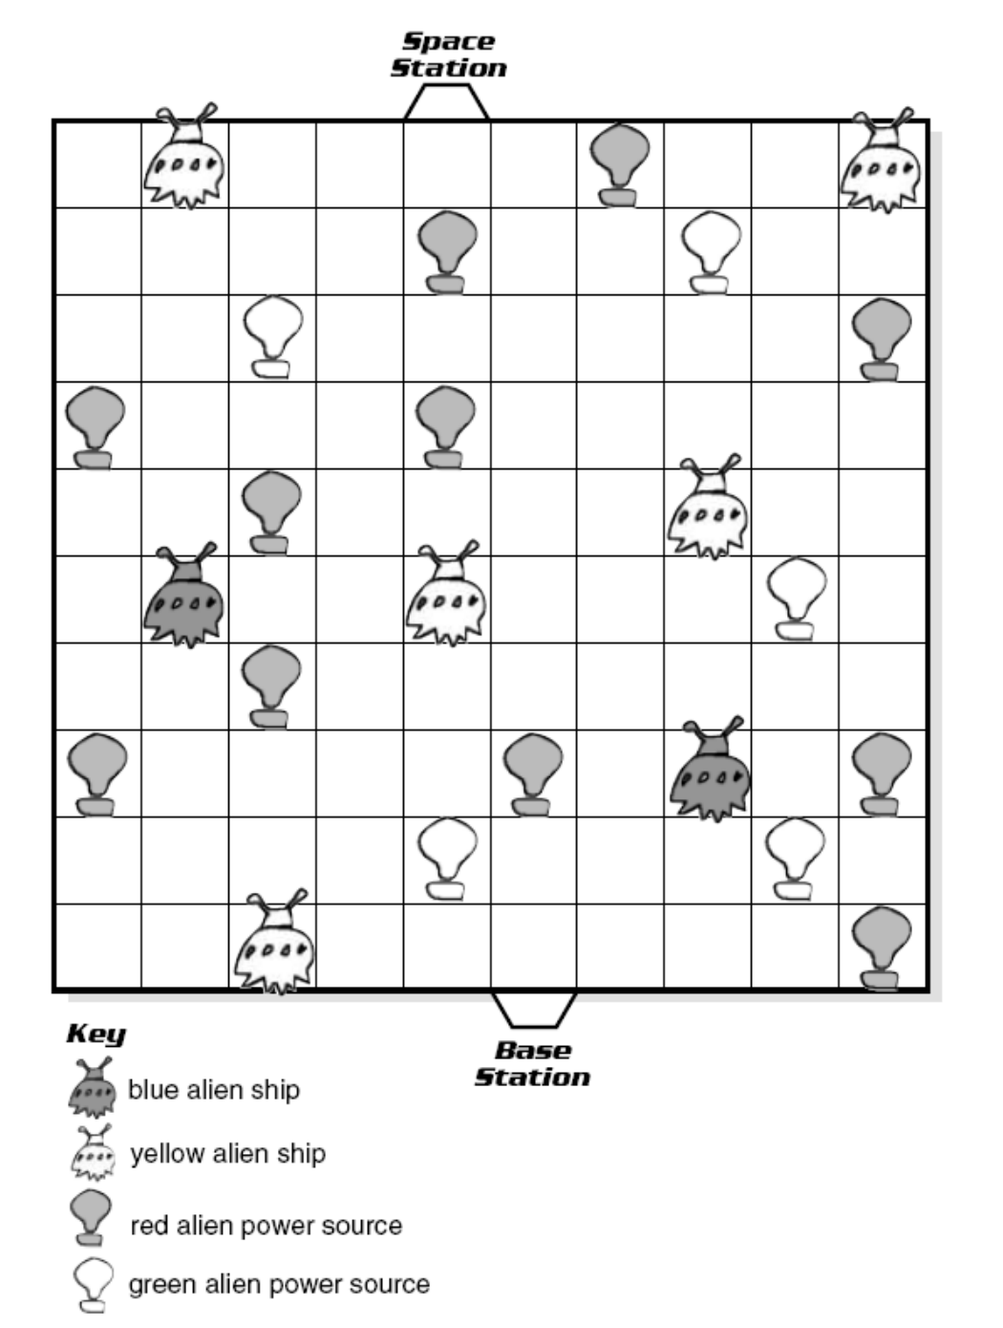

Remember to do your end of day reflection and wellbeing activities (see p. 6 and 8).

Day 3 activity 1: Similarities and differences
Notes for teachers and whānau
In this lesson the learner is going to complete a Venn diagram using a space word mat to make meaning of the similarities and differences to Earth and space.
Note that our Inquiry focus for today is "making meaning" which includes analysing data, organising, and sorting information, summarising, synthesising, making connections/conclusions, building deeper understandings, and thinking critically.

In this activity I am learning to: list similarities and differences using a Venn diagram
What do I need?
- 30 minutes

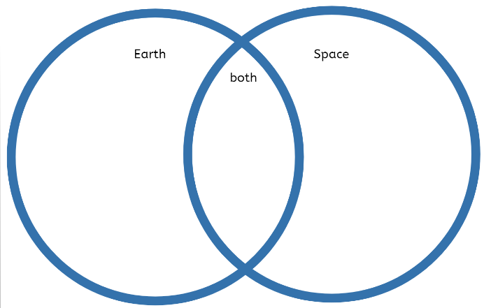
Remember to start your day right (see p. 7).

Instructions:
Draw a Venn diagram in your home learning. On the left circle add the title ‘Earth’, on the right circle add the title ‘Space’ and on the overlapping egg shape in the centre add the title ‘Both’. Spend a few minutes look at the space mat image and reading the vocabulary. This mat will help you when you think about the similarities and differences of Earth and space.

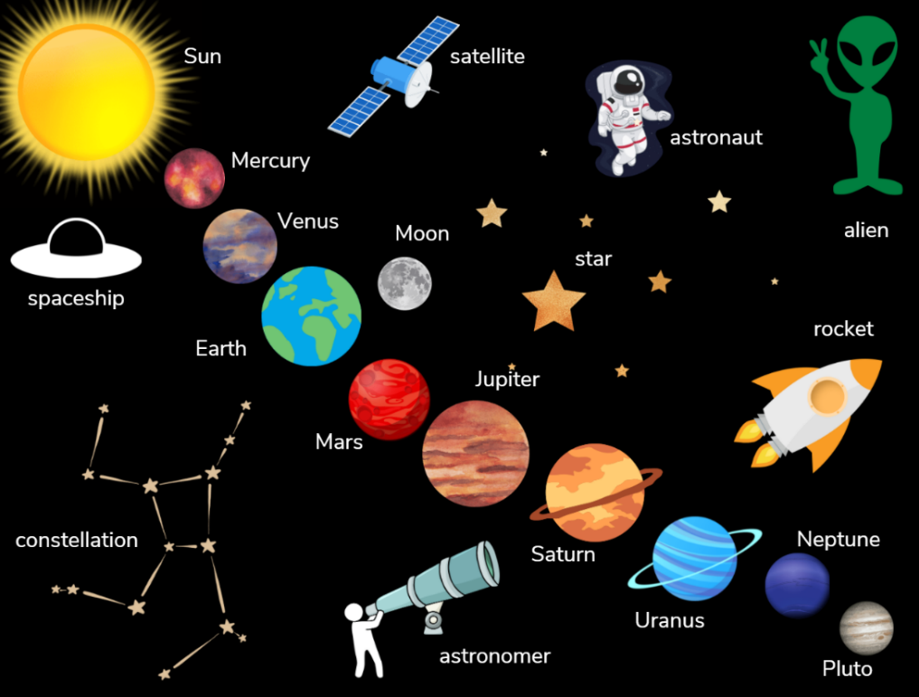
Your task:
Write down/draw all the things you notice about space in the circle titled ‘Space’. Then write down/draw all the things you know about Earth in the circle title ‘Earth’.
What is common to both Earth and space? Your challenge is to see if there are any things that can be written/drawn in the ‘Both’ circle of your Venn diagram.

Day 3 activity 2: Human survival
Notes for teachers and whānau
Your learner will be introduced to the science acronym MRS GREN which if often used to remember all the necessary features of living organisms. This understanding will help them in future lessons as they go further/deeper with exploring the solar system.

In this activity I am learning to: understand that living things display certain characteristics.
What do I need?
- 30 minutes
- Home learning book

Instructions:
MRS GREN is an acronym often used to help remember all the necessary features of living organisms: Movement, Respiration, Sensitivity, Growth, Reproduction, Excretion and Nutrition. They are the seven principles of life. For humans they all have a purpose for ensuring our existence here on Earth.

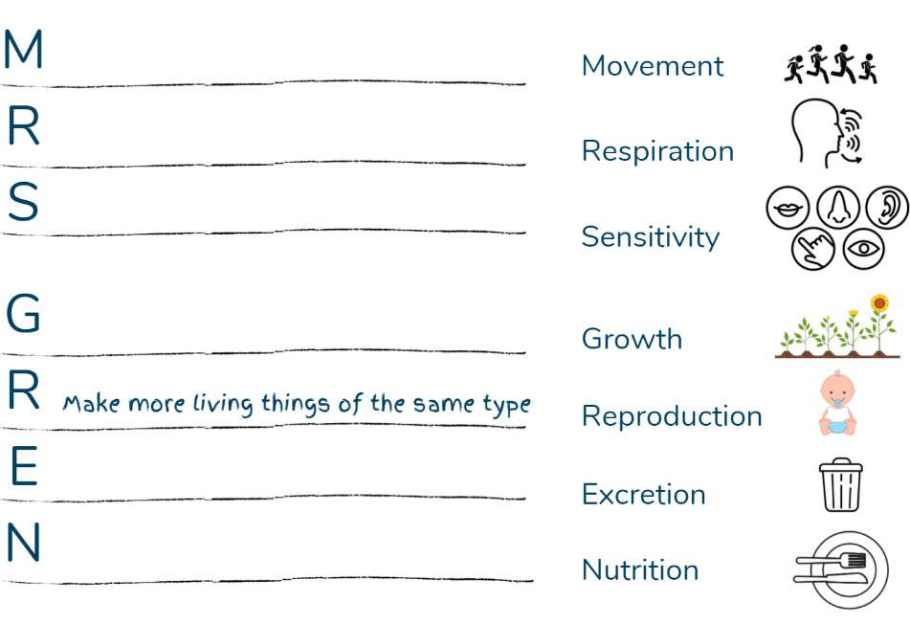
Your task:
In your home learning book write the acronym MRS GREN down the page (one letter for each line) then record the characteristics of living things and write a brief sentence about that characteristic next to it. E.g. Reproduction – make more living things of the same type.
What if humans could travel the solar system, what would we need if we were able to do that? Will the sun ever go out? What would happen to human survival if the sun went out?

Day 3 activity 3: Let’s go exploring
Notes for teachers and whānau
In this activity the learner is challenged to use the learning they completed in activity 2 to think about travelling to Mars. This article helps them to make meaning of what humans need to survive and how this would need to be considered if humans were able to live on other planets.

In this activity I am learning to: read to gain meaning and make connections to prior learning; make a checklist for someone to follow.
What do I need?
- 30 minutes
- A copy of Becoming a Martian, School Journal Level 3 May 2017
- Home learning book

Instructions:
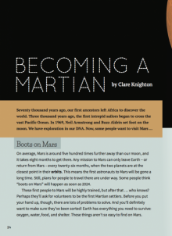
Read the article Becoming a Martian. This is a challenging article, so you are encouraged to find somewhere comfy and quiet to do this reading. There is a glossary at the end which you may find useful to reference as you read. Ask people in your whānau to help you if there are parts you find difficult to understand.

Your task:
After you have read the article create a ‘Camp Mars Packing List’.
Create a list of the things you would need to take with you from Earth to ensure your survival on Mars.
You may like to spend time making this like a check sheet to be included in a camp booklet for someone preparing to travel to Mars. Include hints/tips you learnt from reading the article so that someone is even better prepared.

Day 3 activity 4: 75 is the sum
Notes for teachers and whānau
In this activity the learner is applying their addition facts knowledge and recognising pairs of numbers that add to 75 exactly.

In this activity I am learning to: use my addition skills to recognise compatible numbers for 75.
What do I need?
- 30 minutes
- Pencil and the chart below

Instructions:
Look at the chart below, you are going to use you addition skills to find sums that add up to 75. Think about how to be systematic in your approach, for example you could start in one corner of the chart, and work line by line until all the numbers are used.

Your task:
- Combine two or more numbers on the chart to make a sum of 75.
- Write the sum in your home learning book and cross out the numbers on the chart to show that you have used them.
- Can you find a way to use all of the numbers in the chart?
- Can you make your own chart for a 2-digit number of your choice? Maybe you can challenge someone else in your house to find the number.
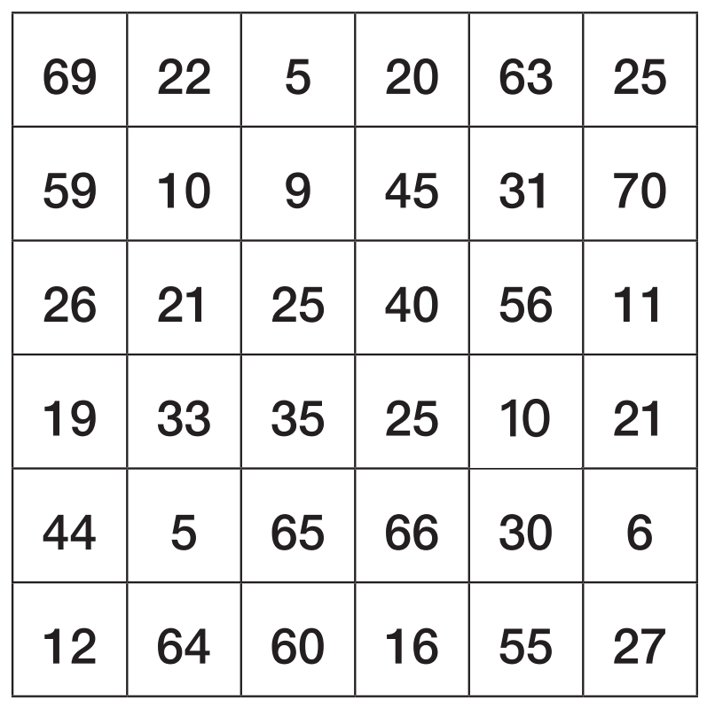
Remember to do your end of day reflection and wellbeing activities (see p. 6 and 8).

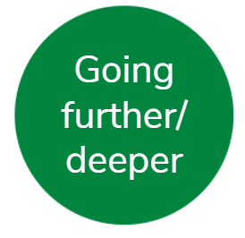
Day 4 activity 1: Te Reo Māori
Notes for teachers and whānau
The learner is learning some of the Māori names for the planets. They will use this new language as well as information from previous lessons to create fact cards to share with their whānau.
Note that today our Inquiry focus is “going further, deeper”. This may include promoting opportunities to engage further and dive deeper through discussions, provocations, exploring further contexts, taking action, or thinking critically and drawing conclusions.

In this activity I am learning to: read, say, and practice in te reo Māori. Recall prior knowledge to inform an audience.
What do I need?
- 30 minutes
- Home learning book
Optional: A device to watch - https://www.youtube.com/watch?v=Gp9ceSUJuFo

Remember to start your day right (see p. 7).

Instructions:
We will begin this lesson by learning the names for the planets in Te Reo Māori. You can find these written below. We will then use this new learning as well as learning from previous lessons to create fact cards to share with your whānau.

Your task:
Read and practice saying the kupu Māori for the planets below.
Draw and label these in your home learning book. As you draw practice the Māori word for that planet aloud. If you have a device you could watch this video that introduces the solar system in te reo Māori - https://www.youtube.com/watch?v=Gp9ceSUJuFo
- Rerenga o Tamanuiterā – The Solar System
- Mercury – Whiro
- Venus – Kōpū (but Tāwera for morning star; Meremere-tū-ahiahi for evening star)
- Earth - Te Ao
- The Moon - Marama.
- Mars - Matawhero
- Jupiter - Hine-i-tīweka or Pareārau (also a name for Saturn)
Note - As Uranus is barely visible to the naked eye, and Neptune and Pluto were only discovered once telescopes were available, they do not have traditional Māori names.
Create 10 fact cards using your learning in previous activities as well as te reo Māori you have just learnt. We will be sharing these fact cards with whānau tomorrow. E.g.
- Did you know that the Moon is called Marama in Māori?
- Did you know that the atmosphere on Mars is 95% carbon dioxide?

Day 4 activity 2: How many strips?
Notes for teachers and whānau
This measuring tasks involves your learner in demonstrating their estimate of 1 metre. They will be creating their own metre ruler from carefully joining A4 length strips of paper end to end and using this ‘ruler’ to measure objects.

In this activity I am learning to: measure using cm and metres, use my addition and problem-solving strategies to explore situations mathematically
What do I need?
- 30 minutes
- A4 sheet of paper
- Tape – masking or sello
- 1 metre (if available) and 30 cm rulers
- https://nzmaths.co.nz/resource/how-many-strips

Instructions:
How far do you think 1 metre is? Stand that distance away from the wall and then using your 1m ruler (or 30cm ruler, 1metre is 100cm) measure your estimate. How close was your estimate? Remember to measure from the 0cm on your ruler, not the beginning of the ruler! The same goes when using the other end of the ruler, finish your measurement at 30cm not the end of the ruler.
Look around your room, what else do you think is 1m long? Check your estimate. When you find something that is 1m long, you will use this to represent the ‘wooden table’ in the task below.
Now that you know the length of 1m, work out a solution to the problem below.

Your task:
Ariana needs a metre ruler, but she can’t find one.
She knows that the wooden table is exactly 1 metre long.
She makes herself a ruler from an A4 sheet of paper torn into strips lengthways which she then tapes together end to end.
How many strips does Ariana need?

Day 4 activity 3: I’m in Space!
Notes for teachers and whānau
Today your learner is going to make meaning by writing a diary entry as though they are travelling in the solar system. They may spend more time brainstorming their ideas than writing the diary entry and this is perfectly okay as it is about them making meaning of all the information they have learnt this week.

In this activity I am learning to: use descriptive writing
What do I need?
- 30 minutes
- Home Learning book

Instructions:
In this activity you are going to imagine our ‘what if’ question really happened… what if humans could travel to the solar system. You are going to write a diary entry for someone back on Earth to read.

Your task:
Imagine you are visiting the solar system.
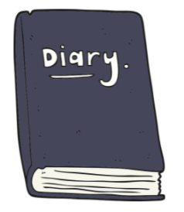
Write a diary entry as if you were an astronaut who has just reached space.
- Use descriptive language and write what you see, feel, smell and can touch.
- Use the things you have learnt from throughout the week as a way of including facts.
- Can you include any of the wonderings (‘what’) and new learning you had in your KWLH chart from day one?
- See if you can also include some te reo Māori in your writing.
You can also use your imagination as much as you like and get creative with what you include in your diary entry.
In space, astronauts have to send messages back to Earth via video, share your diary entry with someone over the phone or record yourself reading your diary entry.

Day 4 activity 4: Matariki reading
Notes for teachers and whānau
There is a lot to explore when we get curious about the solar system. One area that we haven’t yet explored is Matariki. In this lesson the learner will read a journal story introducing Matariki. They may have lots of questions about Matariki after reading this story.

In this activity I am learning to: read for meaning
What do I need?
- 30 minutes
- A copy of Matariki Breakfast, Ready to Read Series. Or you can find a copy and audio book here - https://instructionalseries.tki.org.nz/Instructional-Series/Ready-to-Read-Colour-Wheel/Matariki-Breakfast
- Home learning book
- https://teara.govt.nz/en/matariki-Māori-new-year

Instructions:
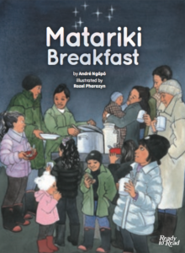
Twinkling in the sky just before dawn, Matariki signals the Māori New Year. It is often a time for families to come together and celebrate. In this story you will meet a character called Wai. She tells the story Andre Ngāpō (author) remembers his grandmother telling him when she was younger.

Your task:
One of the greatest appreciations in life is to sit and simply read. So today your learning task is to do just that! Sustained silent reading. Find a comfy spot, maybe a beanbag by the window in the sunlight and curl up cosy and read Matariki Breakfast.
You will have a chance to share this story tomorrow when you share your learning so you may like to make some notes in your home learning book after you have read.
There is a wonderful website called Te Ara, The Encyclopedia of New Zealand where you can explore more about Matariki https://teara.govt.nz/en/matariki-Māori-new-year

Remember to do your end of day reflection and wellbeing activities (see p.6 & 8).

Day 5 activity 1: You are invited to...
Notes for teachers and whānau
Today your learner will pick and choose aspects from this week’s learning to present and share. You may like to support them with the direction they take with this task if there has been something they have shown particular interest in.
Note that today our Inquiry focus is “present - share learning about the theme” which includes thinking about who the audience is and considering different ways of communicating learning for example, presentation, video, poster, etc.

In this activity I am learning to: use visual and written language to capture the audience’s attention.
What do I need?
- 30 minutes
- Home learning book or a large piece of card/paper
- Felts, pencils, crayons
- Craft items from around the home such as pom pom, cotton balls, small pieces of foil or bubble wrap etc

Remember to start your day right (see p. 7).

Instructions:
This week you have explored the solar system. I bet you wish that our what if we could travel to the solar system was really possible! Wouldn’t it be fun to explore the solar system! This learning activity is one final creative art/visual language task. Give it your all, I know your whānau would love to see what you can do.

Your task:
Design and create an invitation for someone in your whānau or one of your friends to join you on a special mission to explore the solar system. Remember to include where, when, what, who, things to bring. Include enticing visual language and art on your invite. You may even like to make it 3D to reflect the solar system theme, look around your home for things you can use like cotton balls, small pieces of foil, bubble wrap etc. You may like to share some facts or things they will need to consider when joining you on your mission to the solar system. Get creative and have fun!
Present this invite to the person you would like to invite once you have completed it. Do they have any questions for you as the leader of this imaginary mission?

Day 5 activity 2: What made you curious?
Notes for teachers and whānau
This is a reflection task. The learner is being asked to reflect on their learning this week and revisit the things that really made them curious. Perhaps they became really interested in the facts about Mars when reading the article Becoming a Martian. In this task they are going to design a true/false quiz to test out those facts on a whānau member.

In this activity I am learning to: write true/false fact cards to present to an audience.
What do I need?
- 30 minutes
- Home learning book
- Scrap pieces of card (or you can write your facts as a list in your home learning book).

Instructions:
A great way of presenting new information to an audience is by using true/false facts. Audiences love it as they get to respond with what they think the answer is while at the same time learning useful facts and information that they can teach someone else. This week you have learnt so many interesting facts. Now it is your chance to test them out on someone else. You may even like to call someone on the telephone and share your learning and then ask if you can ask them some true/false facts.

Your task:
Review the learning you have done this week. You can do this by rereading the texts included in this pack, looking back over diagrams, pictures, and graphic organisers you have created. Think about what really made you curious… was it when you learnt about the Matariki stars? Was it when you compared Earth and the Solar System? Was it when you read Becoming a Martian?
Create at least 10 true/false questions to present to someone. Remember you must know the answer so you may like to also create an answer sheet at the same time. You may like to include questions like:
- Matariki signals the Māori New Year? True or false
- The moon is full when it is closest to the earth? True or false
You could include questions which test your new te reo Māori vocabulary, or even maths questions from your maths tasks.

Day 5 activity 3: Matariki Breakfast
Notes for teachers and whānau
Your learner might be using this pack some time close to Matariki so they may be keen to connect this learning with the actual celebration, especially as 2022 is the first year there will be an observed public holiday to celebrate Matariki. In this activity your learner is encouraged to retell the Matariki Breakfast text that they read yesterday.

In this activity I am learning to: retell a story to an audience.
What do I need?
- 30 minutes
- A copy of Matariki Breakfast https://instructionalseries.tki.org.nz/Instructional-Series/Ready-to-Read-Colour-Wheel/Matariki-Breakfast
- Some props (from around your home) for you to use to engage the audience with as you retell.

Instructions:
Yesterday you read the beautiful story Matariki Breakfast. It was a special story for the author as it was a story his grandmother told him when he was a young boy. So many of the stories we read have been passed down from generation to generation through oral retelling.

Your task:
Today’s learning task is to retell this story to your whānau. Sharing a story aloud to an audience often includes the use of props and some dramatic techniques like using hand gestures or moving your body. You may like to follow this format:
Re read the story. You may like to take notes in your home learning book on a chart labelled – beginning, middle and end – to help you remember what happens throughout the story.
Think about where you could include props or hand gestures or movement
Practice your retell in a quiet space, perhaps in front of the mirror
Perform your story to your audience

Day 5 activity 4: Estimate and measure
Notes for teachers and whānau
This week your learner has focused on measurement and number during the maths activities. This final maths task asks them to apply this learning to things they can estimate and measure in the home.

In this activity I am learning to: apply the measurement knowledge I learnt this week to a practical task
What do I need?
- 30 minutes
- Home learning book
- 30cm ruler
- A4 paper strips

Instructions:
Now that you know the length of one metre (from yesterday’s task) it is time to challenge members of your whānau.
Write a list of approximately 8-10 things in your home that people would be able to measure using your A4 ruler template.

Your task:
- List the 8-10 items
- Estimate how long/tall you think the item is
- Measure it using your A4 metre long strip and a ruler (if necessary)
- Record the measurement
- Ask different whānau members to estimate the item
- Record their estimate
- Work out the difference between their estimate and the actual estimate
- Award them 5 points if their estimate was exact, 4 points if it was only 1-2cm different, 3 points if it was 3-4cm different, 2 points if it was 5-6cm different, 1 point if it was 7-8cm different, 0 points if it was greater than 9cm different.
- Work out who scored the most points for each item? Who scored the most points overall and was therefore your whānau winner? How close were your estimates to the winners estimates (i.e.? What points did you score yourself?)

Remember to do your end of day reflection and wellbeing activities (see p.6 & 8).

Context 2: How does that work?

The next five days indulge our curiosity by looking at how different things work.
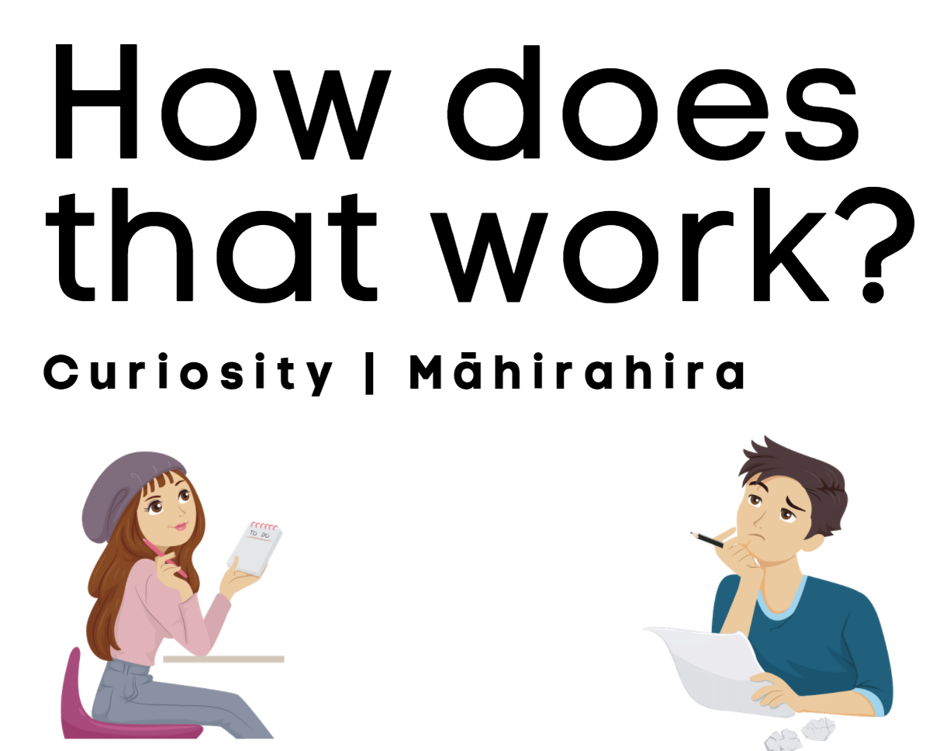

Day 6 activity 1: What do I know right now?
Notes for teachers and whānau
Today we will be looking at what your learner already knows and setting the scene for what they will explore this week. If you can, sit with your learner and help them get started. You do your responses and they do theirs. Then compare results. This is a great conversation starter and will show your learner a “recollection” process that we all engage in when trying to make sense of things. It’s not about right or wrong or how much or how little, it’s about the NOW position.
Note that our Inquiry focus for today is “getting started” which includes generating questions, activating prior knowledge, and introducing the theme.

In this activity I am learning to: brainstorm what I know and how I know it.
What do I need?
- 30 minutes
- Home learning book or digital doc.
- Device to view - https://www.howmanypeopleareinspacerightnow.com/

Instructions:
The focus for your learning in the next five days is “How does a rocket work?” That is a very BIG question. So where to start!
The best place would be to identify what you already know and understand. Your head is already filling up, isn’t it? So, let’s get that down on paper.

Your task:
Make a record of your “NOW” position – What do you already know now about rockets? Write that in the middle of your page and then use drawings, labels, and sentences to record your “now” knowledge. Give it 10 minutes. Remember this is your starting point.
Now look at your page. Think about how you know what you know. How much of your knowledge is from reading a story? How much from movies/gaming/TV? How much from researching/reading about/ documentaries about actual rockets?
What do you notice? Where did you get most of your knowledge from? Did you draw a rocket? Did you label the parts? Did you mention fuel? History? People? Places? Countries? If you did, great! If you didn’t that’s about to change. Your NOW is about to get bigger and EXPAND like the universe.
A lot of our understanding about space, and the machines that get us there, comes from fiction. Stories have captured our imagination and opened up questions of how possible space travel will become for everyday citizens. Right now, space travel is still in the experimental stage. However, there are people in space right now. If you want to know who and where they come from this website provides you with real time information - https://www.howmanypeopleareinspacerightnow.com/.

Day 6 activity 2: Literacy – So many adjectives!
Notes for teachers and whānau
In this lesson your learner will explore and make a list of adjectives to describe a rocket launching. They can either watch a short clip showing a rocket launch with sound effects and no narration, or they can view the image below.

In this activity I am learning to: understand and use describing words.
What do I need?
- 30 minutes
- A device to view this short clip (or use the image below) - https://www.youtube.com/watch?v=ViNcBQ8cDA0

Instructions:
We are going to start the week by viewing a short clip of the Saturn V launch (or imagining the launch by looking at the image below). This might launch your thinking about “How does a rocket work?”
This rocket is described as a behemoth. A behemoth is a monster, a beast. Watch the launch and then complete the literacy task below.

Your task:
Describing words are called adjectives. What adjectives would you use to describe the Saturn V launch (in the video) or the rocket launch in the image below?
Sketch a rocket in the centre of your page and write the adjectives around the sketch, or you could create a simple list, it is up to you.
Making connections – did you write some of these adjectives down in activity 1 when you were thinking about what you already knew about rockets? You may like to watch the clip a few times and see if any other adjectives come to mind as you watch it.
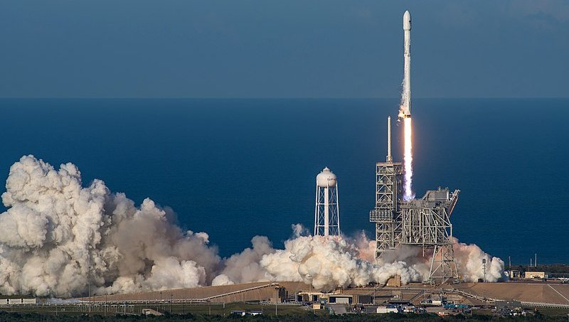

Day 6 activity 3: Science/engineering – What is a rocket?
SpaceX, CC0, via Wikimedia Commons

Notes for teachers and whānau
In the last lesson your learner watched a video of the Saturn V rocket launch. In this activity they are going to watch or read a scientific/engineering explanation. Your learner may need support with some of the technical language/concepts in this activity.

In this activity I am learning to: think critically while viewing, listening to and/or reading a scientific and engineering explanation.

What do I need?
- 30 minutes
- Home learning book
- A device to view this clip (or see transcript below) - https://www.youtube.com/watch?v=8dpkmUjJ8xU

Instructions:
The video of Saturn V launch was a compilation (a lot of different clips) to show different stages and points of view. This next video is an animation. Scientists and engineers use different kinds of representations to model (show) things so that we can better understand what is being studied or explained. Watch the clip and use the CC (closed caption) function. This will help you to focus.
If you do not have access to a device, you can read the same information below in the transcript of the video.
Transcript
Introduction
The Apollo Spacecraft was the incredible machine that allowed astronauts to walk on the moon. It was split up into three parts, the Command Module, the Service Module, and the Lunar Module. Later on we will talk about what each module does, but first let’s talk about the launch vehicle that gets us into orbit.
The Saturn V
Each mission was launched from Cape Canaveral in Florida. Mission Control was all the way in Houston, Texas. The Saturn Five rocket was 33 metres tall.
Three stages
The Saturn V was split up into three stages; each stage has a technical name. The first stage is called the S-1C and is powered by five F1 rocket engines. The second stage is called the S2 and is powered by five, slightly smaller, J2 rocket engines. The third stage is called the S-4B and is powered by only one J2 rocket engine.

The actual spacecraft
The spacecraft was stored up at the top of the rocket stages. During the launch, it was protected by four panels known as the spacecraft Lunar Module adapter. The Service Module contains the engines necessary to enter and leave lunar orbit as well as fuel cells and other electrical components. The Command Module is where the three astronauts spent most of their time. The Launch Escape System is at the very top.
The Launch Escape System
In the event of an emergency, it would carry the Command Module safely away from the rocket. The structure next to the Saturn V is called the Launch Umbilical Tower.
The Launch Umbilical Tower
There are nine service arms that provide access to the Saturn V. On launch day the three astronauts ride an elevator to the top service arm to enter the Command Module.
Launch
Four of the service arms are moved out of the way before the launch. The First Stage ignites eight seconds before the Saturn V leaves the ground. As the Saturn V starts to rise, the remaining five service arms quickly rotate to get out of the way. It takes about 12 seconds for the rocket to completely clear the tower.
Through the atmosphere
As the Saturn V picks up speed, the astronauts will feel as much as 4G’s or 4 times the amount of gravity pressing them into their seats. The First Stage shuts off at 2 minutes 42 seconds at a height of about 67 kilometres. Explosive bolts detonate releasing the first stage, letting it fall back down to the Atlantic Ocean; shortly after, the second stage fires up. We’re high enough up in the atmosphere now, that the Launch Escape system is no longer needed. The second stage shuts off at 9 minutes and 12 seconds at a height of 180km. The third stage fires up for a short amount of time to get the astronauts into a Parking Orbit of 190km.
Parking orbit
The parking orbit shuts off at 11 minutes and 39 seconds but does not detach yet. One of the hardest parts of the mission is over, but the adventure does not stop here.
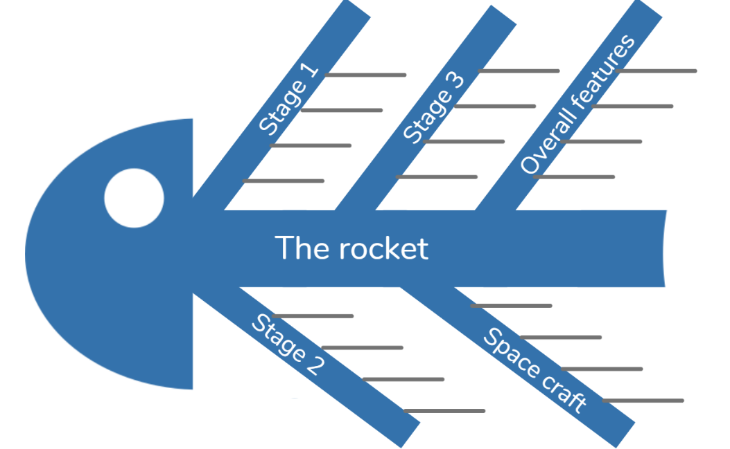

Your task:
Using the information from the clip or from the transcript use a fishbone graphic organiser to show how a rocket works – the main parts of a rocket and what they do.

Day 6 activity 4: Mathematics – Roman numerals
Notes for teachers and whānau
In this activity your learner is introduced to the brief history of Roman numerals and the patterns. They then apply this new learning to solving a few examples.

In this activity I am learning to: understand and read Roman numerals.
What do I need?
- 30 minutes
- Optional song to help: https://www.youtube.com/watch?v=z1UmAgekzbs
- Home learning book

Instructions:
The V in Saturn V represents the number 5. You may have seen examples of Roman numerals before. They are often used by scientists and engineers to help name or classify things. In this task we are going to find out about this number system which came into use in ancient Rome nearly 3000 years ago. It was still used in the Middle Ages. That means for many people it was the way to calculate for nearly 1500 years. That’s about how long we have been using our modern system which is the Hindu-Arabic system.
Like people today, the Romans needed to count things and they made a system that helped people to calculate amounts, particularly to know how much or how many goods they had. For example, the Roman army would need to know how many soldiers they had, and how many shields, swords, and sandals the soldiers would need.
The system was based on how many fingers on each hand. They made a mark, much like we do, to indicate one finger. The V represented the five fingers of one hand. Hold your hand up and you can see that the shape made between your index (pointing) finger and your thumb, makes a V. The X represents two Vs touching so became the symbol for 10.
So now you know that I represents one: V represents five and X represents ten. There are four more symbols that are used to write numbers. They are L, C, D and M.
Here is a great song to help https://www.youtube.com/watch?v=z1UmAgekzbs
Here are the 7 symbols
1 | 5 | 10 | 50 | 100 | 500 | 1000
I | V | X | L | C | D | D

This table shows how the pattern works.
1 | 2 | 3 | 4 | 5 | 6 | 7 | 8 | 9
I | II | III | IV | V | VI | VII | VIII | IX
10 | 20 | 30 | 40 | 50 | 60 | 70 | 80 | 90
X | X X | X X X | XL | L | LX | LXX | LXXX | XC
100 | 200 | 300 | 400 | 500 | 600 | 700 | 800 | 900
C | C C | C C C | CD | D | DC | DCC | DCCC | CM

Cracking the code: When a symbol comes after a larger (or equal) symbol it is added
- Example: XI = X + I = 10 + 1 = 11
- Example: LXXX = L + X + X + X = 50 + 10 + 10 + 10 = 80

Your task:
- Use the examples to help you represent the Roman numeral in our Hindu-Arabic format
XXXIII = | LVI = | CCXII=
- Now write these Hindu-Arabic numbers using the Roman format
35 = | 123= | 532=
If the symbol comes before a larger symbol it is subtracted – this is a bit trickier.
- Example: IX = X − I = 10 − 1 = 9
- Example: XL = L – X = 50 − 10 = 40
- Use the examples to help you represent the Roman numeral in our Hindu-Arabic format
XLII = | XLV = | CCXII=
- Now write these Hindu-Arabic numbers using the Roman format
19 = | 95= | 532=

Remember to do your end of day reflection and wellbeing activities (see p.6 & 8).

Day 7 activity 1: The rocket
Notes for teachers and whānau
Your learner will continue to investigate “how does a rocket work?” Encourage them to record any questions to explore later in the week.
Note that our Inquiry focus for today is “explore, investigate, and discover” which includes choosing and evaluating information, and thinking critically.

In this activity I am learning to: use a diagram to check understanding and develop questions.
What do I need?
- 30 minutes
- Home learning book

Remember to start your day right (see p. 7).

Instructions:
In this activity you are going to check your understanding about the Saturn V rocket.

Your task:
Copy the table below into your home learning book. In each column record what you can see in the image and what you have learnt about each of the parts of the Saturn V. Use this table to also write down any questions or wonderings you have.
First Stage | Second Stage | Third Stage | Apollo Spacecraft

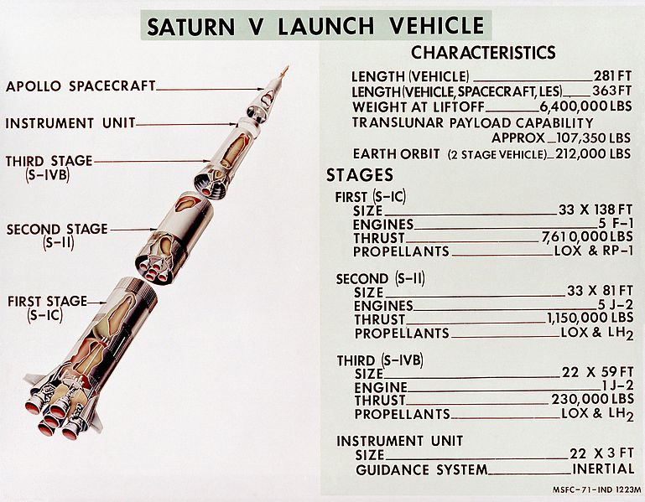
NASA/MSFC, Public domain, via Wikimedia Commons

Day 7 activity 2: Rockets 101!
Notes for teachers and whānau
In this activity the learner listens to a video or reads a transcript. They then decide which information is useful and create a list of facts. The purpose of this lesson is to think carefully about information from multiple sources and whether it is useful.

In this activity I am learning to: analyse the usefulness of information.
What do I need?
- 30 minutes
- A device to view this clip (or read the transcript below) - https://www.youtube.com/watch?v=1yBwWLunlOM

Instructions:
Watch the YouTube video or read the transcript below.
Transcript
The ground begins to tremble. Massive engines roar to life. Billowing clouds of exhaust. And then in a blinding pillar of fire “Lift off. We have a lift off”. A mighty voyager leaves the Earth behind to explore the vast universe among the stars.
Launching a rocket into space is one of humankind’s crowning achievements. Coming in many shapes and sizes all rockets are propelled by engines producing thrust.
Space rockets are made up of 4 major systems based on function. The structural system makes up the frame that holds the rocket together and consists of the cylindrical body, nose cone, and fins. The propulsion system takes up the most room and includes the rocket engine, fuel, and oxidizer. The payload system consists of anything the rocket is carrying into space, like a spacecraft, satellite, or human being. Lastly the guidance system is made up of radars and computers that provide stability for the rocket and control manoeuvres in flight.
In order to launch into space, all 4 of these systems must work together to overcome the force of gravity. The launch begins when the rocket’s propulsion system generates a massive amount of thrust. Thrust is the force produced by burning fuel as exhaust gases escape through the engine. Once the rocket generates more thrust than its own weight it lifts into the air to begin its powered ascent. During this phase of the flight, the weight of the rocket will constantly change as fuel continues to burn off. As a result, most space bound rockets use a technique called staging to reduce dead weight and increase efficiency. The method involves breaking off a large rocket into 2 or 3 smaller rockets that fall away at different stages of the launch. As the rocket continues into orbit, its guidance system maintains balance and steers to keep the flight on track. At the correct altitude and speed the upper engine cuts off completing the rocket’s journey from Earth’s surface into orbit.

Your task:
This information helps us to understand more about rockets and how they work. It is always a good idea to check out more than one source of information or explanation. Together, sources help us to better understand new ideas and information.
Listen to/read the information. Every time the narrator mentions something that you have recently learnt about underline it in the transcript. Is this a useful strategy? Explain your response.
Scan the things you have underlined.
Write the heading Rockets 101 and add the information you have learnt using bullet points. Share these facts with someone in your whānau or to a friend over the phone.

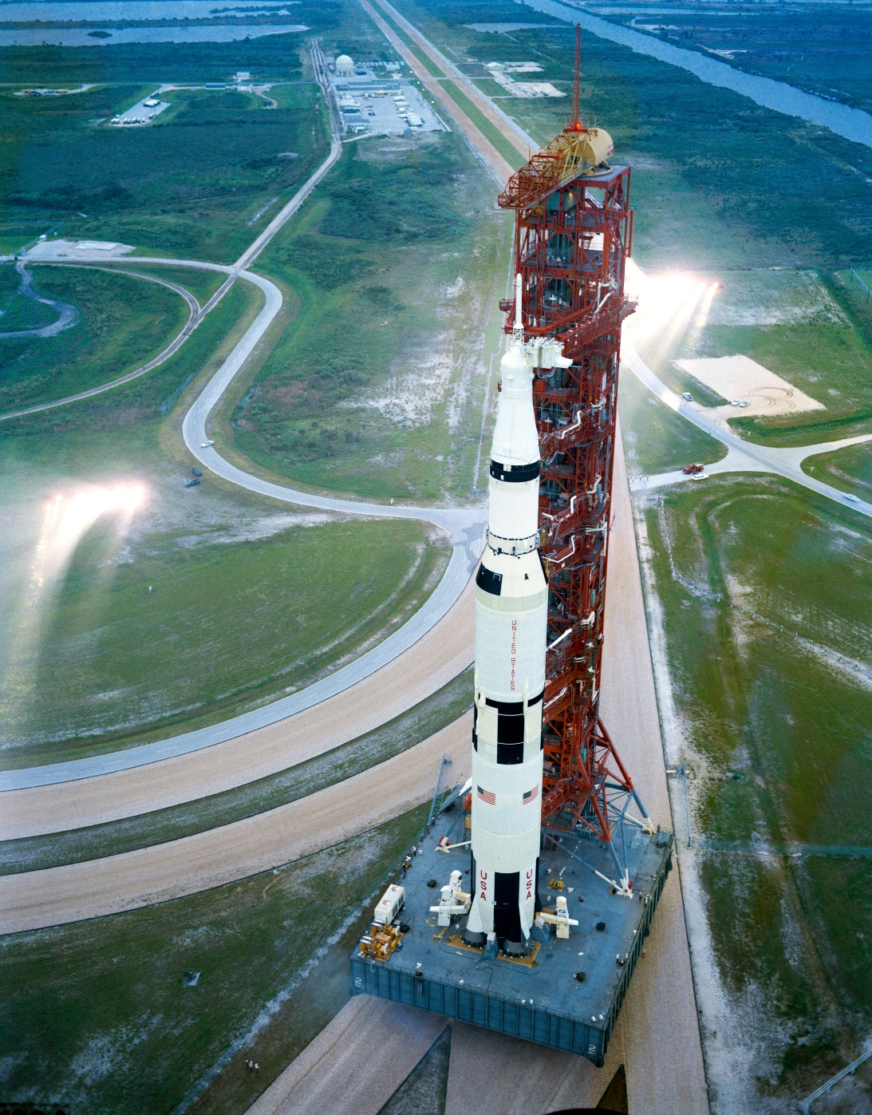
Saturn V Apollo 12. NASA, Public domain, via Wikimedia Commons

Day 7 activity 3: Topic related vocabularly
Notes for teachers and whānau
This activity will introduce your learner to some topic related vocabulary in te reo Māori and New Zealand Sign Language (NZSL). Some words do not have NZSL translations.

In this activity I am learning to: read, say, and sign topic related vocabulary
What do I need?
- 30 minutes
- A device to access the NZSL dictionary - https://www.nzsl.nz/

Instructions:
New Zealand has three recognised languages – English, te reo Māori and NZSL. In this activity you will learn some of the vocabulary we have been reading and hearing.
English | Māori | New Zealand Sign Language
Space | Tuarangi | 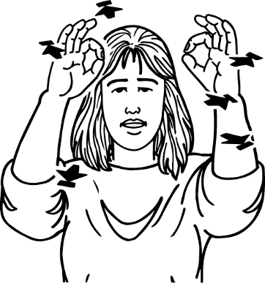
Astronaut | Kaipōkai tuarangi
Space shuttle | Waka kōpiko tuarangi
Space suit | Kākahu tuarangi
Rocket | Tākirirangi | 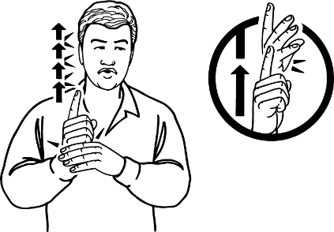
Parts of a rocket | Ngā wāhanga o te tākirirangi
Blast off | Tākiritia

Your task:
- Practice the vocabulary by reading, saying, signing each word/phrase.
- Test yourself by covering parts of the table and saying the word before checking
- Share new vocabulary in te reo Māori and NZSL with people in your whānau.

Day 7 activity 4: Timelines
Notes for teachers and whānau
This is an integrated task involving writing and maths. First they organise the rocket history into chronological time sequence. Next they create a timeline of their life. This second task may require support from whānau as they talk through milestones in their life.

In this activity I am learning to: understand and use a timeline to sequence ideas.
What do I need?
- 30 minutes
- Home learning book
- History sequence of Rockets 101 (or transcript below) https://www.youtube.com/watch?v=1yBwWLunlOM

This information looks at how rockets developed overtime. It is amazing to find out how human ideas and dreams become real things. Our imaginings are always the first step.
Watch or read the transcript of Rockets 101.
Transcript
Long before blasting into space rockets were used on Earth as early as the 13th century introduced by the Chinese. These fire arrows were used to fight against invading armies and were made by attaching fireworks packed with gunpower to long arrows. By the 16th century the use of rockets for amusement had spread from Asia to Europe where they gained popularity in firework displays at celebrations and festivities.
During the following centuries, the work of scientists, like Isaac Newton and his Laws of Motion, increased knowledge into the forces behind rocketry and how to control them. By the end of the 18th century military forces began to apply these new scientific understandings to the battlefield, transforming the earlier crude rockets into powerful weapons of war. The true dawn of space rocketry began in the early 20th century thanks to technological improvements in rocket science and aeronautics. By the 1950s the stage was set for the modern space age, and development began on launch vehicle systems like the Atlas rocket family which launched America’s first astronaut into orbit; the Titan rockets during the Space Race, and the Saturn rocket family, which includes the largest and most powerful rocket successfully launched, the Saturn V.
Standing as high as a 36-storey building and weighing more than 3000 tons, this behemoth was used to launch the Apollo missions to the moon.
Since the beginning of human history adventurers have looked at the skies and dreamt of touching the stars. Today innovations in rocketry are opening up possibilities to launch astronauts farther than ever before. Whether our sights are set on the moon, Mars or beyond, the future of rocketry and space exploration is only just blasting off.

Instructions:
A timeline is a graphic organiser. They are useful to show how things are developed over time. We organise the entries on a timeline in “chronological order”. That means as they happened. Timelines are often used to show how events in history are related to each other. We can get a sense of how something has developed up until an end point or until the most recent significant (important) event.
Timelines all include dates to show when each event happened. They can be represented in many ways such as a diagram, video, interactive or illustration. The entries can be just a few words that help to identify key points or can be whole paragraphs. They are usually more effective if they can be multimodal. That means a combination of images (still or moving), sound and writing.
Your task:
- Re-read the transcript. Look for and underline these excerpts (pieces) from the text and then correctly place the rocketry developments in chronological order on the timeline.
- Make a personal timeline from birth to now. Include those things we call milestones. Your whānau will be a great help. Here are some examples of noteworthy events that you might like to include – first word, first step, arrival of new sibling, starting early childhood, shifting house, starting school, winning a prize, joining a club starting to learn a new skill (music, dance etc). As you can see you will probably have to collaborate with somebody who knows you quite well. You might like to LIMIT yourself to 3 or 4 key events per year.

Remember to do your end of day reflection and wellbeing activities (see p.6 & 8).

Day 8 activity 1: Reading – Kiwis in Space
Notes for teachers and whānau
You might find the full text required for this lesson in the home learning pack. The article ‘Kiwis in Space’ contains a lot of information. In this task we have included excerpts for your learner to read.
Note that our Inquiry focus for today is "making meaning" which includes analysing data, organising, and sorting information, summarising, synthesising, making connections/conclusions, building deeper understandings, and thinking critically.

In this activity I am learning to: read for meaning
What do I need?
- 30 minutes
- A copy of Kiwis in Space – Digital Space, Level 4 Connected series.
Digital link - https://docs.google.com/presentation/d/1ghNSAL_nDm3EBpQQEr8miXijqonUcB-iwrOiD729WRQ/present?slide=id.p

Instructions:

In this task you will be reading a part of an interview. You will use this information in the next lesson and in day 10.

The text below is part of an interview with Naomi Altman reported by Laurie Winkless. It provides background information to help us understand the context. It also introduces us to the interviewee, Naomi, and provides her qualifications. The article tells us about Rocket Lab, a NZ company that started to design and make rockets that could carry small payloads into space. Not all rockets are used to carry people. Some smaller versions are used to launch satellites.

Your task:
Read and discuss (with someone in your whānau) the text on the next page.
Consider
- Why do you think the author included the background information?
- Are there new adjectives that you could add to your adjectives page in your home learning book? (See p.34)
- Are there any words that are new to you? Underline these and use a dictionary (or ask someone in your whānau) to find out what the word means.
- Challenge yourself: Can you work out how many times could Sputnik 1 have ‘zipped around Earth’ in 24 hours? You could challenge someone in your whānau to work it out with you

Background:
On 4 October 1957, the Soviet Union launched the world’s first human-made satellite into space. The basketball-shaped Sputnik 1 zipped around Earth once every ninety-six minutes, sending out a continuous beep that was picked up by radios across the world. The message was clear: the space age had begun.
Since then, only eleven countries have built and launched a rocket that can send satellites into space. New Zealand became the latest country to join that list on 21 January 2018, when Rocket Lab’s Electron rocket took off from the Māhia Peninsula. Just over eight minutes later, Electron successfully released four satellites into orbit.
Naomi Altman is the Avionics Manager at Rocket Lab’s Auckland office. She manages a team of more than twenty technicians and engineers. Together, they design, test, and operate all of the specialist electronics that control and power the Electron rocket. I chatted to Naomi to find out what it takes to reach orbit.
Laurie: Who are Rocket Lab?
Naomi: When you think of the space industry, you probably think of big government agencies like NASA. But lots of commercial companies are now developing cheaper ways to deliver satellites into space. Rocket Lab is one of the leaders in this area. We build lightweight, low-cost rockets that can carry small payloads into space.
Rocket Lab was founded by New Zealander Peter Beck in 2006. It became a United States company in 2013, but most of the people who work for us are still New Zealanders.
We have a big manufacturing facility in Auckland where we build the rocket tanks, test the engines, and fit all the different parts together (the “final integration”). We also launch many of our rockets from our launch site on the Māhia Peninsula. Because the Māhia Peninsula is so remote, it’s the perfect site for launching rockets.

Day 8 activity 2: Tikanga Māori
Notes for teachers and whānau
This lesson looks at kaitiakitanga and tikanga (eg the values local community holds around land use) with a focus on the Māhia Peninsula as mentioned in the article in activity 2. Help your learner understand why Tawapata South Māori Incorporation met with Peter Beck before rockets could be launched from the site.

In this activity I am learning to: understand what kaitiaki and kaitiakitanga are.
What do I need?
- 30 minutes
- A map of New Zealand (optional)

Instructions:
In this activity we are going to explore what being caretakers of the land means.

Your task:
Read this excerpt.
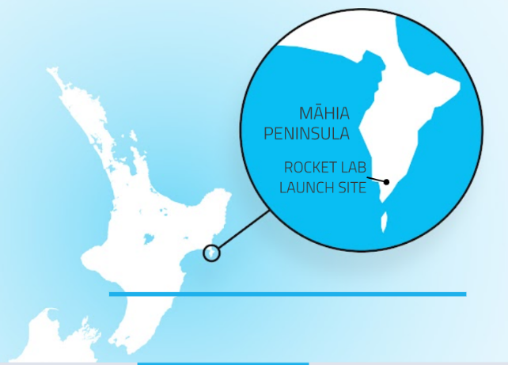
Caretakers of the land
The Māhia launch site is built on land owned by the Tawapata South Māori Incorporation. Before leasing the land, Tawapata met with Peter Beck at the local marae to make sure they shared the same values. “We have a proverb about the land that says, ‘People come and go but the land is forever,” says George Mackey, spokesperson for Tawapata.
“That’s the way we view this. In one hundred years’ time or one thousand years’ time, Rocket Lab may not be here, but the land will still be here.” The two groups reached a deal that included protection of the surrounding environment and cultural sites for future generations.
Do you know where the Māhia Peninsula is? Talk with someone in your whānau about where the Māhia Peninsula is located. If you have a New Zealand map handy locate Māhia on the map. Which towns/cities are close by?
Look at the kupu Māori below and write why Tawapata met with Peter Beck in your home learning book:
- Kaitiaki – is a Māori term used for the concept of guardianship, for the sea, the sky, and the land. A kaitiaki is a guardian
- Kaitiakitanga – the process and practices of looking after the environment
You can read more about kaitiakitanga on Science Learning Lab https://www.sciencelearn.org.nz/resources/2544-understanding-kaitiakitanga

Day 8 activity 3: Paper planes
Notes for teachers and whānau
Your learner won’t be able to make and launch a rocket, however they can make and launch a paper plane. In today’s activity we encourage the learner to follow a procedural text to make a paper plane, launch it, and then reflect on the design and launch. We will think about and make adaptations in tomorrow’s lessons.

In this activity I am learning to: follow a procedural text; launch a paper plane.
What do I need?
- 30 minutes
- A4 paper or a piece of newpaper cut to A4 size

Instructions:
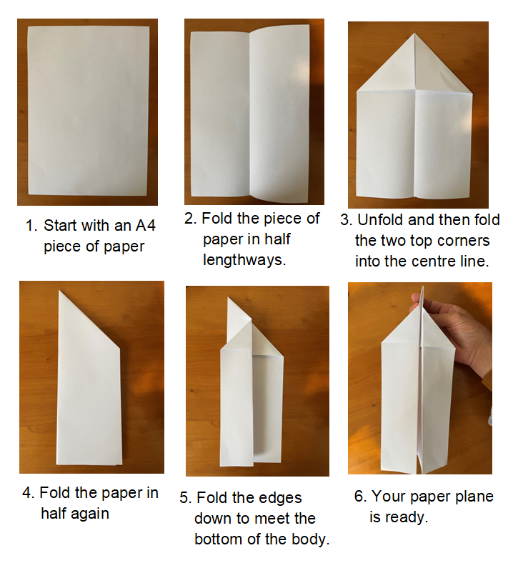
We have learnt that rocketry started off as a response to human imagination and dreams. By making and testing a simple paper plane and using your noticing and wonderings, you will appreciate how often we start with somebody else’s experiences or plans, try them out, and start to think of ways to improve the model.

Your task:
Follow the procedural text to make a paper plane.
In a large indoor space, perhaps your hallway, launch your paper plane.
Create a PMI chart in your home learning book and record:
- What were the positives about your plane and its launch?
- What were the negatives about the plane you made or its launch?
- what was interesting about the plane you made or the launch?
Plus | Minus | Interesting

Day 8 activity 4: Testing paper planes
Notes for teachers and whānau
Your learner is going to think like an engineer, observing and making changes to the paper plane to make it fly faster, straighter, further. They will revisit measuring with a metre ruler and recording their observations in a chart.

In this activity I am learning to: make observations and changes to a prototype.
What do I need?
- 30 minutes
- A4 paper and the paper plane from the last lesson
- Measuring tape (you could use your metre strip from day 4 activity 2)

Instructions:
We are going to turn on our “engineer’s brain”. An engineer is someone who designs, innovates, and builds engines and machines. You are going to observe your paper plane and see how you can modify it to make it better.

Your task:
Setting up the prototype testing conditions:
- Fold another paper plane or use the one from the last activity.
- In a large space (a hallway or outside) mark your starting line.
- Create a chart in your home learning book to record your results (see below)
Begin testing:
- Throw your plane and observe the flight – does it fly straight? Does it curve up or down? Does it spin? Record your observations.
- Measure the distance that your plane travelled and record that on your chart.
Change made | Distance travelled | Observations
e.g original design | 1 metre | Curve to the left and nose dived
Add a paper clip to the nose
- MAKE A CHANGE TO YOUR PLANE – refold, flatten, bend a wing, add a paperclip, fix a crease, change how you throw the plane, etc.
- Repeat the test with your new design. Record your observations and distance travelled.
What difference did your change make? Did it make the plane fly faster or slower? Did it fly a longer or shorter distance?
- Decide if you want to keep that change and then make a new change to your design and record that in your chart.
- Repeat the testing process until you have the ultimate paper plane.
Challenge someone else to a paper plane throwing competition!

Remember to do your end of day reflection and wellbeing activities (see p.6 & 8).

Day 9 activity 1: Geometric shapes
Notes for teachers and whānau
In this activity we are looking at the connection between maths and science and the context of rockets and geometry. We draw on their learning from yesterday’s paper planes activity.
Note that today our Inquiry focus is “going further, deeper”. This may include promoting opportunities to engage further and dive deeper through discussions, provocations, exploring further contexts, taking action, or thinking critically and drawing conclusions.

In this activity I am learning to: recognise and name shapes I am using in my science learning.
What do I need?
- 30 minutes
- A4 piece of paper (or paper planes from previous lesson)
- Home learning book

Remember to start your day right (see p. 7).

Instructions:
A polygon is any 2–dimensional closed shape, formed with straight lines. Triangles, quadrilaterals, pentagons, and hexagons are all examples of polygons. The name tells you how many sides the shape has. When you made your paper plane you started with a sheet of paper. By a series of folds this was transformed from a flat sheet to a shape that could travel some distance through the air.

Your task:
Make another plane and as you make each fold name the shape you see. Be methodical. You should see triangles, quadrilaterals and pentagons. Remember to make sharp creases as you make your folds. It will make your shapes easier to see.
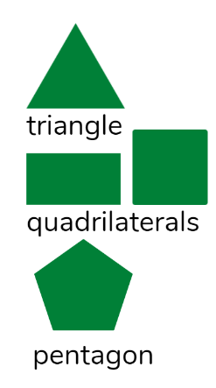
What shape do you think will occur the most?
Make a table (see below) and use tally marks each time you make a shape. Turn your plane over as you count...don’t forget the underside.
polygon | Number of sides | Tally
triangle | 3
quadrilateral | 4
pentagon | 5

Challenge for Polygon Ace Detectives:
Once your plane is made, carefully unfold, and have another look. Look for shapes within shapes!!! It might be useful to outline using different colours, to keep track.

Day 9 activity 2: Paper planes versus air fish
Notes for teachers and whānau
Yesterday your learner spent time making, launching, and exploring the geometry of a paper plane. Today’s lesson encourages them to go further with this learning by making a spinning “air fish”

In this activity I am learning to: follow a procedural text and explore prototyping
What do I need?
- 30 minutes
- Sheet of paper
- Scissors, ruler, and pencil

Instructions:
Yesterday you made a basic paper plane and extended yourself by trying out some different plans. The Paper Plane fan club is worldwide with plenty of enthusiasts everywhere. You can check out plans and demonstrations on the internet.
Now you are going to make a prototype of a different flight capable paper toy – an air fish. We will test its capabilities and test the limits of the design. We are working with somebody else’s plan, but all the best scientists and engineers start with the known.
What is a prototype? A prototype is a full-scale working model of a new product or a new version of an existing product.
What does it mean to test the limits of the design? First you need to see how the protype functions. Look at how it performs. Right. Just do it. Here are the instructions.

Your task:
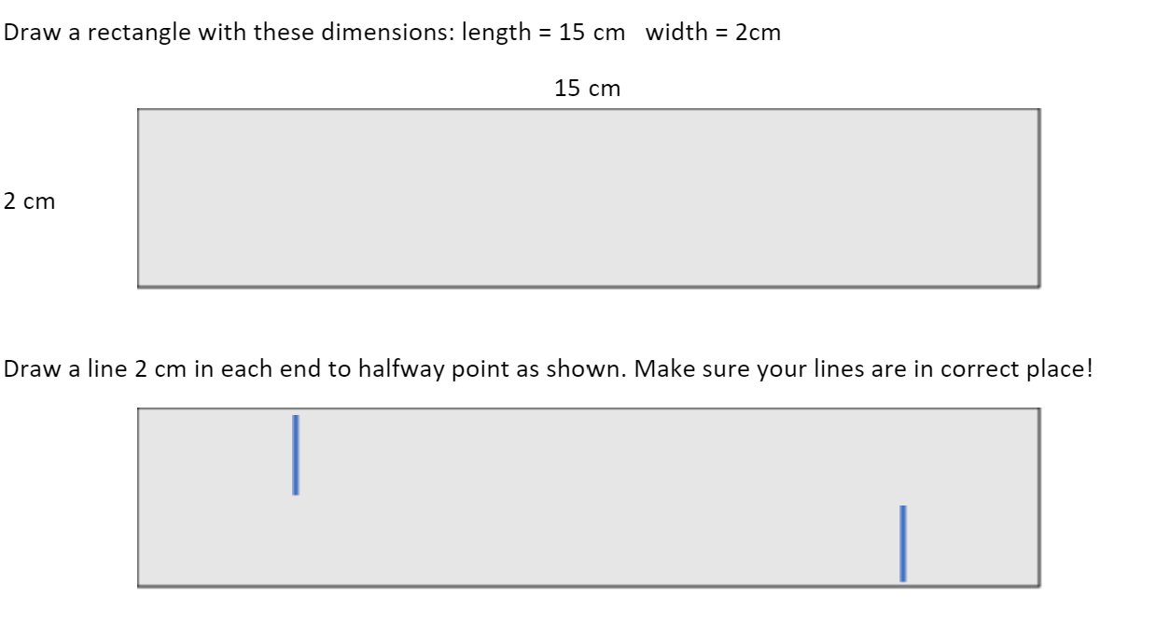

Cut out the rectangle and then make the two halfway cuts.
DOUBLE CHECK BEFORE YOU MAKE THE SECOND CUT!

Now assemble your blimp by curling the strip and connecting at the two cuts.
This is your prototype air fish.

Hold the air fish above your head. Let it drop. Try it again. Stand on a chair (ask permission). Does height make difference? Try throwing it up from ground level and then chair level (again…permission).
Write down - How does this thing move? Does the height change things? What works best - drop or throw?
Change made | Observations

Something to consider. It might be useful to ask somebody in the whānau to join you in this and the next two activities. It is hard to be both an observer and experimenter at the same time! Being able to stand back and watch somebody else trial the air fish gives another “perspective”. This is a science and engineering practice and one that shows how collaboration is a positive way of gathering and then interpreting data.

Day 9 activities 3 & 4: Testing the limits of design
Notes for teachers and whānau
In this activity your learner will extend their ability to test and modify a plan. Encourage them to talk aloud the changes they make to their design before they feel confident recording it in their log.

In this activity I am learning to: explore cause and effect.
What do I need?
- 60 minutes
- 2-3 sheets of paper
- Scissors, ruler, and pencil

Instructions:
This is your chance to conduct another experiment with your prototype. The next step is to start following some protocols or rules so that the data we collect helps to identify what’s going on and why. We are looking at what has happened (the effect) and identifying what might have caused it.

Your task:
First let’s see what happens when you alter the dimensions. Start with changing the length of your air fish … perhaps make it shorter by 5 cm or longer. Try it out. Remember to do at least 3 trials of each new version.
Next, start again and keep the length at 15 cm but alter the width. Again, 3 trials. Log your results in a table like this (copied into your home learning book):
Length | Width | Trial 1- tick for successful plus a statement | Trial 2 | Trial 3
10cm | 2cm
20 cm | 2cm
15 cm | 1 cm
15 cm | 5cm
When testing the limits of your design everything depends on accurate record keeping of measurements and outcomes. Just doing one test run is also a problem.
So looking at your table of results you will be able to see which changes were a pass or a fail…you are right now in the middle of science and engineering practice. Perfect.
If you think about that mighty Saturn V, (day 6 activity 1) those astronauts depended on trials and honest recording of outcomes. They knew that they were taking a risk. But it was what we call a “calculated” risk.
Grab your team (your whānau) and analyse your results table. In your home learning book record which test runs were the most successful? Why do you think they were successful?

Day 10 activity 1: The new ‘now’
Notes for teachers and whānau
In this activity the learner reflects on their new ‘now’. What do they know now that they didn’t know at the start of the week? They will review their day 6 activity 1 learning and add to this. You may like to discuss what they knew then versus what they know now.
Note that today our Inquiry focus is “present – share learning about the theme” which includes thinking about who the audience is and considering different ways of communicating learning for example, presentation, video, poster, etc.

In this activity I am learning to: reflect on my learning and make connections between what I already knew and what has been learnt.
What do I need?
- 30 minutes
- Home learning book

Remember to start your day right (see p. 7).

Instructions:
At the start of the week (day 6 activity 1) you completed a brainstorm of the prior knowledge you had about rockets and how rockets worked. In this task you will revisit that brainstorm and add what you know now.

Your task:
Take 15 minutes to add to the brainstorm you completed at the beginning of the week.
Write down everything that you have learnt this week. You may like to record your new learning in a different colour so that it is easy to see.
Highlight any people or places you have added to your brainstorm. Select one of those people or places and write out three facts you have learnt. You may need to go back and look over your home learning book information to gather the facts. Share these facts with someone in your whānau.
Lastly on a scale of 1-10 rate yourself on how confident you would be having a conversation with somebody about how rockets work.
Why have you given yourself this rating? Share your rating and reasons with someone in your whānau.
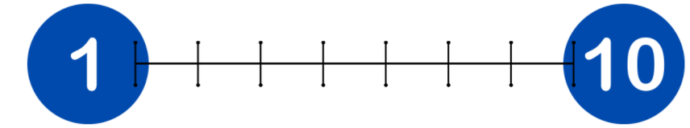

Day 10 activity 2: Small steps; big collaboration
Notes for teachers and whānau
This activity encourages your learner to think about the famous “one small step…” Neil Armstrong quote and to reflect on their learning and achievements. They would benefit from talking with you before recording examples in their home learning book.

In this activity I am learning to: use a phrase/quote as a springboard to reflect on my learning and achievements.
What do I need?
- 30 minutes
- Home learning book

Instructions:
“One small step for a man, one giant leap for mankind."
This famous phrase was said by astronaut Neil Armstrong in 1969 when he became the first person to set foot on the moon.
Our learning pathway is one step at a time. Our willingness to be capable learners takes courage. Neil Armstrong knew that his step may have been at a personal level but the courage to trust the work of everybody who contributed to his capability to take that step took personal courage. The payoff added to his self-esteem but also added to everybody else’s as well (mankind). Everybody's courage and effort adds to the collective good.
Think: Neil Armstrong uses the term ‘mankind’ to describe people. This term isn’t used anymore – why do you think that is?

Your task:
Neil Armstrong’s quote is often used in reference to a breakthrough or advancement. Think about moments in your life where you have taken a big step forward to do something brave or something that required courage and then think about if that big step of yours also helped others.
E.g. I took a small step to lead a whole school assembly… it encouraged others in my class to put their hand up to give it a go.
I put a poster up in the library about a beach clean-up day… a large group joined us to clean up the beach.
Write down one or two examples of where you or someone you know has taken a big step forward and how has that helped everyone else?

Day 10 activity 3: Geometry in the home
Notes for teachers and whānau
In this activity your learner is encouraged to take the family on a scavenger hunt to explore shapes around the home.

In this activity I am learning to: apply my geometry knowledge to the real world.
What do I need?
- 30 minutes
- Home learning book

Instructions:
As part of the maths focus this week you have been exploring geometric shapes. You have no doubt realised that shapes are all around us!

Your task:
Your first task is to teach others about regular polygons – use the learning you completed yesterday.
Challenge someone in your whānau to draw a shape that you name (eg triangle, quadrilateral, pentagon, hexagon) and discuss how many sides it has.
Once everyone is familiar with these shapes go on a hunt for items in and around your home that are regular polygons. You may like to make a table and list the room and which items you find:

Lounge | Bedroom | Bathroom | Garage | Kitchen
Heater – rectangle | Bookshelf – square | Mirror- rectangle | Tent - Pentagon | Grater - triangle

Your second task is to teach your whānau about the shapes your discovered when folding a paper plane. Demonstrate this to them and then ask them to fold their own plane.
Can they see any more polygons?

Day 10 activity 4: Music appreciation
Notes for teachers and whānau
As this week’s learning draws to a close your learner will spend this learning time appreciating music written about travelling in a rocket – Space Oddity, a song by David Bowie. As they listen to this, they will reflect on all that they have learnt and what has inspired them the most about this learning.

In this activity I am learning to: listen to music and record my thoughts and feelings.
What do I need?
- 30 minutes
- A device to listen to this short clip - https://www.youtube.com/watch?v=KaOC9danxNo
- Home learning book

Instructions:
We end our amazing week of learning by listening to music. Space Oddity is a song written and recorded by David Bowie. Space Oddity is a song about a fictional astronaut named Major Tom.
In 2013 a cover of this song was sung by Canadian astronaut Chris Hadfield as the music video was filmed aboard the International Space Station and was the first music video to be filmed in space.

Your task:
Use a device to listen to and watch Chris Hadfield’s cover of Space Oddity. As you listen record any vocabulary related to our focus for the week – rockets.
Write down
- How does this song make you feel?
- What do you notice in the video and how does that connect to what you have learnt this week?
Share this song with someone in your whānau.
Remember to do your end of day reflection and wellbeing activities (see p.6 & 8).

